亚威225KVA 采购合同230714生产质量问题反馈：

The 3 load break switches were not labeled properly (translation was wrong)
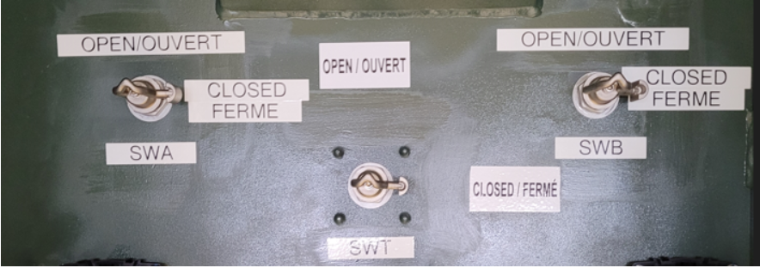

Oil level gauge, leak on conduit (Is it normal on the OLI conduit, there was oil in the conduit ???)
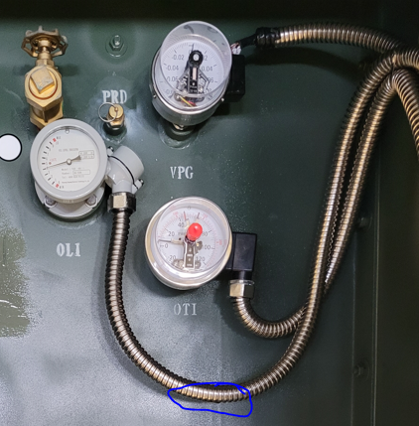

Pressure vacuum gauge (Conduit connector and plastic cover and little screw is missing (please provide replacement parts)
1x Plastic cover c/w installing screw
1x Metal connector for conduit
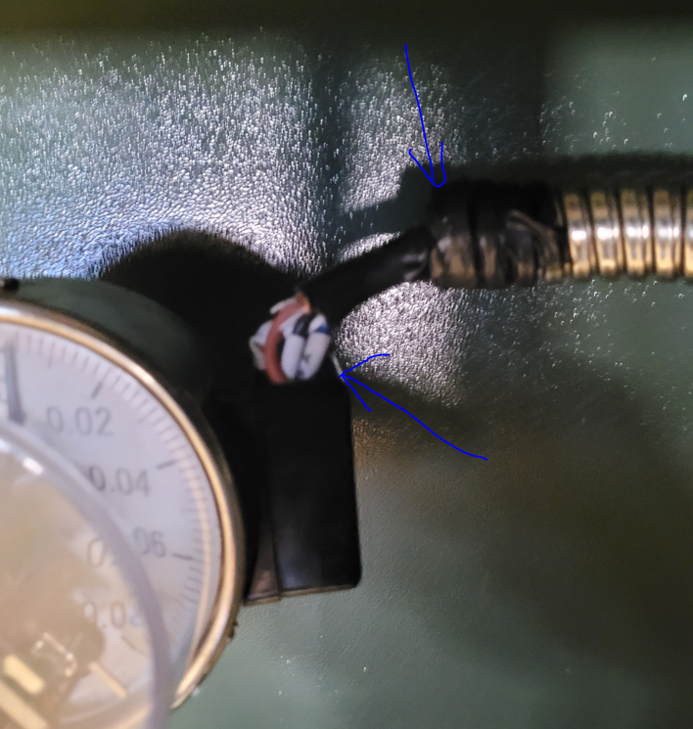

5.2.6 Doors and roof
The doors and roof of the compartment shall be of sufficient size to provide adequate operating and working space when opened.The compartment side, sill, door, and roof shall be electrically bonded to the tank by flexible copper connections. If the compartment side is the integral part of the tank side, flexible copper connections between the tank and compartment side shall not be required. The doors shall be provided with a stay to hold them in both the 90° and 110° open positions.

Welding default
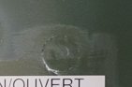

Welding default
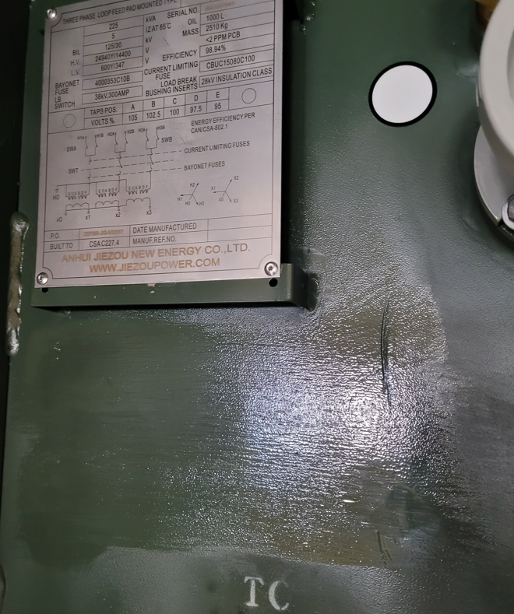
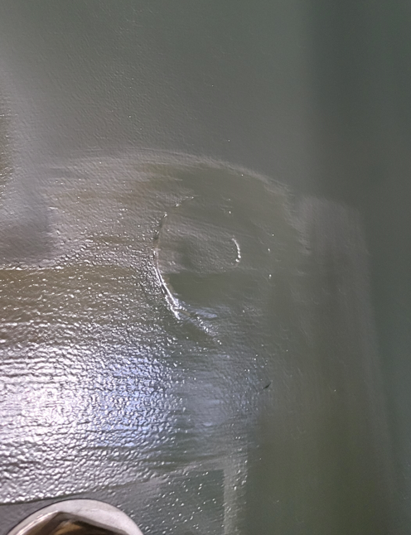

Non-PCBs sticker wasn’t installed
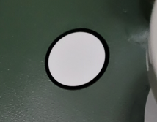

Enclosure paint looks bad (Orange peel grainy appearance) Presence a lot of traces (This is not flat surface paint) It can be improve…Flat paint finish will looks better
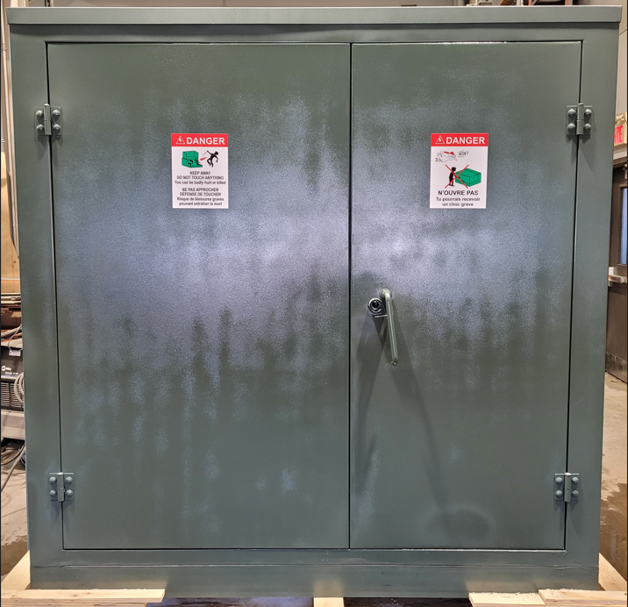

Warning stickers unglued, ‘cause of orange peel unflatted finish

8 Quality of work and finish
8.1 Finish performance
The exterior finish shall conform to ANSI C57.12.28.
8.2 Colour
The colour shall be either seafoam green, Munsell 4.82 G 4.07/3.35, or equipment green, Munsell 9 GY
1.5/2.6. If no colour is specified, seafoam green is supplied.
You does not have the good color code for Munsell 9GY 1.5/2.6 On next projects, be sure to have the great color code
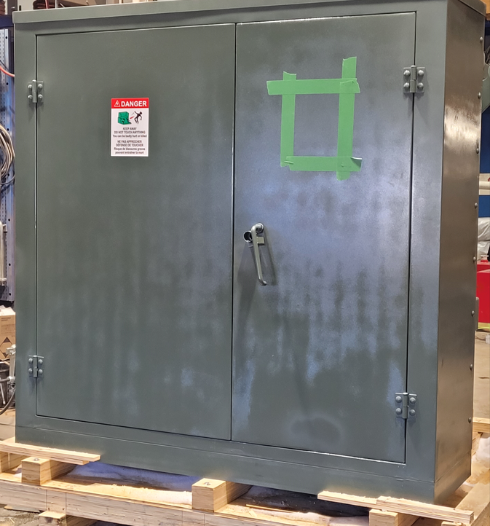

Lower seal on right door is broken
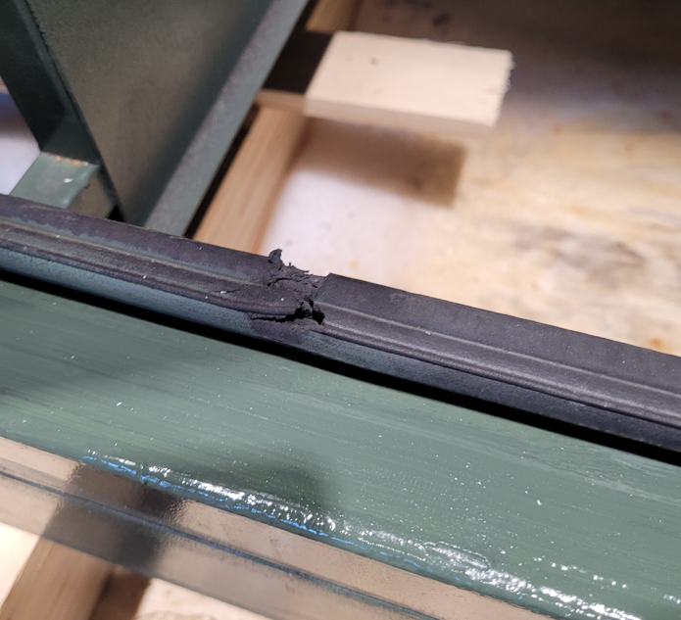

Bad paint finish
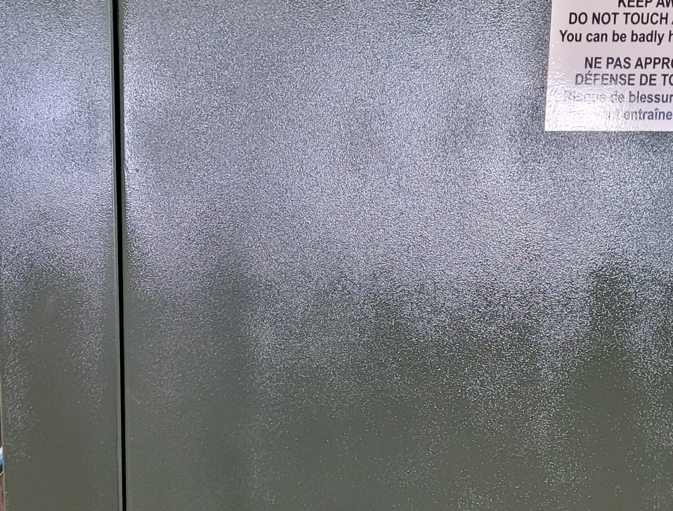

Multi shades in paint finish and missing labels
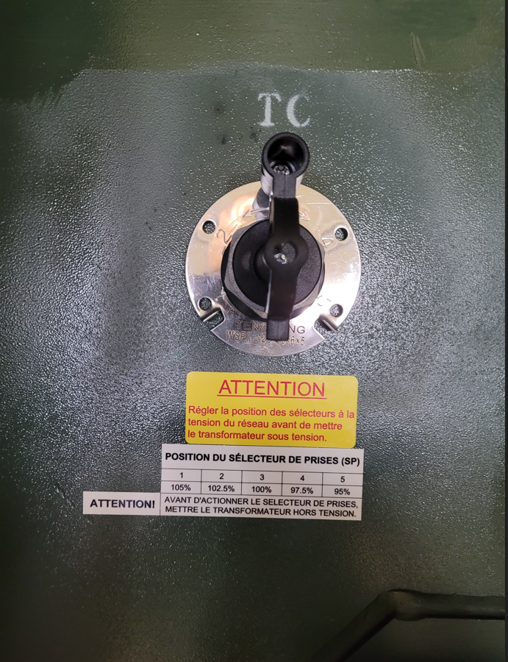
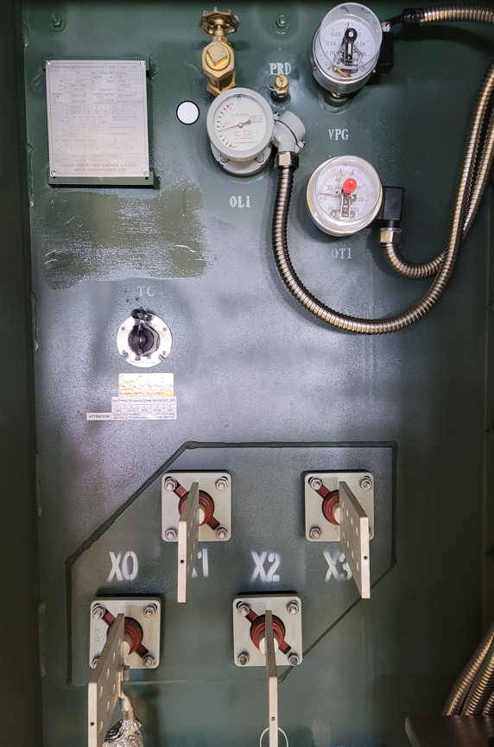
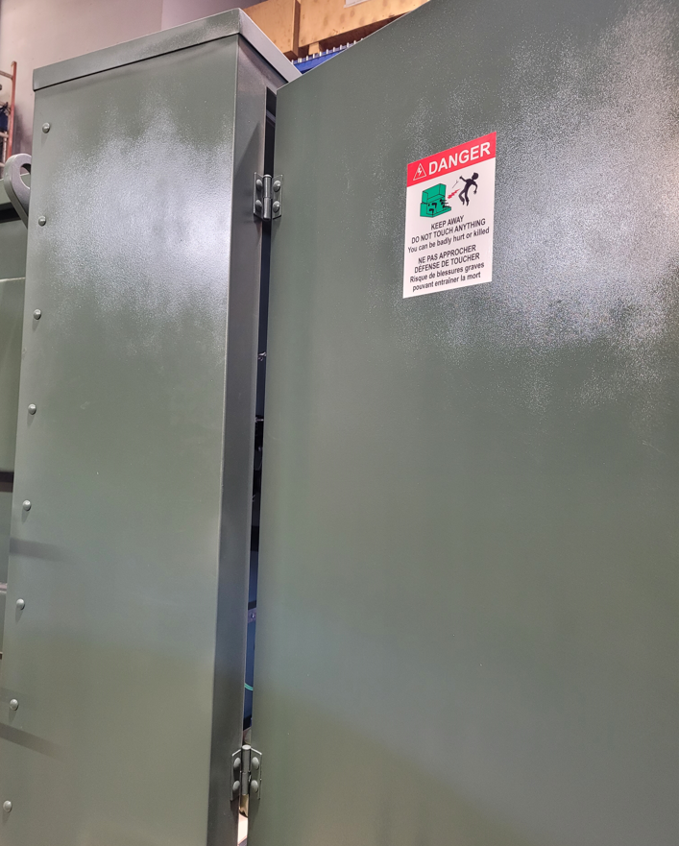

Your welds seems to be good.
However, how do you comply with the below required points by CSA C227.4 ?

8.3 Welding
All welding shall conform to CSA W59. The fabricator shall be fully qualified and approved by the
Canadian Welding Bureau in accordance with CSA W47.1.

In order to close the non-compliances, can you please address it to your quality department, and get back to me with your solutions.

