# ICS A Match Game Manual

Step 1.

Open the terminal to start the game. Go to the folder where the game is installed.

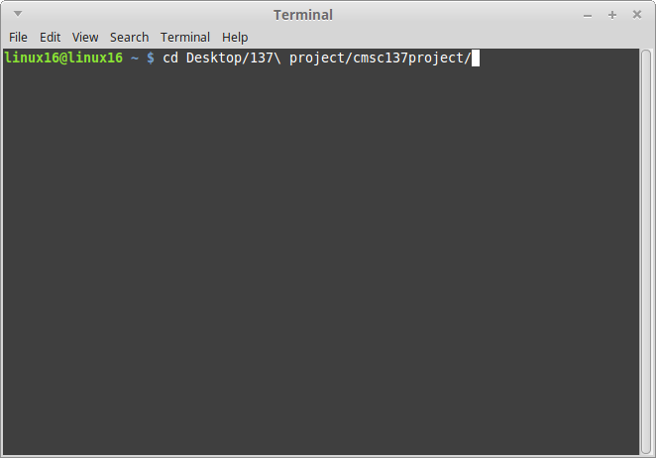

Step 2.

Compile the game by typing ”javac *.java”.

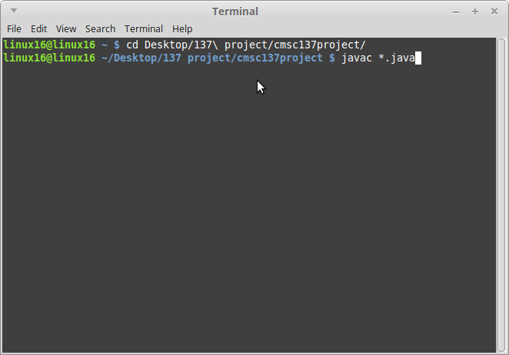

Step 3.

Afterwards, open the game by typing “java TCPClient [the IP address of the server]”.

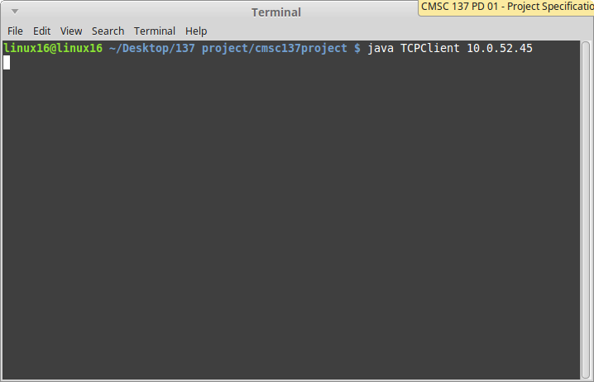

Step 4.

When the window opens, input your name and click “Join Game”. After joining the game, the user will must wait until there are enough players to start the game.

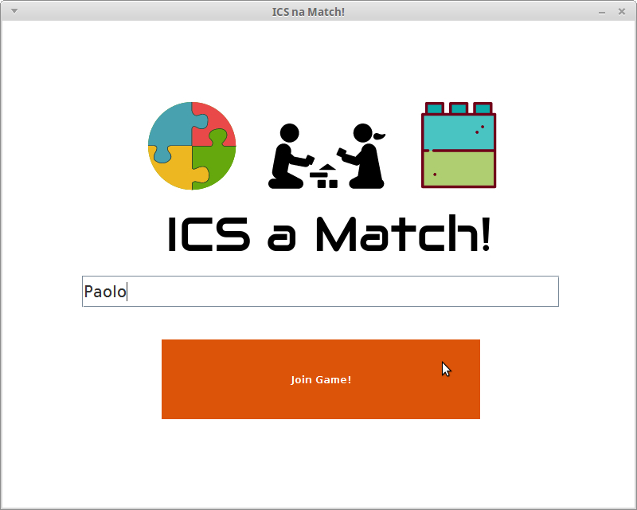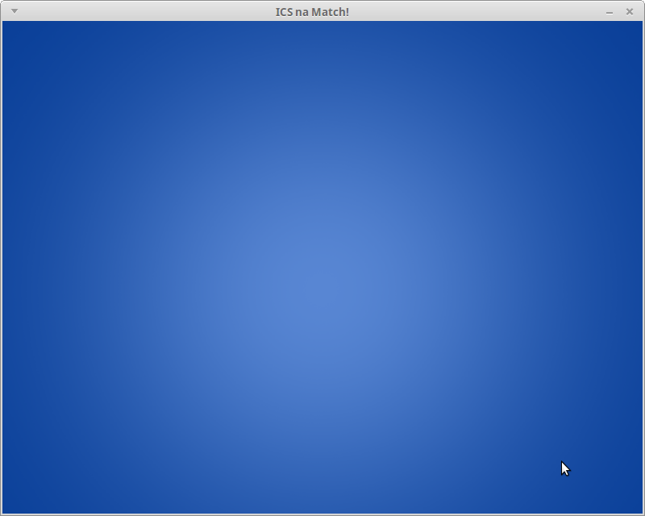

Step 5.

When enough players have connected, the game will start.

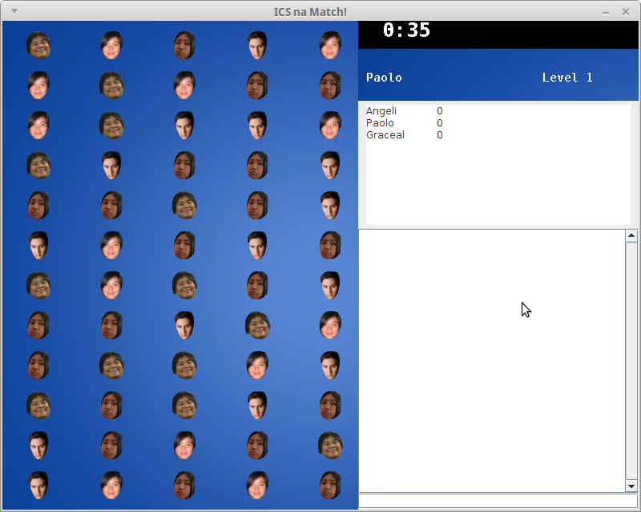

Mechanics:

ICS a Match is a matching game. Drag tokens to match them. Matching tokens allows you to earn points points every time you match three (3) or more tokens in a row or column. Each token is equivalent to 10 points. Depending on how many players have connected, there will be multiple rounds for a single game. Each round lasts one (1) minute. The player with the least number of points when the round ends will be eliminated. The goal is to be the last man or woman standing.

Score Board Player Level

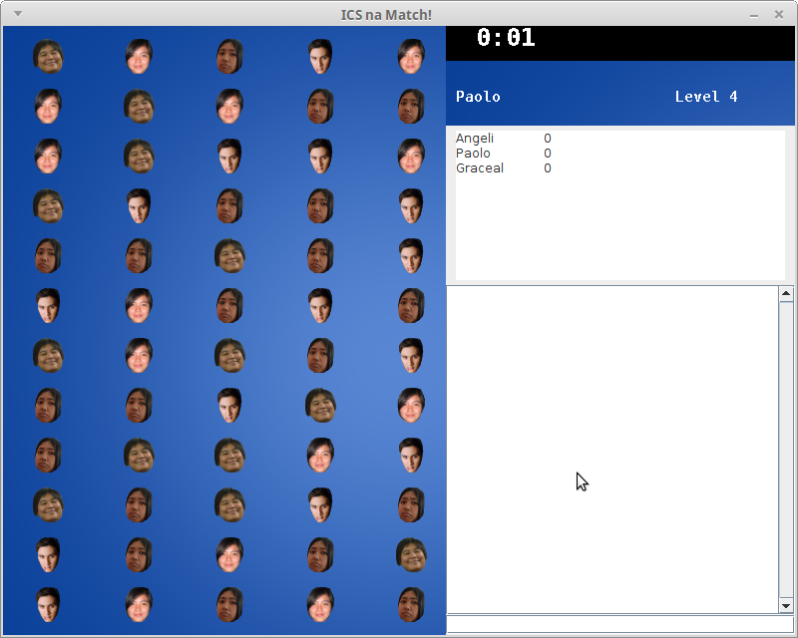 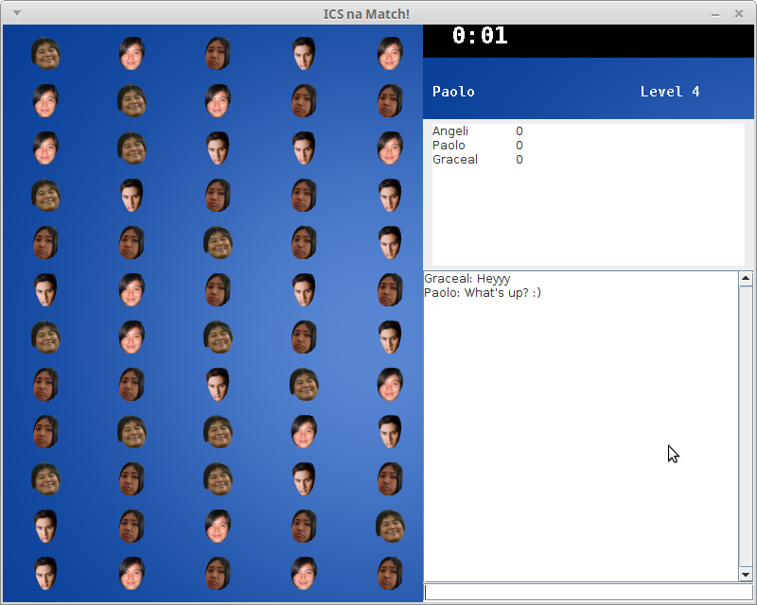

Chat Box



Timer



Token 1 Token 2 Token 3 Token 4

