Dyson School of Design Engineering | MEng Design Engineering

**Module Exam**

|  |  |
| --- | --- |
| Module code and Name | DE4-SIOT Sensing & IoT |
| Student CID |  |
|  |  |
| Assessment date | **10th Jan 2019** |
|  |  |

**Presentation URL (publicly accessible link):**

**Code & Data (publicly accessible link):**

# Coursework 1: Sensing

### Introduction and objectives

According to an article (Ogden, 2016), “In London alone, bad air quality is thought to kill nearly 10,000 people a year.” Currently, it is estimated that air pollution causes 15% of Chronic Obstructive Pulmonary Disorder which is predicted to the third leading cause of premature death worldwide by the World Health Organisation. A King’s College London study estimates that London’s two main pollutants (nitrogen dioxide, NO, and fine particulates) are responsible for 5, 900 premature deaths a year (Excell, 2015).

In this part of the project, the relationship between the how much people care about air pollution and the air quality throughout time is explored. The number of tweets about air pollution over a period is used to represent the awareness and care of the people. A periodic measure of the different pollutants in the air is used to represent the changes in air quality throughout time.

### Data Collection

The data sources used are: (i) OpenAQ API, which provides open air quality data (OpenAQ, 2018). This is used to collect real-time pollutants concentrations of different locations. (ii) Twitter Developer’s Standard Search API, which searches through tweets in Twitter (Twitter, 2018), a popular social media platform. This is used to collect information of real-time twitter posts with the key phrase “air pollution”.

|  |  |  |  |  |  |  |
| --- | --- | --- | --- | --- | --- | --- |
| **Timestamp** | **Location** | **pm25** | **pm10** | **no2** | **o3** | **co** |
| 2019-01-04T14:00:00.000Z | Causeway Bay | 46.7 | 64.3 | 165.8 | 2.7 | 852.8 |
| 2019-01-04T14:00:00.000Z | New Territories | 53.7 | 95.2 | 102.5 | 2 | 877.6 |
| *Sample of the data collected from OpenAQ API* | | | | | | |

Air quality being location dependent, different locations were selected as focus for measuring the air quality. The locations were selected based on the places that have higher tweeting frequencies (more tweets over a period) so that the changes and trends in tweeting frequency can be more obvious, and places that may yield more interesting data about pollution. Data collection occurred throughout ten days (day and night) due to the time dependency of tweet rates, since there are various time differences in the selected locations.

|  |  |  |  |  |  |  |
| --- | --- | --- | --- | --- | --- | --- |
| **Timestamp** | **Text** | **User** | **Tag** | **Location** | **Specific Location** | **General Location** |
| Fri Jan 04 14:45:13 | RT @BkPhilanthropy: Mercury pollution in the air we breathe m is down 81% because of regulations. https://t.co/uhXmCAW5dm | KCSunshineMom |  | Geeks Resist HQ | other | - |
| Fri Jan 04 14:45:02 | Air is OK near Croydon - Park Lane (Pollution Low : 1) | breathinglondon |  | London | London | UK |
| *Sample of the data collected from Twitter API* | | | | | | |

Ideally, the location where each tweet is posted is recorded as the associated location. However, the Twitter API can only provide that information for geo-tagged posts, which is the minority of posts. Instead, the location that is set on the tweeter’s profile, which is provided for each tweet, is used. Further programming was used to categorise the tweets to the chosen different general locations, which is used to relate with the locations used for air quality data collection.

To prevent aliasing and to fulfil Nyquist’s Criteria, the quantities of different air pollutants data are sampled at the maximum sampling frequency rate, which is a sampling period of one hour. OpenAQ API only provides new measured values every hour. The tracking of tweets about air pollution is recorded in real-time with a time stamp. This means that the fixed period chosen to define the tweet rate (number of tweets across a fixed period) can be decided after the data collection.

The data were stored using the Google Sheets API to automatically store the (near-) real-time streaming information into a Google Spreadsheet, which is stored in the cloud.

### Time-series Data Analysis

For initial data processing, the different pollutants data for the individual locations were grouped to give average data for their respective countries/large city. For further simplicity, the measured pollutant concentrations were converted into an Air Quality Index (AQI) for each four general locations. Inspired by how the U.S EPA AQI was calculated: the largest IAQI (Individual AQI), which is the index for each pollutant, was chosen on an hourly basis as the current AQI (EPA Victoria, 2015). IAQI was calculated as such $IAQI= \frac{pollutant concentration}{mean(pollutant concentration)}x100$. Missing data were filled with the most recent previous data. For large data gaps in the data collection due to travelling and lack of Internet connection, as suggested by Pandas (n.d.) as the most common ways of handling these cases, the data gaps were removed, and the remaining data sets were re-indexed.

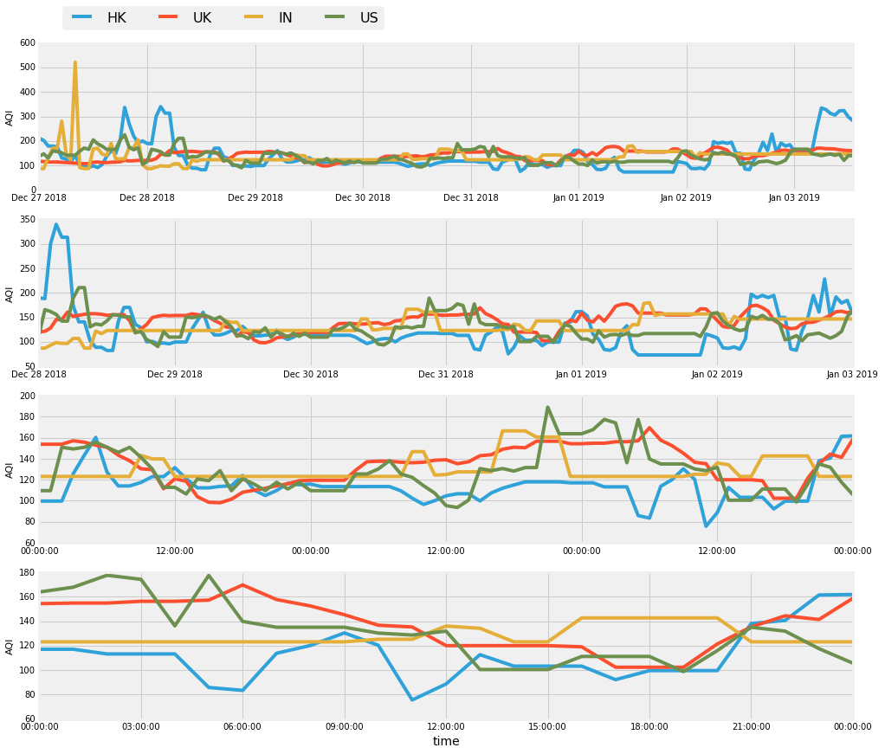

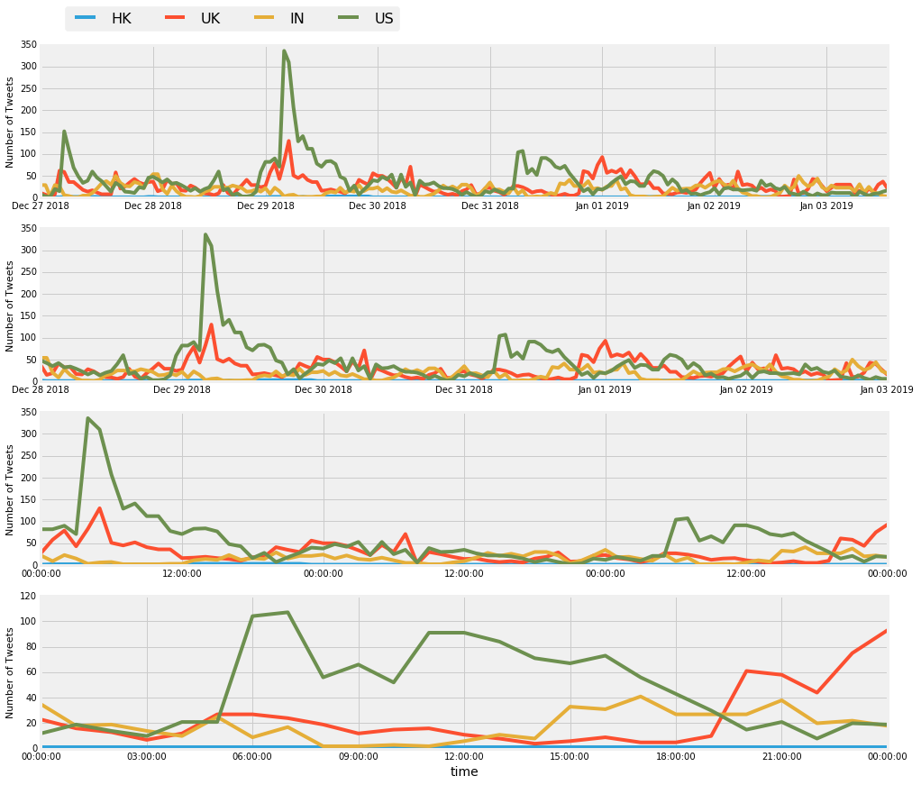

*Graphs showing data collected for AQI and Number of Tweets per hour in different locations*

There is no clear periodicity across the seven days. However, there are some fluctuations suggesting that more periodicity may be shown if more data were to be collected across a year monthly. Due to limited data, a conclusion as to whether there is a periodic pattern is unknown. There appears to be two relatively high peaks for both graphs suggesting anomalies. From looking at the data collected, the spike for the number of US tweets was found to be caused by a viral political tweet message, “The Trump Administration is attempting to dismantle the valuable work the EPA has done to protect the air we breathe. You can submit a public comment against this proposal by emailing a-and-r-docket@epa.gov. Include Docket ID No. EPA-HQ-OAR-2018-0794 in the subject line.” The other spike for India’s AQI was caused by a high concentration of PM10 pollutants in Delhi. Although the spike is indicated to be on the 27th December on the graph, due to time difference, the high AQI occurred on the 26th December India time. That is the day at which the FIATA World Congress event was being hosted in Delhi (Simhan, R., 2018).

Using Python, the different time-series datasets can be decomposed into trend, seasonality, and residual. From the graphs, it can be suggested that there is no clear trend, and a lot of residual (random variations) for both datasets, showing stochastic processes. Although there is no monotonic trend, the fluctuations show that the statistical properties (e.g. mean, variance, autocorrelation) change through time and is a non-stationary series. The lack of a clear trend can also be due to the lack of data. HK, which is relatively small compared to the other compared places, is excluded from further analysis due to the lack of tweet data.

|  |  |  |  |  |  |
| --- | --- | --- | --- | --- | --- |
| UK AQI | HK AQI | | IN AQI | | US AQI |
|  | | | | | |
| UK Tweets | | IN Tweets | | US Tweets | |
|  | | | | | |

From the autocorrelation, and partial autocorrelation graphs for AQI and tweet rate, most lags are less than the confidence interval and are statistically insignificant. This means that there is a lack of correlation between a lagged function of itself, and hence a lack of seasonality for both variables.

|  |  |  |
| --- | --- | --- |
|  |  |  |
|  |  |  |
|  |  |  |
|  |  |  |
| *Graphs showing autocorrelation and partial autocorrelation for AQI and tweet rate in different places* | | |

The graphs below show the fitting of linear time series models, ARMA (Autoregressive Moving Average) model and ARIMA (Autoregressive Integrated Moving Average) model, to help understand the time-series datasets and predict future points. Since the ARIMA model is a generalization of ARMA model to include cases of non-stationarity, it models the datasets better and hence the RMSE (root mean square error) is less or equal to that of ARMA’s RMSE.

|  |  |  |
| --- | --- | --- |
| μ=0.24 θ=0.25 RMSE=14.0 | μ=0.50 θ=0.06 RMSE=28.5 | μ=-0.02 θ=-0.20 RMSE=17.0 |
| μ=0.11 θ=-0.42 RMSE=19.0 | μ=-0.13 θ=-0.31 RMSE=15.1 | μ=-0.04 θ=-0.13 RMSE=24.3 |
| *Graphs showing ARMA model of AQI and tweet rate in different places* | | |

|  |  |  |
| --- | --- | --- |
| μ=-0.00 θ=-0.51 RMSE=13.9 | μ=-0.15 θ=-0.97 RMSE=13.6 | μ=-0.01 θ=-0.67 RMSE=17.0 |
| *Graphs showing ARIMA model of AQI in different places* | | |
| μ=0.01 θ=-0.84 RMSE=19.0 | μ=0.01 θ=-0.83 RMSE=15.1 | μ=0.02 θ=-0.62 RMSE=24.3 |
| *Graphs showing ARIMA model of tweet rate in different places* | | |

### Discussion

There is an initial assumption that the tweet rate about air pollution in a place would correlate to the care people would have to pollution in the area, however this may not be the case. As showcased by the anomaly, there are many other different reasons, such as internet virality, that may cause tweets about air pollution apart from the air quality of the area being poor. Filtering tweets with the keywords “air pollution” is not a rigorous method in filtering tweets, as there are other ways in saying air pollution, for example “air quality”, or comments on how clear the view is, or fog.

In addition to the assumptions, the data quality and quantity could be improved on. The labelling of the user’s location relies on a script which is very conservative and unthorough. Large time gaps and missing information were created due to not being able to collect data when physically travelling and when the internet connection was inconsistent. Although the time quantity was ten days, it was reduced to seven after removing the large time gaps. More data may help in detecting possible larger trends and periodicity, and hence change the results.  
  
Based on the data collected, to conclude, the AQI and tweet rate about air pollution based on the data collected is stochastic and non-stationary. Unfortunately, no time-series patterns could be found.

### References

EPA Victoria, 2015. Calculating a station air quality index. [online] Available at: <https://www.epa.vic.gov.au/your-environment/air/air-pollution/air-quality-index/calculating-a-station-air-quality-index> [Accessed 3 December 2018].

Excell, J., 2015. The lethal effects of London fog. *BBC.* 22 December. [Viewed 14 November 2018]. Available from: <http://www.bbc.com/future/story/20151221-the-lethal-effects-of-london-fog>

Ogden, L.E., 2016. The tiny changes air pollution makes inside you. *BBC*. 11 February. [Viewed 14 November 2018]. Available from: <http://www.bbc.com/future/story/20160210-the-tiny-changes-air-pollution-makes-inside-you>.

OpenAQ, 2018. *Open AQ Platform API.* [online] Available at: <https://docs.openaq.org/> [Accessed 23 December 2018].

Pandas, n.d. *Working with missing data.* [online] Available at: <https://pandas.pydata.org/pandas-docs/stable/missing_data.html> [Accessed 8 January 2019].

Simhan, R., 2018. Global logistics meet in Delhi on Sept 26. *The Hindu Business Line.* [online] Available at: <https://www.thehindubusinessline.com/news/global-logistics-meet-in-delhi-on-sept-26/article24970412.ece> [Accessed 9 January 2019].

## Coursework 2: Internet of Things

### Data analytics, inferences and insights

The cross-correlation below shows how the similarity of AQI and the Twitter tweet rate is the highest when the functions displacement is zero, which means no displacement. Even though this is the case, the highest correlation is not significantly higher than the other displacement’s correlations.

|  |  |  |
| --- | --- | --- |
|  |  |  |
| *Graphs showing cross-correlation between AQI and Twitter’s tweet rate* | | |

The respective Pearson product-moment correlation coefficients for the relationship between AQI and tweet rates in UK (0.13), IN (-0.03), and US(-0.01) suggest that there are insignificant correlations and close to no correlation for the different places.

Although there are problems with air pollution, some people are unaware of the impact. A London study (Taylor and Laville, 2017) showed that only one in ten British adults rated air quality as poor despite the country exceeding the legal limits of air pollution. An article that describes air pollution as a “silent killer” emphasizes the unfamiliarity of Air Quality Index (AQI) to some people in Vietnam (Dat, T., 2018). The effects of air pollution are difficult to comprehend due to it being invisible.

### Data Interaction/visualisation/actuation platform

Gamification, social network (see tweets)

<https://www.fastcompany.com/3049540/5-ways-to-convince-people-to-actually-do-something-about-climate-change>

visualising

<http://www.carbonvisuals.com/blog/2016/2/3/a-breath-of-fresh-air-visualising-air-pollution>

<https://www.fastcompany.com/3062129/these-pollution-sensitive-shirts-visualize-the-filthy-air-youre-breathing>

### Discussions on the important aspects of the project

### Avenues for future work and potential impact

## References

Taylor, M., and Laville, S., 2017. British people unaware pollution levels air they breathe -study. [Viewed 14 November 2018]. Available from: <https://www.theguardian.com/environment/2017/mar/01/british-people-unaware-pollution-levels-air-breathe-friends-earth>

Dat, T., 2018. Air pollution is Vietnam’s silent killer. *Vietname Investment Review.* 26 February. [Viewed 26 December 2018] Available from: <https://www.vir.com.vn/air-pollution-is-vietnams-silent-killer-56542.html>