
Yuna Guillamot
- May 10, 2024
- 2 min read
Rated 0 out of 5 stars. No ratings yet

Passolo Demystified: A Deep Dive into Software Localization Tools

Localisation software Passolo by RWS (formerly SDL) is another tool that is free to use for the translator, but only with packages prepared by the client.
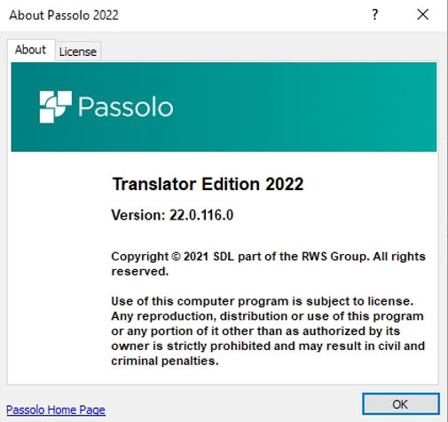

Developed specifically for software localisation, its interface is rather different to other tools. Firstly, different versions of Passolo aren’t compatible with each other. As translators, we’ll need all the translator versions of Passolo our clients use. On my computer, I currently have Passolo 2016, 2018 and 2022. The translator interface is rather intuitive, but for those of us in need of glasses, it might cause some fatigue.
The client prepares bundles of strings that need localisation, and the source text of each string is linked to an ID describing the function of said text in the graphic user interface (GUI). This allows us to translate GUI content more efficiently, for example, than if we were given a list of expressions in an Excel table. I know some of you have had the case!
The software uses a translation memory and a termbase, the same way conventional tools do, and allows concordance searches. It is also compatible with .glo glossary formats and Trados Studio TMs. Google and Bing MT integrations are offered, but I suppose that given how important context is when translation GUIs, it makes sense that MT isn’t a priority.
It doesn’t offer a “what you see is what you get” (WYSIWYG) approach with a preview, a feature we enjoy with most other available softwares. The state of segments is indicated by their colour (red, green, blue, black from untranslated to translated and verified), and errors/conflicts are indicated as they come up.
Localising software is quite a different task than plain old translation, but Passolo allows you to have more information and context regarding the strings you’re working with, as opposed to just having to localise a list of Excel sheet entries with no context. There are no bells and whistles, though, and the software could be more user-friendly with a touch more ergonomics worked into the translators’ interface.
How many of you localise software with Passolo?
What are your personal observations?
Is there anything more you’d like to know about this tool?

