Revision draft — Examiner 3 (2nd round), Comments 2 and 4: Section 1.3 research scope, port terminology and terminal layout
Comment 2 (port, terminal and berth not distinguished) and Comment 4 (scope statement on seaports, river ports and dry ports implies a multimodal system that is not studied), as summarised in your initial plan. Related in-text annotations: p. 13 (port vs terminal productivity), p. 22 (seaport, river port, dry port; “Rewrite this part”), p. 23 (“different levels”; “deals with three ports”) and p. 24 (“Define port activities… why… harbour craft”).
Approach. Part A replaces the current “Research scope” subsection of Section 1.3 in the 10 Oct version with three new subsections. Section 1.3.1 defines port, seaport, river port, dry port, terminal, container terminal, terminal operator, berth and harbour craft from official and academic sources (Table 1, Figure 1). Section 1.3.2 describes the container terminal subsystems and the two basic yard layouts, and links them to Chapters 5 and 6 (Figure 2, Table 2). Section 1.3.3 then states the overall scope and the specific scope of each study (Table 3). Transport infrastructure is mentioned only where it belongs, in the first sub-study of Chapter 4. The existing “Empirical contexts” subsection becomes Section 1.3.4 without change. Part B lists the consistency edits elsewhere in the thesis, Part C is the response letter for Comments 2 and 4, and the references follow.
A note on “landside” and “waterside”. You asked to frame Chapter 5 as landside operation (ship-to-shore/quayside interface and yard) and Chapter 6 as waterside. This is correct at the scale of the port, which consists of a land area and a water area. In the terminal operations literature, however, “landside” means the truck and rail interface at the gate, and the ship-to-shore interface is called the “quayside” or “seaside”. Because Examiner 3 has criticised the terminology twice, the draft defines both scales explicitly and uses “the land side of the port” and “the water side of the port” for the port scale, and the subsystem names (quayside, yard, horizontal transport, landside interface) for the terminal scale. Part B applies the same wording to the sentences elsewhere that use “landside equipment” or “waterside”. The terminal-scale names also match Table 3 in Chapter 2 (file 04), which is organised by seaside, horizontal transport, yard and landside subsystems.
Numbering. The three new tables and two new figures come before the existing Table 1 (rationale for the empirical contexts) and Figure 1 (research process flow), which become Table 4 and Figure 3. If your captions use Word fields, all later numbers update automatically. The figures are drawn by me and saved in examiner4/fig as 300-dpi PNG files; please redraw them in your own style if you prefer. Notes to you are in grey italic boxes. Everything else in Parts A and B is proposed thesis text, to be marked purple; the response in Part C is in green, following your colour scheme.

A. SECTION 1.3: REVISED RESEARCH SCOPE
Keep the heading “1.3 Research scope and context”. Replace the subheading “Research scope” and its six paragraphs (from “This thesis focuses on technology development in ports.” to “…environmental performance of ports.”) with Sections 1.3.1 to 1.3.3 below. The paragraph on hardware and software technologies is kept in Section 1.3.3 in edited form. Then renumber “Empirical contexts” as Section 1.3.4.

1.3.1 Ports, terminals and berths
Because this thesis examines technology advancement at several levels of analysis, the units to which its findings refer must be defined precisely. Ports differ widely in size, function, governance and the activities they host, and the port literature has not settled on a single classification of ports (Bichou & Gray, 2005). This section therefore defines the port-related terms used in the thesis, drawing on official definitions and on the port and terminal literature. The definitions are summarised in Table 1, and Figure 1 shows how the units relate to one another and to the empirical studies.
A port is a node of the transport infrastructure system, in the same way as an airport or a rail freight terminal, at which waterborne transport meets land transport. In European Union law, a maritime port is defined as an area of land and water made up of the infrastructure and equipment that permits, principally, the reception of waterborne vessels, their loading and unloading, the storage of goods, the receipt and delivery of those goods, and the embarkation and disembarkation of passengers, crew and other persons (Regulation (EU) 2017/352). The port geography literature similarly describes ports as harbour areas in which marine terminal facilities transfer cargo and passengers between ships and land transport (Rodrigue & Notteboom, 2024). Two features of these definitions are important for this thesis. First, a port consists of both a land area and a water area. Second, port operations include not only the handling of cargo but also the services provided to vessels. The same regulation lists bunkering, cargo handling, mooring, passenger services, the collection of ship-generated waste and cargo residues, pilotage and towage as port services, which may be provided within the port area or on the waterway access to the port (Regulation (EU) 2017/352).
Ports can be further distinguished by their location and by the vessels and transport modes they serve. A seaport, or maritime port, receives seagoing vessels, including the ships of international liner and bulk shipping. A river port is an inland waterway port: it is located on a navigable inland waterway, such as a river, canal or lake that is not part of the sea, and it receives inland waterway vessels (Eurostat et al., 2019). A dry port has no water side. Under the Intergovernmental Agreement on Dry Ports, it is an inland location that serves as a logistics centre connected to one or more modes of transport, where goods moving in international trade are handled, stored and inspected, and customs control and formalities are carried out (ESCAP, 2013). In the dry port concept, such a terminal is linked to a seaport by high-capacity transport, typically rail, so that shippers can deliver and collect containers as if at the seaport itself (Roso et al., 2009). Because the three types of port serve different carriers, namely seagoing ships, inland waterway vessels, and trucks and trains, they also use different equipment and cargo-handling operations, and a study covering all three would need to treat them as parts of a multimodal transport network. This thesis does not take that perspective. Its empirical focus is on seaports, and Section 1.3.3 specifies which types of port enter each study.
Within a port, cargo is handled in terminals. A terminal is a part of the port’s land area, with its own quay, storage areas and handling equipment, that is dedicated to a particular type of cargo or traffic, such as containers, dry bulk, liquid bulk or passengers (Rodrigue & Notteboom, 2024). In the landlord model of port management, the port authority owns the port land and basic infrastructure, plans the port and acts as regulator, while private terminal operating companies lease the terminals, provide and maintain the superstructure and equipment, and are responsible for terminal operations (World Bank, 2007). A large container port can therefore contain several container terminals run by different operators, including global terminal operators that hold terminals in many ports around the world (Notteboom & Rodrigue, 2012). A container terminal is a terminal at which containers are transferred between modes of transport, from ships to barges, trucks and trains and vice versa, using several types of handling equipment (Vis & de Koster, 2003). Along the quay of a terminal, vessels moor at berths. A berth is the location at which a vessel is stopped and secured for cargo transfer or other purposes (Bureau of Transportation Statistics, n.d.). In container terminals, the quay is either divided into a fixed number of discrete berths or treated as a continuous quay along which vessels are assigned positions (Bierwirth & Meisel, 2010).
Port, terminal and berth are therefore nested units. A port contains one or more terminals, and a terminal contains one or more berths (Figure 1). The distinction matters for measurement. The container throughput of a port is the total of the volumes handled by its terminals, whereas the equipment and operating practices of each terminal are decided by its operator (World Bank, 2007), so terminals in the same port may differ in equipment and performance. In this thesis, “port” refers to the port as a whole, “terminal” to the operational unit managed by a terminal operator, and “berth” to the mooring position at the quay. The empirical analysis in Chapter 5 is conducted at the level of container terminal operators, not of ports.
The vessels that provide services within the port are a further element of port operations. In Singapore, a harbour craft is defined in law as any vessel used in the port for any purpose (Maritime and Port Authority of Singapore Act 1996, s. 2), and harbour craft are licensed by type, including tugs, bulk liquid carriers such as bunker tankers, cargo craft and passenger craft (MPA Singapore, n.d.). Harbour craft operate in the water area of the port and provide several of the port services listed above, such as towage, bunkering and passenger transport, so they differ from the seagoing ships that call at the port. Port emission inventories accordingly treat harbour craft as a separate source category of port-related emissions, alongside ocean-going vessels, cargo-handling equipment, on-road vehicles and rail (US EPA, 2022). On this basis, harbour craft operations are treated in this thesis as part of port operations on the water side of the port, which is the setting of Chapter 6.
Table 1: Definitions of port-related terms used in this thesis
Term | Definition adopted in this thesis | Main source
Port | Area of land and water with the infrastructure and equipment to receive vessels, load and unload them, store goods and serve passengers | Regulation (EU) 2017/352; Rodrigue & Notteboom (2024)
Seaport (maritime port) | Port that receives seagoing vessels | Regulation (EU) 2017/352
River port (inland waterway port) | Port on a navigable inland waterway that receives inland waterway vessels | Eurostat et al. (2019)
Dry port | Inland logistics centre linked to one or more transport modes, with handling, storage, inspection and customs functions; no water side | ESCAP (2013); Roso et al. (2009)
Terminal | Part of a port’s land area, with quay, storage and equipment, dedicated to one type of cargo or traffic | Rodrigue & Notteboom (2024)
Container terminal | Terminal at which containers are transferred between ships, barges, trucks and trains | Vis & de Koster (2003)
Terminal operator | Company that leases a terminal, provides its equipment and runs its operations | World Bank (2007); Notteboom & Rodrigue (2012)
Berth | Location at a quay where a vessel is moored for cargo transfer or other purposes | Bureau of Transportation Statistics (n.d.); Bierwirth & Meisel (2010)
Harbour craft | Vessel used within the port, e.g., tug, bunker tanker, cargo or passenger craft | MPA Act 1996, s. 2; MPA Singapore (n.d.)
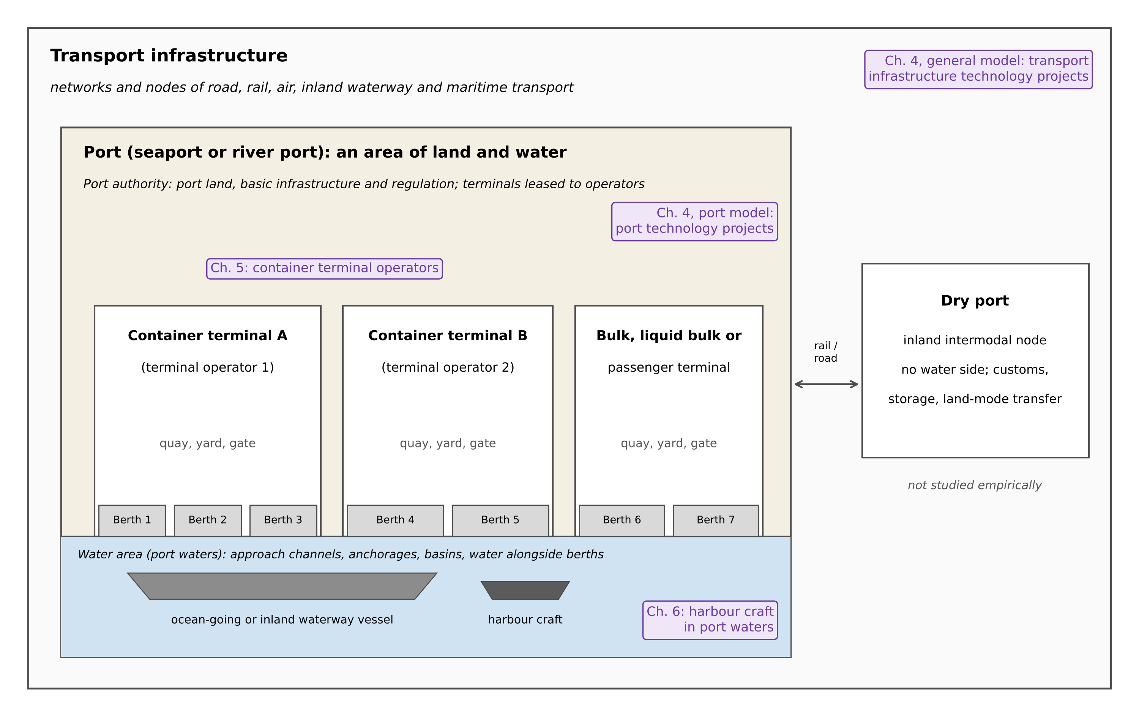
Figure 1: Port, terminal and berth as nested units, and the units examined in each empirical study. Source: drawn by the author based on Regulation (EU) 2017/352, World Bank (2007), ESCAP (2013) and Roso et al. (2009).

1.3.2 Container terminal layout and operational areas
Container terminals are the setting of the organisational-level study, and their internal organisation determines which equipment and technologies that study can observe. The terminal operations literature describes a container terminal as a system of linked subsystems through which containers move between the ship and the hinterland (Steenken et al., 2004; Stahlbock & Voß, 2008). At the quayside, quay cranes (QCs), also known as ship-to-shore (STS) cranes, unload and load vessels at the berth (Bierwirth & Meisel, 2010). Horizontal transport equipment, such as yard trucks, straddle carriers and automated guided vehicles (AGVs), moves containers between the quay and the storage yard (Carlo et al., 2014b). In the yard, containers are stacked in blocks and handled by yard cranes, such as rubber-tyred gantry cranes (RTGs), rail-mounted gantry cranes (RMGs) or automated stacking cranes (ASCs) (Carlo et al., 2014a). At the landside interface, containers are transferred to and from trucks at the gate and trains at rail terminals (Gharehgozli et al., 2016; Kim, 2023). Table 2 summarises these subsystems and the equipment used in each.
The arrangement of the yard blocks relative to the quay is a basic design decision. In one layout, the blocks are parallel to the quay, and containers are transferred beside the blocks, where yard trucks travel in lanes alongside them. In the other, the blocks are perpendicular to the quay, and containers are transferred at the two ends of each block, an arrangement used in automated terminals with automated stacking cranes (Kim et al., 2008; Lee & Kim, 2013; Kim, 2023). Figure 2 illustrates both layouts. The layout affects the choice of handling equipment as well as terminal productivity, and the better layout depends on design parameters such as storage requirements and the throughput capacity of the yard cranes and transporters used (Lee & Kim, 2013). For example, for terminals using automated lifting vehicles with an internal transport area of the same width, the parallel layout was found to reduce container throughput times by 4–12% compared with the perpendicular layout (Gupta et al., 2017).
Two scales of the distinction between land and water are therefore used in this thesis. At the scale of the port, the land side comprises the terminal areas, including their quays, yards and gates, and the water side comprises the port waters, including the waterway access to the port, anchorages, basins and the water alongside the berths (Regulation (EU) 2017/352; Figure 1). At the scale of the terminal, the operations literature uses “quayside” or “seaside” for the ship-to-shore interface and “landside” for the interface with trucks and trains (Steenken et al., 2004; Gharehgozli et al., 2016). In this thesis, “the land side of the port” and “the water side of the port” are used in the port-scale sense, and the terminal subsystems are referred to by their names. Figure 2 shows both scales and the parts covered by Chapters 5 and 6.
Chapter 5 examines cargo-handling equipment on the land side of the port, in the quayside and yard subsystems of container terminals, namely the number and capacity of STS cranes and yard gantry cranes. Horizontal transport equipment, gate operations and yard layout are not modelled, because the terminal-level yearbook data used in Chapter 5 do not report them consistently across operators and years (Section 5.3.2). They are treated as part of the operating context of each terminal, and their omission is discussed as a limitation in Section 5.6. Chapter 6 then turns to the water side of the port, where harbour craft operate.
Please confirm the reason given for not modelling horizontal transport, gate operations and yard layout, i.e. that the China Ports Yearbook does not report these items consistently for the 46 operators. If the yearbook does report, for example, the number of yard trucks or AGVs, the sentence should give the actual reason instead. The limitation in Section 5.6 will be drafted when we deal with Comment 10 (terminal layout and horizontal transport).
Table 2: Container terminal subsystems and their coverage in this thesis
Area or subsystem | Main operations | Typical equipment | Coverage in this thesis
Water side of the port (port waters) | Vessel approach and mooring; towage, bunkering and other port services | Ships; harbour craft (tugs, bunker tankers, cargo and passenger craft) | Chapter 6: harbour craft fuel use and emissions
Quayside (berth and apron) | Unloading and loading of vessels | QCs (STS cranes) | Chapter 5: number and capacity of STS cranes
Horizontal transport | Movement of containers between quay and yard | Yard trucks, straddle carriers, AGVs | Context only
Yard | Stacking, storage and retrieval of containers | RTGs, RMGs, ASCs, straddle carriers | Chapter 5: number and capacity of yard gantry cranes
Landside interface | Transfer to and from trucks and trains; gate processing | Gate systems, rail cranes | Context only
Sources: Regulation (EU) 2017/352; MPA Singapore (n.d.); Steenken et al. (2004); Bierwirth and Meisel (2010); Carlo et al. (2014a, 2014b); Gharehgozli et al. (2016).
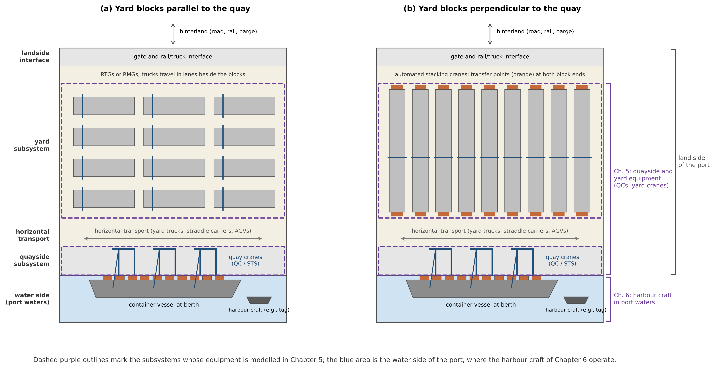
Figure 2: Container terminal layouts and operational areas, and the parts covered by Chapters 5 and 6: (a) yard blocks parallel to the quay; (b) yard blocks perpendicular to the quay. Source: drawn by the author based on Steenken et al. (2004), Lee and Kim (2013) and Kim (2023).
Please check Figure 2 and the layout paragraph against Kim (2023), Fig. 1.1, Fig. 1.2 and Table 1.6, which Examiner 3 recommends. I could confirm the book (Elsevier, ISBN 978-0-443-13823-2) and its table of contents (facilities planning, storage yard design, handling processes and automation), but not the text of those figures. In particular, please confirm that Kim describes the perpendicular layout as the one used in automated terminals with ASCs; if not, delete “Kim, 2023” from that sentence and keep the other two citations. Adding page numbers for Kim (2023) would also help.

1.3.3 Scope of the thesis and of each study
Building on these definitions, this thesis focuses on technology advancement in ports, that is, on how technologies are developed, adopted and evaluated in port infrastructure, in terminal cargo-handling equipment and in the operation of port vessels. Technology is understood to include both hardware and software. Hardware-based technologies include physical infrastructure, cargo-handling equipment, alternative-fuelled machinery and onboard energy technologies, and software-based technologies include digital and information systems, data platforms, algorithmic tools and other ICT-enabled applications. Both categories are recognised throughout the thesis, but the empirical emphasis differs between the studies, as set out below and summarised in Table 3.
Study 1 (Chapter 3) is a systematic literature review of the theories that explain port technology development. It covers studies of ports, seaports, harbours and terminals (Section 3.2) and examines the role of technology advancement in port development and the economic, institutional and organisational theories used to explain it.
Study 2 (Chapter 4) is conducted at the national level. From an investment perspective, it examines how government incentives for R&D, national innovation input and the technology development level of a country are associated with the participation of a country’s organisations in technology projects. Because ports are part of the wider transport infrastructure, the chapter consists of two sub-studies. The first places ports in this wider context. It analyses transport infrastructure projects with a technological component, such as automation, digitalisation or sustainable energy, across air, rail, road, inland waterway and maritime transport, drawn from the European Commission’s TRIMIS database for 35 European countries (Section 4.3.3). The second narrows the analysis to port infrastructure projects. In both sub-studies, the unit of analysis is the country, and ports enter the analysis as the location of technology projects [, which concern maritime ports and inland ports]. The chapter therefore does not examine the operations of individual ports or terminals, or the connections between ports in a multimodal transport network.
Please confirm the bracketed clause. Your previous scope text said the Chapter 4 port model covered “seaports, river ports, and dry ports”, and the TRIMIS search included the inland waterway and maritime modes. (1) If the port projects concern both maritime and inland ports, keep the clause. (2) If any project concerns a dry port, add “and dry ports”. (3) If all the port projects concern seaports, replace the clause with “, all of which concern seaports” and change “Its empirical focus is on seaports” in Section 1.3.1 to “Its empirical analyses concern seaports”. Option (3) is the cleanest answer to Comment 4, so it is worth checking the project list.
Study 3 (Chapter 5) is conducted at the organisational level, in container terminals. Its unit of analysis is the container terminal operator, and its sample consists of 46 container terminal operators in Chinese [coastal] ports, observed from 2015 to 2021 (Section 5.3.2). Within the terminal, it covers the quayside and yard subsystems. It examines how the number and capacity of STS cranes and yard gantry cranes are associated with container throughput over time, and how technological progress, measured by the Malmquist productivity index, is related to the education level of the workforce and to ownership structure. Horizontal transport, gate operations, yard layout and other types of terminal, such as bulk or passenger terminals, are outside its empirical scope.
Please confirm “[coastal]”. If some of the 46 operators are in Yangtze River ports, such as Nanjing or Taicang, write “in Chinese coastal and river ports” instead, and say so again in Section 5.3.2.
Study 4 (Chapter 6) is conducted at the operational level, on the water side of the port. It examines the adoption of biofuel as a sustainable energy technology in harbour craft operating in the port waters of Singapore. Using onboard sensor data collected in sea trials with conventional diesel and biofuel blends, it applies machine-learning models to predict fuel consumption and emissions. The study concerns harbour craft only and does not extend to the ocean-going ships that call at the port.
Overall, the thesis is delimited to the technological aspects of port development. Apart from the first sub-study of Chapter 4, which places ports within the wider transport infrastructure, it does not examine the technologies of other transport modes, the technologies of ocean-going ships, the multimodal connections between seaports, river ports and dry ports, or broader trade policy. Dry ports are defined in Section 1.3.1 to delimit the concept of a port, but they are not studied empirically.
Table 3: Scope of the four studies
Study (chapter) | Level | Unit of analysis | Part of the port | Technologies examined | Outside the scope
Study 1 (Ch. 3) | Theoretical | Published studies | Ports, seaports, harbours, terminals | Port technologies in general | Empirical testing
Study 2 (Ch. 4) | National | Country (35 European countries) | Transport infrastructure (first sub-study); port infrastructure (second sub-study) | Technology projects, e.g., automation, digitalisation, sustainable energy | Operations of individual ports; multimodal links
Study 3 (Ch. 5) | Organisational | Container terminal operator (46, China) | Land side: quayside and yard subsystems | STS cranes, yard gantry cranes; technological progress | Horizontal transport, gate, layout; other terminal types
Study 4 (Ch. 6) | Operational | Harbour craft (Singapore) | Water side: port waters | Biofuel blends; machine-learning prediction | Ocean-going ships

1.3.4 Empirical contexts
The existing “Empirical contexts” text follows here unchanged, apart from its new number. Two small points to check while you are there: the “Setting” cell for Study 2 in the rationale table says “European Union”, but the sample has 35 European countries, which cannot all be EU members, so “European countries” is safer; and the paragraph on China still contains two question marks (“frontier analysis?”, “vary considerably ?”).

B. CONSISTENCY EDITS ELSEWHERE IN THE THESIS
These sentences use “landside” or “waterside” in a way that conflicts with the terminal-scale meaning defined in Section 1.3.2, or describe the scope differently from Section 1.3.3. Page numbers refer to the 10 Oct version. Your initial plan for Comment 1 says that “the closing sentence of the Research Scope section” was revised; since that subsection is now replaced, please update the Comment 1 response to refer to Section 1.3.3.
Location | Current text | Revised text
Summary | “…focuses on the sustainability aspect at port waterside.” | “…focuses on sustainability on the water side of the port.”
1.2, Objective 3 | “on organisational level, the thesis focuses on landside equipment, …” | “at the organisational level, the thesis focuses on cargo-handling equipment in the quayside and yard subsystems of container terminals, …”
1.2, Objective 4 | “on operational level, the thesis focuses on waterside harbour craft, …” | “at the operational level, the thesis focuses on harbour craft operating on the water side of the port, …”
1.4, third stage | “…for the port terminals at landside, where…” | “…in container terminals, on the land side of the port, where…”
1.4, fourth stage | “…focusing on environmental sustainability at the waterside operation of the ports.” | “…focusing on environmental sustainability in harbour craft operations on the water side of the port.”
1.5 | “…how landside equipment deployment is associated with throughput growth…” | “…how the deployment of quay cranes and yard cranes is associated with throughput growth…”
1.5 | “…sustainable technology adoption in port waterside operations.” | “…sustainable technology adoption in port operations on the water side of the port.”
1.6, Chapter 5 | “Chapter 5 zooms in to focus on port terminal operation on landside, …” | “Chapter 5 focuses on container terminal operations in the quayside and yard subsystems, …”
1.6, Chapter 6 | “Chapter 6 focuses on waterside port operations.” / “…in waterside port operations for the port like Singapore.” | “Chapter 6 focuses on port operations on the water side of the port.” / “…in harbour craft operations in ports such as Singapore.”
6, introduction | “…and landside productivity (equipment deployment and technological progress in container terminals).” | “…and terminal productivity on the land side of the port (equipment deployment and technological progress in container terminals).”
6, introduction | “Other than looking into cargo handling equipment from landside presented in previous chapter, this chapter focuses on waterside operation from harbour craft…” | “Whereas Chapter 5 examined cargo-handling equipment on the land side of the port, this chapter focuses on harbour craft operations on the water side…”
6.1 | “…particularly in cargo-handling equipment, which dominate energy use within ports landside emissions.” | “…particularly in cargo-handling equipment, which dominates energy use and emissions on the land side of ports.”
6.1 | “…extends the coverage from landside to waterside operation.” | “…extends the coverage from the land side to the water side of the port.”
7.1.2 | “…decarbonisation in both landside and waterside port activities.” | “…decarbonisation in port activities on both the land side and the water side.”

C. RESPONSE TO EXAMINER 3
For the response letter, to be placed under Comments 2 and 4 in your initial plan. Page numbers will be added once the revised thesis is paginated.
Comment 2 – Port vs. terminal vs. berth not distinguished
Response: I thank the examiner for this important comment, and I agree that the distinction between a port, a terminal and a berth was not made clearly enough. A port is a subset of transport infrastructure; a container port typically contains several terminals, which may be leased to and run by different terminal operators, including global terminal operators; and each terminal has one or more berths. The revised thesis now makes this distinction explicit at the start, in a new Section 1.3.1 “Ports, terminals and berths”. The section defines port, seaport, river port, dry port, terminal, container terminal, terminal operator, berth and harbour craft using official and academic sources, including Regulation (EU) 2017/352 on port services, the Glossary for Transport Statistics (Eurostat, ITF and UNECE), the UN Intergovernmental Agreement on Dry Ports, the World Bank Port Reform Toolkit, Notteboom and Rodrigue (2012) and Vis and de Koster (2003). The definitions are summarised in a new Table 1, and a new Figure 1 shows the port, its terminals and their berths as nested units. The section also explains that, under the landlord model, terminal operators provide their own equipment and run their own operations, so that terminals in the same port may differ in equipment and performance, and that port throughput is the sum of the volumes handled by its terminals. The terms are now used consistently throughout the thesis: “port” refers to the port as a whole, “terminal” to the operational unit run by a terminal operator, and “berth” to the mooring position at the quay. Section 1.3.3 states that the unit of analysis in Chapter 5 is the container terminal operator, not the port. [The sentence on p. 13 that combined port productivity and “port terminal productivity” has been revised to refer to container terminals; see also the response to Comment 5.]
In addition, a new Section 1.3.2 “Container terminal layout and operational areas” describes the subsystems of a container terminal (quayside, horizontal transport, yard and landside interface) and the two basic yard layouts, with blocks parallel or perpendicular to the quay, drawing on Kim (2023), as the examiner recommended, and on Steenken et al. (2004), Lee and Kim (2013) and Gupta et al. (2017). A new Figure 2 and Table 2 show these subsystems and indicate which of them are covered by Chapters 5 and 6. The section also states that horizontal transport, gate operations and yard layout are not modelled in Chapter 5 and are treated as context; this point is taken up further in the response to Comment 10.
Comment 4 – Scope statement implies a multimodal system not discussed in the thesis
Response: I thank the examiner for pointing out this inconsistency, and I agree that the statement that the scope “includes seaports, river ports, and dry ports” implied a multimodal transport system that the thesis does not analyse. The statement has been removed. The revised Section 1.3.1 now defines the three types of port and explains that they serve different carriers (seagoing ships, inland waterway vessels, and trucks and trains) and therefore use different equipment and cargo-handling operations, so that studying them together would require a multimodal network perspective. It then states explicitly that the thesis does not take that perspective and that its empirical focus is on seaports. The revised Section 1.3.3 specifies, for each study, the level of analysis, the unit of analysis, the part of the port covered and the technologies examined (Table 3). Chapter 4 is a national-level study in which the country is the unit of analysis; its first sub-study places ports in the wider transport infrastructure, and its second sub-study analyses port infrastructure technology projects, in which ports appear as the location of the projects [, which concern maritime and inland ports]. Chapter 5 studies container terminal operators in Chinese ports, and Chapter 6 studies harbour craft in the port waters of Singapore. Section 1.3.3 also states that the thesis does not examine the multimodal connections between seaports, river ports and dry ports, and that dry ports are defined only to delimit the concept of a port.
Regarding the examiner’s related remark on p. 23 about the different “levels”, Section 1.3.3 now explains that the national, organisational and operational levels are levels of analysis, each with its own unit of analysis: the country in Chapter 4, the container terminal operator in Chapter 5 and the harbour craft in Chapter 6 (Table 3). Regarding the remark on p. 24 asking why harbour craft relate to port activities, Section 1.3.1 now defines harbour craft as vessels used within the port, which provide port services such as towage, bunkering and passenger transport in port waters (Maritime and Port Authority of Singapore Act 1996; Regulation (EU) 2017/352), and notes that port emission inventories treat harbour craft as a separate source of port-related emissions (US EPA, 2022). Harbour craft operations are therefore treated as part of port operations on the water side of the port, which is the scope of Chapter 6.

REFERENCES
New entries for the reference list (APA 7). † = already in your list. ‡ = a detail I could not confirm (stated after the entry). “(file 04)” = also added by file 04, so do not add it twice. If you keep the existing World Bank (2025) entry for the Port Reform Toolkit web page, please replace it with the World Bank (2007) entry below, which identifies the edition and module cited.
Bichou, K., & Gray, R. (2005). A critical review of conventional terminology for classifying seaports. Transportation Research Part A: Policy and Practice, 39(1), 75–92. https://doi.org/10.1016/j.tra.2004.11.003
Bierwirth, C., & Meisel, F. (2010). A survey of berth allocation and quay crane scheduling problems in container terminals. European Journal of Operational Research, 202(3), 615–627. https://doi.org/10.1016/j.ejor.2009.05.031
Bureau of Transportation Statistics. (n.d.). Port Performance Freight Statistics Program: Glossary. U.S. Department of Transportation. https://www.bts.gov/sites/bts.dot.gov/files/docs/browse-statistical-products-and-data/port-performance/217681/ppfsp-glossary.pdf ‡ (publication year not shown in the record)
Carlo, H. J., Vis, I. F. A., & Roodbergen, K. J. (2014a). Storage yard operations in container terminals: Literature overview, trends, and research directions. European Journal of Operational Research, 235(2), 412–430. https://doi.org/10.1016/j.ejor.2013.10.054 (file 04)
Carlo, H. J., Vis, I. F. A., & Roodbergen, K. J. (2014b). Transport operations in container terminals: Literature overview, trends, research directions and classification scheme. European Journal of Operational Research, 236(1), 1–13. https://doi.org/10.1016/j.ejor.2013.11.023 (file 04)
ESCAP. (2013). Intergovernmental Agreement on Dry Ports. United Nations Economic and Social Commission for Asia and the Pacific. https://treaties.un.org/doc/Treaties/2013/11/20131107%2012-02%20PM/XI-E-3.pdf
Eurostat, ITF, & UNECE. (2019). Glossary for transport statistics (5th ed.). Publications Office of the European Union. https://ec.europa.eu/eurostat/web/products-manuals-and-guidelines/-/ks-gq-19-004 ‡ (definition wording checked through a mirrored copy, as the PDF could not be opened)
Gharehgozli, A. H., Roy, D., & de Koster, R. (2016). Sea container terminals: New technologies and OR models. Maritime Economics & Logistics, 18(2), 103–140. https://doi.org/10.1057/mel.2015.3 †
Gupta, A., Roy, D., de Koster, R., & Parhi, S. (2017). Optimal stack layout in a sea container terminal with automated lifting vehicles. International Journal of Production Research, 55(13), 3747–3765. https://doi.org/10.1080/00207543.2016.1273561
Kim, K. H. (2023). Planning and operation of container terminals. Elsevier. ISBN 978-0-443-13823-2. https://shop.elsevier.com/books/planning-and-operation-of-container-terminals/kim/978-0-443-13823-2 ‡ (Elsevier lists both October 2023 and January 2024 as the publication date; use the year printed in your copy)
Kim, K. H., Park, Y.-M., & Jin, M.-J. (2008). An optimal layout of container yards. OR Spectrum, 30(4), 675–695. https://doi.org/10.1007/s00291-007-0111-6
Lee, B. K., & Kim, K. H. (2013). Optimizing the yard layout in container terminals. OR Spectrum, 35(2), 363–398. ‡ (DOI not confirmed)
Maritime and Port Authority of Singapore Act 1996, s. 2 (Singapore). https://sso.agc.gov.sg/Act/MPASA1996
MPA Singapore. (n.d.). Licensing of harbour craft and pleasure craft. Maritime and Port Authority of Singapore. https://www.mpa.gov.sg/port-marine-ops/harbourcraft-and-pleasure-craft-regulations/licensing-of-harbour-craft-pleasure-craft
Notteboom, T., & Rodrigue, J.-P. (2012). The corporate geography of global container terminal operators. Maritime Policy & Management, 39(3), 249–279. https://doi.org/10.1080/03088839.2012.671970
Regulation (EU) 2017/352 of the European Parliament and of the Council of 15 February 2017 establishing a framework for the provision of port services and common rules on the financial transparency of ports. Official Journal of the European Union, L 57. http://data.europa.eu/eli/reg/2017/352/oj ‡ (OJ page range not confirmed)
Rodrigue, J.-P., & Notteboom, T. (2024). Port terminals. In J.-P. Rodrigue, The geography of transport systems (6th ed., Section 6.3). Routledge. https://transportgeography.org/contents/chapter6/port-terminals/ ‡ (book page numbers not confirmed)
Roso, V., Woxenius, J., & Lumsden, K. (2009). The dry port concept: Connecting container seaports with the hinterland. Journal of Transport Geography, 17(5), 338–345. https://doi.org/10.1016/j.jtrangeo.2008.10.008
Stahlbock, R., & Voß, S. (2008). Operations research at container terminals: A literature update. OR Spectrum, 30(1), 1–52. https://doi.org/10.1007/s00291-007-0100-9
Steenken, D., Voß, S., & Stahlbock, R. (2004). Container terminal operation and operations research: A classification and literature review. OR Spectrum, 26(1), 3–49. https://doi.org/10.1007/s00291-003-0157-z (file 04)
US EPA. (2022). Port emissions inventory guidance: Methodologies for estimating port-related and goods movement mobile source emissions (EPA-420-B-22-011). U.S. Environmental Protection Agency. https://www.epa.gov/state-and-local-transportation/port-emissions-inventory-guidance
Vis, I. F. A., & de Koster, R. (2003). Transshipment of containers at a container terminal: An overview. European Journal of Operational Research, 147(1), 1–16. https://doi.org/10.1016/S0377-2217(02)00293-X
World Bank. (2007). Port reform toolkit (2nd ed.), Module 3: Alternative port management structures and ownership models. World Bank. https://ppiaf.org/sites/ppiaf.org/files/documents/toolkits/Portoolkit/Toolkit/module3/index.html (replaces World Bank, 2025 †)

