#include <iostream>
#include <string>
#include <cstring>
#include <cstdio>

using namespace std;

int main()
{
string text, pattern;

cout << "Enter the string" << endl;
getline(cin, text);
int text_len = text.length();

cout << "Enter the substring you wish to search for" << endl;
cin >> pattern;
int pattern_len = pattern.length();

cout<< text << " " << text_len << " " << pattern << " " << pattern_len << endl;

int i, j;
for (i = 0, j = 0; j < pattern_len && i < text_len; i++, j++){
while (text[i] != pattern[j] && text[i] != '?') {i -= j - 1; j = 0;}
if (j == pattern_len) cout << i - pattern_len << endl;
else cout << i << endl;;
}

return 0;
}

When I use the exact algorithm it doesn’t just return the index of where the word is but also the index of all of the letters in the word…

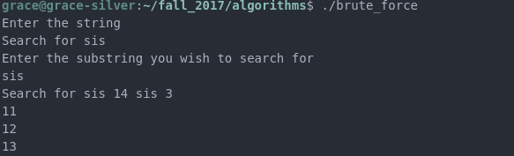

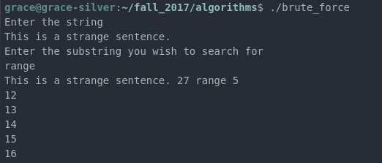
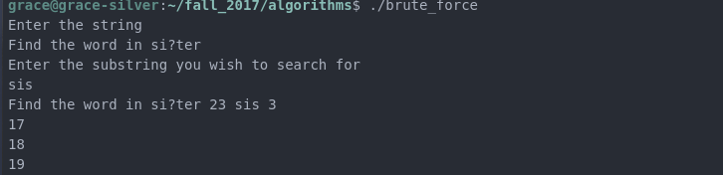

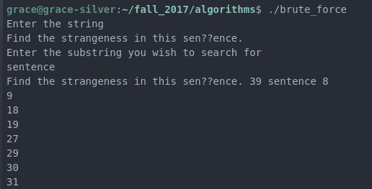
I modified the program and it seemed to work fine with only one ?:

#include <iostream>
#include <string>
#include <cstring>
#include <cstdio>

using namespace std;

int main()
{
string text, pattern;

cout << "Enter the string" << endl;
getline(cin, text);
int text_len = text.length();

cout << "Enter the substring you wish to search for" << endl;
cin >> pattern;
int pattern_len = pattern.length();

int i, j;

for (i = 0; i <= text_len - pattern_len; i++){
for(j = 0; j < pattern_len; j++){
if(pattern[j] != text[i+j] && text[i] != '?') break;
}
if (j == pattern_len) cout << "Pattern found at: " << i << endl;
}

return 0;
}

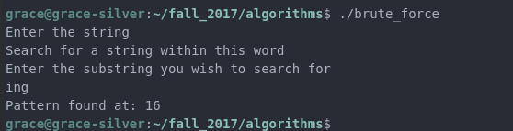
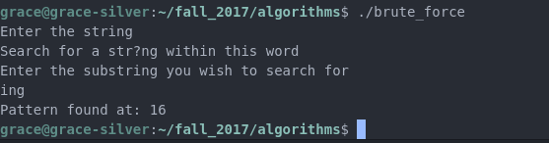

With multiple ??? it seems to break:
