[Project 1 Network and App Security:](https://www.alienvault.com/forums/discussion/7730/ossim-server-installation-and-configuration)

<https://www.alienvault.com/forums/categories/ossim-how-to-guides>

**I created three VMs:**

* Windows 7 ip 172.16.236.129 gateway 172.16.236.2
* Kali Linux ip 172.16.236.128 gateway 172.16.236.0
* Alien Ossim ip 172.16.236.130

Information on my host machine:

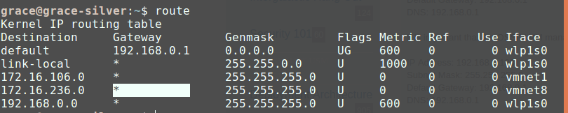

**Tested that Windows and Kali can communicate with each other.**

**Scanning the machines:**

So when I scanned ran Ossim with just the windows machine running:

It takes up a lot of resources...

