November 2nd, 2007

Note on running various systems:

GAGAGAGA systems:

infinite sheet systems

infinite stack systems

Abeta systems:

GGVVIA (Abeta 37-42)
Crystal structure of this hexamer peptide solved by Sawaya, 2007
The PDB code is 2ONV. Only the asymmetric unit (just the peptide) is published on the PDB database .
Website http://www.doe-mbi.ucla.edu/~sawaya/chime/xtalpept/ has the “pair of sheets with dry interface” structure (or steric zipper) (5 stranded)
I took the pair of sheet structure from the website so that I don't have to apply the space group symmetry operations on the asymmetric unit to get the correct geometry.
First step, is use “pdb2gmx” to create a topology for the system. Each peptide is defined as a chain in the PDB file, so pdbgmx creates an itp file containing the parameters for each peptide. itp files are all the same. So in my top file I just include an itp for one chain but indicate that I have 10 strands of such chain, rather than 1 of each chain.
There are also 10 crystal waters in the “pair of sheets” PDB file. These are recognized as HOH residues in by pdb2gmx. Unless I want to track my crystal waters, I should rename HOH to SOL, otherwise grompp will not create a TPR file if I don't temperature couple the HOH waters.

Second was to generate the correct terminii for the peptides in the structure.
I decided to generate one system with both terminii charged (not the zwitterion one) and one with both terminii uncharged. I used the uncharged terminii structure for invacuo simulations.

Third was orienting the sheet face so that the “strand axis” is along x, the “fibril extension/backbone hydrogen bonding elongation axis” is along y and the “stacking axis” along z. This is done by putting the structure at it's origin; Rotation always comes before translation.
Then the box needs to be resized so that the adjacent Calpha – Calpha distances between two adjacent images are the same as the the Calpha-Calpha distances in the same image. This is to ensure that the sheet is truly infinite along y.
Bounding box size of the 5 stranded
Final box size is
Solvate with tip3p water, 1 water molecule ended up being placed inside the dry interface by genbox

Red = X
Green = Y
Blue = Z

KLVFFAE (Abeta 16-21):

Octane system:
My goal is test out how well octane slab will stabilize a GAGAGAGA beta sheet.
I want to place an 8 stranded GAGAGAGA beta sheet on top of an slab of octane
and an 7 stranded parallel GAGAGAGA beta sheet with glycine facing the slab

Making an octane layer:

First I need to make a Octane layer ( or slab as Regis calls it) with the correct octane liquid density, which is 0.702 g/mL or 702 g/L (see Wikipedia or google it)

I took a box filled with 128 octanes using genconf and slightly enlarged the box to 3 by 3 by 2.5 nm^3 and did energy minimization, and run with pressure coupling (Berendsen) to allow it to relax to the proper density at 300 K. So far I have 100 ps of NPT dynamics which does not look equilibrated to me at all. Below are the pressure, density, volume vs time plots:
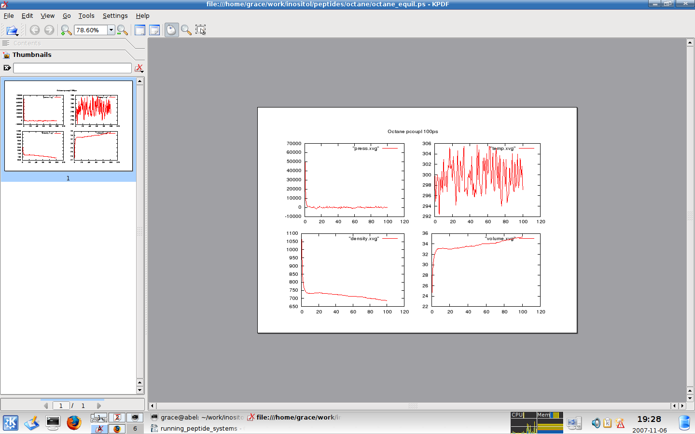
As can be seen, the density and volume of the system have not reached a plateau

Cytochrome P450cam system:

