December 10, 2007

Mini Report :

So far we have constructed models using GAGAGAGA peptides roughly corresponding to the three species in the Amyloid-beta aggregation pathway.

Monomer | Monomers/sheet-like/amorphous aggregates | Infinite sheets/fibrils/ordered aggregates

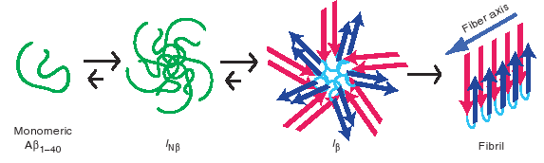
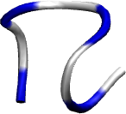
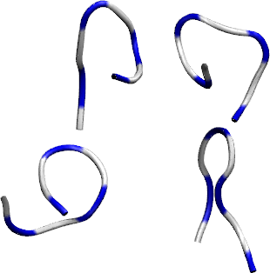
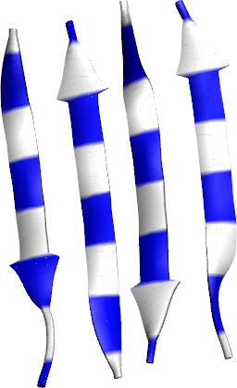
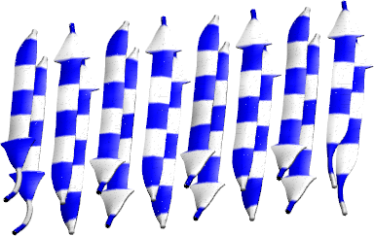
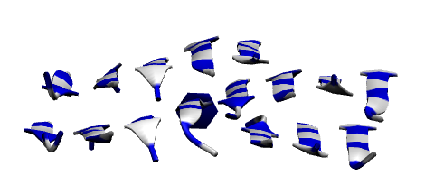

This is also reflected in the kinetic model from a recent paper by Chimon et al (see figure directly above). These models serve as checkpoints of various amyloid species along the aggregation pathway and we simulated each species with scyllo-inositol.

Below is a summary of simulations, analysis and discussions that have been done for each model for the impatient. A more detailed report follows the table.

System | Sampling avail. | Sampling running | Analysis done | To Do
Monomer | 300 ns starting from completely extended conformations, both restrained and unrestrained with 4 inositols in a box with volume 3x3x3 nm^3 |  |  | Sarah has selected 1100 GAGAGAGA monomer conformations from her simulated tempering runs that best approximates the end-to-end distribution at equilibrium for T = 296K. Run using these conformations with 4 inositol in a box of volume 3 x 3 x 3 nm^3 for 10 ns each
amorphous aggregates  (ap1f, ap2f, XchYino) | 100 ns per inositol for each system | - rerunning steph's ap1face system  - 4 systems of ap1face with randomly placed inositols, and different initial seeds  - ap1f, ap2f with chiro-inositol  - control systems for 4 chains and 2 chains. | In addition to Stephanie's analysis  - average # of inter, intra, inositol-peptide HBs  - time evolution of inter-strand, intra-strand and inositol - peptide HBs  - 2D map of inter-strand vs inositol-peptide HBs, intra-strand vs. inositol , intra vs inter -strand Hbs  - distribution of number of hydrogen bonds per inositol  - distribution of number of chains bound per inositol  - fraction of inositols bound to n chains, given that it makes m hydrogen bonds with peptides | - What are the sequence of events of disaggregation? Intercalation (replacing either inter or intra-strand Hbs) or dehydration (binding to exposed backbone)  - Use DSSP to quantify the presence of secondary structure (SS) and plot fractions of various SS vs time (like what Ana has done for her slab aggregation)
Infinite stacked sheets | - perfect fibril: 2.35 microseconds of inositol time | - slate system with 4 inositols at 105 ns per inositol |  | - spatial distribution of inositol for both “slated” imperfect and perfect infinite fibril systems  - repeat analysis done on amorphous aggregates

Amorphous Aggregates

AP1FACE – antiparallel, all methyls of alanine on a single face of the sheet or can be thought of as a sheet with TWO DIFFERENT faces
AP2FACES – antiparallel, methyls of alanine on different faces of the sheet. This sheet has 2 IDENTICAL faces.
MONO-INOSITOL – simulations starting from monomers of GAGAGAGA initially dissociated.

System (code name) | box size | peptide concentration | inositol concentration | Sampling avail. (ns)
2 chains with 2 inositol (2ch2ino) | 3 x 3 x 3 nm^3 |  |  | 100
2ch4ino | 3 x 3 x 3 nm^3 |  |  | 100
4ch2ino | 3 x 3 x 3 nm^3 |  |  | 100
4ch4ino | 3 x 3 x 3 nm^3 |  |  | 100

