Snapshots from a 20 ns trajectory of phenylalanine dipeptide with scyllo inositol (4 molecules)

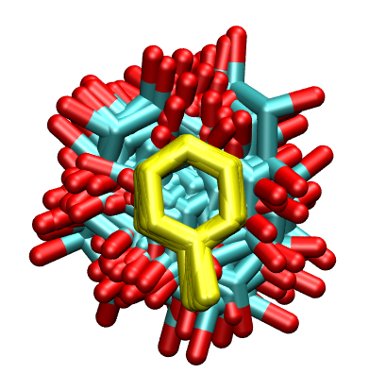

Frames 7078 to 7120 overlapped with inositol hydroxyl hydrogens removed and the phenyl ring hydrogens removed

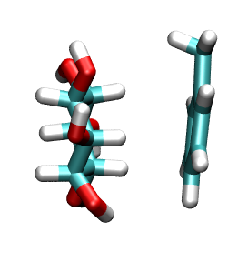
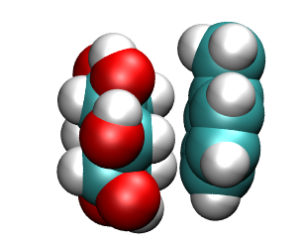

Snapshot 7086 – face to face in licorice and VdW representations (rendered from VMD)

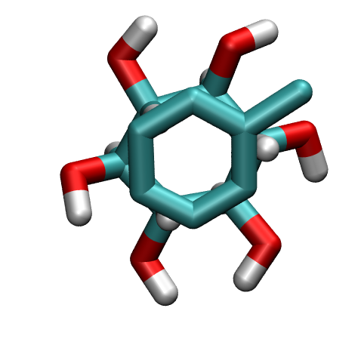

The same snapshot showing the ring-ring stacking viewed from the top of the phenyl ring – this figure is a little misleading as it seems like the carbons are almost completely matching each other in this ring-ring face-face inositol-phenyl interaction – but in the actual snapshot there is some

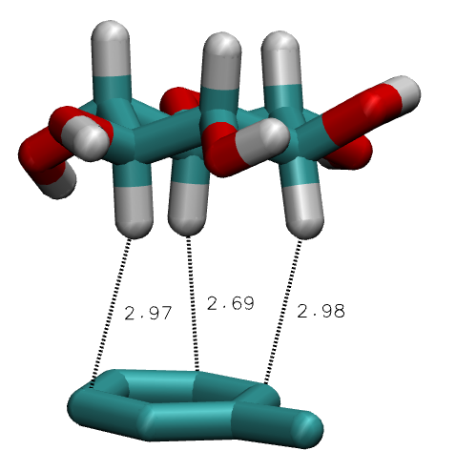

Left: same snapshot; some distance measurements between H of CH on the inositol ring to the carbons of the phenyl ring

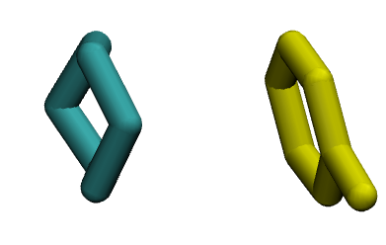
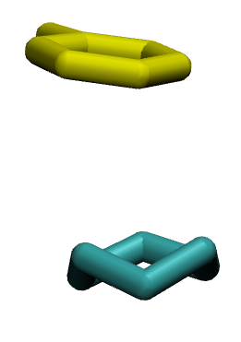

same snapshot, but showing only the rings (blue/green is inositol ring; yellow is the phenyl ring)

