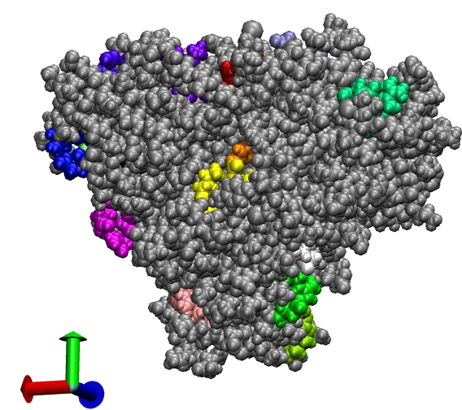

Distal side
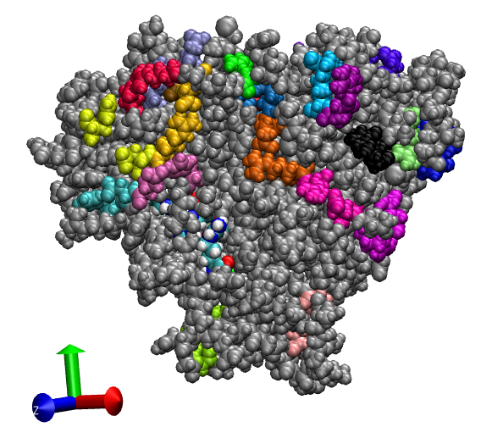

Proximal side
Colored by name are salt bridge involving heme propionate groups

