**Hands on 1**

**Spring Data JPA - Quick Example**   
  
**This is my code:**

package com.cognizant.ormlearn.service;

import java.util.List;

import jakarta.transaction.Transactional;

import org.springframework.beans.factory.annotation.Autowired;

import org.springframework.stereotype.Service;

import com.cognizant.ormlearn.model.Country;

import com.cognizant.ormlearn.repository.CountryRepository;

@Service

public class CountryService {

@Autowired

private CountryRepository countryRepository;

@Transactional

public List<Country> getAllCountries() {

return countryRepository.findAll();

}

}

package com.cognizant.ormlearn.repository;

import org.springframework.data.jpa.repository.JpaRepository;

import org.springframework.stereotype.Repository;

import com.cognizant.ormlearn.model.Country;

@Repository

public interface CountryRepository extends JpaRepository<Country, String> {

}

package com.cognizant.ormlearn.model;

import jakarta.persistence.Column;

import jakarta.persistence.Entity;

import jakarta.persistence.Id;

import jakarta.persistence.Table;

@Entity

@Table(name = "country")

public class Country {

@Id

@Column(name = "code")

private String code;

@Column(name = "name")

private String name;

public String getCode() {

return code;

}

public void setCode(String code) {

this.code = code;

}

public String getName() {

return name;

}

public void setName(String name) {

this.name = name;

}

}

spring.application.name=orm-learn

# Spring Datasource Config

spring.datasource.url=jdbc:mysql://localhost:3306/ormlearn

spring.datasource.username=root

spring.datasource.password=2004@Jgm

spring.datasource.driver-class-name=com.mysql.cj.jdbc.Driver

spring.jpa.properties.hibernate.dialect=org.hibernate.dialect.MySQLDialect

spring.jpa.hibernate.ddl-auto=update

logging.level.org.hibernate.SQL=debug

logging.level.org.hibernate.type.descriptor.sql=trace

server.port=8085

package com.cognizant.ormlearn;

import java.util.List;

import org.springframework.beans.factory.annotation.Autowired;

import org.springframework.boot.CommandLineRunner;

import org.springframework.boot.SpringApplication;

import org.springframework.boot.autoconfigure.SpringBootApplication;

import com.cognizant.ormlearn.model.Country;

import com.cognizant.ormlearn.repository.CountryRepository;

@SpringBootApplication

public class OrmLearnApplication implements CommandLineRunner {

@Autowired

private CountryRepository countryRepository;

public static void main(String[] args) {

SpringApplication.run(OrmLearnApplication.class, args);

System.out.println("Inside main");

}

@Override

public void run(String... args) throws Exception {

System.out.println("Start");

List<Country> countries = countryRepository.findAll();

for (Country country : countries) {

System.out.println("Country Code: " + country.getCode() + ", Name: " + country.getName());

}

System.out.println("End");

}

}

**This is my output:**

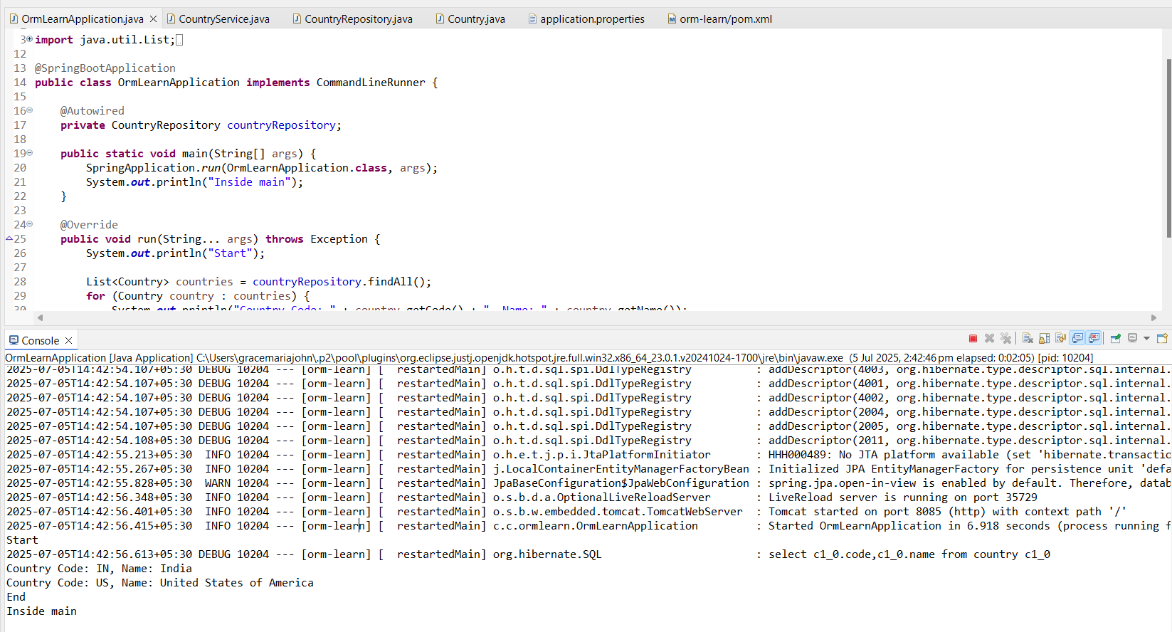

**Hands on 2**

**Difference between JPA, Hibernate and Spring Data JPA**   
  
**This is my code :**

create table employee (

id int primary key auto_increment,

name varchar(100),

department varchar(100),

salary double

);

package com.cognizant.ormlearn.model;

import jakarta.persistence.*;

@Entity

@Table(name = "employee")

public class Employee {

@Id

@GeneratedValue(strategy = GenerationType.IDENTITY)

private int id;

private String name;

private String department;

private double salary;

// Getters and Setters

public int getId() { return id; }

public void setId(int id) { this.id = id; }

public String getName() { return name; }

public void setName(String name) { this.name = name; }

public String getDepartment() { return department; }

public void setDepartment(String department) { this.department = department; }

public double getSalary() { return salary; }

public void setSalary(double salary) { this.salary = salary; }

@Override

public String toString() {

return "Employee [id=" + id + ", name=" + name + ", department=" + department + ", salary=" + salary + "]";

}

}

package com.cognizant.ormlearn.repository;

import org.springframework.data.jpa.repository.JpaRepository;

import org.springframework.stereotype.Repository;

import com.cognizant.ormlearn.model.Employee;

@Repository

public interface EmployeeRepository extends JpaRepository<Employee, Integer> {

}

package com.cognizant.ormlearn.service;

import java.util.List;

import org.springframework.beans.factory.annotation.Autowired;

import org.springframework.stereotype.Service;

import org.springframework.transaction.annotation.Transactional;

import com.cognizant.ormlearn.model.Employee;

import com.cognizant.ormlearn.repository.EmployeeRepository;

@Service

public class EmployeeService {

@Autowired

private EmployeeRepository employeeRepository;

@Transactional

public void addEmployee(Employee employee) {

employeeRepository.save(employee);

}

public List<Employee> getAllEmployees() {

return employeeRepository.findAll();

}

}

package com.cognizant.ormlearn;

import java.util.List;

import org.slf4j.Logger;

import org.slf4j.LoggerFactory;

import org.springframework.boot.SpringApplication;

import org.springframework.boot.autoconfigure.SpringBootApplication;

import org.springframework.context.ApplicationContext;

import com.cognizant.ormlearn.model.Employee;

import com.cognizant.ormlearn.service.EmployeeService;

@SpringBootApplication

public class OrmLearnApplication {

private static final Logger LOGGER = LoggerFactory.getLogger(OrmLearnApplication.class);

private static EmployeeService employeeService;

public static void main(String[] args) {

ApplicationContext context = SpringApplication.run(OrmLearnApplication.class, args);

employeeService = context.getBean(EmployeeService.class);

LOGGER.info("Inside main");

testAddEmployee();

testGetAllEmployees();

}

private static void testAddEmployee() {

LOGGER.info("Start testAddEmployee");

Employee emp = new Employee();

emp.setName("Grace John");

emp.setDepartment("IT");

emp.setSalary(70000);

employeeService.addEmployee(emp);

LOGGER.info("Employee Added");

LOGGER.info("End testAddEmployee");

}

private static void testGetAllEmployees() {

LOGGER.info("Start testGetAllEmployees");

List<Employee> empList = employeeService.getAllEmployees();

empList.forEach(e -> LOGGER.debug("{}", e));

LOGGER.info("End testGetAllEmployees");

}

}

spring.datasource.driver-class-name=com.mysql.cj.jdbc.Driver

spring.datasource.url=jdbc:mysql://localhost:3306/ormlearn

spring.datasource.username=root

spring.datasource.password=root

spring.jpa.hibernate.ddl-auto=update

spring.jpa.properties.hibernate.dialect=org.hibernate.dialect.MySQL5Dialect

logging.level.org.springframework=info

logging.level.com.cognizant=debug

**This is my output:**

