**TASK 1:**

**Code:**

**// src/components/ListofPlayers.js**

**import React from 'react';**

**const ListofPlayers = () => {**

**const players = [**

**{ name: 'Virat', score: 85 },**

**{ name: 'Rohit', score: 90 },**

**{ name: 'Dhoni', score: 65 },**

**{ name: 'Kohli', score: 45 },**

**{ name: 'Pant', score: 78 },**

**{ name: 'Ashwin', score: 70 },**

**{ name: 'Jadeja', score: 60 },**

**{ name: 'Rahul', score: 82 },**

**{ name: 'Bumrah', score: 50 },**

**{ name: 'Shami', score: 40 },**

**{ name: 'Siraj', score: 88 },**

**];**

**// ES6 Map to list all players**

**const playerList = players.map((player, index) => (**

**<li key={index}>**

**{player.name} - {player.score}**

**</li>**

**));**

**// ES6 Arrow + Filter: players with score < 70**

**const lowScorers = players.filter(player => player.score < 70);**

**return (**

**<div>**

**<h2>All Players</h2>**

**<ul>{playerList}</ul>**

**<h3>Players with score below 70</h3>**

**<ul>**

**{lowScorers.map((p, i) => (**

**<li key={i}>{p.name} - {p.score}</li>**

**))}**

**</ul>**

**</div>**

**);**

**};**

**export default ListofPlayers;**

**// src/components/IndianPlayers.js**

**import React from 'react';**

**const IndianPlayers = () => {**

**const players = ['Virat', 'Rohit', 'Dhoni', 'Kohli', 'Pant', 'Ashwin'];**

**// Destructure odd and even team players**

**const oddTeam = players.filter((_, index) => index % 2 === 0);**

**const evenTeam = players.filter((_, index) => index % 2 !== 0);**

**// Declare two arrays and merge**

**const T20players = ['Suryakumar', 'Hardik', 'Arshdeep'];**

**const RanjiTrophyPlayers = ['Pujara', 'Rahane', 'Shaw'];**

**// Merge using spread operator (ES6)**

**const allPlayers = [...T20players, ...RanjiTrophyPlayers];**

**return (**

**<div>**

**<h2>Odd Team Players</h2>**

**<ul>**

**{oddTeam.map((player, index) => (**

**<li key={index}>{player}</li>**

**))}**

**</ul>**

**<h2>Even Team Players</h2>**

**<ul>**

**{evenTeam.map((player, index) => (**

**<li key={index}>{player}</li>**

**))}**

**</ul>**

**<h2>All Players (Merged T20 + Ranji Trophy)</h2>**

**<ul>**

**{allPlayers.map((player, index) => (**

**<li key={index}>{player}</li>**

**))}**

**</ul>**

**</div>**

**);**

**};**

**export default IndianPlayers;**

**// src/App.js**

**import React from 'react';**

**import ListofPlayers from './components/ListofPlayers';**

**import IndianPlayers from './components/IndianPlayers';**

**function App() {**

**const flag = true; // Toggle this to false to see IndianPlayers instead**

**return (**

**<div className="App">**

**<h1>🏏 Cricket App Dashboard</h1>**

**{flag ? <ListofPlayers /> : <IndianPlayers />}**

**</div>**

**);**

**}**

**export default App;**

**Output:**

When Flag=true

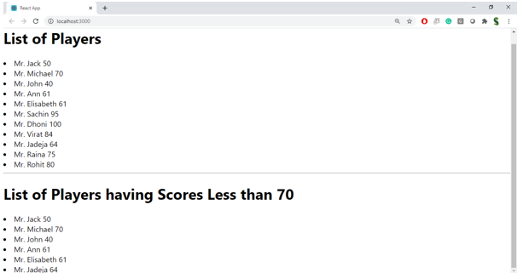

When Flag=false

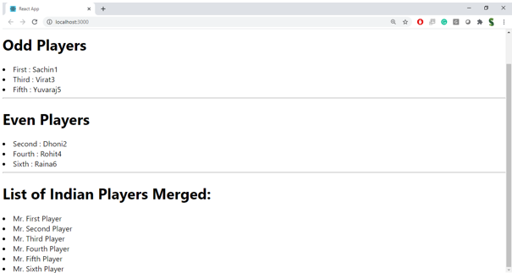

**Hint:**

