PROJECT PART 1:

1. In your own words, explain three principles of effective data communication from the lecture material.
   1. **Delivery -** The system must deliver data to the correct destination.
   2. **Accuracy -** The system must deliver data accurately.
   3. **Purposeful -** The goal of the system is to be easily decipherable just by looking at it.
2. In your own words summarize the following concepts as they relate to visual perception.
   1. **Order –** The data should follow a logical order.
   2. **Hierarchy –** The way data is arranged in a tree like structure, or the way things are organized.
   3. **Relationships –** A set of related data fields.
   4. **Convention –** Rules that are followed to identify and categorize info to make it easier to understand.
   5. **ANSWER THE FOLLOWING:** How will an understanding of these concepts help you create better data visualizations?
      1. Learning and utilizing all these concepts gives me the ability to make my data findings not just be visually appealing, but also easy to understand to people I could be presenting to.
3. Given the scenarios below, write which graph would be best to use for the data and what makes it an effective choice:
   1. **Comparison between values –** Bar graph
   2. **Comparison to the whole –** Pie chart
   3. **Change over time –** Line graph
   4. **Ranking data –** Bar graph
   5. **Correlation –** Scatter plot
   6. **Geographical charts –** Heat map
   7. **Measuring a target –** Bar graph
   8. **Showing outliers –** Box plot or scatter plot
   9. **ANSWER THE FOLLOWING:** How will an understanding of these concepts help you create better data visualizations?
      1. Understanding what charts/plots/graphs work best for a given situation will help me choose how to present my data findings in a way that everyone will understand.
4. What do you think is meant by this statement: *“It is easy to lie with statistics. It is hard to tell the truth without it.” -Andrejs Dunkels*
   1. This quote seems to be saying that it can be easy to warp data/graphs/charts to push a decision one way or the other, however you can’t make a decision without any findings in front of you.
   2. **Provide 3 examples of misleading graphs:**
      1. Chart, bar chart

         Description automatically generated This chart is trying to show how many people are receiving some form of federal welfare, however it is incredibly misleading because the Y-Axis starts at 94 million instead of zero, therefore making the differences between the numbers exaggerated.
      2. 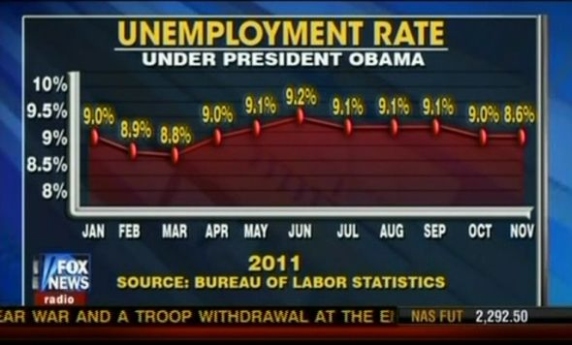 This chart is showing unemployment rate under President Obama. As you can see, Fox News warped the numbers and the graph to allow for “confirmation bias”. At the beginning of the graph, 9.0% and 8.8% have a significant difference between them, but at the end of the graph 9.0% and 8.6% are on the same line.
      3. 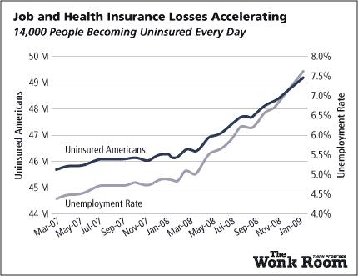 The issue with this graph is obvious, and it’s that it contains two Y-Axes. One is measuring uninsured Americans; another is showing unemployment rate. By overlapping the two lines, it is extremely hard to tell how they are measuring each data point (whole number or percent).
5. In your own words, answer the following questions:
   1. What is “visualization clutter”?
      1. Using too many visuals to show your findings, however the visuals take away from the point you are trying to make.
   2. What are the main components of a graph?:
      1. Title
      2. X & Y Axis
      3. Labels
      4. Data points
      5. Legend
   3. What are three techniques you learned to make data visualizations more clear?:
      1. Only focusing on key elements
      2. Using muted colors, unless you are trying to highlight a significant difference
      3. Starting your axes at the right numbers to avoid skewing results
   4. How can the use of color affect the way your visualizations are understood?:
      1. Certain colors and color schemes can resonate more with an audience. For example, a business might use the color green to show positive progress, and red to show areas that need focusing on.