Name: ___Grace Miguel_______ Date: __3/12/21___

Pledge: ___I pledge my honor that I’ve abided by the Stevens Honor System.________

For each of the graphs below, list the order in which the vertices are visited in a **breadth-first search**, starting with vertex 1. If there are multiple vertices adjacent to a given vertex, visit the adjacent vertex with the lowest value first. Then repeat the process for **depth-first search**.

1. 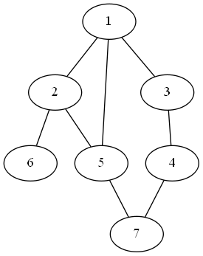

BFS: 1 2 3 5 6 7 4________

DFS: ___1 2 5 7 6 3 4__________

1. 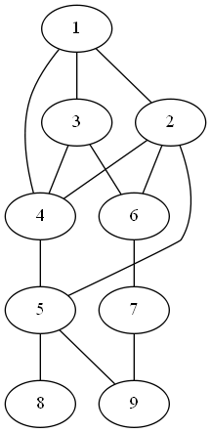

BFS: __1 2 3 4 5 6 8 9 7_____

DFS: _1 2 4 5 8 9 6 7 3 __________

1. 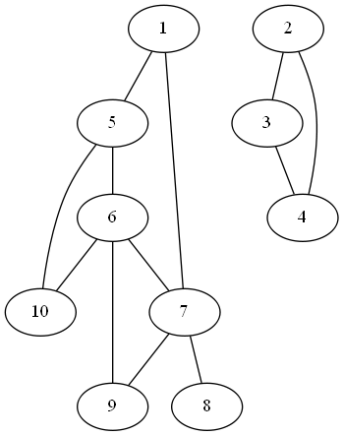

BFS: ____1 5 7 6 10 8 9 2 3 4 ____________

DFS: _1 5 6 7 8 9 10 2 3 4______

For each of the graphs below, list the order in which the vertices are visited in a **topological sort**, starting with vertex 1. If there are multiple vertices adjacent to a given vertex, visit the adjacent vertex with the lowest value first.

1. 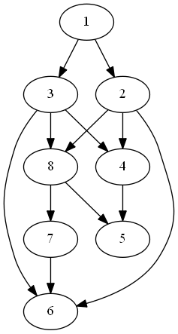

Topological sort: __1 2 3 4 8 5 7 6_________

1. 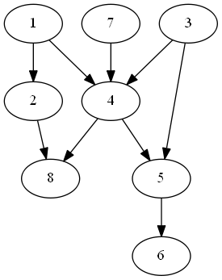

Topological sort: _1 2 3 7 4 5 6 8_________