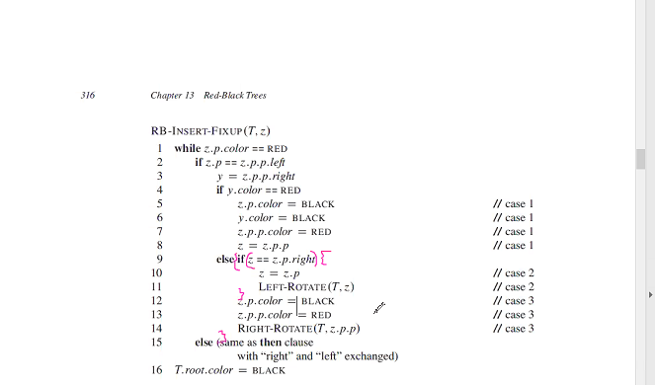

[Www.Cs.usfcsa.edu/-galles/visualization/RedBlack.html](http://Www.Cs.usfcsa.edu/-galles/visualization/RedBlack.html)