THA4

**Research Question:**

Our overall hypothesis is that Out Migration in the Chitwan Valley in Nepal will decrease the overall agricultural productivity/output in the region.

In order to test that hypothesis, I am investigating my smaller research question. Does outmigration in Nepal affect the production and cultivation of wheat in the region? Wheat is one of the major crops produced in the country and the region. This research question will help see agricultural output in Chitwan Valley.

**Data Source**

The Data source for this project comes from the Chitwan Valley [Nepal] Family Study: Labor Outmigration, Agricultural Productivity and Food Security Household Agriculture and Migration Survey.

You can access the data on the google drive [here](https://https//drive.google.com/drive/u/1/folders/14zC51PKe4KMkbua1cRBjRBtB0_ThbpEw" \t "_blank)

I have saved a copy of the .dta file on my google drive for access. You will have to download the data as a .dta and upload to Python

**Independent variable:** Migration and remittances received from household in Chitwan (2006-2015)

**Dependent variable:** Amount of land area used for crop cultivation for wheat,), production of wheat.

**Workflow- Do File- Stata**

**Recoded New Variables**

foreach x of varlist A\* B\* MIG REM {

recode `x' (999=.)

recode `x' (998=.)

^The code above removes households that did not exist, which is code 999

^ This code 998 is household merge which will drop missing values since the household combined and one household does not exist anymore

**Recoded New Variables**

recode B11\_ (2=1)

recode B11\_ (3=1)

^ The code above codes creates a yes answer =1 and a no answer = 0. B11 stand for rice production in data set. Yes for rice planting = 1

^B11 also had households who rented land out for planting. This was coded as = 3. This counts as rice planting in the household even though the land was rented out, so this was also coded as a yes and therefore = 1.

**Replaced Old Variable with New Measurements**

replace B11A\_ = B11A\_/11.97295

replace B13A\_= B13A\_/11.97295

B11A=Rice planting land area (in Katha)

B13A=Wheat planting land area (Katha)

We wanted to look at total production of agricultural product wheat and in order to look at total production we will look at the production of the crop (wheat or rice) over total land that was used for production in order to see total proportion of production (for wheat and rice). In order to do that, we needed to change the Nepali land measurement in Katha to the U.S. measurement of acre.

^The code above changes the land used and the land that the crop was produced on from Nepali Katha to acres.

**Generated New Variables**

generate wheat\_prod= B13B\_/B13A\_

generate rice\_prod= B11B\_/B11A\_

^The code above gives the total rice production by calculating B11B/B11A (production of wheat/land area used for wheat production)

**Regresssion**

regress MIG rice\_prod

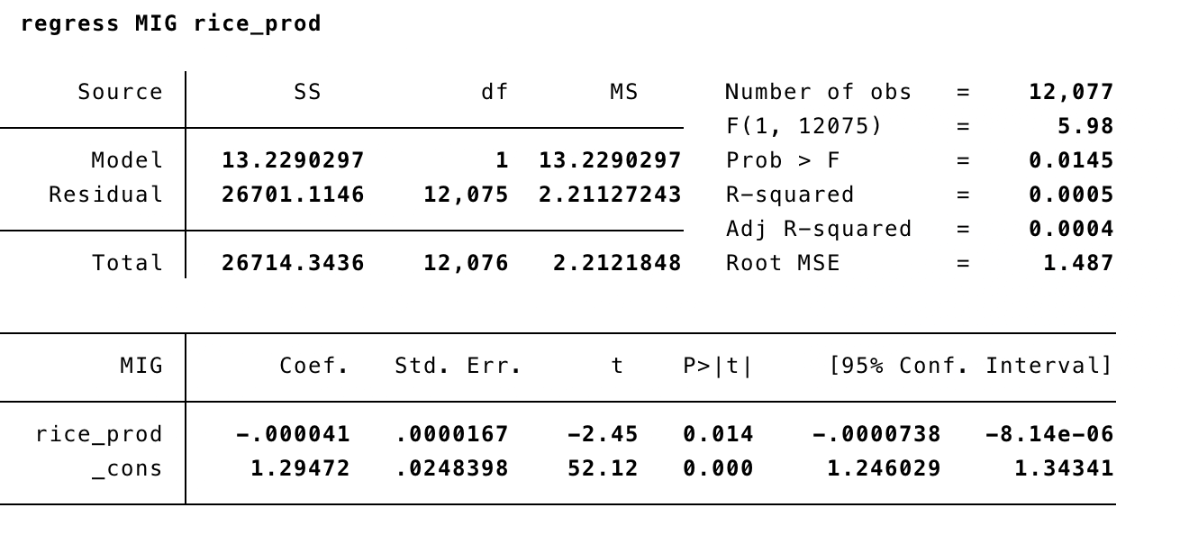

**Results**

The results show that with each 1.29 persons migrating out of the household, there is -.000041 negative effect on rice production. These two do not seem to have a high correlation since the R-squared is .005. We will continue to look for variables that have a more significant impact on agriculture in Nepal for our final project.