Student-persona Beer Game: evidence report

Evidence and outcome
Saved API evidence from hypothetical LLM role agents; no real student responses were collected.
Run status: complete. A clean behavioral comparison is not established: calibration passed=False, completed chains=2/2, clean chains=2, missing decisions=0, fallback orders=0.
Calibration did not validate a token contrast. The predeclared 8192/16384 caps are engineering diagnostic settings, not validated treatment thresholds.
Local saved requests: 480; estimated local charges/reservations: $5.1936. Measured local output: 1,092,470 tokens, including 1,087,004 reasoning tokens. Prior reused calibration requests and charges are reported separately.

Calibration state correction
Calibration states were corrected before game outcomes: fields received, shipped; state items 0, 2, 6, 8, 12, 14, 18, 20. Positive post-shipment inventory with fulfilled demand requires recorded shipments; the original zero placeholders were inconsistent. The import metadata excludes 38 old request files from the corrected calibration screen and reuses 86 files with unchanged compatible prompts. The excluded responses remain preserved in requests/*.json and marked in request_index.csv; they are not observations in calibration.csv or the threshold screen. Their saved charges/reservations ($0.4588) remain included in the local campaign ledger, together with all other historical transport attempts. The corrected prompts, matched/excluded file lists and reason are retained in calibration_import.json and manifest.json.

Game sample planning
Selected chain pairs: 1; configured maximum: 3. Forecast cost per full pair: $7.6571. Selection uses calibration token costs before game outcomes, with a 15% forecast margin and common onboarding allowances. This budget-based sample choice is not a power calculation or a guarantee that later histories and generation will fit the forecast. The local spending guard remains binding; changing group count after observing game outcomes would create a different design.

Model and intervention
Requested model: gpt-5.4-mini-2026-03-17. Returned models: gpt-5.4-mini-2026-03-17. Fixed reasoning effort: high. Selected total-output caps: short 8192, adequate 16384. Exact prompts, state histories and responses are retained in manifest.json and requests/*.json. The allowance applies to total generated output, including reasoning tokens and the structured decision; nonreasoning tokens equal total output minus the reasoning subset. Unused allowance is not measured effort. Selected caps are recorded in selection.json / calibration_recommendation.json.
The common 180.0-second transport timeout is operational reliability protection, not a deadline treatment. Recorded latency includes service and transport delay. Tokens do not have a validated conversion to human thinking seconds; the study manipulates an LLM computational allowance. A separate time-limit experiment requires separate calibration. Usage summaries include measured requests only; unobserved usage remains missing, and its reserved charge remains in the ledger.

Decisions, failures and costs
Zero is a permitted decision. No positive-order floor or advertised order maximum is imposed. Concerning zero orders (positive backlog with no stock or outstanding replenishment) are reported without being changed or excluded. Fallback orders belong to a disclosed diagnostic continuation policy, not the model. A completed chain with fallbacks does not become a complete model-behavior sample. Full costs are descriptive whenever fallbacks occur; incomplete chains have only accumulated observed costs.
Costs include all 40 game weeks, including 4 fixed warmup weeks, plus 12 automatic continuation weeks. Automatic and fallback orders are excluded from valid model decision zero rates. Raw failures and their charges/reservations remain in the request ledger; no failed generation is converted into a valid zero decision.

Bullwhip and beta
Bullwhip ratios use sample variance over the full 40 game weeks including warmup, or the observed partial window when stopped. Both local incoming demand and external customer demand are reported. A zero-variance denominator produces a missing ratio. The single demand step and different timing upstream make these descriptive ratios sensitive to the window; a ratio alone does not establish sustained oscillation.
Beta is an exploratory fitted supply-line weight, not a direct measurement of thinking or a diagnosed human bias. A role with invalid/fallback decisions has an unusable fit. Variation, fit quality and identification flags remain visible. Chain beta requires four usable role fits. No confirmatory p-values are calculated for this small feasibility pilot; weekly calls are not independent participants.

Research scope
The common persona is a hypothetical second-year business student at University at Buffalo. A demographic prompt does not validate a population model. Repeated calls represent model-generated decisions, not independent University at Buffalo students. Claims about actual students require answers from real students using comparable tasks; see Bisbee et al. (https://doi.org/10.1017/pan.2024.5) on the limits of synthetic survey respondents. The cited GPT behavioral-operations study (https://doi.org/10.1287/msom.2023.0279) motivates investigating model decisions across operational tasks; this Beer Game alone does not diagnose all eighteen biases. Deliberately requesting a bias or oscillation would change the behavior being studied. Prompt, model, effort, budget selection and failure policy must remain fixed within the comparison, and historical none-effort protocols must remain separate.

Sources and reproducibility
Game timing/cost background: MIT / John Sterman Beer Game (https://web.mit.edu/jsterman/www/SDG/beergame.html). API token accounting and incomplete responses: OpenAI reasoning guide (https://developers.openai.com/api/docs/guides/reasoning). Response schema mechanics: OpenAI structured outputs (https://developers.openai.com/api/docs/guides/structured-outputs). These sources support game/API mechanics; they do not validate student realism or tokens as human time.
The manifest, raw requests, calibration, rule checks and trajectory CSVs are the reproducible evidence. Currency values are local estimated charges/reservations, not an account balance; unresolved request usage may remain reserved. Software checks and offline synthetic runs cannot supply missing live results.

Condition outcomes
condition | chains_complete | clean_chains | missing_decisions | fallback_count | zero_rate_valid | max_submitted_order | mean_total_scored_cost
adequate | 1 | 1 | 0 | 0 | 0 | 8 | 156
short | 1 | 1 | 0 | 0 | 0 | 8 | 156

Group outcomes
group_id | full_game | fallback_count | total_scored_cost | usable_role_betas
b000_adequate | yes | 0 | 156 | 0
b000_short | yes | 0 | 156 | 0

Calibration
limit | n | genuine_api_n | completed_valid_n | completion_denominator | completion_rate | positive_reasoning_n | measured_usage_n
512 | 24 | 24 | 0 | 24 | 0 | 0 | 24
1024 | 24 | 24 | 2 | 24 | 0.08333 | 2 | 24
2048 | 24 | 24 | 5 | 24 | 0.2083 | 5 | 24
4096 | 24 | 24 | 11 | 24 | 0.4583 | 11 | 24
8192 | 24 | 24 | 23 | 24 | 0.9583 | 23 | 24
16384 | 24 | 24 | 24 | 24 | 1 | 24 | 24

Beta diagnostics
group_id | role | beta | usable | fit_flag
b000_adequate | distributor | 1.504 | no | weak_inventory_response;parameter_boundary
b000_adequate | factory | 1.504 | no | weak_inventory_response;parameter_boundary
b000_adequate | retailer | missing | no | insufficient_variation
b000_adequate | wholesaler | 1.404 | no | weak_inventory_response;parameter_boundary
b000_short | distributor | 1.504 | no | weak_inventory_response;parameter_boundary
b000_short | factory | 1.504 | no | weak_inventory_response;parameter_boundary
b000_short | retailer | missing | no | insufficient_variation
b000_short | wholesaler | 1.404 | no | weak_inventory_response;parameter_boundary
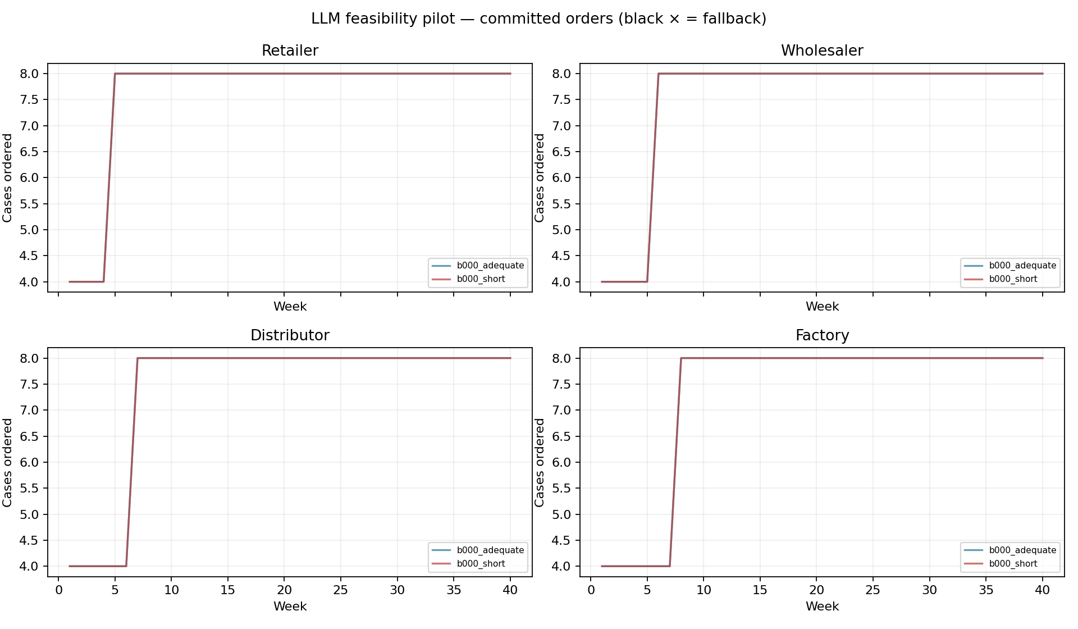
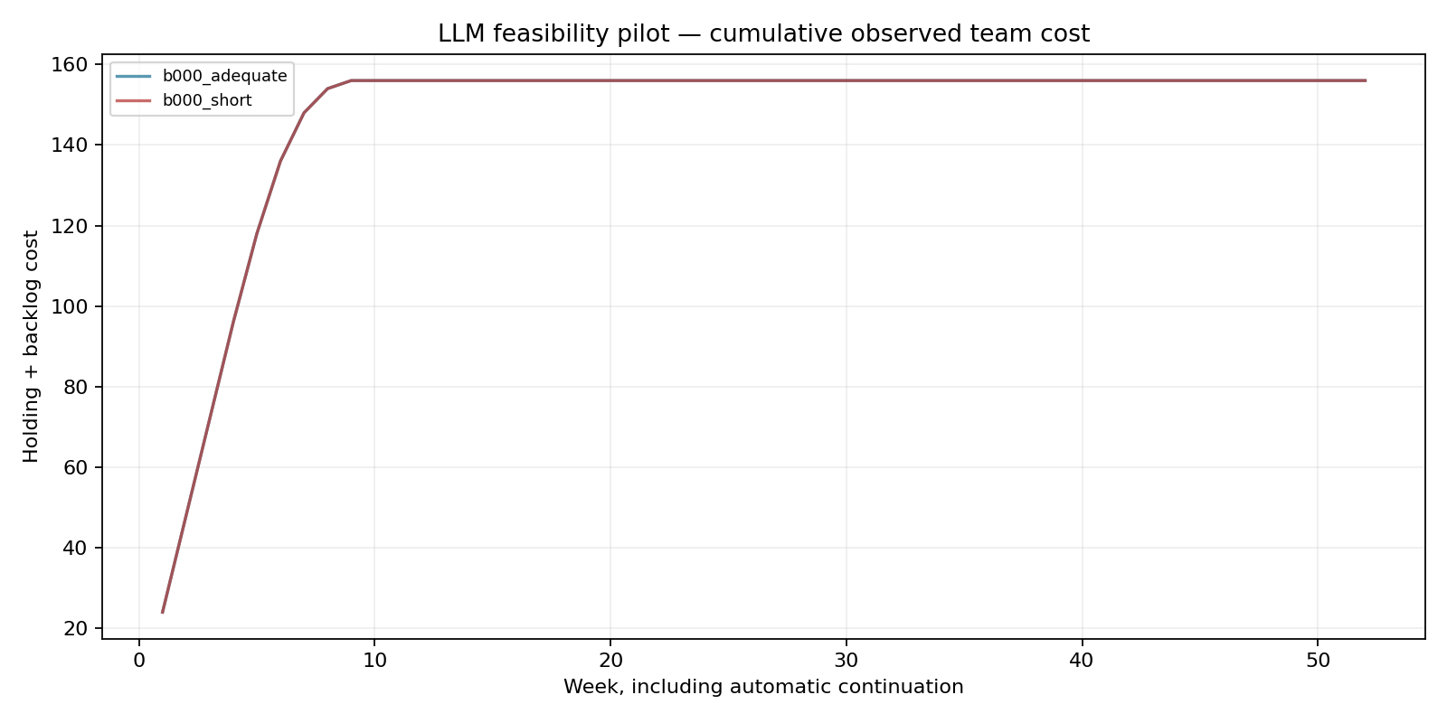
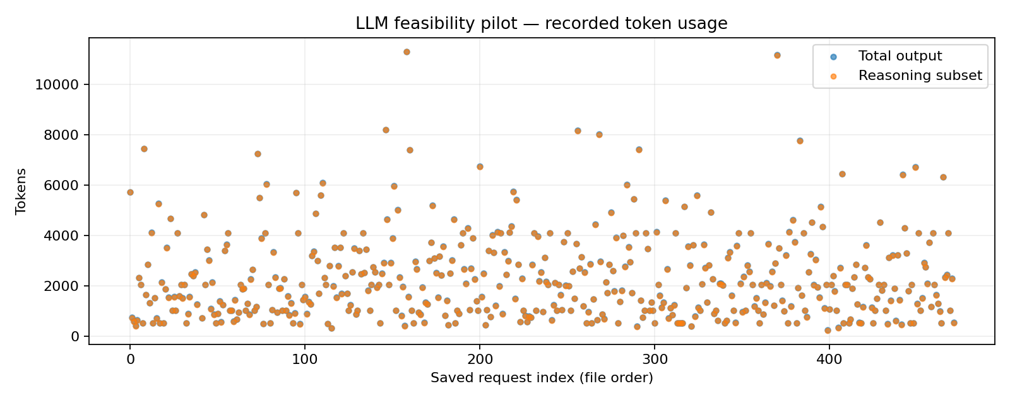

Operational recovery and charge accounting
Before game outcomes, eight calibration states were repaired for consistent receipts/shipments. The 38 excluded old-state responses and their $0.45876525 charges remain immutable paid evidence, excluded from the matched calibration screen. At week 12, a Windows file lock stopped progress saving after 64 valid decisions, zero fallbacks and $3.14142525 charged/reserved. Resume reused exact paid checkpoints with unchanged prompts, pinned model, high effort, caps, game horizon, replicate and scientific source hashes. Actual concurrency/request interval changed from 2 / 2 seconds before the stop to 8 / 1 second afterward, commonly across both conditions. Operational provenance (operational_io/) preserves the separate helper's source, full SHA-256 and invocation settings. Its seven-attempt file-save wrapper adds only bounded PermissionError backoff totaling 1.57 seconds; it adds no API retries or observations. This scheduling change and transport latency cannot establish human thinking time. Final game outcomes and spending are reported separately.
Imported same-campaign charges ($1.53672975) are already included in the $5.19360675 local total. Parent/checkpoint copies are not additional spending.

