The internal representation of a MySQL table has a maximum row size limit of 65,535 bytes, even if the storage engine is capable of supporting larger rows. [BLOB](https://dev.mysql.com/doc/refman/5.7/en/blob.html) and [TEXT](https://dev.mysql.com/doc/refman/5.7/en/blob.html) columns only contribute 9 to 12 bytes toward the row size limit because their contents are stored separately from the rest of the row.

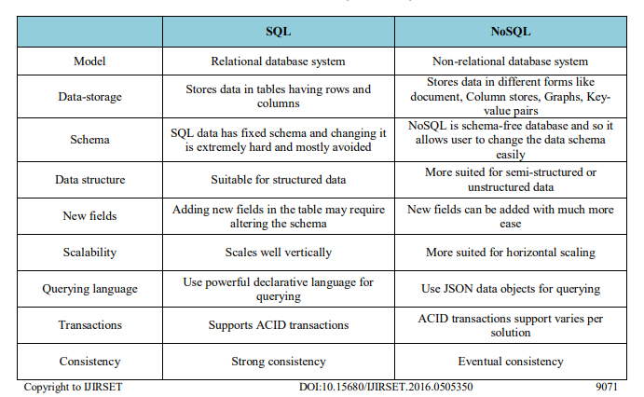

<http://www.ijirset.com/upload/2016/may/350_Sharvari%20Paper.pdf>

SQL has many advantages such as it is easy to use and setup, structured schema helps to avoid mistakes which may arise in case of flexible schema, strong consistency, gives secured storage. But, for IoT applications where data is going to be huge and is heterogeneous, it is not a suitable option. Whereas, No SQL is capable of storing any type of data, is capable of handling the big data, also supports horizontal scalability, runs well on cloud platforms.

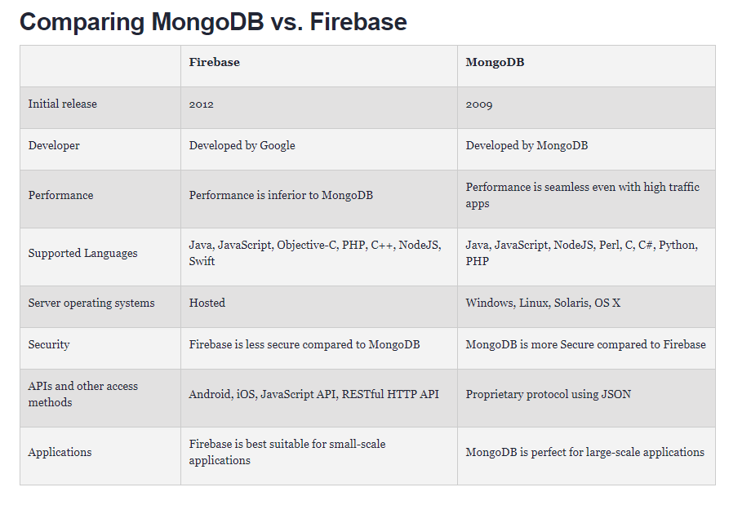

<https://dzone.com/articles/firebase-vs-mongodb-which-database-to-use-for-your>

<https://stackoverflow.com/questions/29223835/mongodb-vs-firebase>

offline support

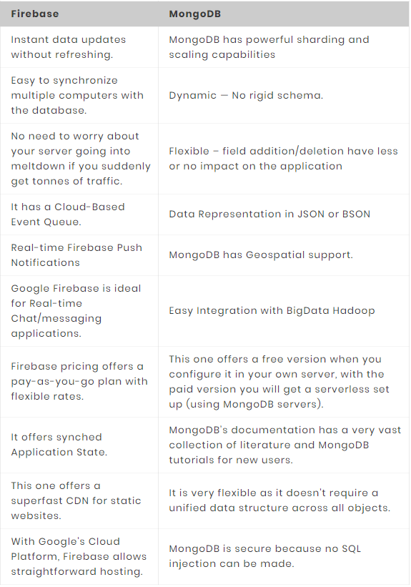

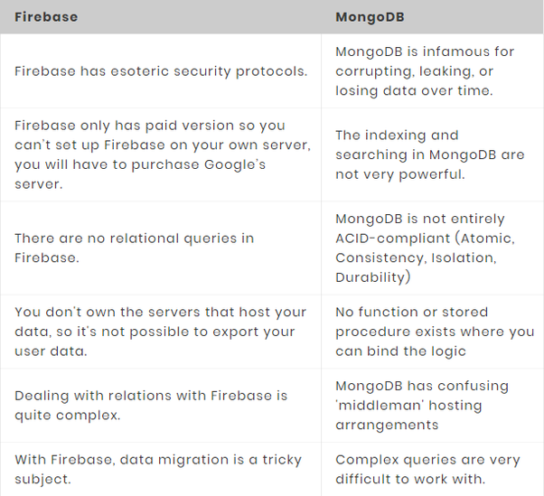

<https://www.excellentwebworld.com/mongodb-vs-firebase/>

The most common issues **with databases are:**

* **Designing a database from scratch is very tricky,** given that you need to make an easy path for scalability.
* **It consumes a lot of bandwidths from trafficking** between the database and application front-end.
* **Database hostage is a very tough and costly** task for new startups in the making.
* **Managing your own authentication system becomes tricky** and complicated if you lack database expertise.