Prompt: Create a data visualization for these data. Calcium.csv
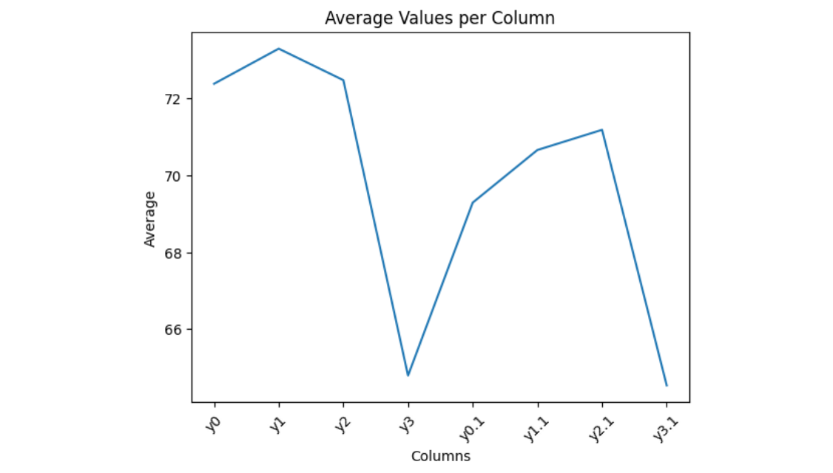
I created a visualization showing the average value of each column in your dataset.

What this shows:
- Each point represents the mean (average) of one column (y0, y1, y2, y3, etc.).
- You can quickly compare which variables tend to have higher or lower values overall.
- For example, some columns cluster around ~70–73, while others drop closer to ~65.

If you want something more insightful, I can also create:
- Boxplots (to show spread and outliers)
- Time series plots (if rows represent time/order)
- Correlation heatmaps
- Side-by-side comparisons (e.g., y0 vs y0.1)
Just tell me 👍
Prompt: What is your version information?
You’re chatting with ChatGPT based on the GPT-5.3 architecture.

Key details:
- Model: GPT-5.3
- Knowledge cutoff: August 2025
- Current date (system): March 31, 2026
If you need more technical details (capabilities, differences vs GPT-4/5, etc.), just let me know 👍
(This chat took place on Tuesday, March 31st, 2026.)

