Introduction:

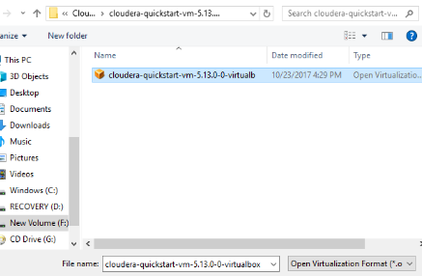



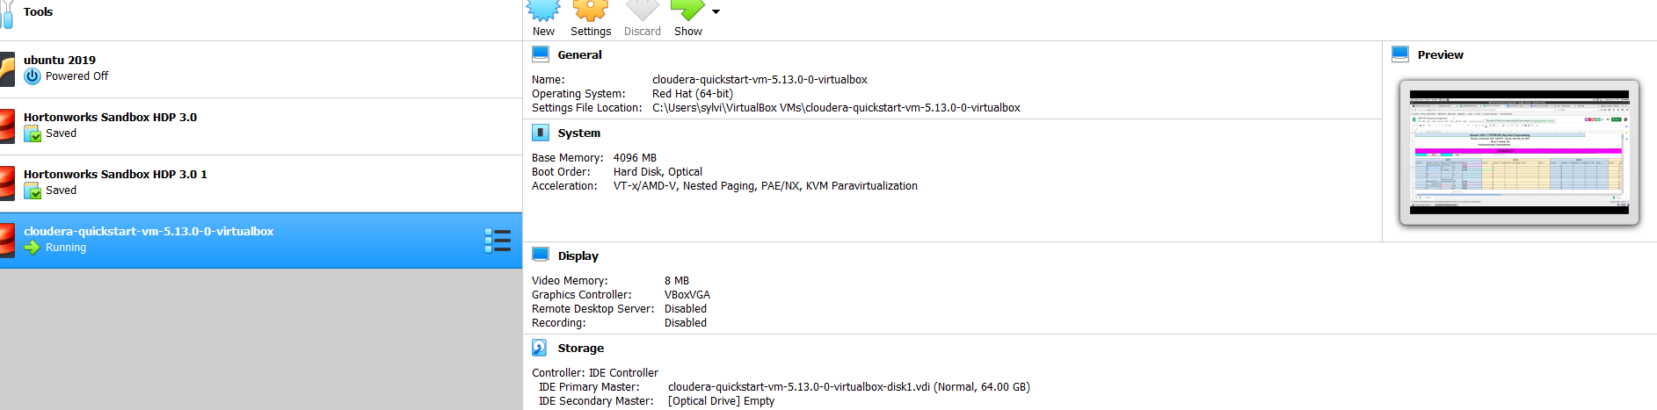

Installation of cloudera in VM.

Cloudera is installated after few minutes.

GO to the command prompt and give the following command so that dataset is loaded into hdfs and appended it .

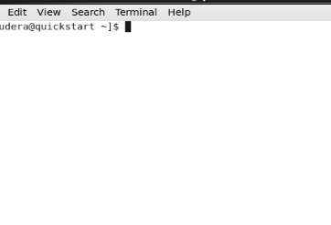

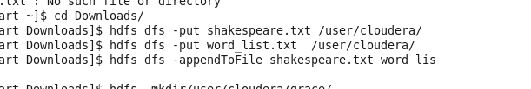

Name:Grace Stalin.

ID:16291038

Class ID:30

Thus the following screen shot shows that the dataset is appended in cloudera and viewed successfully in HUE(Hadoop User experience)

