Exploratory Data Analysis
import pandas as pd
import numpy as np
import matplotlib.pyplot as plt
import seaborn as sns
import kagglehub
from sklearn.model_selection import train_test_split
from collections import Counter
from wordcloud import WordCloud
import re
import nltk
nltk.download('punkt')
from nltk.tokenize import word_tokenize
import contractions
from bs4 import BeautifulSoup
import nltk
nltk.download('punkt')
nltk.download('punkt_tab')
from nltk.tokenize import word_tokenize
from sklearn.metrics import accuracy_score,recall_score, classification_report, confusion_matrix,recall_score,precision_score, f1_score
#logistic regression,SVM,Naive Bayes,Random Forest and MultinomialNB
from sklearn.ensemble import RandomForestClassifier
from sklearn.linear_model import LogisticRegression
from sklearn.naive_bayes import MultinomialNB
from sklearn.svm import SVC
from sklearn.linear_model import RidgeClassifier
[nltk_data] Downloading package punkt to
[nltk_data] C:\Users\GRACE\AppData\Roaming\nltk_data...
[nltk_data] Package punkt is already up-to-date!
[nltk_data] Downloading package punkt to
[nltk_data] C:\Users\GRACE\AppData\Roaming\nltk_data...
[nltk_data] Package punkt is already up-to-date!
[nltk_data] Downloading package punkt_tab to
[nltk_data] C:\Users\GRACE\AppData\Roaming\nltk_data...
[nltk_data] Package punkt_tab is already up-to-date!
!pip install wordcloud
!pip install nltk contractions beautifulsoup4 wordcloud
Requirement already satisfied: wordcloud in c:\users\grace\miniconda3\lib\site-packages (1.9.6)
Requirement already satisfied: numpy>=1.19.3 in c:\users\grace\miniconda3\lib\site-packages (from wordcloud) (2.3.4)
Requirement already satisfied: pillow in c:\users\grace\miniconda3\lib\site-packages (from wordcloud) (12.1.0)
Requirement already satisfied: matplotlib in c:\users\grace\miniconda3\lib\site-packages (from wordcloud) (3.10.8)
Requirement already satisfied: contourpy>=1.0.1 in c:\users\grace\miniconda3\lib\site-packages (from matplotlib->wordcloud) (1.3.3)
Requirement already satisfied: cycler>=0.10 in c:\users\grace\miniconda3\lib\site-packages (from matplotlib->wordcloud) (0.12.1)
Requirement already satisfied: fonttools>=4.22.0 in c:\users\grace\miniconda3\lib\site-packages (from matplotlib->wordcloud) (4.61.1)
Requirement already satisfied: kiwisolver>=1.3.1 in c:\users\grace\miniconda3\lib\site-packages (from matplotlib->wordcloud) (1.4.9)
Requirement already satisfied: packaging>=20.0 in c:\users\grace\miniconda3\lib\site-packages (from matplotlib->wordcloud) (24.2)
Requirement already satisfied: pyparsing>=3 in c:\users\grace\miniconda3\lib\site-packages (from matplotlib->wordcloud) (3.3.2)
Requirement already satisfied: python-dateutil>=2.7 in c:\users\grace\miniconda3\lib\site-packages (from matplotlib->wordcloud) (2.9.0.post0)
Requirement already satisfied: six>=1.5 in c:\users\grace\miniconda3\lib\site-packages (from python-dateutil>=2.7->matplotlib->wordcloud) (1.17.0)
Requirement already satisfied: nltk in c:\users\grace\miniconda3\lib\site-packages (3.9.4)
Requirement already satisfied: contractions in c:\users\grace\miniconda3\lib\site-packages (0.1.73)
Requirement already satisfied: beautifulsoup4 in c:\users\grace\miniconda3\lib\site-packages (4.13.5)
Requirement already satisfied: wordcloud in c:\users\grace\miniconda3\lib\site-packages (1.9.6)
Requirement already satisfied: click in c:\users\grace\miniconda3\lib\site-packages (from nltk) (8.3.1)
Requirement already satisfied: joblib in c:\users\grace\miniconda3\lib\site-packages (from nltk) (1.5.3)
Requirement already satisfied: regex>=2021.8.3 in c:\users\grace\miniconda3\lib\site-packages (from nltk) (2026.4.4)
Requirement already satisfied: tqdm in c:\users\grace\miniconda3\lib\site-packages (from nltk) (4.67.1)
Requirement already satisfied: textsearch>=0.0.21 in c:\users\grace\miniconda3\lib\site-packages (from contractions) (0.0.24)
Requirement already satisfied: soupsieve>1.2 in c:\users\grace\miniconda3\lib\site-packages (from beautifulsoup4) (2.8)
Requirement already satisfied: typing-extensions>=4.0.0 in c:\users\grace\miniconda3\lib\site-packages (from beautifulsoup4) (4.12.2)
Requirement already satisfied: numpy>=1.19.3 in c:\users\grace\miniconda3\lib\site-packages (from wordcloud) (2.3.4)
Requirement already satisfied: pillow in c:\users\grace\miniconda3\lib\site-packages (from wordcloud) (12.1.0)
Requirement already satisfied: matplotlib in c:\users\grace\miniconda3\lib\site-packages (from wordcloud) (3.10.8)
Requirement already satisfied: anyascii in c:\users\grace\miniconda3\lib\site-packages (from textsearch>=0.0.21->contractions) (0.3.3)
Requirement already satisfied: pyahocorasick in c:\users\grace\miniconda3\lib\site-packages (from textsearch>=0.0.21->contractions) (2.3.1)
Requirement already satisfied: colorama in c:\users\grace\miniconda3\lib\site-packages (from click->nltk) (0.4.6)
Requirement already satisfied: contourpy>=1.0.1 in c:\users\grace\miniconda3\lib\site-packages (from matplotlib->wordcloud) (1.3.3)
Requirement already satisfied: cycler>=0.10 in c:\users\grace\miniconda3\lib\site-packages (from matplotlib->wordcloud) (0.12.1)
Requirement already satisfied: fonttools>=4.22.0 in c:\users\grace\miniconda3\lib\site-packages (from matplotlib->wordcloud) (4.61.1)
Requirement already satisfied: kiwisolver>=1.3.1 in c:\users\grace\miniconda3\lib\site-packages (from matplotlib->wordcloud) (1.4.9)
Requirement already satisfied: packaging>=20.0 in c:\users\grace\miniconda3\lib\site-packages (from matplotlib->wordcloud) (24.2)
Requirement already satisfied: pyparsing>=3 in c:\users\grace\miniconda3\lib\site-packages (from matplotlib->wordcloud) (3.3.2)
Requirement already satisfied: python-dateutil>=2.7 in c:\users\grace\miniconda3\lib\site-packages (from matplotlib->wordcloud) (2.9.0.post0)
Requirement already satisfied: six>=1.5 in c:\users\grace\miniconda3\lib\site-packages (from python-dateutil>=2.7->matplotlib->wordcloud) (1.17.0)
data = kagglehub.dataset_download('lakshmi25npathi/imdb-dataset-of-50k-movie-reviews')
print(data)
C:\Users\GRACE\.cache\kagglehub\datasets\lakshmi25npathi\imdb-dataset-of-50k-movie-reviews\versions\1
df = pd.read_csv(data + '/IMDB Dataset.csv')
df.head(10)
df.shape
df.dtypes
df.columns
df['sentiment'].value_counts()
print('duplicate values:', df.duplicated().sum())
print('null values:', df.isnull().sum())
duplicate values: 418
null values: review 0
sentiment 0
dtype: int64
print("total review length:", df['review'].str.len().sum())
total review length: 65471551
missing_df = pd.DataFrame({'column_name': df.columns, 'missing_values': df.isnull().sum(),
'missing_percentage': df.isnull().sum() / len(df) * 100})
print(missing_df)
column_name missing_values missing_percentage
review review 0 0.0
sentiment sentiment 0 0.0
duplicate_df = pd.DataFrame({'column_name': df.columns, 'duplicate_values': df.duplicated().sum(),
'duplicate_percentage': df.duplicated().sum() / len(df) * 100})
print(duplicate_df)
column_name duplicate_values duplicate_percentage
0 review 418 0.836
1 sentiment 418 0.836
memory_usage = df.memory_usage(deep=True).sum() / (1024 ** 2) # Convert to MB
print(memory_usage)
76.96946811676025
df.describe
print("\nDUPLICATE ANALYSIS:")
print("-"*70)
# Find duplicate rows
duplicates = df[df.duplicated(keep=False)]
print(f'Total duplicate rows: {len(duplicates)}')
print(f'Unique duplicate groups: {df.duplicated().sum()}')
# Show a few duplicates
print('\nSample duplicates:')
print(duplicates.head(4))
# Decision: Keep or remove?
print('\n' + "="*70)
print('ACTION NEEDED:')
print('Remove duplicates? (Yes - they bias the model)')
print("="*70)
DUPLICATE ANALYSIS:
----------------------------------------------------------------------
Total duplicate rows: 824
Unique duplicate groups: 418
Sample duplicates:
review sentiment
42 Of all the films I have seen, this one, The Ra... negative
84 We brought this film as a joke for a friend, a... negative
140 Before I begin, let me get something off my ch... negative
219 Ed Wood rides again. The fact that this movie ... negative
======================================================================
ACTION NEEDED:
Remove duplicates? (Yes - they bias the model)
======================================================================
df.describe()
fig, axes = plt.subplots(1, 2, figsize=(12, 5))
sns.countplot(x='sentiment', data=df, ax=axes[0])
axes[0].set_title('Sentiment Distribution')
sns.histplot(df['review'].str.len(), bins=30, ax=axes[1])
axes[1].set_title('Review Length Distribution')
plt.tight_layout()
plt.show()
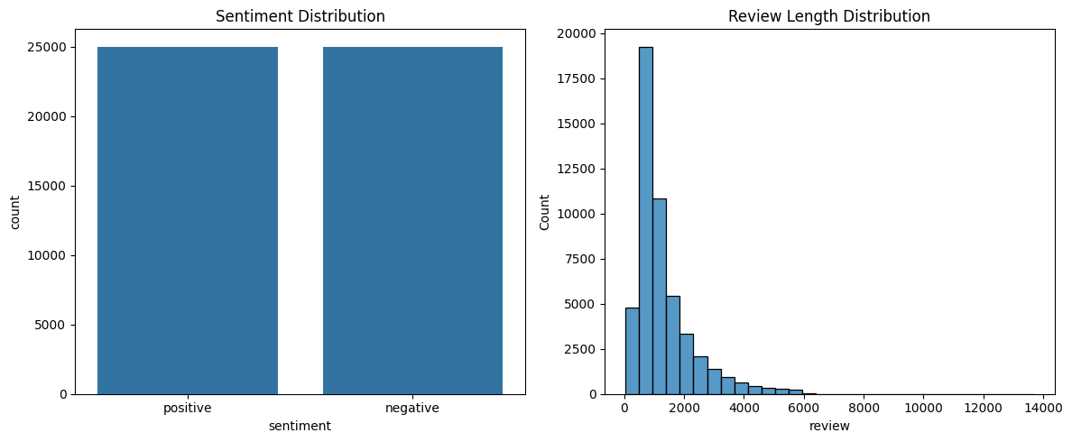
Empty_review = df[df['review'].str.len() == 0]
print(f'Total empty reviews: {len(Empty_review)}')
Review_length = df['review'].str.len()
print(f'Min review length: {Review_length.min()}')
print(f'Max review length: {Review_length.max()}')
print(f'Average review length: {Review_length.mean()}')
Total empty reviews: 0
Min review length: 32
Max review length: 13704
Average review length: 1309.43102
Review_length.describe()
df['word_count'] = df['review'].str.split().apply(len)
df['char_count'] = df['review'].str.len()
print(df[['word_count','char_count']].describe().round(2))
word_count char_count
count 50000.00 50000.00
mean 231.16 1309.43
std 171.34 989.73
min 4.00 32.00
25% 126.00 699.00
50% 173.00 970.00
75% 280.00 1590.25
max 2470.00 13704.00
df.head()
sentiment_counts = df.groupby('sentiment')['word_count'].describe()
sentiment_counts
print("="*70)
print("\nText EDA Summary: ")
print("="*70)
review= df['review'].dropna()
all_words = "".join(review).lower().split()
word_freq = Counter(all_words)
print(f'Top 10 most common words: {word_freq.most_common(10)}')
print(word_freq.most_common(10))
sns.barplot(x=[w for w, _ in word_freq.most_common(10)], y=[c for _, c in word_freq.most_common(10)])
plt.title('Top 10 Most Common Words in Reviews')
plt.xlabel('Words')
plt.ylabel('Frequency')
plt.xticks(rotation=45)
======================================================================
Text EDA Summary:
======================================================================
Top 10 most common words: [('the', 635766), ('a', 315257), ('and', 313549), ('of', 286598), ('to', 264402), ('is', 204825), ('in', 179158), ('i', 132384), ('this', 131309), ('that', 130096)]
[('the', 635766), ('a', 315257), ('and', 313549), ('of', 286598), ('to', 264402), ('is', 204825), ('in', 179158), ('i', 132384), ('this', 131309), ('that', 130096)]
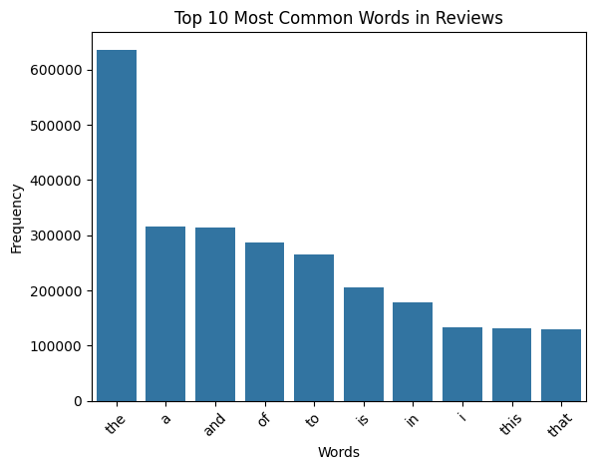
import matplotlib.pyplot as plt
print('\nTOP 20 MOST FREQUENT WORDS (ALL DATA):')
print("-"*70)
top_20 = word_freq.most_common(20)
words = [word for word, count in top_20]
counts = [count for word, count in top_20]
# Print
for i, (word, count) in enumerate(top_20, 1):
print(f'{i:2}. {word:15} | {count:6,}')
# Visualize
plt.figure(figsize=(12, 6))
plt.barh(words, counts, color='steelblue')
plt.xlabel('Frequency')
plt.title('Top 20 Most Frequent Words in All Reviews')
plt.gca().invert_yaxis()
plt.tight_layout()
plt.show()
print('Observation: These are mostly STOP WORDS (common words like "the", "a", "is")')
TOP 20 MOST FREQUENT WORDS (ALL DATA):
----------------------------------------------------------------------
1. the | 635,766
2. a | 315,257
3. and | 313,549
4. of | 286,598
5. to | 264,402
6. is | 204,825
7. in | 179,158
8. i | 132,384
9. this | 131,309
10. that | 130,096
11. it | 129,013
12. /><br | 100,979
13. was | 93,232
14. as | 87,679
15. with | 84,455
16. for | 84,197
17. but | 77,832
18. on | 62,807
19. movie | 61,431
20. are | 56,996
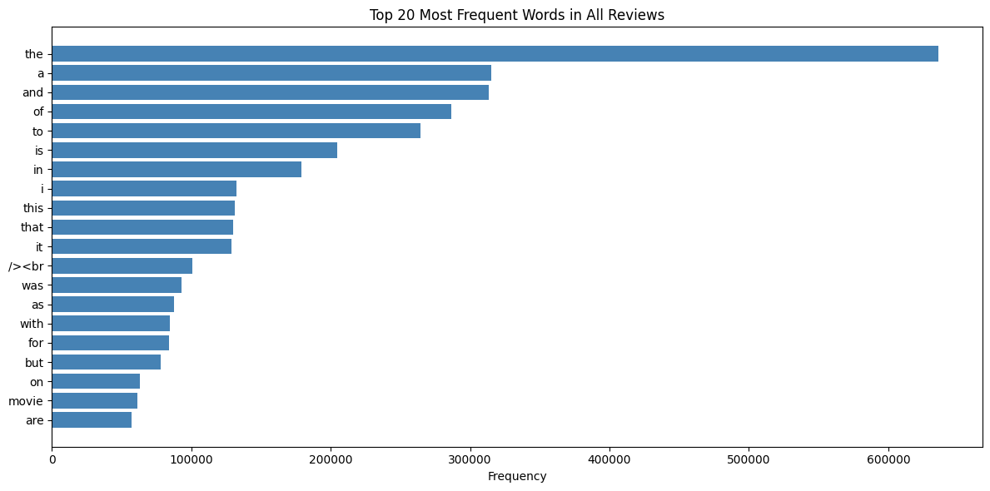
Observation: These are mostly STOP WORDS (common words like "the", "a", "is")
positive_review = df[df['sentiment'] == 'positive']['review']
positive_words = "".join(positive_review).lower().split()
positive_word_freq = Counter(positive_words)
top_20_positive = positive_word_freq.most_common(20)
negative_review = df[df['sentiment'] == 'negative']['review']
negative_words = "".join(negative_review).lower().split()
negative_word_freq = Counter(negative_words)
top_20_negative = negative_word_freq.most_common(20)
top_20_positive
print("\nSENTIMENT ANALYSIS:")
print("-"*70)
fig, axes = plt.subplots(1, 2, figsize=(14, 6))
# Positive words
word_positive = [word for word, count in top_20_positive]
count_positive = [count for word, count in top_20_positive]
axes[0].barh(word_positive, count_positive, color='green')
axes[0].set_title('Top 20 Most Frequent Words in Positive Reviews')
axes[0].set_xlabel('Frequency')
axes[0].set_ylabel('Words')
# Negative words
word_negative = [word for word, count in top_20_negative]
count_negative = [count for word, count in top_20_negative]
axes[1].barh(word_negative, count_negative, color='red')
axes[1].set_title('Top 20 Most Frequent Words in Negative Reviews')
axes[1].set_xlabel('Frequency')
axes[1].set_ylabel('Words')
SENTIMENT ANALYSIS:
----------------------------------------------------------------------
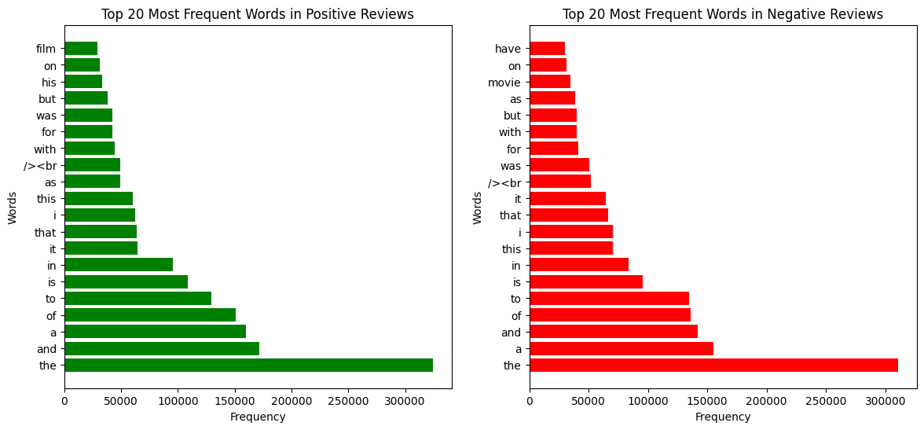
fig, axes = plt.subplots(1, 2, figsize=(30, 10))
# Positive words
Text_positive = ''.join(positive_words)
# Negative words
Text_negative = ''.join(negative_words)
cloud_positive = WordCloud(width=400, height=300, background_color='white', colormap='Greens').generate(Text_positive)
cloud_negative = WordCloud(width=400, height=300, background_color='white', colormap='Reds').generate(Text_negative)
axes[0].imshow(cloud_positive, interpolation='bilinear')
axes[0].set_title('Positive Words')
axes[0].axis('off')
axes[1].imshow(cloud_negative, interpolation='bilinear')
axes[1].set_title('Negative Words')
axes[1].axis('off')
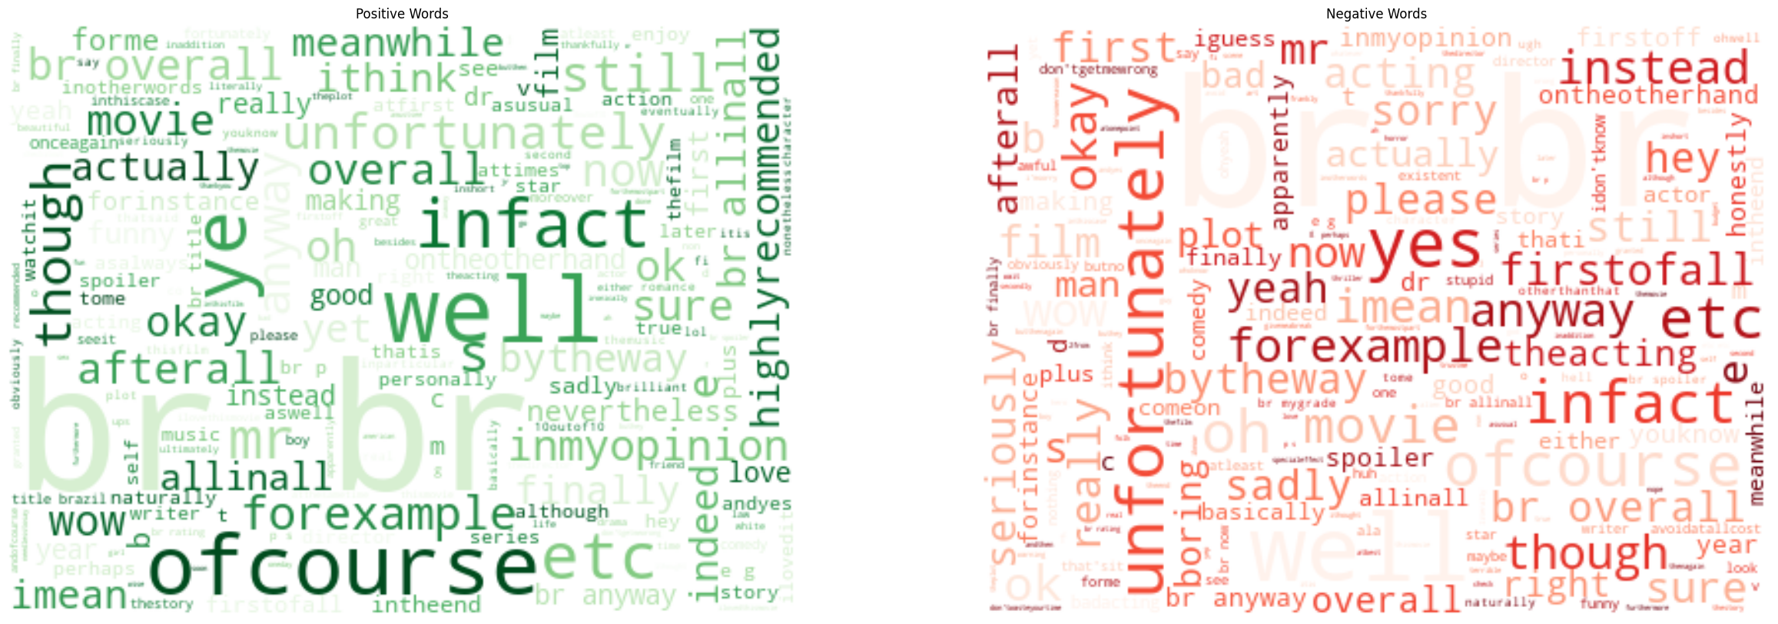
print(f'Count: {len(positive_review)}')
print(f'\nCharacter Length')
print(f'Min: {positive_review.str.len().min()}')
print(f'Max: {positive_review.str.len().max()}')
print(f'Mean: {positive_review.str.len().mean():.2f}')
print(f'word: {len(positive_review.str.split())}')
print(f'Min: {positive_review.str.split().min()}')
print(f'Max: {positive_review.str.split().max()}')
Count: 25000
Character Length
Min: 65
Max: 13704
Mean: 1324.80
word: 25000
Min: ['\x08\x08\x08\x08A', 'Turkish', 'Bath', 'sequence', 'in', 'a', 'film', 'noir', 'located', 'in', 'New', 'York', 'in', 'the', "50's,", 'that', 'must', 'be', 'a', 'hint', 'at', 'something', '!', 'Something', 'that', 'curiously,', 'in', 'all', 'the', 'previous', 'comments,', 'no', 'one', 'has', 'pointed', 'out', ',', 'but', 'seems', 'to', 'me', 'essential', 'to', 'the', 'understanding', 'of', 'this', 'movie', '<br', '/><br', '/>the', 'Turkish', 'Baths', 'sequence:', 'a', 'back', 'street', 'at', 'night,', 'the', 'entrance', 'of', 'a', 'sleazy', 'sauna,', 'and', 'Scalise', 'wrapped', 'in', 'a', 'sheet,', 'getting', 'his', 'thighs', 'massaged.', 'Steve,', 'the', 'masseur', 'is', 'of', 'the', 'young', 'rough', 'boxer', '(', 'Beefcake!)', 'type', ',', 'and', 'another', 'guy,', 'a', 'bodyguard?', 'finishes', 'dressing', 'up.', 'Dixon', 'obviously', 'hates', 'what', 'he', 'sees', 'there', 'and', 'gets', 'rough', 'right', 'away.', 'We', 'know', 'he', 'has', 'a', 'reputation', 'for', 'roughing', 'up', 'suspects.', 'Good', 'cop', 'but', 'getting', 'out', 'of', 'control', 'easy.', 'Why', 'is', 'it', 'that', 'he', 'hates', 'them', 'so', 'much', '?', '<br', '/><br', '/>Could', 'it', 'be', 'that', 'he', 'hates', 'himself.', 'This', 'part', 'of', 'himself', 'he', 'inherited', 'from', 'his', 'father', '?', 'That', 'dark', 'side', 'that', 'could', 'lead', 'him', 'right', 'at', 'the', 'end', 'of', 'the', 'sidewalk,', 'into', 'the', 'gutter', '?', 'What', 'if', 'that', 'dark', 'side', 'lurked', 'within', 'a', '"closet"', '?', 'Remember', ':', 'whenever', 'Dixon', 'meets', 'Scalise', '(', '3', 'times),', 'the', 'guy', 'is', 'lying', 'on', 'a', 'bed,', 'and', 'he', 'only', 'has', 'men', 'around', 'him', 'for', 'company', '(', 'the', 'irony', 'of', 'the', '"', 'Girls"', 'poster', 'pinned', 'up', 'on', 'the', 'wall', 'near', 'his', 'bed', '!).<br', '/><br', '/>Scalise', 'acts', 'funny:', 'affected', 'manners,', 'cranking', 'his', 'neck', 'arrogantly,', 'defiant,', 'shoving', 'his', 'inhalator', '(', 'poppers', '?)', 'into', 'his', 'nostrils', 'each', 'time', 'he', 'talks', 'to', 'Dixon.', 'Dixon,', 'with', 'a', 'vengeance,', 'is', 'bent', 'on', 'pinning', 'down', 'Scalise', 'who', 'seems', 'not', 'to', 'understand', ':', '"I', 'never', 'saw', 'a', 'man', 'so', 'full', 'of', 'hate', 'as', 'you.', 'I', 'consider', 'it', 'almost', 'humorous', 'the', 'way', 'you', 'came', 'after', 'me', 'alone.', '"', 'Four', 'years', 'jumping', 'at', 'me', 'as', 'if', 'I', 'was', 'somebody', 'special!', 'Why?', '"<br', '/><br', '/>Because', 'Scalise', 'is', 'someone', 'special', 'indeed', ':', 'he', 'is', 'the', 'direct', 'inheritor', 'of', "Dixon's", 'father', ':', '"', 'Your', 'father', 'liked', 'me",', '"Your', 'father', 'set', 'me', 'up', 'in', 'business".', 'He', 'stands', 'as', "Dixon's", 'criminal', 'brother,', 'his', 'dark', 'side', 'incarnate.', 'And', 'to', 'top', 'it', 'all,', 'he', 'prefers', 'the', 'company', 'of', 'men.', 'Dixon', 'knows', 'it', 'well', ':"', 'Who', 'killed', 'him', '(Paine)?', 'You', 'or', 'one', 'of', 'your', 'playmates?"', 'Playmates', '!', 'Notice', 'how', 'each', 'time', 'they', 'meet,', 'Dixon', 'manhandles', 'Scalise:', 'he', 'picks', 'the', 'address-book', 'out', 'of', 'his', 'jacket,', 'slaps', 'his', 'face,', 'punches', 'him.', 'Scalise', ':', '"I', 'warn', 'you', 'not', 'to', 'touch', 'me!', '"', '.', "Dixon's", 'homophobia', 'is', 'obvious.', 'Or', 'put', 'it', 'different', ':', 'his', 'unexpressed', 'homosexuality', '.', 'Dixon,', 'aka', "Dixon's", 'kid,', 'is', 'the', 'son', 'of', 'a', 'thief.', 'In', 'reaction', 'to', 'this,', 'he', 'decided', 'to', 'become', 'a', 'cop,', 'a', 'good', 'one,', 'but', 'there', 'is', 'something', 'of', 'the', 'criminal', 'in', 'him,', 'a', 'dark', 'side:', 'he', 'is', 'a', 'violent', 'copper,', 'a', 'murderer,', 'a', 'liar.', 'Besides,', 'he', 'is', 'not', 'married,', 'brings', '"a', 'dizzy', 'blonde"', 'to', 'his', 'familiar', 'eat-out', 'place', 'every', 'now', 'and', 'then,', 'but', 'nothing', 'else.', 'The', 'waitress', 'scoffing', 'says', 'that', 'he', "doesn't", 'know', 'how', 'to', 'make', 'love', 'to', 'a', 'woman.', 'Dixon', 'has', 'a', 'deep', 'feeling', 'of', 'guilt', 'and', 'hates', 'himself', 'for', 'those', 'reasons."', 'A', 'hood', 'and', 'a', 'mobster', 'like', 'his', 'old', 'man.', 'Blood', 'will', 'tell".', 'Finally,', 'in', 'order', 'to', 'achieve', 'redemption,', 'Dixon', 'decides', 'to', 'sacrifice', 'himself', ':', 'if', 'he', 'gets', 'his', 'alter', 'ego', 'Scalise', 'to', 'kill', 'him,', 'he', 'will', 'free', 'himself', 'from', 'the', 'guilt', 'and', 'free', 'the', 'girl', 'and', 'her', 'father', 'too.<br', '/><br', '/>The', 'end', 'of', 'the', 'movie', 'brings', 'us', 'back', 'to', 'the', 'opening', 'sequence', ':', 'Scalise', 'is', 'pushed', 'in', 'the', 'gutter', 'and', 'Dixon', 'deserves', 'the', 'right', 'to', 'walk', 'the', 'sidewalk', 'and', 'wins', 'the', 'love', 'of', 'the', 'dame.', 'He', 'is', 'straight', 'at', 'last.<br', '/><br', '/>The', 'unspoken', 'theme', 'of', 'the', 'movie', 'could', 'very', 'well', 'be', 'that', 'of', 'a', 'man', 'who', 'in', 'order', 'to', 'cover', 'his', 'repressed', 'feelings,', 'wants', 'to', 'experience', 'a', "woman's", 'love', '(', 'Jean', 'Douchet)<br', '/><br', '/>(These', 'notes', 'owe', 'a', 'lot', 'to', 'the', 'film', 'commentary', 'by', 'Jean', 'Douchet', 'in', 'the', 'French', 'DVD', 'edited', 'by', 'CarlottaI']
Max: ['ý', 'thýnk', 'uzak', 'ýs', 'the', 'one', 'of', 'the', 'best', 'films', 'of', 'all', 'times', 'and', 'everybody', 'must', 'realize', 'this', 'movie.I', 'm', 'a', 'Turkish', 'boy', 'and', 'a', 'big', 'cinema', 'fun.', 'and', 'in', 'this', 'days', 'our', 'cinema', 'industry', 'is', 'highing', 'up.And', 'UZAK', 'is', 'the', 'best', 'Turkish', 'film', 'of', 'last', 'ten', 'years.and', 'maybe', 'one', 'of', 'the', 'best', 'films', 'of', 'all', 'times.director', 'nuri', 'bilge', 'ceylan', 'is', 'quite', 'amazing.telling', 'story,characters,atmosphere', 'is', 'wonderful.he', 'is', 'a', 'minimalist', 'director', 'and', 'tells', 'about', 'routine', 'event', 'family,dreams,expects,life.tells', 'about', 'you', ',tells', 'about', 'me,tells', 'about', 'us.I', 'promise', 'you', 'will', 'find', 'a', 'piece', 'of', 'your', 'body', 'in', 'this', 'movie.cinema', 'life', 'welcomes', 'a', 'new', 'director.he', 'is', 'waiting', 'to', 'realize.I', 'promise', 'yo', 'you', 'will', 'love', 'this', 'movie', 'please', 'watch', 'it']
print(f'count: {len(negative_review)}')
print(f'\nCharacter Length')
print(f'Min: {negative_review.str.len().min()}')
print(f'Max: {negative_review.str.len().max()}')
print(f'Mean: {negative_review.str.len().mean():.2f}')
print(f'word: {len(negative_review.str.split())}')
print(f'Min: {negative_review.str.split().min()}')
print(f'Max: {negative_review.str.split().max()}')
count: 25000
Character Length
Min: 32
Max: 8969
Mean: 1294.06
word: 25000
Min: ['!!!', 'Spoiler', 'alert!!!<br', '/><br', '/>The', 'point', 'is,', 'though,', 'that', 'I', "didn't", 'think', 'this', 'film', 'had', 'an', 'ending', 'TO', 'spoil...', 'I', 'only', 'started', 'watching', 'it', 'in', 'the', 'middle,', 'after', 'Matt', 'had', 'gotten', 'into', "Sarah's", 'body,', 'but', 'then', 'I', 'became', 'fascinated', 'by', 'the', 'bizarreness', 'of', 'the', 'plot,', 'even', 'for', 'a', 'Channel', '5', 'movie...', 'and', "couldn't", 'possibly', 'see', 'how', 'Matt', 'wld', 'end', 'up', 'happy.', 'What', 'about', 'his', 'fiancee?', 'At', 'one', 'stage', 'looked', 'like', 'he', 'was', 'gonna', 'get', 'with', 'his', 'best', 'friend,', 'surely', 'icky', 'and', 'wrong...', 'and', 'then', 'the', 'whole', "'oggi", 'oggi', "oggi'", 'thing', 'does', 'NOT', 'WORK', 'as', 'a', 'touching', 'buddy-buddy', 'catchphrase,', 'tis', 'just', 'ridiculous...', 'so', 'was', 'going', "'surely", 'he', "can't", 'just', 'come', 'back', 'to', 'life?', 'and', 'yet', 'how', 'can', 'he', 'live', 'as', 'a', "woman?'", 'and', 'then', 'the', 'film', 'just', 'got', 'over', 'that', 'by', 'ending', 'and', 'not', 'explaining', 'anything', 'at', 'all!!!!!', "What's", 'that', 'about???', 'I', 'was', 'so', 'cross,', 'wasted', 'a', 'whole', 'hour', 'of', 'my', 'life', 'for', 'no', 'reason', 'at', 'all!!!', ':)', 'but', 'was', 'one', 'of', 'the', 'funniest', 'films', "I've", 'ever', 'seen,', 'so,', 'swings', 'and', 'roundabouts']
Max: ['{rant', 'start}', 'I', "didn't", 'want', 'to', 'believe', 'them', 'at', 'first,', 'but', 'I', 'guess', 'this', 'is', 'what', 'people', 'are', 'talking', 'about', 'when', 'they', 'say', 'South', 'Korean', 'cinema', 'has', 'peaked', 'and', 'may', 'even', 'be', 'going', 'downhill.', 'After', 'the', 'surprisingly', 'fun', 'and', 'moving', 'monster', 'movie', '"Gwoemul"', '(aka', '"The', 'Host")', 'of', '2006--', 'which', 'actually', 'succeeded', 'in', 'making', 'a', 'sharp', 'satire', 'out', 'of', 'a', 'B-movie', 'genre--', 'successive', 'Korean', 'blockbusters', 'have', 'become', 'more', 'and', 'more', 'generic,', 'even', 'though', 'their', 'budgets', '(mainly', 'spent', 'on', 'special', 'effects)', 'have', 'become', 'more', 'and', 'more', 'fantastic.', 'Do', 'South', 'Korean', 'movie-makers', 'really', 'want', 'to', 'squander', 'all', 'the', 'audience', 'and', 'investor', 'goodwill,', 'which', 'their', 'industry', 'has', 'built', 'up', 'since', 'the', '1999', 'break-out', 'film', '"Shiri/Swiri",', 'by', 'making', 'a', 'whole', 'series', 'of', 'big', 'budget', 'mediocre', 'movies', 'like', 'mainland', 'China', 'did?', '{rant', 'end}<br', '/><br', '/>The', 'only', '"reason"', 'I', 'can', 'fathom', 'for', 'making', 'this', 'movie', 'is', 'to', 'dupe', 'the', 'investors', 'into', 'financing', 'the', 'most', 'detailed', 'and', 'fluid', 'digital', 'animation', 'of', 'a', 'Korean/', 'East', 'Asian-styled', 'dragon', 'I', 'have', 'seen', 'to', 'date,', 'for', 'the', 'final', 'scenes.', 'Now', 'if', 'they', 'had', 'introduced', 'that', 'dragon', 'at', 'the', 'beginning', 'and', 'given', 'it', 'more', 'personality', 'and', 'purpose', 'like', 'in', 'the', '1996', '"Dragonheart",', 'the', 'movie', 'might', 'have', 'had', 'a', 'few', 'more', 'redeeming', 'qualities', 'other', 'than', 'having', 'lots', 'of', 'digitally', 'animated', 'dragons.', 'Remember', '"Dungeons', '&', 'Dragons"', 'in', '2000?', "Hasn't", 'anyone', 'learnt', 'that', 'the', 'trick', 'is', 'not', 'how', 'MUCH', 'special', 'effects', 'you', 'use,', 'but', 'how', 'WELL', 'you', 'use', 'it?', 'I', 'hope', 'there', 'are', 'more', '(and', 'better)', 'Korean', 'legends', 'they', 'can', 'use,', 'because', 'they', 'have', 'just', 'killed', 'a', 'lot', 'of', 'international', 'interest', 'in', 'Korean', 'dragon', 'legends', 'with', 'the', 'way', 'they', 'filmed', 'this', 'one.<br', '/><br', '/>In', 'short,', 'I', 'agree', 'with', 'all', 'the', 'negative', 'reviews', 'gone', 'before', 'and', 'wonder', 'how', 'Koreans', 'felt', 'about', 'having', 'their', 'folk', 'anthem', '"Arirang"', 'being', 'played', 'at', 'the', 'very', 'end.', 'As', 'a', 'creature', 'feature,', 'I', 'would', 'have', 'given', 'it', 'at', 'least', '5', 'stars', 'out', 'of', '10', 'if', 'the', 'special', 'effects', 'or', 'action', 'sequences', 'had', 'been', 'worth', 'it,', 'but', "I've", 'seen', 'many', 'video', 'games', 'with', 'better', 'camera', 'work', 'and', 'scripting', '(just', 'less', 'dragons).']
#Grouping by sentiment
from turtle import pos
neg_review = df[df['sentiment'] == 'negative']['review']
pos_review = df[df['sentiment'] == 'positive']['review']
#sentence using regex
neg_sentences = neg_review.str.count(r'[.!?]+').mean()
pos_sentences = pos_review.str.count(r'[.!?]+').mean()
#grouping by sentiment
pos_char = pos_review.str.len().round(2)
neg_char = neg_review.str.len().round(2)
pos_word = pos_review.str.split().apply(len).round(2)
neg_word = neg_review.str.split().apply(len).round(2)
#Comparison DataFrame
print('\nComparison')
print("-"*70)
comparison_df = pd.DataFrame({'Metric':['count','Avg_length(chars)','Avg_length(words)','avg_sentences'],
'Positive':[len(pos_review),pos_char.mean().round(2), pos_word.mean().round(2),pos_sentences.round(2)],
'Negative':[len(neg_review),neg_char.mean().round(2), neg_word.mean().round(2),neg_sentences.round(2)]})
print(comparison_df)
Comparison
----------------------------------------------------------------------
Metric Positive Negative
0 count 25000.00 25000.00
1 Avg_length(chars) 1324.80 1294.06
2 Avg_length(words) 232.85 229.46
3 avg_sentences 12.79 13.52
comparison_df['Difference'] = comparison_df['Positive'] - comparison_df['Negative']
print(comparison_df.to_string(index=False))
Metric Positive Negative Difference
count 25000.00 25000.00 0.00
Avg_length(chars) 1324.80 1294.06 30.74
Avg_length(words) 232.85 229.46 3.39
avg_sentences 12.79 13.52 -0.73
fig, axes = plt.subplots(1, 3, figsize=(18, 5))
axes[0].boxplot([pos_char, neg_char], labels=['Positive', 'Negative'])
axes[0].set_title('Character Length Distribution')
axes[1].boxplot([pos_word, neg_word], labels=['Positive', 'Negative'])
axes[1].set_title('Word Count Distribution')
axes[2].bar(['Positive', 'Negative'], [pos_sentences, neg_sentences], color=['green', 'red'])
axes[2].set_title('Average Sentences per Review')
plt.tight_layout()
plt.show()
C:\Users\GRACE\AppData\Local\Temp\ipykernel_348\2456996560.py:3: MatplotlibDeprecationWarning: The 'labels' parameter of boxplot() has been renamed 'tick_labels' since Matplotlib 3.9; support for the old name will be dropped in 3.11.
axes[0].boxplot([pos_char, neg_char], labels=['Positive', 'Negative'])
C:\Users\GRACE\AppData\Local\Temp\ipykernel_348\2456996560.py:5: MatplotlibDeprecationWarning: The 'labels' parameter of boxplot() has been renamed 'tick_labels' since Matplotlib 3.9; support for the old name will be dropped in 3.11.
axes[1].boxplot([pos_word, neg_word], labels=['Positive', 'Negative'])
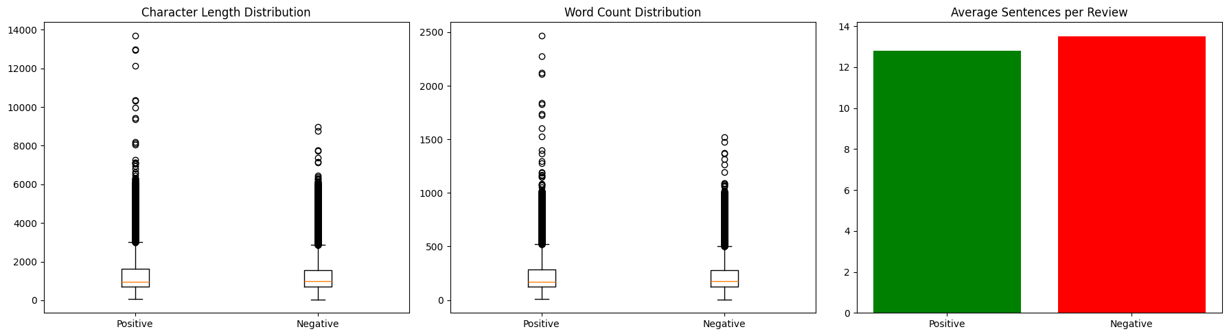
"""print("="*70)
print('PHASE 6: FEATURE ENGINEERING OPPORTUNITIES')
print("="*70)
print('\n1. POTENTIAL FEATURES TO CREATE:')
print("-"*70)
features = {
'Review Length': {
'Description': 'Character count of review',
'Why': 'Longer reviews may indicate more thoughtful opinions',
'Implementation': 'df["length_chars"] = df["review"].str.len()'
},
'Word Count': {
'Description': 'Number of words in review',
'Why': 'More words = more detail',
'Implementation': 'df["word_count"] = df["review"].str.split().str.len()'
},
'Sentence Count': {
'Description': 'Number of sentences',
'Why': 'Structure indicator',
'Implementation': 'df["sentence_count"] = df["review"].str.count(r"[.!?]+")'
},
'Uppercase Ratio': {
'Description': '% of uppercase letters',
'Why': 'Strong emotions use caps (GREAT! BAD!)',
'Implementation': 'df["uppercase_ratio"] = df["review"].str.count(r"[A-Z]") / df["review"].str.len()'
},
'Exclamation Count': {
'Description': 'Number of ! marks',
'Why': 'Indicates strong emotion',
'Implementation': 'df["exclamation_count"] = df["review"].str.count("!")'
},
'Question Count': {
'Description': 'Number of ? marks',
'Why': 'Rhetorical questions show engagement',
'Implementation': 'df["question_count"] = df["review"].str.count("\\?")'
},
}
for feature, info in features.items():
print(f'\n✓ {feature}')
print(f' Description: {info["Description"]}')
print(f' Why: {info["Why"]}')
print(f' Code: {info["Implementation"]}')"""

Feature Engineering
df.head(5)
dff = df.copy()
dff.duplicated().sum()
dff.drop_duplicates(inplace=True)
dff.duplicated().sum()
#Feature Engineering: Adding review length and word count
dff['length_chars'] = dff['review'].str.len()
dff['word_count'] = dff['review'].str.split().str.len()
#uppercase ratio,exclamation count and question count
dff['uppercase_ratio'] = dff['review'].str.count(r'[A-Z]') / dff['review'].str.len()
dff['exclamation_count'] = dff['review'].str.count('!')
dff['question_count'] = dff['review'].str.count(r'\?')
#avg length of sentences
dff['avg_length'] = dff['review'].str.len() / dff['word_count']
dff.head()
#random probe on 4th row, 1st column (review text)
dff.iloc[3,0]
dff.tail(10)
dff.iloc[0,0]
dff['Review_Cleaned'] = dff['review'].apply(lambda x: contractions.fix(str(x)))
dff.head()
dff['Review_Cleaned'] = dff['Review_Cleaned'].str.lower()
dff.head()
#html tags removal
dff['Review_Cleaned'] = dff['Review_Cleaned'].apply(lambda x: BeautifulSoup(x, "html.parser").get_text())
#url and emaill removal
dff['Review_Cleaned'] = dff['Review_Cleaned'].apply(lambda x: re.sub(r'http\S+|www\S+|https\S+', '', x))
#number removal
dff['Review_Cleaned'] = dff['Review_Cleaned'].apply(lambda x: re.sub(r'\d+', '', x))
#REPEATED WORDS REMOVAL(reducing "good good good" to "good" and "soooo good" to "so good")
dff['Review_Cleaned'] = dff['Review_Cleaned'].apply(lambda x: re.sub(r'\b(\w+)( \1\b)+', r'\1', x))
dff['Review_Cleaned'] = dff['Review_Cleaned'].apply(lambda x: re.sub(r"(\w)\1{2,}", r"\1", x))
#special characters removal
dff['Review_Cleaned'] = dff['Review_Cleaned'].apply(lambda x: re.sub(r'[^a-zA-Z\s]', '', x))
dff.head()
#tokenization
dff['Review_Tokens'] = dff['Review_Cleaned'].apply(lambda x: word_tokenize(x))
#removal of stop words
from nltk.corpus import stopwords
nltk.download('stopwords')
stop_words = set(stopwords.words('english'))
#negations
negations = {"not", "no", "never", "nor",'neither','nothing','nobody'}
stop_words = stop_words - negations
dff['Token_Filtered'] = dff['Review_Tokens'].apply(lambda x: [word for word in x if word not in stop_words])
[nltk_data] Downloading package stopwords to
[nltk_data] C:\Users\GRACE\AppData\Roaming\nltk_data...
[nltk_data] Package stopwords is already up-to-date!
dff.head()
import nltk
nltk.download('averaged_perceptron_tagger')
nltk.download('averaged_perceptron_tagger_eng')
nltk.download('wordnet') # ← this was missing
nltk.download('omw-1.4') # ← recommended addition
from nltk.stem import WordNetLemmatizer
from nltk.corpus import wordnet
lemmatizer = WordNetLemmatizer()
import nltk
nltk.download('wordnet')
nltk.download('omw-1.4') # Optional but recommended — Open Multilingual Wordnet
[nltk_data] Downloading package averaged_perceptron_tagger to
[nltk_data] C:\Users\GRACE\AppData\Roaming\nltk_data...
[nltk_data] Package averaged_perceptron_tagger is already up-to-
[nltk_data] date!
[nltk_data] Downloading package averaged_perceptron_tagger_eng to
[nltk_data] C:\Users\GRACE\AppData\Roaming\nltk_data...
[nltk_data] Package averaged_perceptron_tagger_eng is already up-to-
[nltk_data] date!
[nltk_data] Downloading package wordnet to
[nltk_data] C:\Users\GRACE\AppData\Roaming\nltk_data...
[nltk_data] Package wordnet is already up-to-date!
[nltk_data] Downloading package omw-1.4 to
[nltk_data] C:\Users\GRACE\AppData\Roaming\nltk_data...
[nltk_data] Package omw-1.4 is already up-to-date!
[nltk_data] Downloading package wordnet to
[nltk_data] C:\Users\GRACE\AppData\Roaming\nltk_data...
[nltk_data] Package wordnet is already up-to-date!
[nltk_data] Downloading package omw-1.4 to
[nltk_data] C:\Users\GRACE\AppData\Roaming\nltk_data...
[nltk_data] Package omw-1.4 is already up-to-date!
from nltk.corpus import wordnet
nltk.download('averaged_perceptron_tagger')
nltk.download('averaged_perceptron_tagger_eng')
def get_wordnet_pos(word):
"""Map POS tag to first character lemmatize() accepts"""
tag = nltk.pos_tag([word])[0][1][0].upper()
tag_dict = {"J": wordnet.ADJ,
"N": wordnet.NOUN,
"V": wordnet.VERB,
"R": wordnet.ADV}
return tag_dict.get(tag, wordnet.NOUN) # Default to noun if not found
def lemmatize_with_pos(tokens):
return [lemmatizer.lemmatize(word, get_wordnet_pos(word)) for word in tokens]
dff['Token_Lemma'] = dff['Token_Filtered'].apply(lemmatize_with_pos)
[nltk_data] Downloading package averaged_perceptron_tagger to
[nltk_data] C:\Users\GRACE\AppData\Roaming\nltk_data...
[nltk_data] Package averaged_perceptron_tagger is already up-to-
[nltk_data] date!
[nltk_data] Downloading package averaged_perceptron_tagger_eng to
[nltk_data] C:\Users\GRACE\AppData\Roaming\nltk_data...
[nltk_data] Package averaged_perceptron_tagger_eng is already up-to-
[nltk_data] date!
dff['final_review'] = dff['Token_Lemma'].apply(lambda x: ' '.join(x))
dff.head()
#Encooding the sentiment labels to numerical values
from sklearn.preprocessing import LabelEncoder
le = LabelEncoder()
dff['sentiment_encoded'] = le.fit_transform(dff['sentiment'])
dff.head(5)
x = dff['final_review']
y = dff['sentiment_encoded']
from sklearn.model_selection import train_test_split
X_train, X_test, y_train, y_test = train_test_split(x, y, test_size=0.2, random_state=42)
from sklearn.feature_extraction.text import TfidfVectorizer
vectorizer = TfidfVectorizer(max_features=5000)
X_train_tfidf = vectorizer.fit_transform(X_train)
X_test_tfidf = vectorizer.transform(X_test)
x_train_ = X_train_tfidf
x_test_ = X_test_tfidf
#logistic regression
from sklearn.metrics import accuracy_score, classification_report, confusion_matrix
from sklearn.linear_model import LogisticRegression
model_lr = LogisticRegression()
model_lr.fit(x_train_, y_train)
y_pred_lr = model_lr.predict(x_test_)
acc_lr = accuracy_score(y_test, y_pred_lr)
recall_lr = recall_score(y_test, y_pred_lr)
f1_lr = f1_score(y_test, y_pred_lr)
precision_lr = precision_score(y_test, y_pred_lr)
print(f'Logistic Regression Accuracy: {acc_lr:.4f}')
print(f'Logistic Regression Recall: {recall_lr:.4f}')
print(f'Logistic Regression Precision: {precision_lr:.4f}')
print(f'Logistic Regression F1 Score: {f1_lr:.4f}')
sns.heatmap(confusion_matrix(y_test, y_pred_lr), annot=True, fmt='d', cmap='Blues')
plt.title('Logistic Regression Confusion Matrix')
plt.xlabel('Predicted')
plt.ylabel('Actual')
plt.show()
Logistic Regression Accuracy: 0.8819
Logistic Regression Recall: 0.8945
Logistic Regression Precision: 0.8733
Logistic Regression F1 Score: 0.8838
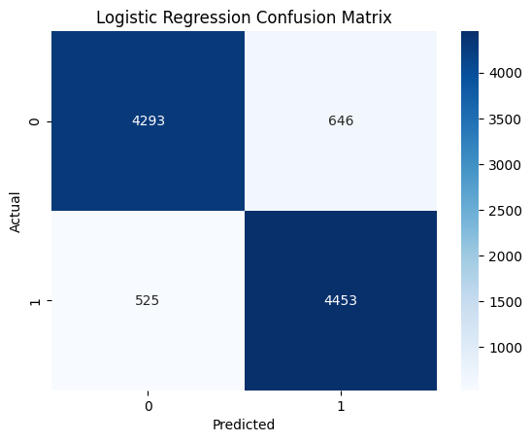
#naive bayes
model_nb = MultinomialNB()
model_nb.fit(x_train_, y_train)
y_pred_nb = model_nb.predict(x_test_)
acc_nb = accuracy_score(y_test, y_pred_nb)
recall_nb = recall_score(y_test, y_pred_nb)
f1_nb = f1_score(y_test, y_pred_nb)
precision_nb = precision_score(y_test, y_pred_nb)
print(f'Naive Bayes Accuracy: {acc_nb:.4f}')
print(f'Naive Bayes Recall: {recall_nb:.4f}')
print(f'Naive Bayes Precision: {precision_nb:.4f}')
print(f'Naive Bayes F1 Score: {f1_nb:.4f}')
sns.heatmap(confusion_matrix(y_test, y_pred_nb), annot=True, fmt='d', cmap='Blues')
plt.title('Naive Bayes Confusion Matrix')
plt.xlabel('Predicted')
plt.ylabel('Actual')
plt.show()
Naive Bayes Accuracy: 0.8470
Naive Bayes Recall: 0.8534
Naive Bayes Precision: 0.8437
Naive Bayes F1 Score: 0.8485
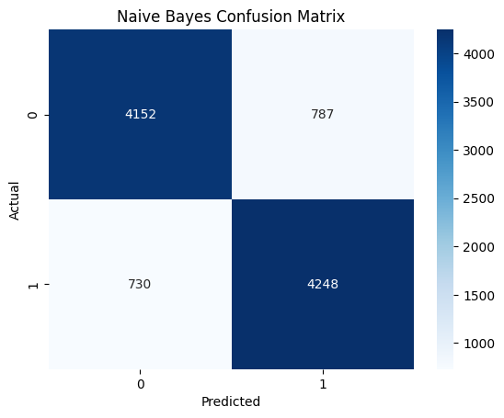
model_rf = RandomForestClassifier(n_estimators=100, random_state=42)
model_rf.fit(x_train_, y_train)
y_pred_rf = model_rf.predict(x_test_)
acc_rf = accuracy_score(y_test, y_pred_rf)
recall_rf = recall_score(y_test, y_pred_rf)
f1_rf = f1_score(y_test, y_pred_rf)
precision_rf = precision_score(y_test, y_pred_rf)
print(f'Random Forest Accuracy: {acc_rf:.4f}')
print(f'Random Forest Recall: {recall_rf:.4f}')
print(f'Random Forest Precision: {precision_rf:.4f}')
print(f'Random Forest F1 Score: {f1_rf:.4f}')
sns.heatmap(confusion_matrix(y_test, y_pred_rf), annot=True, fmt='d', cmap='Blues')
plt.title('Random Forest Confusion Matrix')
plt.xlabel('Predicted')
plt.ylabel('Actual')
plt.show()
Random Forest Accuracy: 0.8356
Random Forest Recall: 0.8305
Random Forest Precision: 0.8402
Random Forest F1 Score: 0.8353
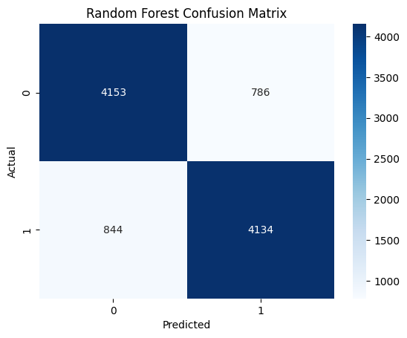
model_rc = ridgeclassifier = RidgeClassifier()
model_rc.fit(x_train_, y_train)
y_pred_rc = model_rc.predict(x_test_)
acc_rc = accuracy_score(y_test, y_pred_rc)
recall_rc = recall_score(y_test, y_pred_rc)
f1_rc = f1_score(y_test, y_pred_rc)
precision_rc = precision_score(y_test, y_pred_rc)
print(f'Ridge Classifier Accuracy: {acc_rc:.4f}')
print(f'Ridge Classifier Recall: {recall_rc:.4f}')
print(f'Ridge Classifier Precision: {precision_rc:.4f}')
print(f'Ridge Classifier F1 Score: {f1_rc:.4f}')
sns.heatmap(confusion_matrix(y_test, y_pred_rc), annot=True, fmt='d', cmap='Blues')
plt.title('Ridge Classifier Confusion Matrix')
plt.xlabel('Predicted')
plt.ylabel('Actual')
plt.show()
Ridge Classifier Accuracy: 0.8783
Ridge Classifier Recall: 0.8915
Ridge Classifier Precision: 0.8693
Ridge Classifier F1 Score: 0.8803
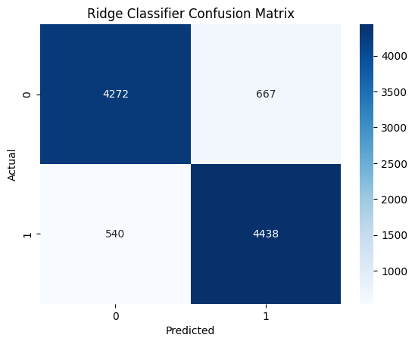
results_Metrics = pd.DataFrame({
'Model': ['Logistic Regression', 'Naive Bayes', 'Random Forest', 'Ridge Classifier'],
'Accuracy': [acc_lr, acc_nb, acc_rf, acc_rc],
'Recall': [recall_lr, recall_nb, recall_rf, recall_rc],
'Precision': [precision_lr, precision_nb, precision_rf, precision_rc],
'F1 Score': [f1_lr, f1_nb, f1_rf, f1_rc]
})
print("\nMODEL PERFORMANCE COMPARISON:")
print("-"*70)
print(results_Metrics.to_string(index=False))
MODEL PERFORMANCE COMPARISON:
----------------------------------------------------------------------
Model Accuracy Recall Precision F1 Score
Logistic Regression 0.881920 0.894536 0.873308 0.883795
Naive Bayes 0.847030 0.853355 0.843694 0.848497
Random Forest 0.835636 0.830454 0.840244 0.835320
Ridge Classifier 0.878290 0.891523 0.869344 0.880294
#Detailed classification reports for each model
#Logistic Regression
classification_report_lr = classification_report(y_test, y_pred_lr)
print("\nClassification Report for Logistic Regression:")
print(classification_report_lr)
#Naive Bayes
classification_report_nb = classification_report(y_test, y_pred_nb)
print("\nClassification Report for Naive Bayes:")
print(classification_report_nb)
#Random Forest
classification_report_rf = classification_report(y_test, y_pred_rf)
print("\nClassification Report for Random Forest:")
print(classification_report_rf)
#Ridge Classifier
classification_report_rc = classification_report(y_test, y_pred_rc)
print("\nClassification Report for Ridge Classifier:")
print(classification_report_rc)
Classification Report for Logistic Regression:
precision recall f1-score support
0 0.89 0.87 0.88 4939
1 0.87 0.89 0.88 4978
accuracy 0.88 9917
macro avg 0.88 0.88 0.88 9917
weighted avg 0.88 0.88 0.88 9917
Classification Report for Naive Bayes:
precision recall f1-score support
0 0.85 0.84 0.85 4939
1 0.84 0.85 0.85 4978
accuracy 0.85 9917
macro avg 0.85 0.85 0.85 9917
weighted avg 0.85 0.85 0.85 9917
Classification Report for Random Forest:
precision recall f1-score support
0 0.83 0.84 0.84 4939
1 0.84 0.83 0.84 4978
accuracy 0.84 9917
macro avg 0.84 0.84 0.84 9917
weighted avg 0.84 0.84 0.84 9917
Classification Report for Ridge Classifier:
precision recall f1-score support
0 0.89 0.86 0.88 4939
1 0.87 0.89 0.88 4978
accuracy 0.88 9917
macro avg 0.88 0.88 0.88 9917
weighted avg 0.88 0.88 0.88 9917
results_Cr = pd.DataFrame({
'Model': ['Logistic Regression', 'Naive Bayes', 'Random Forest',
'Ridge Classifier'],
'Classification Report': [classification_report_lr, classification_report_nb, classification_report_rf, classification_report_rc]
})
print(results_Cr.to_string(index=False))
Model Classification Report
Logistic Regression precision recall f1-score support\n\n 0 0.89 0.87 0.88 4939\n 1 0.87 0.89 0.88 4978\n\n accuracy 0.88 9917\n macro avg 0.88 0.88 0.88 9917\nweighted avg 0.88 0.88 0.88 9917\n
Naive Bayes precision recall f1-score support\n\n 0 0.85 0.84 0.85 4939\n 1 0.84 0.85 0.85 4978\n\n accuracy 0.85 9917\n macro avg 0.85 0.85 0.85 9917\nweighted avg 0.85 0.85 0.85 9917\n
Random Forest precision recall f1-score support\n\n 0 0.83 0.84 0.84 4939\n 1 0.84 0.83 0.84 4978\n\n accuracy 0.84 9917\n macro avg 0.84 0.84 0.84 9917\nweighted avg 0.84 0.84 0.84 9917\n
Ridge Classifier precision recall f1-score support\n\n 0 0.89 0.86 0.88 4939\n 1 0.87 0.89 0.88 4978\n\n accuracy 0.88 9917\n macro avg 0.88 0.88 0.88 9917\nweighted avg 0.88 0.88 0.88 9917\n
#cross-validation for logistic regression
from sklearn.model_selection import cross_val_score
cross_val_scores_lr = cross_val_score(model_lr, x_train_, y_train, cv=5, scoring='accuracy')
print("\nCross-Validation Scores for Logistic Regression:")
print(cross_val_scores_lr)
print(f'Average CV Accuracy: {cross_val_scores_lr.mean():.4f}')
Cross-Validation Scores for Logistic Regression:
[0.88339846 0.88188579 0.88314635 0.88390268 0.87923862]
Average CV Accuracy: 0.8823
#most important features for logistic regression
feature_names = vectorizer.get_feature_names_out()
coefficients = model_lr.coef_[0]
feature_importance = pd.DataFrame({'Feature': feature_names, 'Coefficient': coefficients})
feature_importance['Abs_Coefficient'] = feature_importance['Coefficient'].abs()
feature_importance.sort_values(by='Abs_Coefficient', ascending=False, inplace=True)
top_features = feature_importance.head(20)
print("\nTop 20 Most Important Features for Logistic Regression:")
print(top_features[['Feature', 'Coefficient']].to_string(index=False))
Top 20 Most Important Features for Logistic Regression:
Feature Coefficient
bad -10.916865
waste -8.699513
awful -7.669202
great 7.313512
excellent 6.938755
boring -6.174262
terrible -5.766654
poor -5.730901
nothing -5.324593
dull -5.283527
perfect 5.225315
horrible -5.092072
best 4.899364
amaze 4.896205
wonderful 4.793391
poorly -4.776852
fails -4.760903
love 4.726937
suppose -4.649147
favorite 4.543587
#Grouping the features into positive and negative based on coefficient sign
feature_importance['Sentiment'] = feature_importance['Coefficient'].apply(lambda x: 'Positive' if x > 0 else 'Negative')
print("\nFeature Importance with Sentiment:")
print(feature_importance[['Feature', 'Coefficient', 'Sentiment']].head(20).to_string(index=False))
Feature Importance with Sentiment:
Feature Coefficient Sentiment
bad -10.916865 Negative
waste -8.699513 Negative
awful -7.669202 Negative
great 7.313512 Positive
excellent 6.938755 Positive
boring -6.174262 Negative
terrible -5.766654 Negative
poor -5.730901 Negative
nothing -5.324593 Negative
dull -5.283527 Negative
perfect 5.225315 Positive
horrible -5.092072 Negative
best 4.899364 Positive
amaze 4.896205 Positive
wonderful 4.793391 Positive
poorly -4.776852 Negative
fails -4.760903 Negative
love 4.726937 Positive
suppose -4.649147 Negative
favorite 4.543587 Positive
feature_importance.head(10)
#predicting on new reviews
new_reviews = [
"I absolutely hated this movie. The plot was bad and the acting was not superb.",
"This was the worst film I've ever seen. It was a complete waste of time.",
"i do not like this movie.."
]
new_reviews_tfidf = vectorizer.transform(new_reviews)
new_predictions = model_lr.predict(new_reviews_tfidf)
print("\nPredictions for New Reviews:")
for review, pred in zip(new_reviews, new_predictions):
sentiment = 'Positive' if pred == 1 else 'Negative'
print(f'Review: "{review}"\nPredicted Sentiment: {sentiment}\n')
Predictions for New Reviews:
Review: "I absolutely hated this movie. The plot was bad and the acting was not superb."
Predicted Sentiment: Negative
Review: "This was the worst film I've ever seen. It was a complete waste of time."
Predicted Sentiment: Negative
Review: "i do not like this movie.."
Predicted Sentiment: Negative

