Vanier College Fitness Appraisal

At Vanier College we offer a unique Fitness Appraisal experience.
Somewhere around week 10 or 11, the entire gym complex is turned in to a testing center for an entire week during which all PE classes will complete the appraisal at their specific class times.

Students are provided with a fun group activity that will allow them to analyze all of the components of fitness. The Appraisal is meant to be an educational tool for students to learn about the various components of fitness and to allow for personal reflection. Students will be able to assess their level of fitness and any changes that occur both positive and negative during their time at Vanier.

Students are also required to complete a written assignment for each of the different course levels. (101-102-103) The forms for these tests are at the end of the document.

In some classes, pre and post testing is done so that students can practice goal setting and monitor their fitness improvements throughout a semester. This tool is primarily used in 102 and 103 classes where students will be tested at the beginning and then again at the end of the semester. After the initial testing students will be able to set personal fitness goals and work on improving their fitness level, they will then have the opportunity to redo the tests and see improvement results.

The selection of the tests used for the Vanier Appraisal is based on the following considerations:
- ease for group testing.
- accurate representation norms for the average CEGEP population.
- ease in which the exercises can be practiced at home and thus used as a goal setting improvement experiment.

Resting Heart Rate / Pre-Exercise Heart Rate

Students should be instructed to take their resting heart rate before the test.
- Take heart rate first thing in the morning before getting out of bed for 30 seconds x 2.
- They can take heart rate at the radial or carotid pulse sites.
- The norm table can be used if they have their resting heart rate.

- There is also a pre-exercise heart rate for them to record so that they can evaluate the difference between their resting HR and factors that can increase heart rate during the day.

- A desirable RHR is between 60-70 beats/min.
- Monitoring Resting Heart rate as with blood pressure and cholesterol levels can help identify possible cardiovascular health risks.
- High resting heart readings of > 80 bpm have been linked to high blood pressure, high body weight, and higher levels of blood fat and increased risks of premature death.
- A lower resting heart rate can be associated with a higher level of physical fitness and lower risk of heart attack.
- Low RHR can also be due to aging electrical nodes of the heart may cause occasional dizziness or fatigue.

Resting Heart Rate Verbal Rating |  |  | 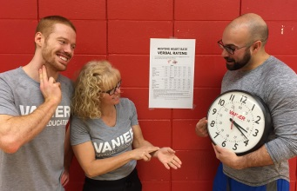
Males
Age | 16-25 | 26-35 |  | 36-45 | 46-55 | 56-65 | 65 +
Athlete | 49-55 | 49-54 |  | 50-56 | 50-57 | 51-56 | 50-55
Excellent | 56-61 | 55-61 |  | 57-62 | 58-63 | 57-61 | 56-61
Good | 62-65 | 62-65 |  | 63-66 | 64-67 | 62-67 | 62-65
Above Average | 66-69 | 66-70 |  | 67-70 | 68-71 | 68-71 | 66-69
Average | 70-73 | 71-74 |  | 71-75 | 72-76 | 72-75 | 70-73
Below Average | 74-81 | 75-81 |  | 76-82 | 77-83 | 76-81 | 74-79
Poor | 82 + | 82 + |  | 83 + | 84 + | 82 + | 8- +
Females
Age | 16-25 | 26-35 |  | 36-45 | 46-55 | 56-65 | 65 +
Athlete | 54-60 | 54-59 |  | 54-59 | 54-60 | 54-59 | 54-59
Excellent | 61-65 | 60-64 |  | 60-64 | 61-65 | 60-64 | 60-64
Good | 66-69 | 65-68 |  | 65-69 | 66-69 | 65-68 | 65-68
Above Average | 70-73 | 69-72 |  | 70-73 | 70-73 | 69-73 | 69-72
Average | 74-78 | 73-76 |  | 74-78 | 74-77 | 74-77 | 73-76
Below Average | 79-84 | 77-82 |  | 79-84 | 78-83 | 78-83 | 77-83
Poor | 85 + | 83 + |  | 85 + | 84 + | 84 + | 84 +
Source: http://www.carlbtaylor.com
Body Composition Analysis

Body Composition learning objectives:

- Understanding Body composition (fat vs muscle / lean body weight – body types).
- Understanding why body weight is not a good indicator of health (muscle mass, skinny fat, body types, and fitness level.).
- The different methods of assessing body composition (height-weight (BMI) / body weight distribution (WHR and WHtR) / % body fat)
- The risk factors associated with high levels of body fat, low levels of muscle mass and more specifically having fat stored close to the internal organs.
- The lifestyle habits recommended achieving and maintaining healthy body composition.

A variety of tests and procedures are provided to make the experience a positive, educational one.

It is recommended to watch the Vanier Body Composition Video prior to testing (in class or via MIO).

Assessment # 1. Body Mass Index (Height cm and Weight (lbs or kg) is needed)

Students are asked to refer to the BMI chart to determine their verbal rating and their proposed healthy weight range (lower and upper weight limits in the healthy range).
Students need to know their body weight in pounds. They can weigh themselves prior to the test, on site (privately) or they can skip it all together and use the other 2 Body composition test methods if they prefer.

- Students should be aware of the inaccuracy of just looking at body weight to determine health risk.
- Critics of the BMI test are concerned that the BMI test does not take into account muscle mass or location of fat stores (abdominal fat) and thus feel that the test does not provide enough health feedback. By looking at the results of all of the body composition tests (WHR and WHtR) students will have a more accurate assessment.
- Students should also understand that physical fitness level is also an extremely important health indicator and that they should not simply focus on body composition results.

Body Mass Index
Height / Weight Analysis
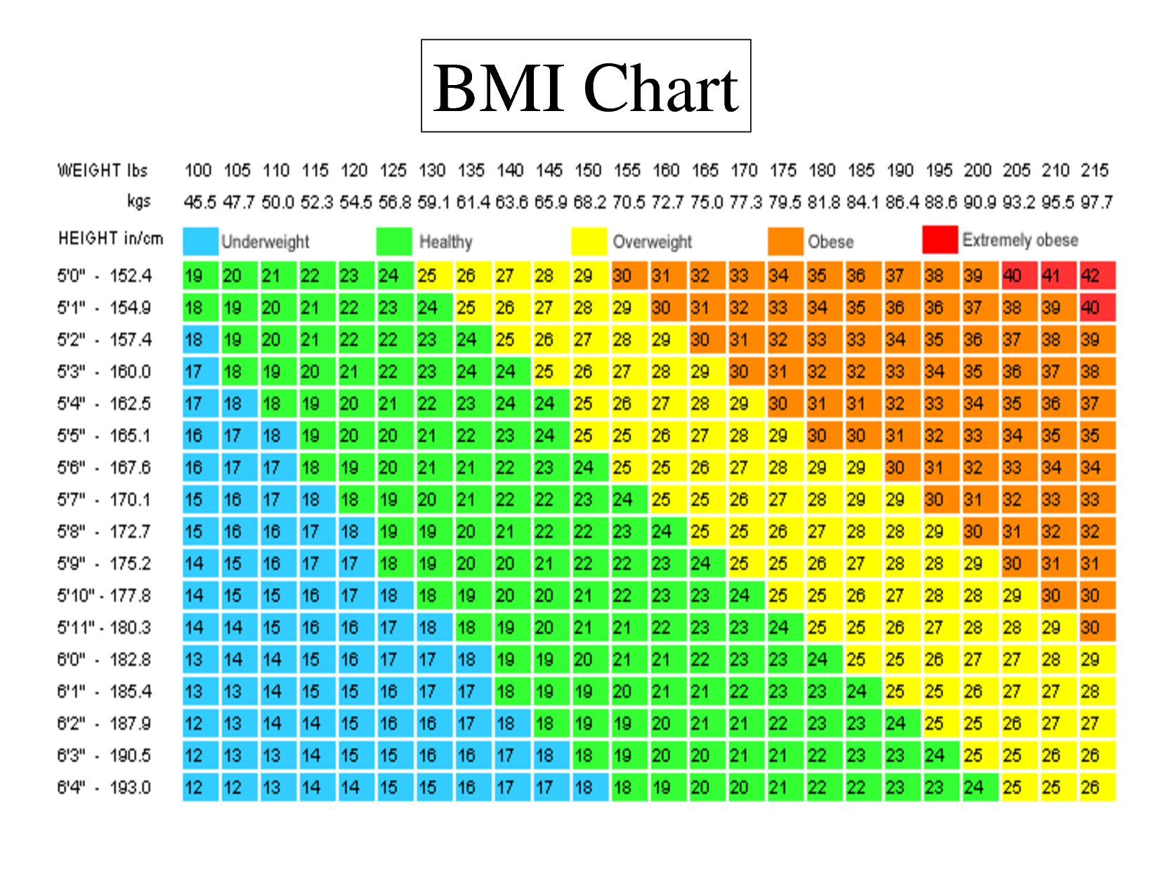
NHLBI OBESITY EDUCATION INITIATIVE. NATIONAL INSTITUTES OF HEALTH, 1998.

To find your HEALTHY WEIGHT RANGE result,
find the weight (on the top) of the chart that corresponds with the first and last BMI numbers in the green zone for your height.

Body Mass Index
VERBAL RATING
Important Considerations:

The BMI is just a general scale that should only be used as a guide
and should always be used in combination with the other Body Composition tests.

The BMI test does not take into account activity level, muscle mass, gender or body type so it cannot accurately determine body fat %.

The BMI test does not take into account location of fat stores so it is not always an accurate evaluation of health risk. It is very important to take into account your fitness level, body shape and location of body fat to determine your health risk.

Less than 18.5  Underweight | 18.5 - 25  Healthy Weight | 26 - 30  Overweight | 31 - 40 High Risk | More than 40 Extremely High Risk
May be associated with health problems for some people.  It may be a good idea to consult a dietician and/or physician for advice. | This range is associated with the lowest risk of body composition related illness for most people.  This is the range you want to stay in –  for life! | A BMI over 25 due to high body fat levels can be associated with health problems for some people.  Corresponds to 10 % over ideal body weight. | A BMI over 30 (30 lbs. or more overweight) due to high body fat levels especially with fat storage in the abdominal area is associated with increased risk of developing health problems such as heart disease, high blood pressure and diabetes. It is recommended to evaluate your present lifestyle and consult a dietician or physician for advice.
Statement from Diabetes Canada
“Regular exercise also has special advantages if you have type 2 diabetes.
It can also help prevent or delay type 2 diabetes from developing.
Regular physical activity improves your body’s sensitivity to insulin and helps manage your blood glucose (sugar) levels.”
http://www.diabetes.ca/diabetes-and-you/healthy-living-resources/exercise/physical-activity-diabetes

HIGH BMI
MUSCLE OR BODY FAT???

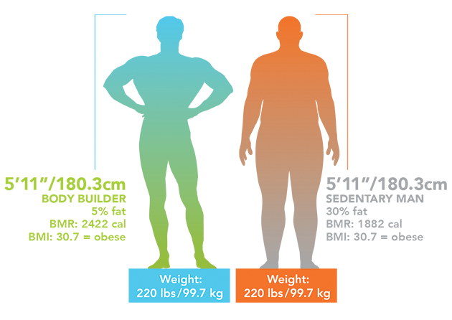
Assessment # 2. Waist to Hip Ratio (Analyzing Weight Distribution)

Students need to measure the circumference of their waist and hip in cm.
A teacher or partner should be taking their measurements at the accurate location.

- Students should be made aware that the purpose of this test is to determine risk in relation to body shape (apple vs pear).
- A high risk rating does not necessarily mean they are overfat, it means that they have a high risk shape (apple shape) in that they tend to store more fat closer to their heart and around the visceral organs.
- Students should understand that by looking at the results of all of the body composition tests will give them a more accurate assessment.

For example:

A high risk WHR but low risk BMI = risky shape not high fat.
An Overweight BMI and High risk WHR = excess weight in the abdominal region.

Assessment # 3. Height to Waist Ratio - (Analyzing Weight Distribution)
A person's waist-to-height ratio (WHtR) is determined by calculating their waist circumference divided by their height (both measured in the same units – cm).
The WHtR is a measure of the distribution of body fat. Higher values of WHtR indicate higher risk of obesity-related cardiovascular diseases; it is correlated with abdominal obesity.
N.B: A 2010 study that followed 11,000 subjects for up to eight years concluded that WHtR is a much better measure of the risk of heart attack, stroke or death than the more widely used body mass index. However, a 2011 study that followed 60,000 participants for up to 13 years found that waist-hip ratio (when adjusted for BMI) was a better predictor of ischaemic heart disease mortality than WHtR. Hence, the decision the include BMI, WHR and WHtR in the Vanier Fitness Appraisal.

Waist to Hip Ratio
Waist ÷ Hip = Waist to Hip Ratio
The waist to hip ratio test is designed to determine where you distribute your body weight.
Do you store fat around your waist???? Apple Shape
Do you store fat around your hips???? Pear Shape / Hourglass
Do you have a rectangle shape??? Banana
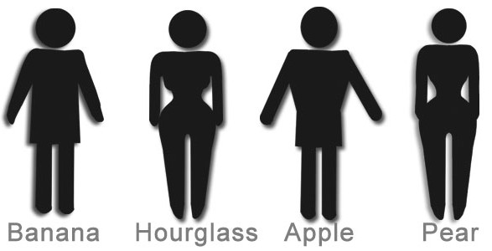
MEASURE the WAIST:  1. Find someone to measure your waist in centimeters  2. Measure at the smallest point of your waist. (Approximately 1 inch above the bellybutton)  3. Record results on your form under Waist to Hip Ratio. | MEASURE the HIP  1. Find someone to measure your Hip in centimeters.  2. Measure at the largest point of your bottom.  3. Record results on your form under Waist to Hip Ratio.
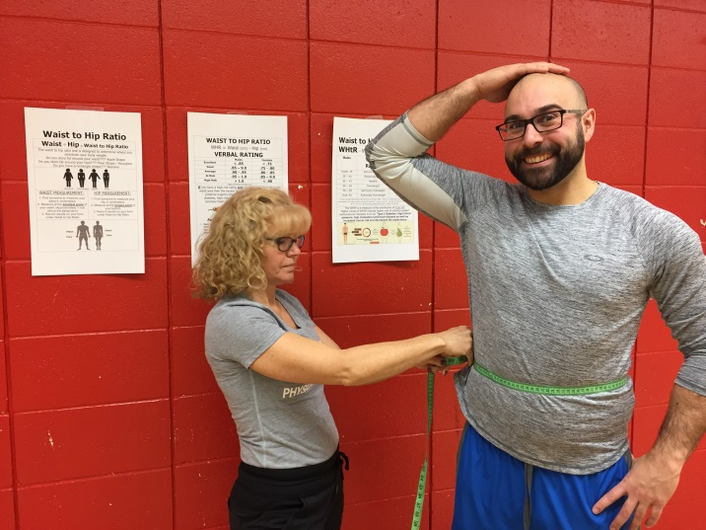 | 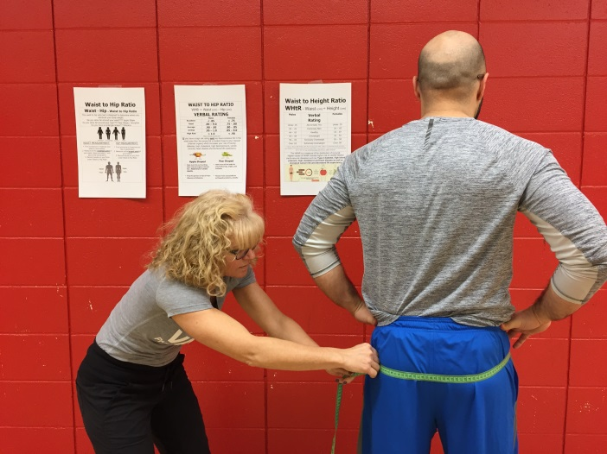

WAIST TO HIP RATIO

WHR = Waist (cm) ÷ Hip (cm)

VERBAL RATING
 | Males | Females
Excellent | < .85 | < .75
Good | .85 – 9.0 | .75 - .80
Average | .90 - .95 | .80 - .85
At Risk | .95 – 1.0 | .85 – 9.0
High Risk | > 1.0 | < .90
https://articles.mercola.com
If you have a high risk rating and you have excessive fat in the waist area then the excess fat is located close to your visceral (internal organs) which increases your risk of having:
diabetes, high cholesterol, high blood pressure, cancer,
coronary heart disease and shortened life expectancy.

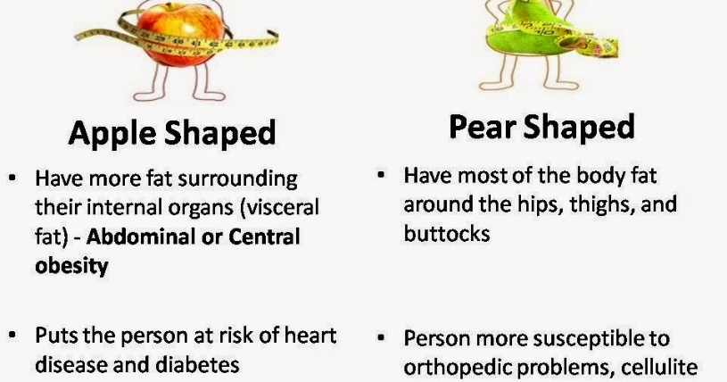

Waist to Height Ratio

WHtR = Waist (cm) ÷ Height (cm)
Males | Verbal Rating | Females
Under .35 | Abnormally Thin | Under .35
.35 – .43 | Extremely Slim | .35 – .42
.44 – .53 | Healthy | .43 - .49
.54 – .58 | Overweight | .50 - .54
.59 – .63 | Seriously Overweight | .55 – .58
Over .63 | Extremely Overweight | Over .58
CM Lee, Huxley RR, Wildman RP, Woodward M (July 2008). "Indices of abdominal obesity are better discriminators of cardiovascular risk factors than BMI: a meta-analysis'". Journal of Clinical Epidemiology. 61 (7): 646–653. doi:10.1016/j.jclinepi.2007.08.012. PMID 18359190.
The WHtR is a measure of the distribution of body fat.
Higher values of WHtR indicate higher risk of obesity-related cardiovascular diseases such as: Type 2 diabetes, high blood pressure, high cholesterol and heart disease as well as increased cancer risk and decreased life expectancy
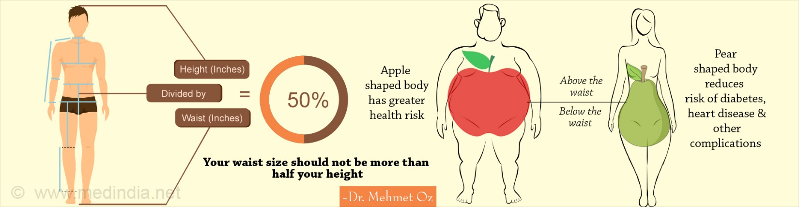

WHAT TO DO for a
Healthy Body Composition?
Balancing caloric intake and output is the key!

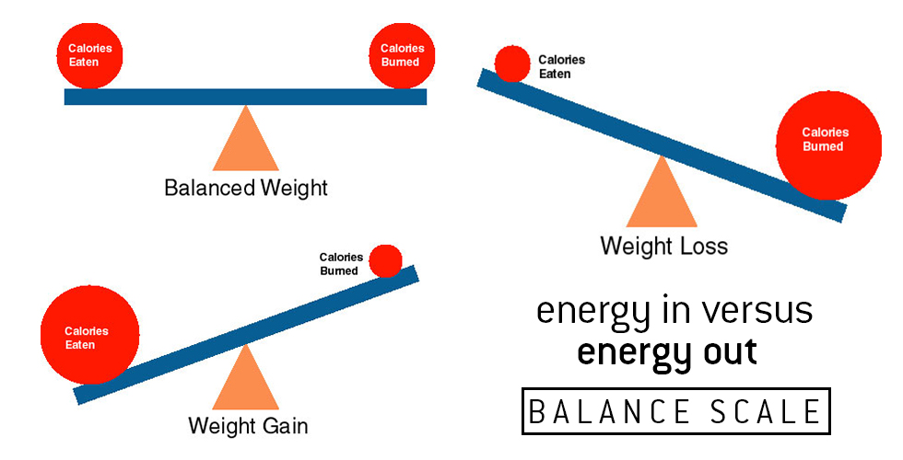
https://www.google.ca/search?client=firefox-b- ab&dcr=0&biw=1280&bih=871&tbm=isch&sa=1&ei=XwYeWtLfFIqUjwTPuaSoDg&q=calorie+intake&oq=calorie+in&gs_l=psy-ab.1.0.0l10.912653.915004.0.917780.11.11.0.0.0.0.404.1330.8j2j4-1.11.0....0...1c.1.64.psy-ab..0.11.1324...0i67k1.0.-FUZDCXZYXE#imgdii=ZoMwkQJuGIBN_M:&imgrc=8f8hmA7uPUPiyM:
Adopt Healthy Eating Habits

↑ Vegetables, fruits, lean proteins, whole grains, fiber.
↓ sugar, sugar drinks, fried foods, processed food.

Increase Physical Activity

- 30-60 minutes of daily activity (walk, move, stairs)
- Cardiovascular activity 2-3 x/week (walk, jog, bike.)
- Muscular conditioning exercises 2x /wk (push-ups, squats.)

Muscular Strength and Endurance Testing

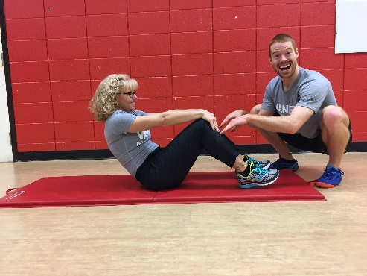
Find a partner

The Plank, Vertical Jump, Balance, Curl-Ups, Triceps Dips, Side Hops and Push-Ups Tests should be performed with a partner. The partner can ensure that proper technique is maintained and help keep count of the repetitions. It also provides a human contact element and motivation for the students.

It is important that proper technique is performed so that results from semester to semester and from teacher to teacher are as accurate as possible.

Tests done in the Palestre:
1. Wall Squat – Muscle Endurance
2. Front Plank – Muscle Endurance
3. Vertical Jump – Muscle Strength and Power
4. One Foot Balance – Balance and Coordination

Tests done in the Gym:
5. One minute Curl-Ups Test – Muscle Endurance
6. Triceps Dips – Muscle Endurance
7. Side Hop Test
8. Push-Ups – Muscle Endurance

Wall Squat
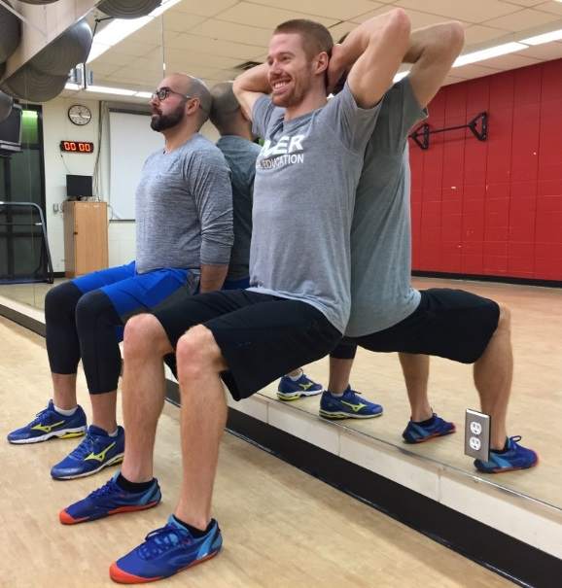
Back flat on wall - 90 ° angle at the knee - Hands on wall or behind the head
Verbal Rating for Wall Squats
 | Females | Males
Excellent | ≥ 117 sec. | ≥ 159 sec.
Above Average | 77-116 sec. | 99-158 sec.
Average | 57-76 sec. | 69-98 sec.
Below Average | ≤56 sec. | ≤68 sec.
The Wall Squat test measures the muscle endurance of the quadriceps muscles.
Poor muscular endurance signifies low levels of muscle mass, fitness and increased risk of illness, fatigue and injury risk.
To improve your muscle endurance perform muscular conditioning exercises like squats, lunges and step ups 2-3 times each week. Adding weight while performing
the exercises will increase the intensity and fitness improvement.

École de dos. Renforcer les quadriceps. Université de Québec en Abitibi-Témiscamingue..

Retrieved from: http://uriic.uqat.ca/chroniquep/03preparationphysique/

THE FRONT PLANK
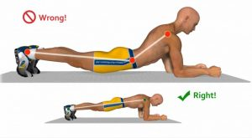 |  | 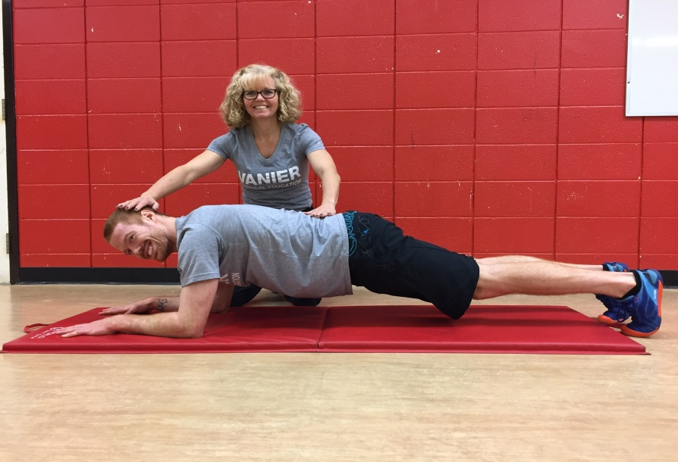
PROPER PLANK TECHNIQUE
Place elbows directly under shoulders – Bring toes forward – Raise hips so that body is parallel to the floor – Keep head up – Keep the upper back flat, not rounded –
Keep legs contracted and together – Keep hips up as to not allow lower back to sway
As soon as the correct plank position cannot be maintained you are done.
Males | Verbal Rating |  | Females
2:21 + | Excellent |  | 2:01 +
1:45 – 2:20 | Above Average |  | 1:31‐2:00
1:34 - 1:44 | Average |  | 1:20 - 1:30
1:17 - 1:33 | Below Average |  | 1:03 ‐ 1:19
< 1:17 | Poor |  | <1:03
The plank test measures the strength, endurance and stability of the trunk / core. Maintaining a strong core is a very important component of muscular fitness.

Performing the plank exercise 2-4 times each week for
(30-90 seconds) will help improve posture, decrease back injury, tighten the abdominal musculature, improve balance and athletic performance.

Source: Strand, S. L., Hjelm, J., Shoepe, T. C., & Fajardo, M. A. (2014). Norms for an
Isometric Muscle Endurance Test. Journal of Human Kinetics, 40, 93–102. http://doi.org/10.2478/hukin-2014-0011 (new Norms for 2018)
Vertical Jump - MUSCLE POWER TEST
- In this test you need to first mark off your standing height with one arm extended overhead.
- You will then jump as high as you can in one explosive motion and mark off your vertical jump distance with a piece of chalk.
- You make take one step and then jump.
- Calculate the difference between your standing height and the maximum jump height that you reached.
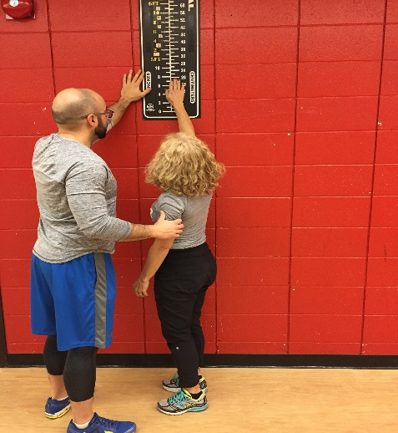 | 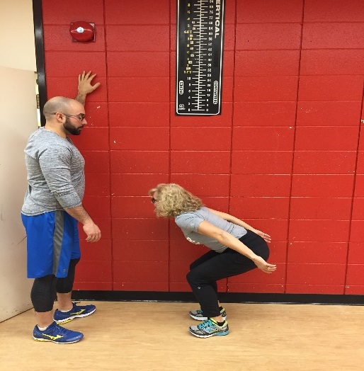 | 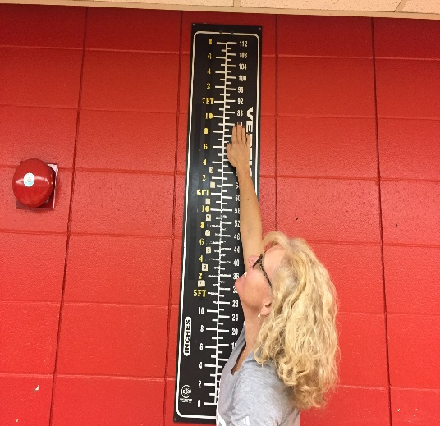

THE VERTICAL JUMP
Males | Verbal Rating | Females
> 65  61 – 64  48 – 60  40 – 47  24 – 39  12 – 24  < 11 | Superior  Excellent  Above Average  Average  Below Average  Poor  Very Poor | > 42  38 – 41  35 – 37  25- 34  17 -24  7 – 16  < 6
The vertical jump is a measurement of leg strength and power.
It measures how much force your leg muscles can create in a single contraction.
The higher you can jump, the stronger and more powerful your legs.
To improve muscle strength it is necessary to do weight training exercises, sprinting, jumping and other plyometric exercise will also help.
If weight training try to train each muscle 2-3 days each week and use heavier weights which will force you to reach muscular fatigue within 5-12 repetitions. Perform 3-5 sets.

Modified from: Lawrence, Arthur Golding, Myers, Clayton R., Sinning, Wayne E. (1986) Y's way to physical fitness: the complete guide to fitness testing and instruction. Champaign, IL: Published for YMCA of the USA by Human Kinetics Publishers.
Test # 4: Standing Balance Test - Balance and Coordination

Standing Balance
- Place your hands on your hips  - Lift your foot and place it on the inside of your right leg (knee height)  - Close your eyes and hold the position for as long as you can.  - The test is over when you left foot touches the floor.  - Complete on the right and then the left leg. | 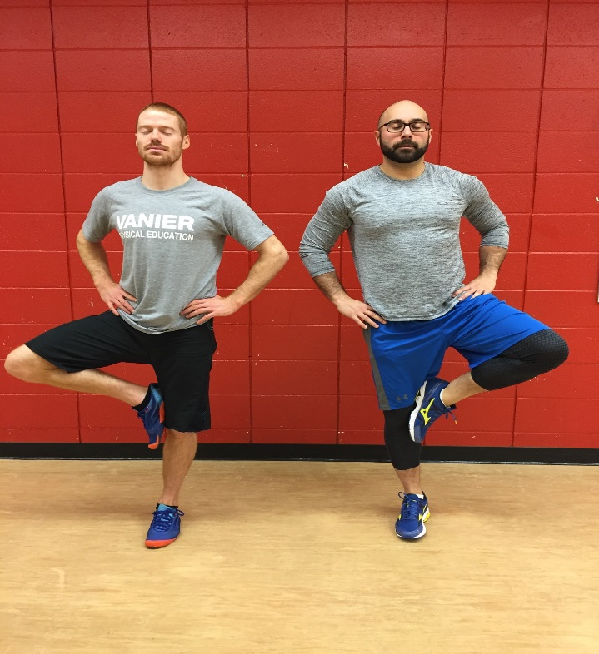

Record how long you can stay in the position.

NORMS for Standing Balance
 | Females | Males
Excellent | ≥ 27 sec. | ≥ 31 sec.
Above Average | 24-26 sec. | 27 – 30 sec.
Average | 18-23 sec. | 21-26 sec.
Below Average | 15-17 sec. | 17-20 sec.
Poor | ≤14 sec. | ≤16 sec.

Richard Chevalier, Richard. À vos marques, prêts, santé! (2010). Saint-Laurent, Québec: ERPI

1 Minute CURL-UPS
Muscle Strength and Endurance
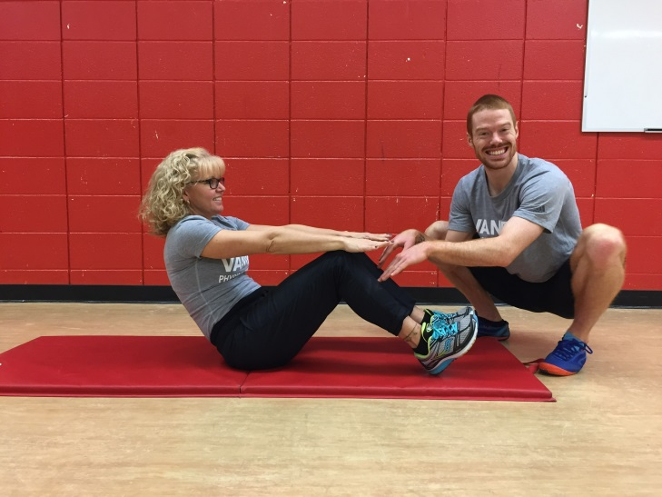 | Have a partner count  and check technique.  - Start with your feet flat on the floor with your knees bent at 90°.  - Your hands are resting on your thighs.  - Curl-Up high enough so that your wrist meets the top of your knees. Your fingers will be touching the top of your shin. If you do not go high enough – do not count it!  - Do not bounce, raise your legs or rock on your back.  - When or if you cannot reach the tops of your knees, you are done.  - Have your partner count how many “PROPER” curl-ups you can do in one minute.

VERBAL RATING
1 minute CURL-UPS test
Age | 16 – 25 |  | 26 - 35 |  | 36 – 45 |  | 46 – 55 |  | 56 – 65
Gender | M | F | M | F | M | F | M | F | M | F
Excellent | > 49 | > 43 | > 45 | > 39 | > 41 | > 33 | > 35 | > 27 | > 31 | > 24
Very Good | 44 - 49 | 37 - 43 | 40 - 45 | 33 - 39 | 35 - 41 | 27 - 33 | 29 - 35 | 22 - 27 | 25 - 31 | 18 – 24
Above Avg. | 39 - 43 | 33 - 36 | 35 - 39 | 29 - 32 | 30 - 34 | 23 - 26 | 25 – 28 | 18 - 21 | 21 - 24 | 13 – 17
Average | 35 - 38 | 29 - 32 | 31 - 34 | 25 - 28 | 27 - 29 | 19 - 22 | 22 - 24 | 14 - 17 | 17 - 20 | 10 – 12
Below Avg. | 31 - 34 | 25 - 28 | 29 - 30 | 21 - 24 | 23 - 26 | 15 - 18 | 18 - 21 | 10 – 13 | 13 - 16 | 7 – 9
Poor | 25 - 30 | 18 - 24 | 22 - 28 | 13 - 20 | 17 - 22 | 7 - 14 | 13 - 17 | 5 – 9 | 9 - 12 | 3 – 6
Very Poor | < 25 | < 18 | < 22 | < 20 | < 17 | < 7 | < 9 | < 5 | < 9 | < 3
The Curl-ups test is a measurement of the muscular endurance of your abdominal muscles. Poor abdominal strength and endurance is associated with low muscle mass, poor posture and lower back injury risk. By performing abdominal exercises like curl-ups, the plank and leg raises 2-3 x/week you will experience rapid improvements in your muscular fitness level. Once you can perform 25-30 repetitions of an abdominal exercise you are ready to select a harder exercise.

Lawrence, Arthur Golding, Myers, Clayton R., Sinning, Wayne E.

Y's way to physical fitness - the complete guide to fitness testing and instruction, (1986) p. 117

Triceps Chair Dips
Muscle Strength and Endurance
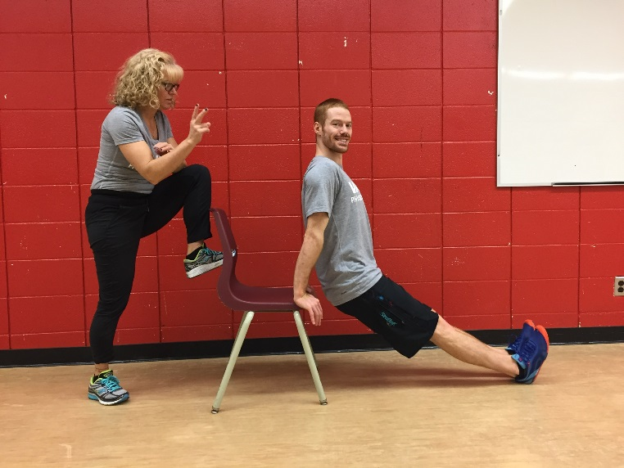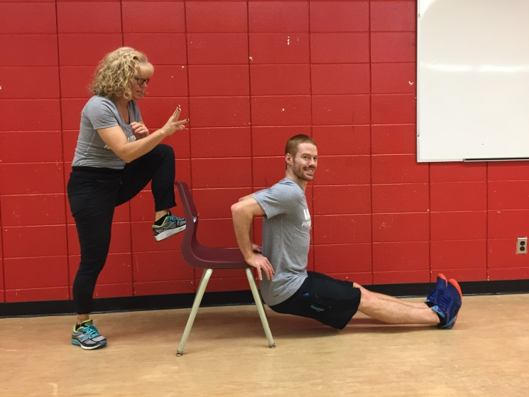
This test is designed to measure the muscle endurance of your upper arms (triceps and shoulders).
How many chair dips can you do?

- Sit on a bench with your palms on the bench – thumbs pointing in
- Straighten your legs out in front of you and then move your bum off the bench (no more than 2 inches away from the bench).
- Bend your elbows towards the back and you are doing a chair dip.
- Lower down until you reach 90º at your elbow and then push yourself back up.
- Do as many as you can without stopping and record your results.

To improve your triceps dips score try completing triceps dips 2-3 times each week.
You can easily do this exercise at home. If you find them too difficult with your legs straight, you can decrease the intensity by bending your knees. Within no time you will build up the strength and endurance in your upper arms and you will see your numbers increase.

VANIER NORMS FOR CHAIR-DIPS
Verbal Rating | Females | Males
Excellent | 40 + | 60 +
Above Average | 30 – 39 | 45 – 59
Average | 20 – 29 | 30 – 44
Below Average | 10 – 19 | 15 – 29
Poor | 0 – 9 | 0 – 14

1 minute – Side Hops Test
This test is designed to measure muscle agility, coordination and endurance.
How to:
Start on a line (center)
Hop right – center – left – center = 1 cycle

Have your partner count how many cycles you can do in one minute.

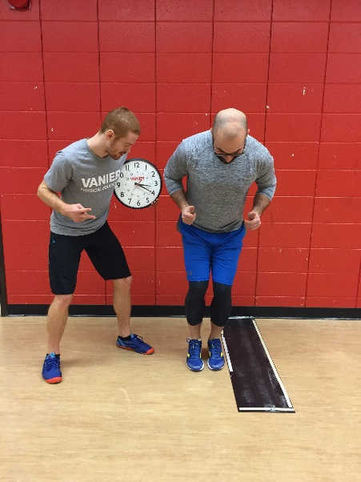 | 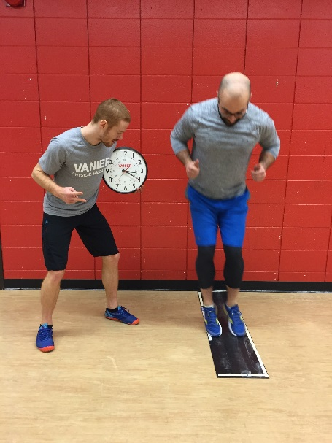 | 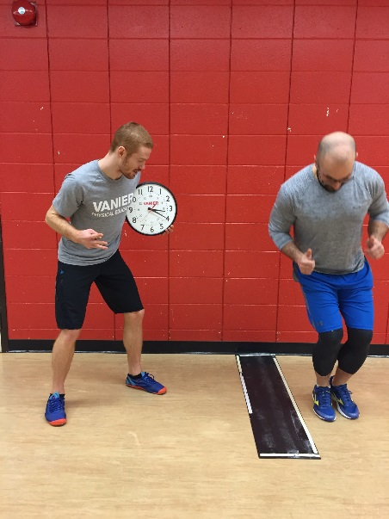

VANIER NORMS FOR SIDE HOPS
 | Females | Males
Excellent | ≥ 46 | ≥ 50
Above Average | 42-45 | 46-49
Average | 38-41 | 42-45
Below Average | 34-37 | 38-41
Poor | ≤ 33 | ≤ 37

Push-Ups - Muscle Strength and Endurance

Verbal Rating for Men
Full Push-Ups - Chest must touch the yoga block
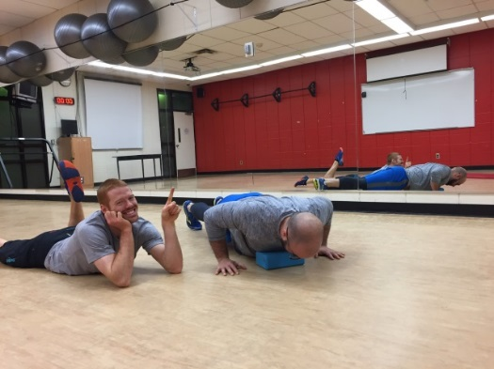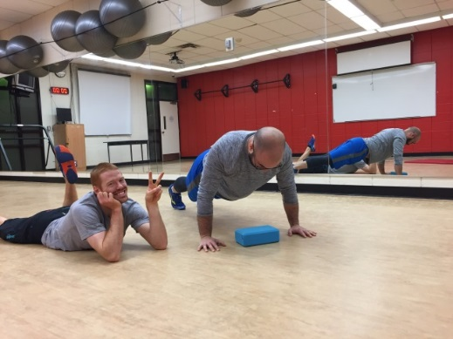
Age | 17-19 |  | 20-29 |  | 30-39 |  | 40-49 |  | 50-59 |  | 60-65
Excellent | > 56 |  | > 47 |  | > 41 |  | > 34 |  | > 31 |  | > 30
Good | 47-56 |  | 39-47 |  | 34-41 |  | 28-34 |  | 25-31 |  | 24-30
Above average | 35-46 |  | 30-39 |  | 25-33 |  | 21-28 |  | 18-24 |  | 17-23
Average | 19-34 |  | 17-29 |  | 13-24 |  | 11-20 |  | 9-17 |  | 6-16
Below average | 11-18 |  | 10-16 |  | 8-12 |  | 6-10 |  | 5-8 |  | 3-5
Poor | 4-10 |  | 4-9 |  | 2-7 |  | 1-5 |  | 1-4 |  | 1-2
Very Poor | < 4 |  | < 4 |  | < 2 |  | 0 |  | 0 |  | 0
Modified Push-Ups - Verbal Rating for Women
Modified Push-Ups (knees) - Chest must touch the yoga block
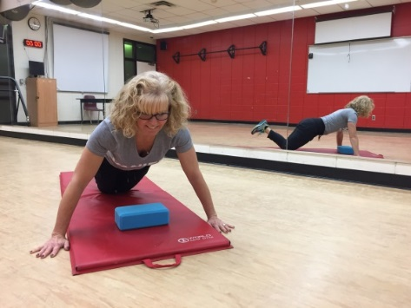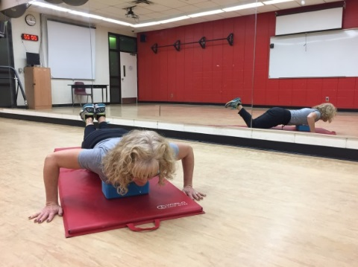
Age | 17-19 | 20-29 |  | 30-39 |  | 40-49 |  | 50-59 |  | 60-65
Excellent | > 35 | > 36 |  | > 37 |  | > 31 |  | > 25 |  | > 23
Good | 27-35 | 30-36 |  | 30-37 |  | 25-31 |  | 21-25 |  | 19-23
Above average | 21-27 | 23-29 |  | 22-30 |  | 18-24 |  | 15-20 |  | 13-18
Average | 11-20 | 12-22 |  | 10-21 |  | 8-17 |  | 7-14 |  | 5-12
Below average | 6-10 | 7-11 |  | 5-9 |  | 4-7 |  | 3-6 |  | 2-4
Poor | 2-5 | 2-6 |  | 1-4 |  | 1-3 |  | 1-2 |  | 1
Very Poor | 0-1 | 0-1 |  | 0 |  | 0 |  | 0 |  | 0
Source: Y’s Way to Physical Fitness: The Complete Guide to Fitness Testing and Instruction (3rd Edition) by Lawrence Golding and Clayton Myers.

Males and Females
If you have Verbal Ratings of Above Average or Higher

TRY

John Sifferman’s
Totally Unofficial Push-Up Test Standards
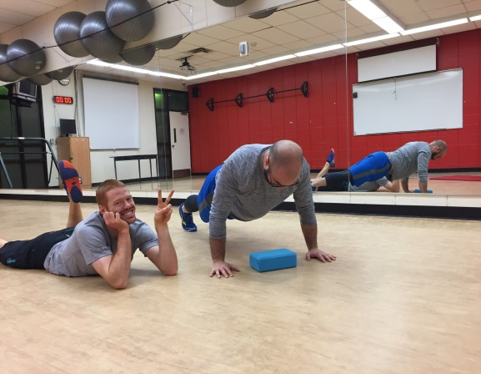 | Keep Body Straight  Keep head aligned  Keep your belly up  Bend at your elbows  Complete full Range  Breathe  Don’t Give Up  You got This! | 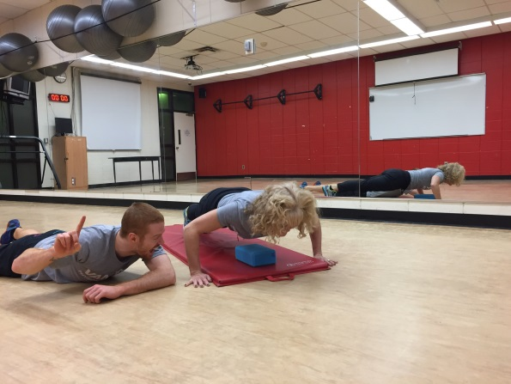
Males | Verbal Rating | Females
1 – 10 | Newbie | 1 – 7
11-20 | Beginner | 8 – 13
21- 40 | Intermediate | 14 – 27
41 - 60 | Advanced | 28 – 40
61 - 90 | Expert | 41 – 60
91 - 120 | Master | 61 – 80
121 - 140 | Wicked Sick | 81 – 93
141 - 160 | Super Human | 94 – 107
161 - 180 | Olympian | 108 – 120
181 + | Immortal | 121 +
Source: http://physicalliving.com

Push-Up Result Considerations

- If you are below average or poor, you are demonstrating poor muscular strength in the chest and shoulders.

- The best way to improve your muscle endurance is to improve your strength in the chest, triceps and shoulder muscles. By doing as many push-ups as you can 2-3 days each week and you will start to see your strength and endurance increase.

- If you are unable to do a proper Push-Up, do modified push-ups until you can perform up to 20-25 repetitions.

- Once you can complete 20-25 reps easily, start adding full Push-ups.

- If you are unable to do a proper Modified Push-Up you can elevate your upper body on a bench or step and it will be easier. Once you can manage that, progress to the regular modified push-up and eventually you will be doing full push-ups.

- Females who score above average or higher on the Modified Push-Ups test should be using full push-ups in their workouts.

Cooper 12 Minute Run
This test is a measurement of your cardiovascular endurance level. Your cardiovascular fitness level is one of the most important components of fitness and health.
Benefits of Good Cardiovascular Endurance
↓ risk of Heart attacks and strokes  ↓ risk of having high blood pressure  ↓ risk of having type 2 diabetes  ↓ risk of anxiety and depression | ↓ risk of obesity and related illnesses  ↑ lifespan  ↑ energy levels  ↑ concentration and focus
So what are you waiting for?
Start walking, jogging, biking swimming, dancing, playing
15-30 minutes / 3-5 days a week is all you need!

The goal of the test is to cover as much distance as you can in a 12 minute period.
Before you begin the test it is recommended to warm-up your muscles and increase your heart rate. This will prevent muscle soreness and cramping and will also help you to improve your performance in the test. Walk briskly for 3-5 minutes and do some light stretching before starting the test.
Count the # of laps that you can complete in 12 minutes.
You can count ½ laps so do not stop until the buzzer goes off.
Pace yourself throughout the test – try and maintain a comfortable running pace throughout the test

12 Minute Run

DISTANCE CALCULATION for the Main Gym - 1 lap = 160m
# Laps | Distance | # Laps | Distance
1 | 160 | 14 | 2240
2 | 320 | 15 | 2400
3 | 480 | 16 | 2560
4 | 640 | 17 | 2720
5 | 800 | 18 | 2880
6 | 960 | 19 | 3040
7 | 1120 | 20 | 3200
8 | 1280 | 21 | 3360
9 | 1440 | 22 | 3520
10 | 1600 | 23 | 3680
11 | 1760 | 24 | 3840
12 | 1920 | 25 | 4000
13 | 2080

DISTANCE CALCULATION for the Upstairs Hallway
1 lap = 100m

12 Minute Run - VERBAL RATING – MALES
The distance (in meters) completed in 12 minutes
Verbal Rating | Under 30  years | 30-39  years | 40-49  years | 50-59  years
Excellent | 2,800 + | 2,640 + | 2,480 + | 2,400 +
Above Average | 2,400- 2,799 | 2,240- 2,639 | 2,080 – 2,479 | 2,090 – 2,399
Average | 2,000- 2,399 | 1,840 – 2,239 | 1,680 – 2,079 | 1,600 – 2,089
Below Average | 1,600- 1,999 | 1,520 – 1,839 | 1,360 – 1,679 | 1,280 – 1,599
Poor | < 1,600 | < 1,520 | < 1,360 | < 1,280

12 Minute Run - VERBAL RATING – FEMALES
The distance (in meters) completed in 12 minutes
Verbal Rating | Under 30  Years | 30-39  years | 40-49  years | 50-59  years
Excellent | 2,640 + | 2,320 + | 2,320 + | 2,160 +
Above Average | 2,160– 2,639 | 2,000- 2,319 | 1,840 – 2,319 | 1,680 – 2,159
Average | 1,840- 2,159 | 1,680 – 1,999 | 1,520 – 1,839 | 1,360 – 1,679
Below Average | 1,520- 1,839 | 1,360 – 1,679 | 1,200 – 1,519 | 1,040 – 1,360
Poor | < 1,520 | < 1,360 | < 1,200 | < 1,040

Sit and Reach
The sit and Reach test measures the flexibility of the  Hamstrings and Lower Back.  Poor flexibility can lead to injury, muscle stiffness, pain headaches and poor posture. | 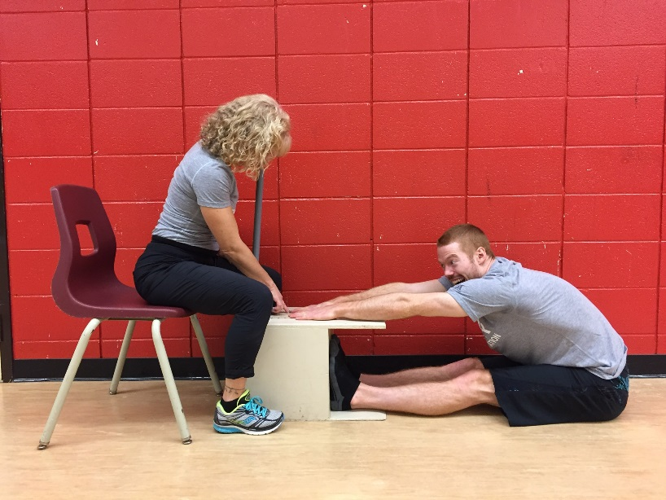
How to:
- Remove shoes.
- Sit on the floor and place the soles of your feet flat against the box.
- Both knees should be locked and pressed flat to the floor (DO NOT BEND YOUR KNEES)
- With the palms facing downwards, reach forward along the measuring line as far as possible.
- Hands must remain at the same level, not one reaching further forward than the other.
- Hold the stretch for (no bouncing or jerking)
- Record the distance.

NORMS FOR SIT AND REACH – TRUNK FLEXIBILITY
Age | 17 -19 |  | 20 - 29 |  | 30 – 39 |  | 40 -49 |  | 50 - 59
Gender | M | F | M | F | M | F | M | F | M | F
Excellent  Above Avg.  Average  Below Avg.  Poor | ≥ 41  30-40  19-29  8-18  ≤ 7 | ≥ 40  30-39  21-29  12-20  ≤ 11 | ≥ 37  29-37  18-28  8-17  ≤ 7 | ≥ 40  30-39  20-29  10-19  ≤ 9 | ≥ 38  27-37  17-26  6-16  ≤ 5 | ≥ 40  29-39  19-28  9-18  ≤ 8 | ≥ 36  25-35  15-24  4-14  ≤ 3 | ≥ 39  29-38  18-28  7-17  ≤ 6 | ≥ 35  25-34  12-24  1-11  ≤ 0 | ≥ 38  28-37  17-27  8-16  ≤ 7

