RESTING HEART RATE
VERBAL RATING
- Your resting heart Rate must be taken first thing in the morning before getting out of bed.  - Count your pulse for 30 seconds and then multiply by 2.  - Take your heart rate at the radial or carotid pulse sites. |  |  | 
Males
Age | 16-25 | 26-35 |  | 36-45 | 46-55 | 56-65 | 65 +
Athlete | 49-55 | 49-54 |  | 50-56 | 50-57 | 51-56 | 50-55
Excellent | 56-61 | 55-61 |  | 57-62 | 58-63 | 57-61 | 56-61
Good | 62-65 | 62-65 |  | 63-66 | 64-67 | 62-67 | 62-65
Above Average | 66-69 | 66-70 |  | 67-70 | 68-71 | 68-71 | 66-69
Average | 70-73 | 71-74 |  | 71-75 | 72-76 | 72-75 | 70-73
Below Average | 74-81 | 75-81 |  | 76-82 | 77-83 | 76-81 | 74-79
Poor | 82 + | 82 + |  | 83 + | 84 + | 82 + | 8- +
Females
Age | 16-25 | 26-35 |  | 36-45 | 46-55 | 56-65 | 65 +
Athlete | 54-60 | 54-59 |  | 54-59 | 54-60 | 54-59 | 54-59
Excellent | 61-65 | 60-64 |  | 60-64 | 61-65 | 60-64 | 60-64
Good | 66-69 | 65-68 |  | 65-69 | 66-69 | 65-68 | 65-68
Above Average | 70-73 | 69-72 |  | 70-73 | 70-73 | 69-73 | 69-72
Average | 74-78 | 73-76 |  | 74-78 | 74-77 | 74-77 | 73-76
Below Average | 79-84 | 77-82 |  | 79-84 | 78-83 | 78-83 | 77-83
Poor | 85 + | 83 + |  | 85 + | 84 + | 84 + | 84 +
- A desirable Resting Heart Rate is between 60-70 beats/min.
- Monitoring Resting Heart rate as with blood pressure and cholesterol levels can help identify possible cardiovascular health risks.
- High resting heart readings of > 80 bpm have been linked to high blood pressure, high body weight, and higher levels of blood fat and increased risks of premature death.
- A lower resting heart rate can be associated with a higher level of physical fitness and lower risk of heart attack.
- Low RHR can also be due to aging electrical nodes of the heart may cause occasional dizziness or fatigue.
Source: http://www.carlbtaylor.com
Body Mass Index
Height / Weight Analysis
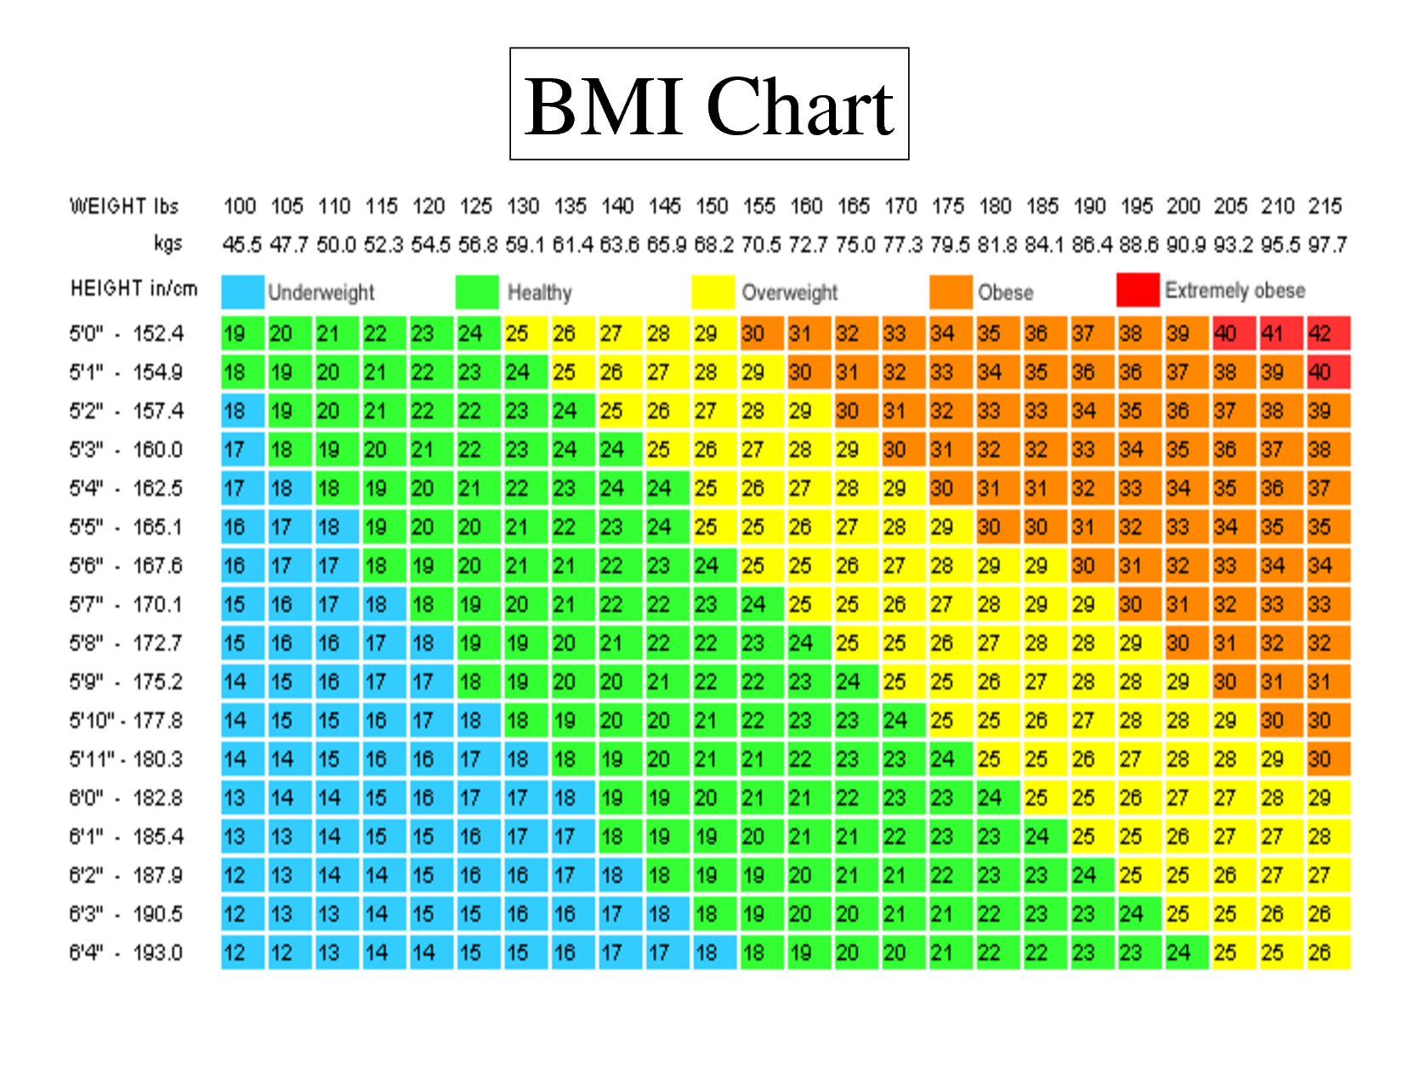
NHLBI OBESITY EDUCATION INITIATIVE. NATIONAL INSTITUTES OF HEALTH, 1998.

To find your HEALTHY WEIGHT RANGE result,
find the weight (on the top) of the chart that corresponds with
the first and last BMI numbers in the green zone for your height.

BODY MASS INDEX
VERBAL RATING
Important Considerations:

The BMI is just a general scale that should only be as a guide
and should always be used in combination
with the other Body Composition tests.

The BMI test does not take into account activity level, muscle mass, gender or body type so it cannot accurately determine body fat %.

The BMI test does not take into account location of fat stores so it is not always an accurate evaluation of health risk.

It is very important to take into account your fitness level, body shape and location of body fat to determine your health risk.

Less than 18.5  Underweight | 18.5 - 25  Healthy Weight | 26 - 30  Overweight | 31 - 40 High Risk | More than 40 Extremely High Risk
May be associated with health problems for some people.  It may be a good idea to consult a dietician and/or physician for advice. | This range is associated with the lowest risk of body composition related illness for most people.  This is the range you want to stay in –  for life! | A BMI over 25 due to high body fat levels can be associated with health problems for some people.  Corresponds to 10 % over ideal body weight. | A BMI over 30 (30 lbs. or more overweight) due to high body fat levels especially with fat storage in the abdominal area is associated with increased risk of developing health problems such as heart disease, high blood pressure and diabetes. It is recommended to evaluate your present lifestyle and consult a dietician or physician for advice.
Statement from Diabetes Canada

“Regular exercise also has special advantages if you have type 2 diabetes. It can also help prevent or delay type 2 diabetes from developing. Regular physical activity improves your body’s sensitivity to insulin and helps manage your blood glucose (sugar) levels.”

http://www.diabetes.ca/diabetes-and-you/healthy-living-resources/exercise/physical-activity-diabetes

HIGH BMI
MUSCLE OR BODY FAT ???

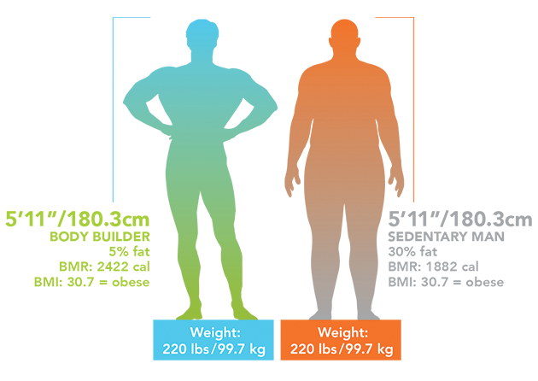
Waist to Hip Ratio
Waist ÷ Hip = Waist to Hip Ratio
The waist to hip ratio test is designed to determine where you distribute your body weight.
Do you store fat around your waist???? Apple Shape
Do you store fat around your hips???? Pear Shape / Hourglass
Do you have a rectangle shape??? Banana
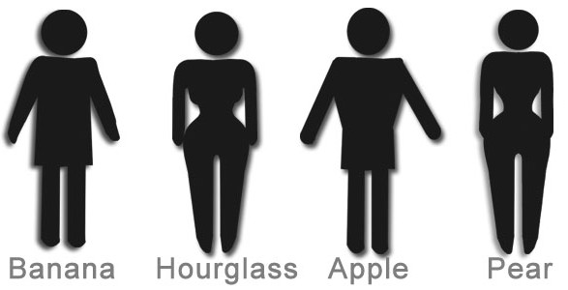
WAIST MEASUREMENT:  1. Find someone to measure your waist in centimeters  2. Measure at the smallest point of your waist. (Approximately 1 inch above the bellybutton)  3. Record results on your form under Waist to Hip Ratio. | HIP MEASUREMENT:  1. Find someone to measure your Hip in centimeters.  2. Measure at the largest point of your bottom.  3. Record results on your form under Waist to Hip Ratio.
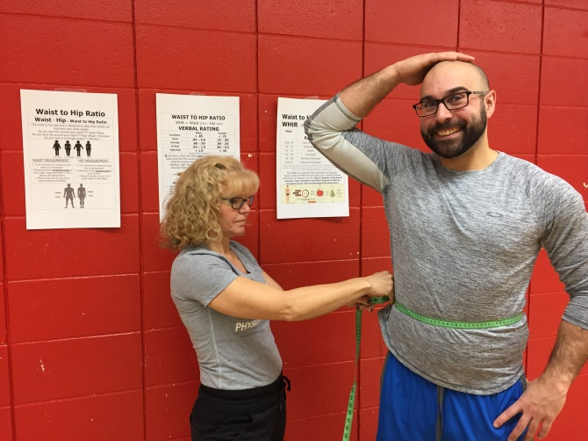 | 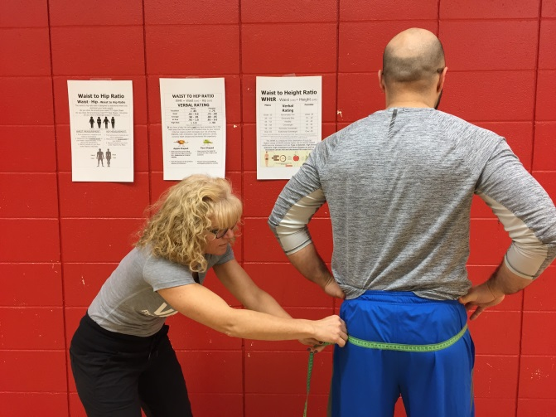

WAIST TO HIP RATIO

WHR = Waist (cm) ÷ Hip (cm)

VERBAL RATING
 | Males | Females
Excellent | < .85 | < .75
Good | .85 – 9.0 | .75 - .80
Average | .90 - .95 | .80 - .85
At Risk | .95 – 1.0 | .85 – 9.0
High Risk | > 1.0 | < .90
https://articles.mercola.com
If you have a high risk rating and you have excessive fat in the waist area then the excess fat is located close to your visceral (internal organs) which increases your risk of having:
diabetes, high cholesterol, high blood pressure, cancer,
coronary heart disease and shortened life expectancy.

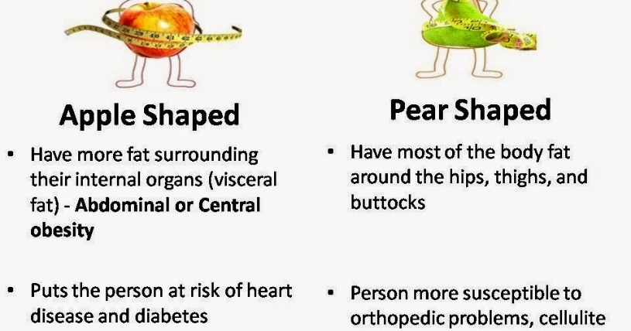

Waist to Height Ratio
WHtR = Waist (cm) ÷ Height (cm)
Males | Verbal Rating | Females
Under .35 | Abnormally Thin | Under .35
.35 – .43 | Extremely Slim | .35 – .42
.44 – .53 | Healthy | .43 - .49
.54 – .58 | Overweight | .50 - .54
.59 – .63 | Seriously Overweight | .55 – .58
Over .63 | Extremely Overweight | Over .58
CM Lee, Huxley RR, Wildman RP, Woodward M (July 2008). "Indices of abdominal obesity are better discriminators of cardiovascular risk factors than BMI: a meta-analysis'". Journal of Clinical Epidemiology. 61 (7): 646–653. doi:10.1016/j.jclinepi.2007.08.012. PMID 18359190.
The WHtR is a measure of the distribution of body fat.
Higher values of WHtR indicate higher risk of obesity-related cardiovascular diseases such as: Type 2 diabetes, high blood pressure, high cholesterol and heart disease as well as increased cancer risk and decreased life expectancy
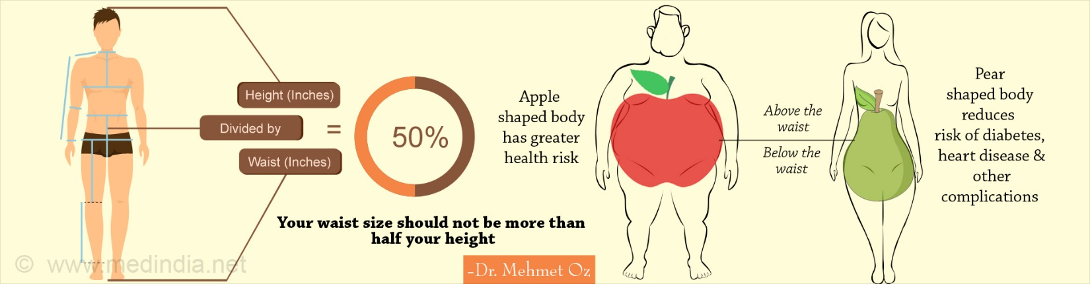

WHAT TO DO for a Healthy Body Composition?
Balancing caloric intake and output is the key!

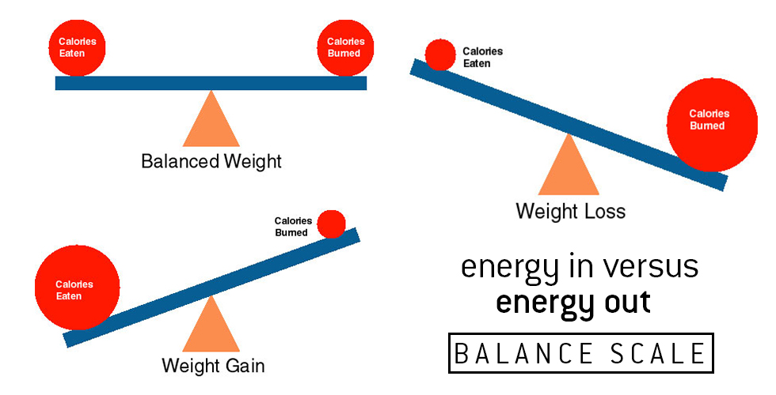
https://www.google.ca/search?client=firefox-b- ab&dcr=0&biw=1280&bih=871&tbm=isch&sa=1&ei=XwYeWtLfFIqUjwTPuaSoDg&q=calorie+intake&oq=calorie+in&gs_l=psy-ab.1.0.0l10.912653.915004.0.917780.11.11.0.0.0.0.404.1330.8j2j4-1.11.0....0...1c.1.64.psy-ab..0.11.1324...0i67k1.0.-FUZDCXZYXE#imgdii=ZoMwkQJuGIBN_M:&imgrc=8f8hmA7uPUPiyM:
Adopt Healthy Eating Habits

↑ Vegetables, fruits, lean proteins, whole grains, fiber.
↓ sugar, sugar drinks, fried foods, processed food.

Increase Physical Activity

- 30-60 minutes of daily activity (walk, move, stairs)
- Cardiovascular activity 2-3 x/week (walk, jog, bike.)
- Muscular conditioning exercises 2x /wk (push-ups, squats.)

