**PRACTICAL N0 – 4**

**Aim:** Indexing using Mongodb

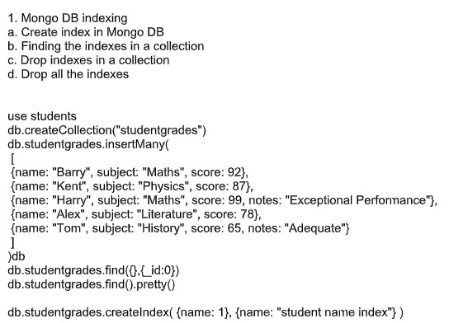

**Code:**

use students; db.createCollection("studentsgrades") db.studentgrades.insertMany(

[

{name:"Barray",subject:"Maths",score:92},

{name:"Kent",subject:"Physics",score:87},

{name:"Harry",subject:"Maths",score:99,notes:"Exceptional

Performance"},

{name:"Alex",subject:"Literature",score:78}, {name:"Tom",subject:"History",score:65,notes:"Adequate"}]); **Output:**

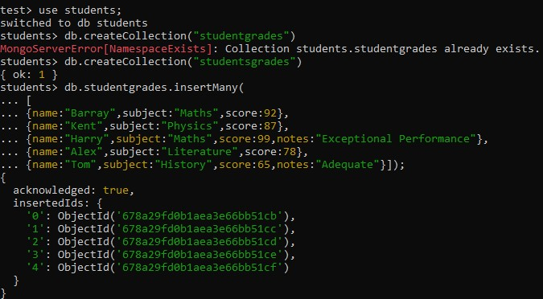

**Code:**

db.studentgrades.find({},{_id:0}); **Output:**

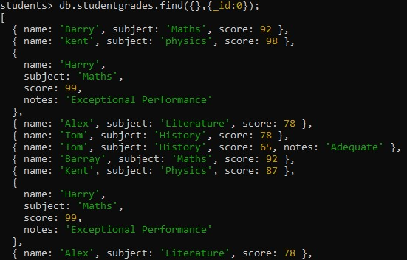

**Code:**

db.studentgrades.find().pretty(); **Output:**

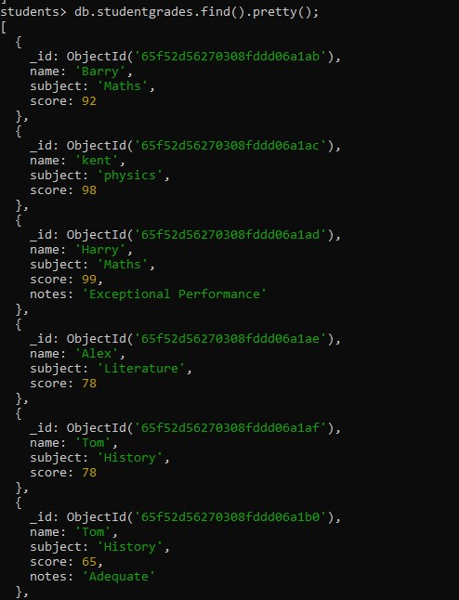

**Code:**

db.studentgrades.createIndex({name: 1},{name:"student name index"}); **Output:**



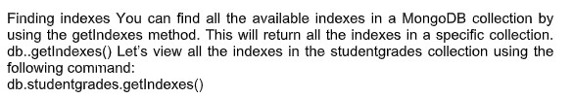

**Code:**

db.studentgrades.getIndexes(); **Output:**

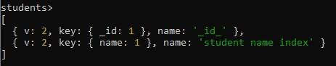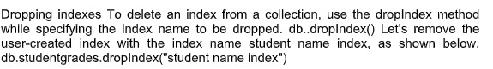

**Code:**

db.studentgrades.dropIndex("student name index"); **Output:**

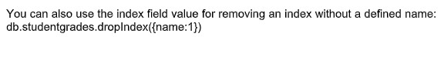

**Code:**

db.studentgrades.dropIndex({name:1});

**Output:**



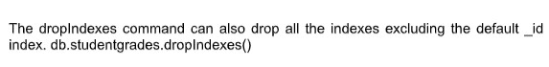

**Code:**

db.studentgrades.dropIndexes(); **Output:**

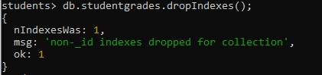

**Step 1:** Go to mongodb compass

**Step 2:** Connect to the localhost

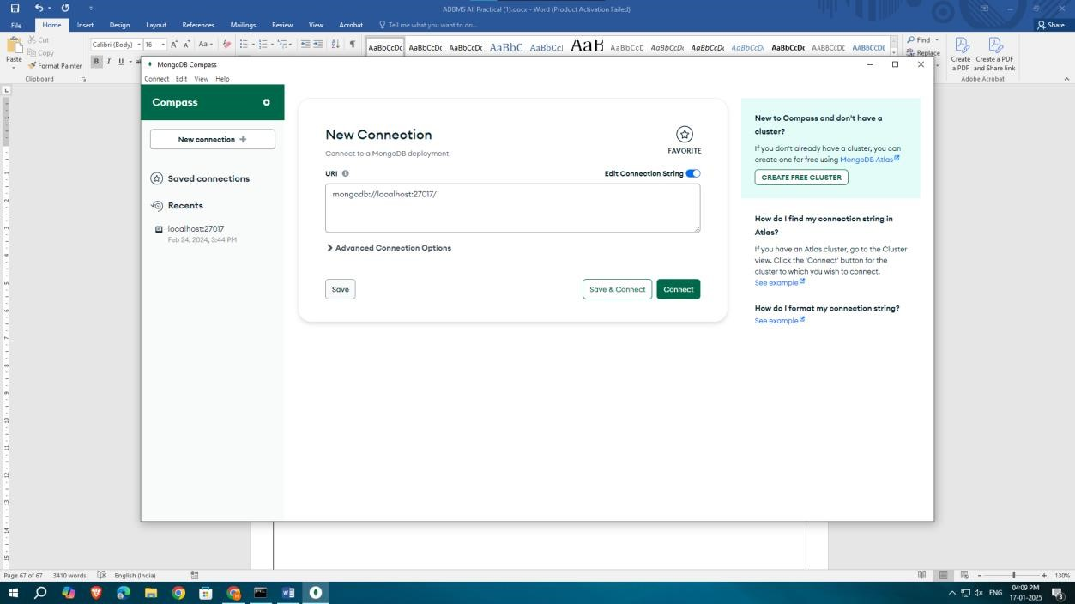

**Step 3:** Create a databases and upload airport file

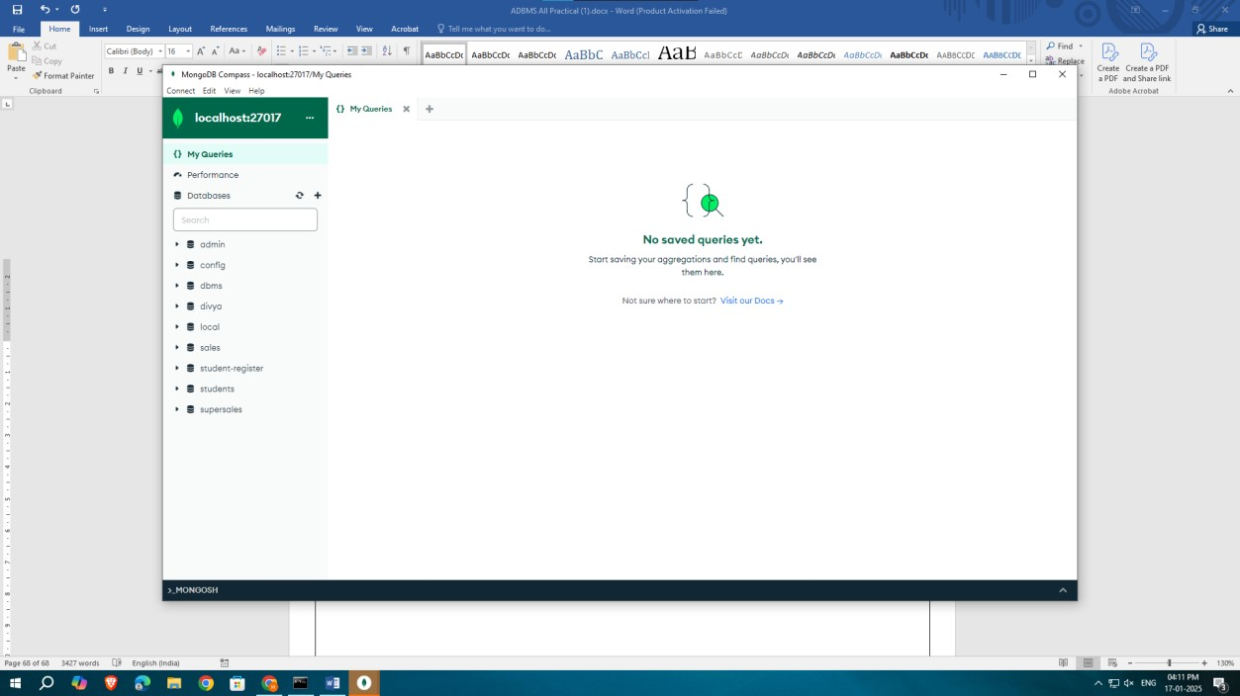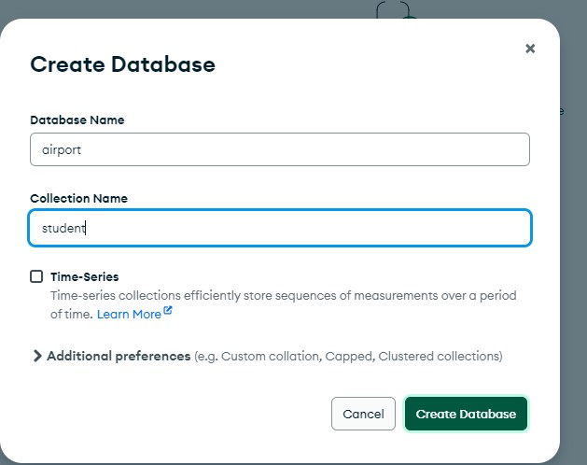

**Step 4:** Import data and click on import

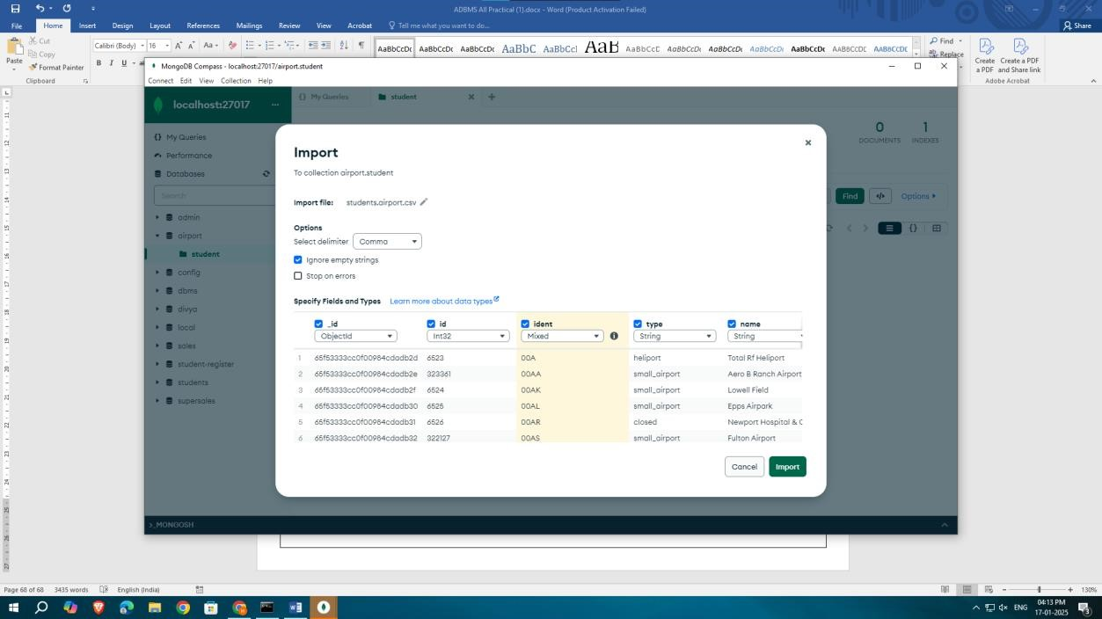

**Step 5:** Create Indexes

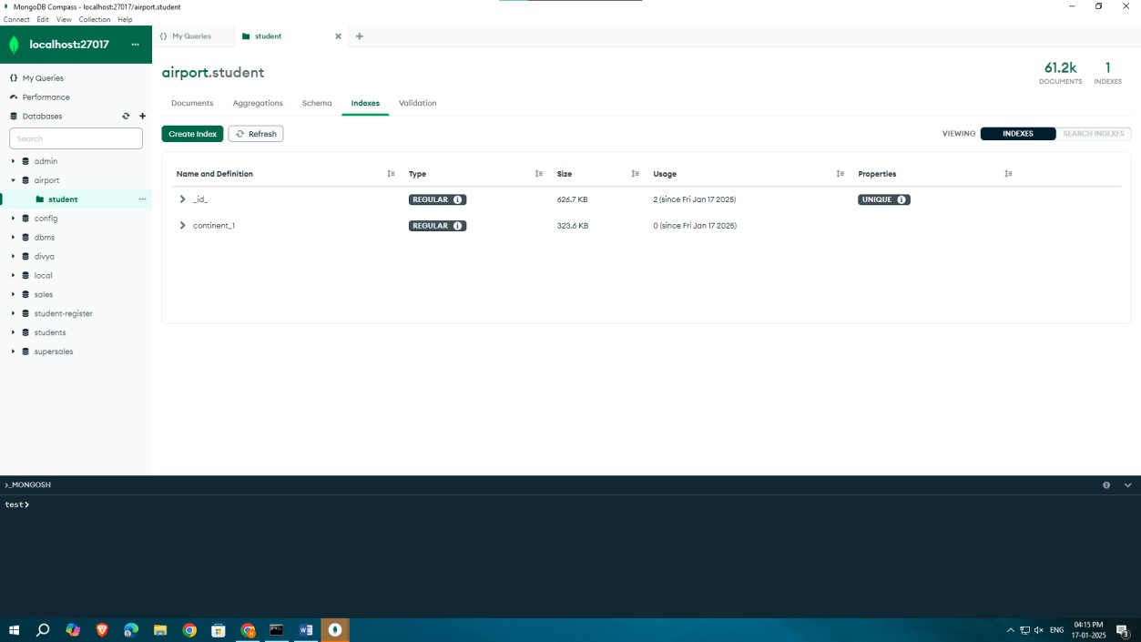

**Step 6:** Using different indexes

