Testing

### Register values can be changed and displayed

**Purpose:** Checks for successful modification of a specified register’s value.

**Configuration:** The register values are initially displayed, all with initialized value of 0x0000. Next, R0’s value is modified to 0xFFFF. The register values are then displayed again.

**Expected Results:** The first register values should all be the initialized value of 0x0000. The second displayed values should reflect the change in R0.

**Actual results:** The instructions print as expected.

### Value at specified instruction memory can be changed

**Purpose:** Checks for successful modification to instruction memory value at specified address.

**Configuration:** Display initial instruction memory values. Next, modify an instruction memory value within the displayed range. Then, display the same instruction memory values.

**Expected Results:** The second instruction memory display should show the changes.

**Actual results:** The instruction values print as expected.

**Pass/Fail:** PASS

### Value at specified memory address can be changed

**Purpose:** Checks for successful modification to data memory value at specified address.

**Configuration:** Display initial data memory values. Next, modify a data memory value within the displayed range. Then, display the same data memory values.

**Expected Results:** The second data memory display should show the changes.

**Actual results:** The data values print as expected.

**Pass/Fail:** PASS

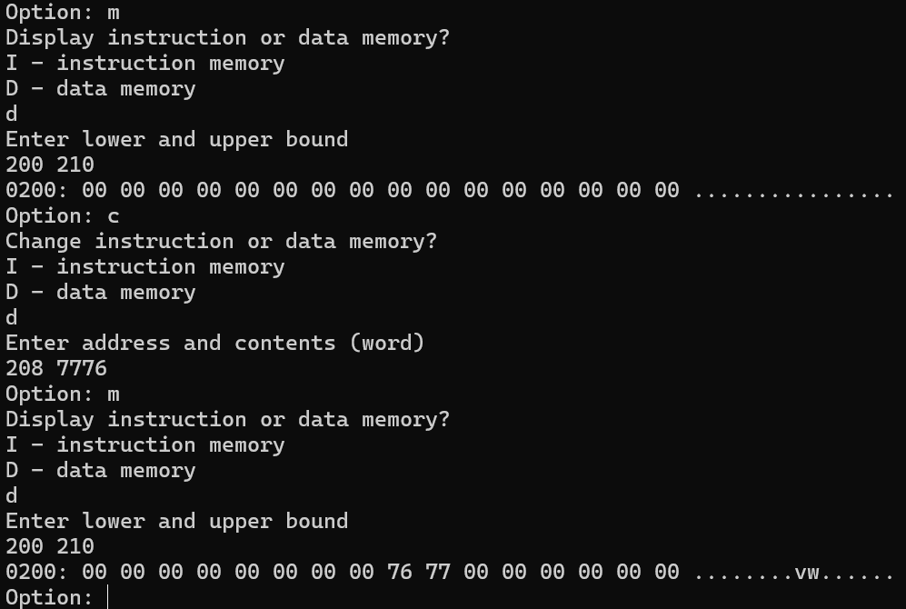

### Pipeline stops at specified breakpoint

**Purpose:** Checks for pipeline stops at specified breakpoint.

**Configuration:** Set a breakpoint within the instruction memory range of a .xme file and run the pipeline.

**Expected Results:** The pipeline will stop at the specified breakpoint.

**Actual results:** The pipeline stops as expected.

**Pass/Fail:** PASS

