# Deliverables for <Agile-Schizo/Agile-Sister/Agile-Scum/#AJEGILE>



by

**Lydia Gracia (18222035)**

# PRODUCT BACKLOG

The following table consists of product backlog items categorized by every requirement on Seleksi B Laboratorium Sistem Terdistribusi.

| **ID** | **User Story** | **Story Points** |
| --- | --- | --- |
| PB-01 | **What you're refering to as Linux, is in fact, GNU/Linux**  As Carlye, I want to install and configure Linux, so that I can better understand Linux systems and share my knowledge. | 30 |
| PB-02 | **2 nm TranSISTER**  As Carlye, I want to create a 4-bit computer simulator, so that I can better understand how a CPU works. | 7 |
| PB-03 | **Cisco 🅱️acket Tracer: Of Routers and Switches**  As Carlye, I want to design and simulate an internet network using Cisco Packet Tracer, so that I can better understand how the internet works. | 10 |
| PB-04 | **Wolfman|Sigma**  As Carlye, I want to use parallel programming APIs, so that I can better understand parallel optimization. | 12 |
| PB-05 | **McLaren Lo Warna Apa Bos?**  As Carlye, I want to develop a CLI-based chatting application that ensures data security, so that I can better understand cryptography and how data is transferred over the internet. | 17 |
| PB-06 | **monkeDB**  As Carlye, I want to configure an RDBMS, so that I can better understand replication in distributed systems. | 6 |
| PB-07 | **Carpal Tunnel Syndrome**  As Carlye, I want to set up an OpenVPN server, so that I can learn the concept of VPNs. | 8 |
| PB-08 | **Capture The Flag: CRY, REV, and PWN edition**  As Caryle, I want to retrieve the flag, so that I ~~won't be a disappointment~~ can improve my CTF skills. | 10 |
| PB-09 | **SISTER.Js**  As Carlye, I want to create a backend framework, so that I can better understand backend development. | 10 |
| PB-10 | **Jancuk Pristail**  As Caryle, I want to obtain back the flag, so that I ~~can be a hengker~~ try penetration testing. | 8 |
| PB-11 | **Benchmarking**  As Caryle, I want to benchmark various programming languages, so that I can flex 10 programming languages on my Github. | 6 |
| PB-12 | **Fotosop**  As Caryle, I want to make a program to filter images, so that I can learn about parallel systems. | 6 |
| PB-13 | **I am Dripping**  As Caryle, I want to manage a cluster with Kubernetes, so that I can better understand cloud engineering. | 3 |
| PB-14 | **Pelabuhan**  As Caryle, I want to dockerize and deploy a multi-tier web, so that I can learn about web deployment. | 3 |
| PB-15 | **BMI - Belajar Matematika Isekai (TBD)**  As Caryle, I want to solve mathematics instructions, so that I can better understand ARM architecture. | 2 |
| PB-16 | **Klak-klak-klakulator: "Help! I accidentally summoned Cthulhu!" Edition**  As Caryle, I want to create a Perl calculator, so that I can learn Perl the legacy code. | 5 |
| PB-17 | **TTKI - Tulis Tulis Karya Imajinasi**  As Caryle, I want to write the background lore for Sister courses, so that I can spread Jang Wonyoung to STEI-K peeps. | 2 |

# SPRINT 1

## Sprint Backlog

The following table consists of sprint backlog items for sprint 1.

| **ID** | **PB ID** | **Task Description** | **Definition of Done** |
| --- | --- | --- | --- |
| SB-01 | PB-01 | Installing Linux on my laptop. | Having a working Arch Linux terminal on my laptop. |
| SB-02 | PB-01 | Installing GUI for Linux. | Having a working GUI for Arch Linux installed. |
| SB-03 | PB-01 | Installing doom-ascii and ani-cli on Linux. | Able to play anime and doom-ascii on terminal. |
| SB-04 | PB-01 | Write the deliverables for Linux. | Ready draft for article. |
| SB-06 | PB-11 | Write the Strassen algorithm for matrix inverse. | Ten (10) working program for matrix inverse. |
| SB-06 | PB-03 | Make the network design for Cisco Packet Tracer. | Having a rough design for Cisco Packet Tracer. |
| SB-06 | PB-16 | Write a Perl calculator for basic functions. | Having a working Perl calculator for addition, subtraction, multiplication, and division. |

The "working products" we aim to achieve by the end of this sprint are products that have at least one sprint backlog item completed.

## 

## 

## Kanban Board

The following images are the Kanban Board for sprint 2.

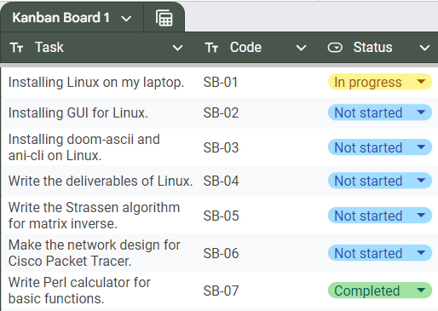

KB-01 progress 1

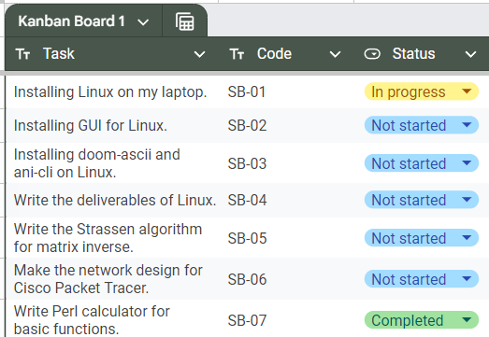

KB-01 progress 2

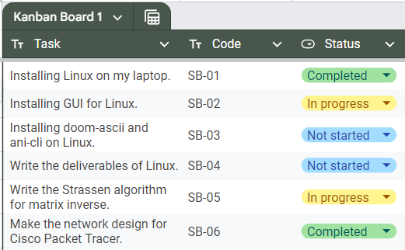

KB-01 progress 3

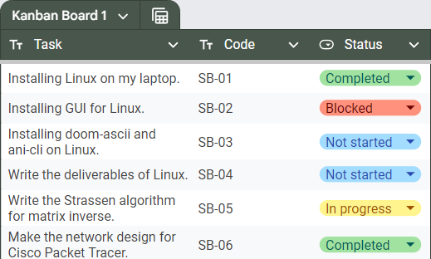

KB-01 progress 4

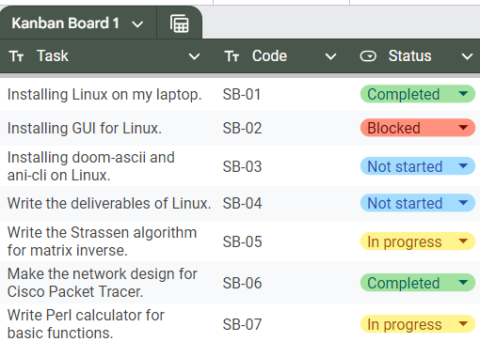

KB-01 progress 5

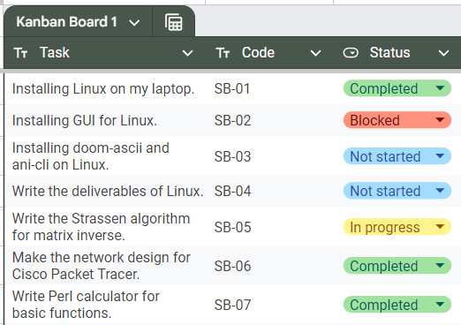

KB-01 progress 6

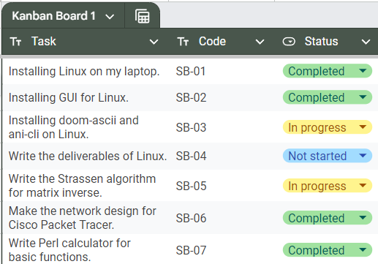

KB-01 progress 7

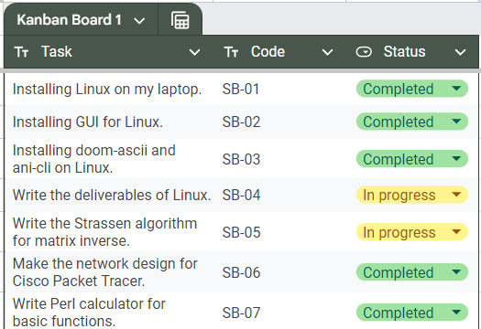

KB-01 progress 8

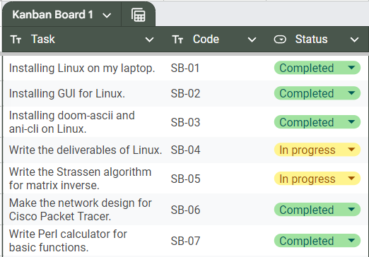

KB-01 progress 9

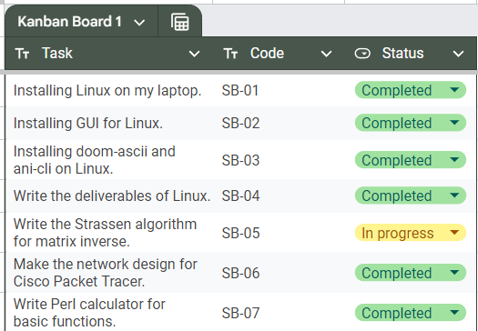

KB-01 progress 10

## 

## Burndown Chart

The following images are the Burndown Chart for sprint 1.

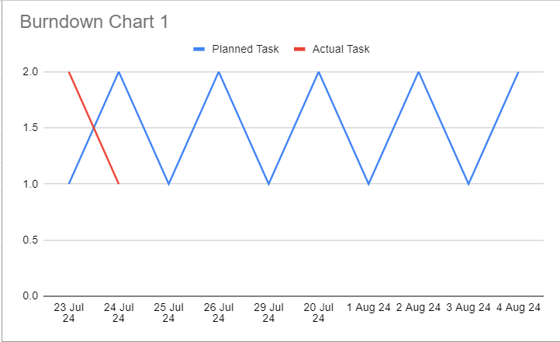

BC-01 progress 1

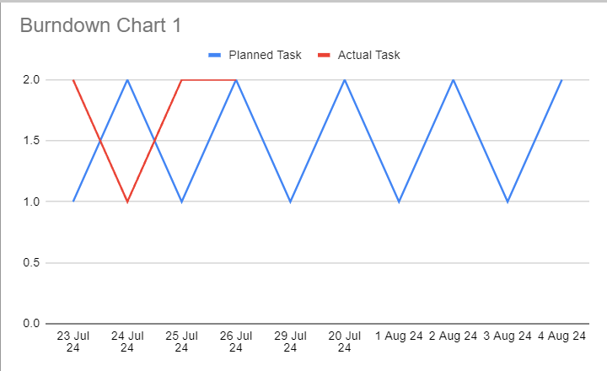

BC-01 progress 2

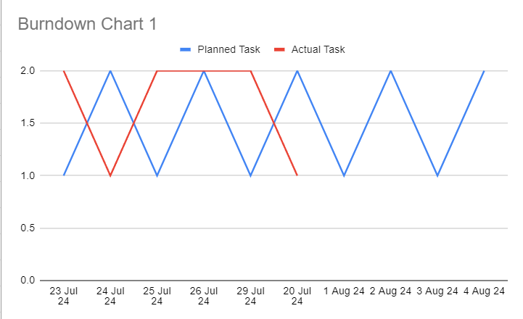

BC-01 progress 3

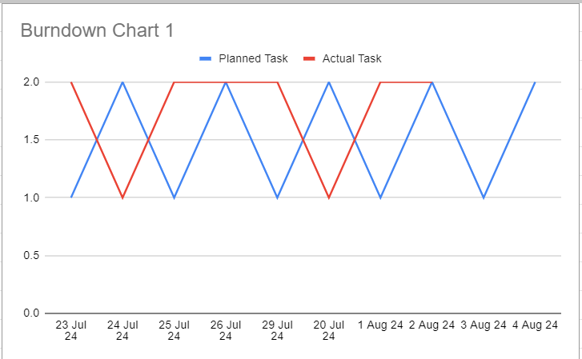

BC-01 progress 4

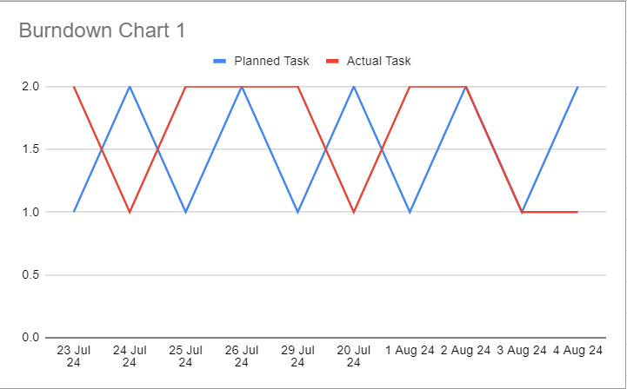

BC-01 progress 5

## Sprint Review

The following table consists of the status of the product at the end of sprint 1.

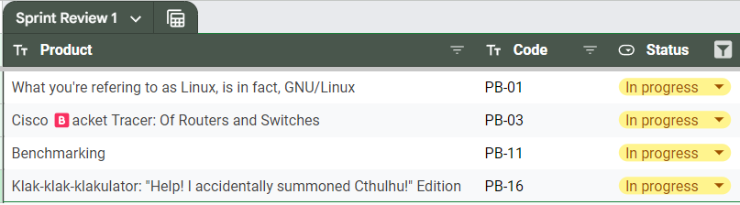

SR-01

## Sprint Retrospective

Throughout the sprint 1, we’ve progressed on several product backlog items, such as Linux, Cisco, Benchmarking, and Calculator. We’ve learned that

1. Python, Ruby, and Java implementation of Strassen inverse.
2. Gauss-Jordan algorithm might be more feasible to do.
3. Bitwise operation in Perl
4. Bonus specification of Calculator might be feasible.
5. Install Arch Linux. :)
6. Don’t rely on one tutorial or documentation to install Linux, seek for other forums whenever you’re stuck.
7. Write more deliverables.

# SPRINT 2

## Sprint Backlog

The following table consists of sprint backlog items for sprint 2.

| **ID** | **PB ID** | **Task Description** | **Definition of Done** |
| --- | --- | --- | --- |
| SB-08 | PB-08 | Solve CTF problems. | At least (3) three of the challenges are solved. |
| SB-09 | PB-03 | Implement Cisco Packet Tracer. | At least one (1) requirement is working. |
| SB-10 | PB-11 | Write the Gauss-Jordan algorithm for matrix inverse. | At least ten (10) programs are running. |
| SB-11 | PB-11 | Write the deliverables for benchmarking. | Available document, placeholder is allowed while waiting for SB-10.. |
| SB-12 | PB-16 | Write the deliverables for Perl. | Ready document. |
| SB-13 | PB-02 | Make ALU in minecraft. | Working ALU to do addition and subtraction. |

The "working products" we aim to achieve by the end of this sprint are products that have at least one sprint backlog item completed.

## Kanban Board

The following images are the Kanban Board for sprint 2.

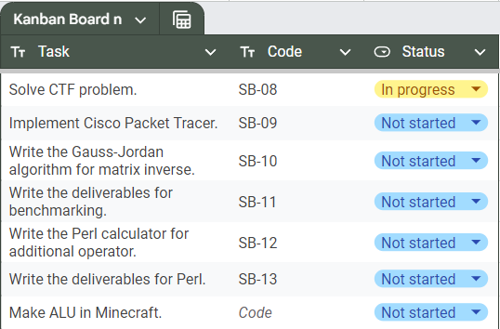

BC-02 progress 1

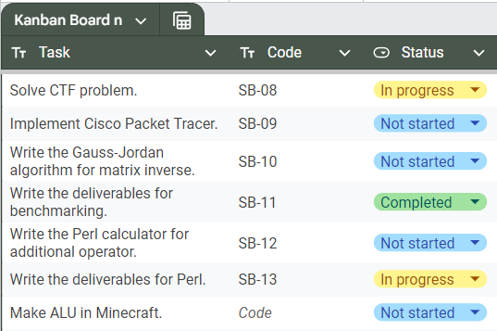

BC-02 progress 2

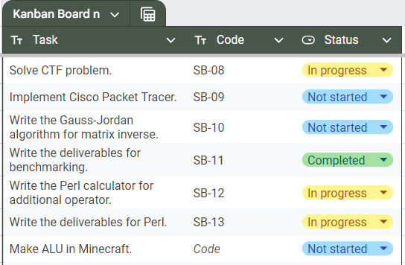

BC-02 progress 3

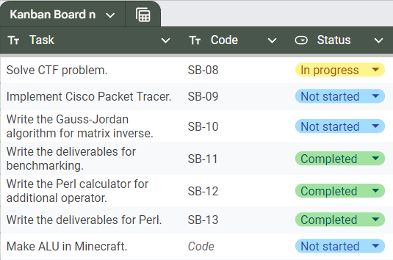

BC-02 progress 4

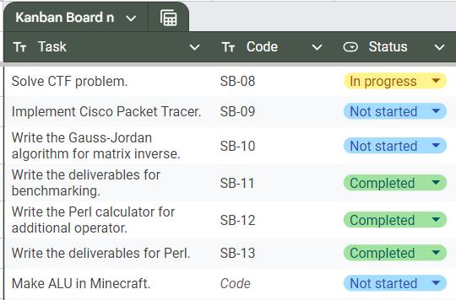

BC-02 progress 5

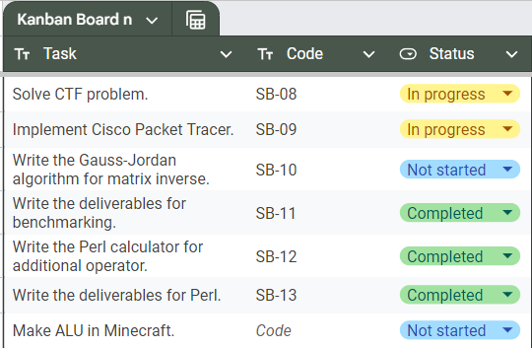

BC-02 progress 6

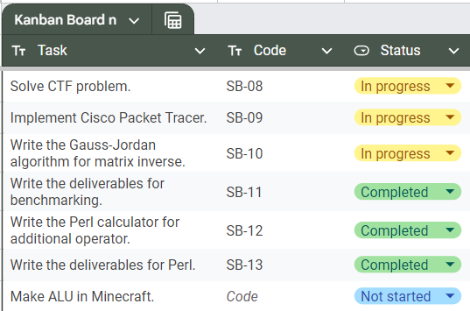

BC-02 progress 7



BC-02 progress 8

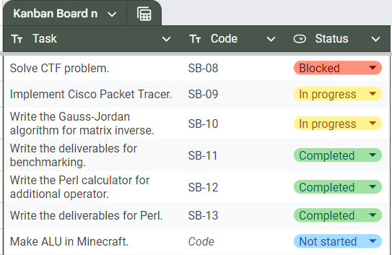

BC-02 progress 9



BC-02 progress 10

## Burndown Chart

The following images are the Burndown Chart for sprint 2.

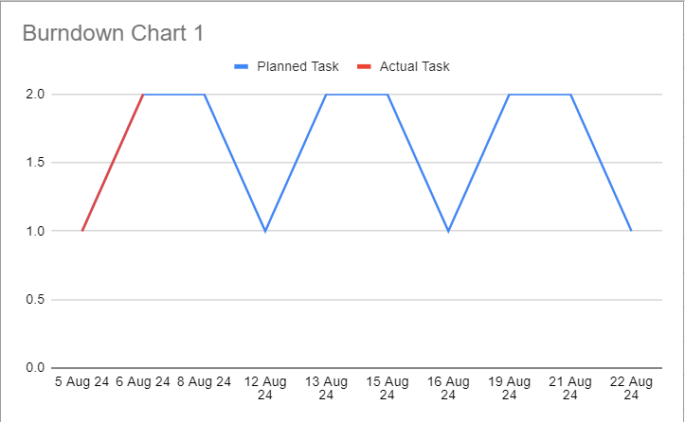

BC-02 progress 1

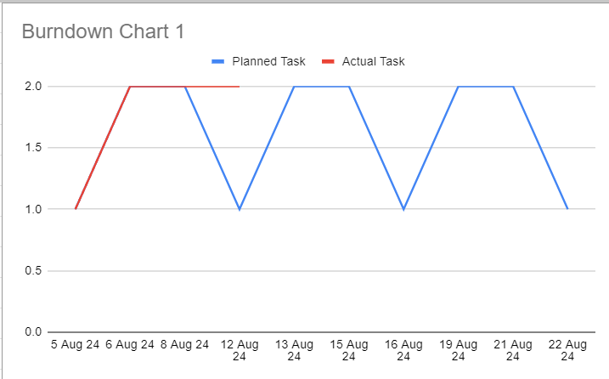

BC-02 progress 2

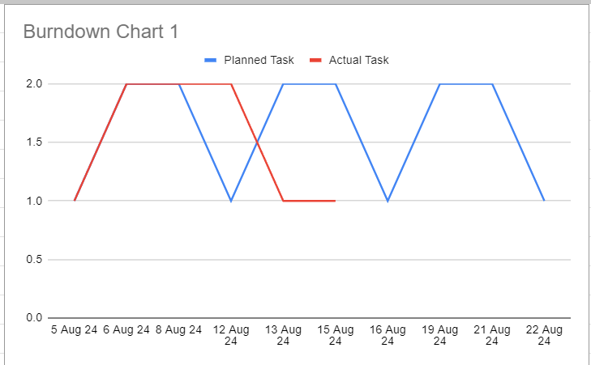

BC-02 progress 3

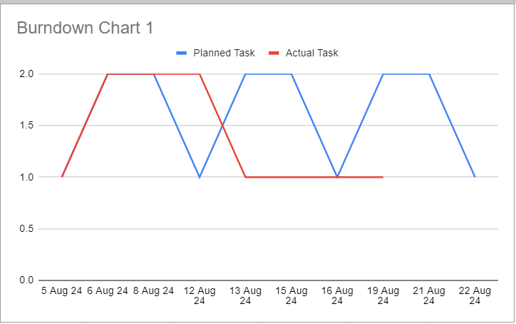

BC-02 progress 4

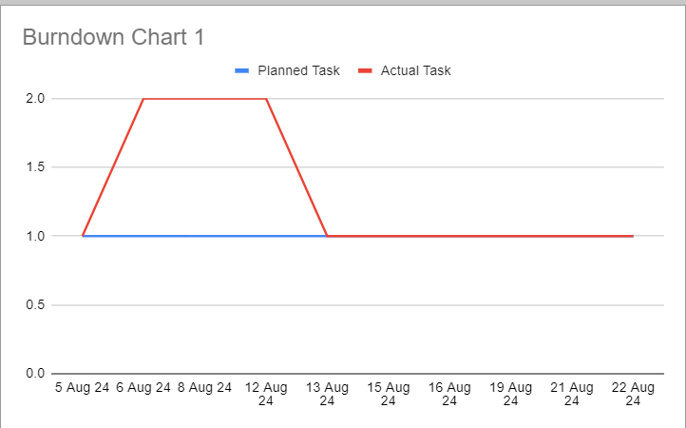

BC-02 progress 5

## 

## Sprint Review

The following table consists of the status of the product at the end of sprint 2.

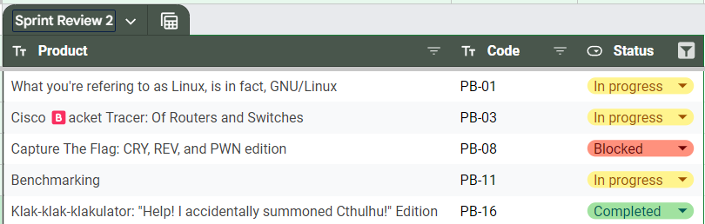

SR-02

## Sprint Retrospective

Throughout the sprint 2, we’ve progressed on several product backlog items, such as Linux, CTF, Benchmarking, and Calculator. We’ve learned that

1. Gauss-Jordan Python, C, Ruby, x86, Java, Go.
2. Implementation of bitwise and inverse square root on Perl.
3. Easy level AES OFB challenge using XOR.
4. Write more programs for benchmarking :).

# 

# SPRINT 3

## Sprint Backlog

The following table consists of sprint backlog items for sprint 3.

| **ID** | **PB ID** | **Task Description** | **Definition of Done** |
| --- | --- | --- | --- |
| SB-14 | PB-01 | Make an Instagram post about Linux. | Post an instagram post. |
| SB-10 | PB-11 | Write the Gauss-Jordan algorithm for matrix inverse. | At least ten (10) programs are running. |
| SB-09 | PB-03 | Implement Cisco Packet Tracer. | At least one (1) requirement is working. |
| SB-15 | PB-10 | Pwn a machine. | Obtain the root flag of a machine in HackTheBox. |
| SB-16 | PB-17 | Write lab lore. | Completed lore for two (2) labs. |

The "working products" we aim to achieve by the end of this sprint are products that have at least one sprint backlog item completed.

## Kanban Board

The following images are the Kanban Board for sprint 3.

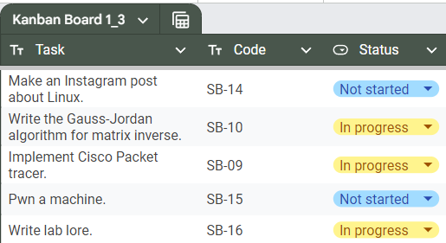

KB-03 progress 1

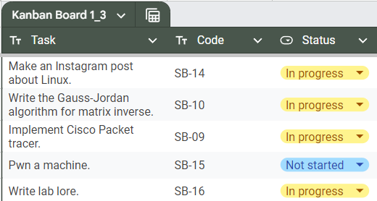

KB-03 progress 2

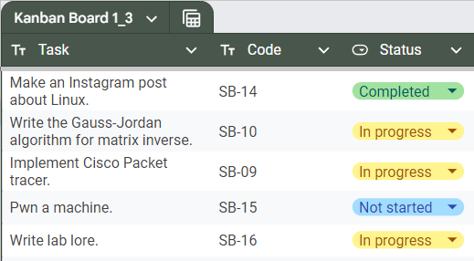

KB-03 progress 3

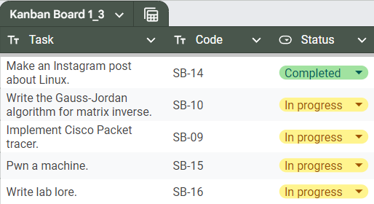

KB-03 progress 4

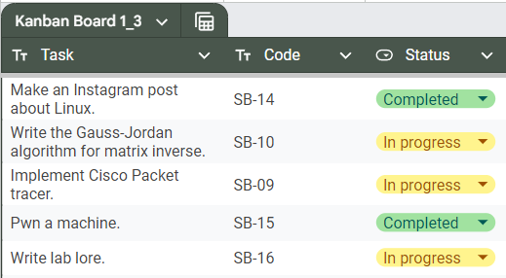

KB-03 progress 5

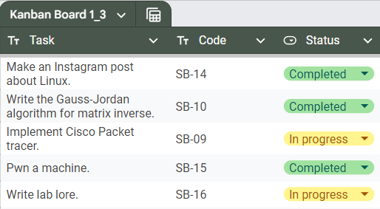

KB-03 progress 6

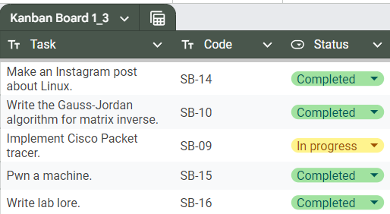

KB-03 progress 7

## Burndown Chart

The following images are the Burndown Chart for sprint 2.

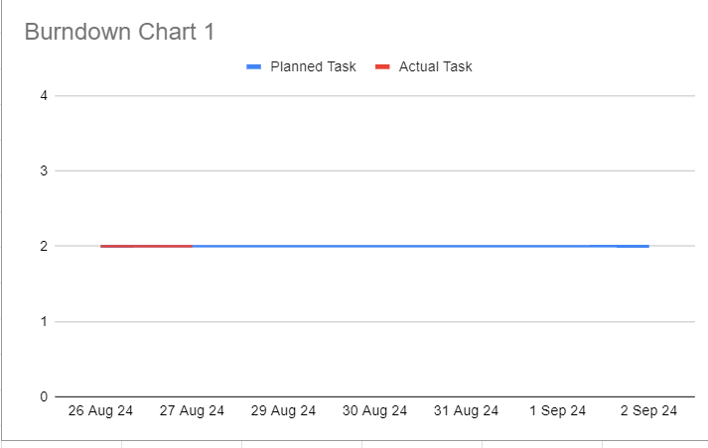

BC-03 progress 1

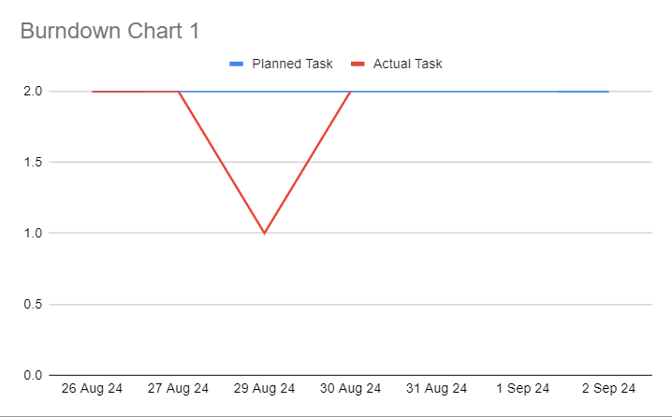

BC-3 progress 2

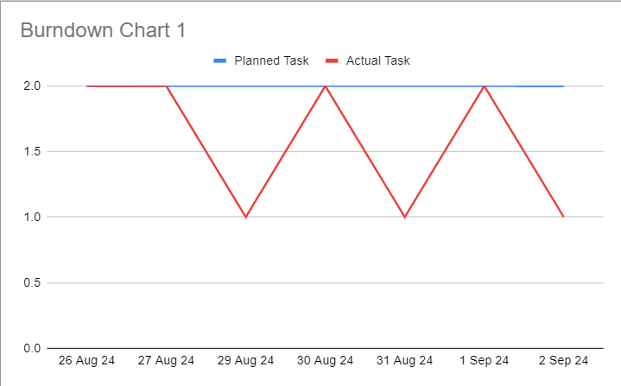

BC-3 progress 3

## Sprint Review

The following table consists of the status of the product at the end of sprint 3.

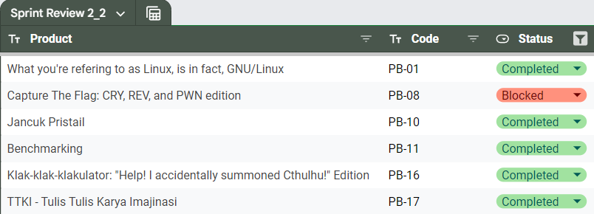

SR-3

## 

## Sprint Retrospective

Throughout the sprint 3, we’ve progressed on several product backlog items, such as Linux, Benchmarking, and TTKI, and Pentesting. We’ve learned that

1. Gauss-Jordan in 15 programming languages.
2. Multithreading executing other programs in C.
3. Keyword start to compile the program on the Windows command line.
4. Security level of FTP, TLS, and SSH.
5. Analyzing packets on Wireshark.
6. Vulnerability effect on CIA triad and the strategy to fix it.
7. I am just a delulu girl wanting IVE to have a concert at Sabuga :).