# **Deliverables for <Klak-klak-klakulator: "Help! I accidentally summoned Cthulhu!" Edition>**



by

**Lydia Gracia (18222035)**

# **USAGE**

Klak-klak-kalkulator is a simple calculator program that supports integer operands and the following operator:

1. Addition (**+**)
2. Subtraction (**-**)
3. Multiplication (**\***)
4. Division (**/**)
5. Power (**^**)

## **Running the Program**

Klak-klak-kalkulator is written in Perl. Ensure Perl is installed on your device. You can download Perl from this [link](https://www.perl.org/get.html). Once Perl is installed, follow the steps below to run the program:

1. Navigate to the directory containing the source code.
2. Run the following command:

| perl myCalc.pl |
| --- |

1. Follow the instruction and enter your arithmetic expression (e.g., 2+3-4).

## **Caveats**

Please note the following limitations of Klak-klak-kalkulator:

1. The program does not support negative number inputs (e.g., -2 + 3 or 2 + -3). However, it will correctly display negative results if they arise from the calculations.
2. The program does not follow the standard order of operations. It calculates expressions strictly from left to right, step by step.

# **TESTING**

These following are demonstrations of how klak-klak-kalkulator behaves on several test cases:

1. Basic addition

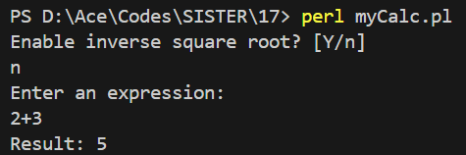

| **Expression** | **Expected** | **Result** |
| --- | --- | --- |
| 2+3 | 5 | 5 |

1. Basic subtraction

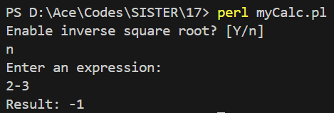

| **Expression** | **Expected** | **Result** |
| --- | --- | --- |
| 2-3 | -1 | -1 |

1. Basic multiplication

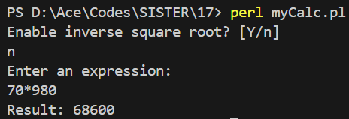

| **Expression** | **Expected** | **Result** |
| --- | --- | --- |
| 70*980 | 68600 | 68600 |

1. Basic division

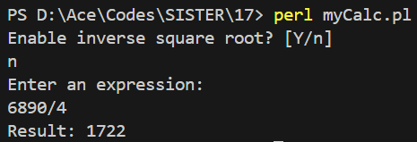

| **Expression** | **Expected** | **Result** |
| --- | --- | --- |
| 6890/4 | 1722 (rounded) | 1722 |

1. Basic division

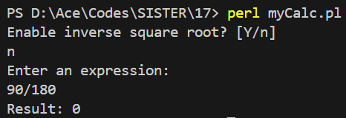

| **Expression** | **Expected** | **Result** |
| --- | --- | --- |
| 90/180 | 0 (rounded) | 0 |

1. Basic power

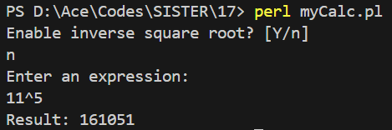

| **Expression** | **Expected** | **Result** |
| --- | --- | --- |
| 11^5 | 161051 | 161051 |

1. Consecutive operations

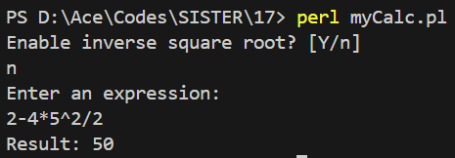

| **Expression** | **Expected** | **Result** |
| --- | --- | --- |
| 2-4*5^2/2 | 50 | 50 |

1. Inverse square root

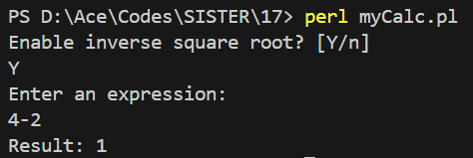

| **Expression** | **Expected** | **Result** |
| --- | --- | --- |
| 1/√(4-2) | 1 (rounded) | 1 |