Assignment 4

Gracie White

November 12, 2018

## INTRODUCTION

## DATA AND METHODS

## RESULTS AND DISCUSSION

*Lobster Abundance and Fishing Pressure* 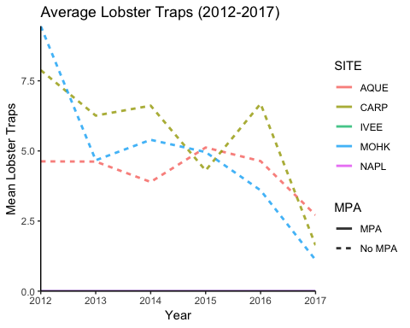

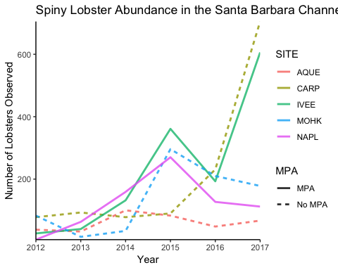

*Mean Lobster Size in 2017*

## Warning in leveneTest.default(y = y, group = group, ...): group coerced to  
## factor.

## Df Sum Sq Mean Sq F value Pr(>F)   
## SITE 4 2355 588.6 3.424 0.0085 **  
## Residuals 1663 285871 171.9   
## ---  
## Signif. codes: 0 '***' 0.001 '**' 0.01 '*' 0.05 '.' 0.1 ' ' 1

## Tukey multiple comparisons of means  
## 95% family-wise confidence level  
##   
## Fit: aov(formula = SIZE ~ SITE, data = lsize_expanded)  
##   
## $SITE  
## diff lwr upr p adj  
## CARP-AQUE -1.6657352 -6.24294710 2.911477 0.8582355  
## IVEE-AQUE -2.4433772 -7.05292315 2.166169 0.5968998  
## MOHK-AQUE -1.8955224 -7.02720717 3.236162 0.8514711  
## NAPL-AQUE 2.3366205 -3.19311600 7.866357 0.7775633  
## IVEE-CARP -0.7776420 -2.76097123 1.205687 0.8216104  
## MOHK-CARP -0.2297872 -3.23309697 2.773523 0.9995765  
## NAPL-CARP 4.0023556 0.36042398 7.644287 0.0228728  
## MOHK-IVEE 0.5478548 -2.50450730 3.600217 0.9882889  
## NAPL-IVEE 4.7799976 1.09751057 8.462485 0.0037001  
## NAPL-MOHK 4.2321429 -0.08607271 8.550358 0.0579286

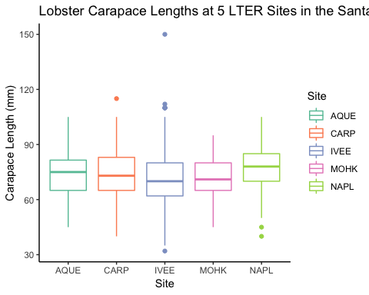

## # A tibble: 5 x 4  
## SITE count mean sd  
## <chr> <int> <dbl> <dbl>  
## 1 AQUE 67 73.9 11.9   
## 2 CARP 705 72.2 13.2   
## 3 IVEE 606 71.5 14.3   
## 4 MOHK 178 72 9.28  
## 5 NAPL 112 76.2 11.4

*Changes in Lobster Size from 2012-2017 in MPA and non-MPA sites*

##   
## F test to compare two variances  
##   
## data: IVEE_2012 and IVEE_2017  
## F = 0.71311, num df = 25, denom df = 605, p-value = 0.307  
## alternative hypothesis: true ratio of variances is not equal to 1  
## 95 percent confidence interval:  
## 0.4322948 1.3698611  
## sample estimates:  
## ratio of variances   
## 0.713111

##   
## Two Sample t-test  
##   
## data: IVEE_2012 and IVEE_2017  
## t = -1.885, df = 630, p-value = 0.0599  
## alternative hypothesis: true difference in means is not equal to 0  
## 95 percent confidence interval:  
## -10.9750916 0.2246473  
## sample estimates:  
## mean of x mean of y   
## 66.07692 71.45215

##   
## Cohen's d  
##   
## d estimate: -0.3775177 (small)  
## 95 percent confidence interval:  
## inf sup   
## -0.77136540 0.01633002

##   
## Two-sample t test power calculation   
##   
## n = 632  
## d = 0.377  
## sig.level = 0.05  
## power = 0.9999989  
## alternative = two.sided  
##   
## NOTE: n is number in *each* group

##   
## F test to compare two variances  
##   
## data: NAPL_2012 and NAPL_2017  
## F = 1.064, num df = 5, denom df = 111, p-value = 0.7685  
## alternative hypothesis: true ratio of variances is not equal to 1  
## 95 percent confidence interval:  
## 0.3966019 6.4626426  
## sample estimates:  
## ratio of variances   
## 1.064048

##   
## Two Sample t-test  
##   
## data: NAPL_2012 and NAPL_2017  
## t = -0.67636, df = 116, p-value = 0.5002  
## alternative hypothesis: true difference in means is not equal to 0  
## 95 percent confidence interval:  
## -12.697051 6.232765  
## sample estimates:  
## mean of x mean of y   
## 73.00000 76.23214

##   
## Cohen's d  
##   
## d estimate: -0.2834216 (small)  
## 95 percent confidence interval:  
## inf sup   
## -1.1141889 0.5473456

##   
## Two-sample t test power calculation   
##   
## n = 118  
## d = 0.283  
## sig.level = 0.05  
## power = 0.5811829  
## alternative = two.sided  
##   
## NOTE: n is number in *each* group

##   
## F test to compare two variances  
##   
## data: AQUE_2012 and AQUE_2017  
## F = 0.72863, num df = 37, denom df = 66, p-value = 0.2986  
## alternative hypothesis: true ratio of variances is not equal to 1  
## 95 percent confidence interval:  
## 0.419142 1.327868  
## sample estimates:  
## ratio of variances   
## 0.7286314

##   
## Two Sample t-test  
##   
## data: AQUE_2012 and AQUE_2017  
## t = -1.2622, df = 103, p-value = 0.2097  
## alternative hypothesis: true difference in means is not equal to 0  
## 95 percent confidence interval:  
## -7.445357 1.654312  
## sample estimates:  
## mean of x mean of y   
## 71.00000 73.89552

##   
## Cohen's d  
##   
## d estimate: -0.2563169 (small)  
## 95 percent confidence interval:  
## inf sup   
## -0.6606014 0.1479675

##   
## Two-sample t test power calculation   
##   
## n = 105  
## d = 0.256  
## sig.level = 0.05  
## power = 0.4548344  
## alternative = two.sided  
##   
## NOTE: n is number in *each* group

##   
## F test to compare two variances  
##   
## data: CARP_2012 and CARP_2017  
## F = 1.2244, num df = 77, denom df = 704, p-value = 0.2043  
## alternative hypothesis: true ratio of variances is not equal to 1  
## 95 percent confidence interval:  
## 0.896208 1.750406  
## sample estimates:  
## ratio of variances   
## 1.224405

##   
## Two Sample t-test  
##   
## data: CARP_2012 and CARP_2017  
## t = 1.3361, df = 781, p-value = 0.1819  
## alternative hypothesis: true difference in means is not equal to 0  
## 95 percent confidence interval:  
## -0.998958 5.257332  
## sample estimates:  
## mean of x mean of y   
## 74.35897 72.22979

##   
## Cohen's d  
##   
## d estimate: 0.1594364 (negligible)  
## 95 percent confidence interval:  
## inf sup   
## -0.07493682 0.39380971

##   
## Two-sample t test power calculation   
##   
## n = 783  
## d = 0.159  
## sig.level = 0.05  
## power = 0.8818203  
## alternative = two.sided  
##   
## NOTE: n is number in *each* group

##   
## F test to compare two variances  
##   
## data: MOHK_2012 and MOHK_2017  
## F = 1.3015, num df = 82, denom df = 177, p-value = 0.1509  
## alternative hypothesis: true ratio of variances is not equal to 1  
## 95 percent confidence interval:  
## 0.9085131 1.9131403  
## sample estimates:  
## ratio of variances   
## 1.301535

##   
## Two Sample t-test  
##   
## data: MOHK_2012 and MOHK_2017  
## t = 4.0689, df = 259, p-value = 6.276e-05  
## alternative hypothesis: true difference in means is not equal to 0  
## 95 percent confidence interval:  
## 2.710776 7.795248  
## sample estimates:  
## mean of x mean of y   
## 77.25301 72.00000

##   
## Two Sample t-test  
##   
## data: MOHK_2012 and MOHK_2017  
## t = 4.0689, df = 259, p-value = 3.138e-05  
## alternative hypothesis: true difference in means is greater than 0  
## 95 percent confidence interval:  
## 3.121847 Inf  
## sample estimates:  
## mean of x mean of y   
## 77.25301 72.00000

##   
## Cohen's d  
##   
## d estimate: 0.5408116 (medium)  
## 95 percent confidence interval:  
## inf sup   
## 0.2749635 0.8066597

##   
## Two-sample t test power calculation   
##   
## n = 261  
## d = 0.5408  
## sig.level = 0.05  
## power = 0.999987  
## alternative = two.sided  
##   
## NOTE: n is number in *each* group

## # A tibble: 10 x 5  
## # Groups: SITE [?]  
## SITE YEAR mean_lobs_size sd sample_size  
## <chr> <int> <dbl> <dbl> <int>  
## 1 AQUE 2012 71 10.2 38  
## 2 AQUE 2017 73.9 11.9 67  
## 3 CARP 2012 74.4 14.6 78  
## 4 CARP 2017 72.2 13.2 705  
## 5 IVEE 2012 66.1 12.1 26  
## 6 IVEE 2017 71.5 14.3 606  
## 7 MOHK 2012 77.3 10.6 83  
## 8 MOHK 2017 72 9.28 178  
## 9 NAPL 2012 73 11.7 6  
## 10 NAPL 2017 76.2 11.4 112

*Legal and Illegal Lobster Trapping in 2017*

## Warning: Setting row names on a tibble is deprecated.

##   
## Pearson's Chi-squared test  
##   
## data: lsize_prop_table  
## X-squared = 18.497, df = 4, p-value = 0.0009864

#in console, running lsize_x2$stdres to see which sites differ significantly: Above Legal Minimum Below Legal Minimum AQUE 0.1464223 -0.1464223 CARP 1.8631463 -1.8631463 IVEE -1.2357993 1.2357993 MOHK -3.2327773 3.2327773 NAPL 2.5706474 -2.5706474

Standardized residuals greater than |2| indicate significance (I think?)

### So, we can say that the proportions between legal/illegal lobster size is differant at MOHK and NAPL. At MOHK, 87% of lobsters observed were smaller than the legal limit. At NAPL (an MPA), only 66% of lobsters were below the legal limit. The other three sites had between 74-78% of their lobsters below the legal size limit.

Above Legal Minimum

Below Legal Minimum

AQUE

0.24

0.76

CARP

0.25

0.75

IVEE

0.21

0.79

MOHK

0.13

0.87

NAPL

0.33

0.67

map <- read_csv("Long Lat.csv")

## Parsed with column specification:  
## cols(  
## Site = col_character(),  
## Longtitude = col_double(),  
## Latitude = col_double()  
## )

my_map <- leaflet() %>%  
 addTiles() %>% # Add default OpenStreetMap map tiles  
 addMarkers(lng=map$Longtitude, lat=map$Latitude, popup="LTER Site")  
  
my_map

## CONCLUSION

## REFERENCES