**To:** The County Planning Office of Santa Barbara

**From:** Gracie White and Andrew Paterson

**Re:** Assessing the Demand for and Economic Value of Whale Conservation Efforts

The City of Santa Barbara, California benefits from its bountiful natural resources through tourism, recreational opportunities, and intangible non-use factors such as happiness among residents from a healthy ecosystem. Notable among these benefits are the spectacular annual migrations of endangered whales through the Santa Barbara Channel. Unfortunately, commercial ships concurrently operating in this water occasionally kill these whales through incidental collisions, diminishing the value of this resource and to some extent, happiness among residents.

By implementing a proposed vessel speed reduction (VSR) program in the channel, the county of Santa Barbara could reduce the frequency of such whale collisions by 60%. However, at a cost of $7 million and with a long list of justifiable causes that could receive this money, it is important to understand the value of such a policy to local residents. To that end, we have analyzed the results of a contingent valuation survey conducted on the subject.

It is our recommendation that the county implement the VSR program. Our analysis suggests that residents collectively value the projected 60% reduction in annual whale mortality at $9,675,000, which provides a net benefit to society of $2,675,000 after considering the costs of implementing the program. Extrapolating the results of previous scientific research, this would lead to an average of 15 avoided fatal whale collisions every year.

We arrived at this conclusion through a linear regression of available data from the survey participants to determine the factors that predict an individual’s willingness to pay to protect these whales. Notable trends that we observed in this regression are that people under 30 are most likely to support the program, and increasing wealth predicts greater support, though this is not the case at the “one-percent” income level. The full extent of derived coefficients from our model are displayed in Figure 1, and their meanings in Technical Appendix 1.

It is important to consider these predictive factors because it is somewhat misleading to consider the county as one collective entity instead of a group of people with widely ranging levels of support for the program. Even if the proposed VSR has a significant net benefit to the county, this is the only manifestation that we considered. Perhaps a lower-cost VSR with a lower risk reduction would actually have a higher net benefit to the county— further research and analysis would help answer this question.

An additional alternative would be to encourage container ships to take advantage of voluntary emissions trading markets.  By slowing their pace through the channel, these ships will reduce carbon emissions and can then sell these emissions credits to outside parties that are not able to reduce their emissions as easily. In order to achieve the same speed associated with a 60% risk reduction, we assume an increased operational cost to the shipping companies of $1,000 for slowing down in the channel and 20 fewer tons of CO2 emitted per transit. Under these conditions, the price of carbon would have to reach $50 per ton for these companies to voluntarily reduce their speeds. Santa Barbara County would receive the full $9,675,000 in social benefit from reduced whale mortality without any of the social cost associated with the mandated VSR.

Our unequivocal recommendation is to implement the VSR; even when the county would pay $7,000,000 to implement the program, the net social benefit is significant.  Figure 2 conveys the major values supporting this conclusion. Further research to illuminate the socially optimal level of whale mortality risk reduction, as well as the long-term feasibility of carbon trading as a vehicle for reducing vessel speeds could make this an even more attractive policy.

**Technical Appendix**

1. We created the linear probability model in R with the lm() function, with age, income, environmental concern, annual household payment amount, and risk reduction corresponding to that payment set up to predict their probability of supporting the program.  The output was deemed significant at the less than .001 level, suggesting the model is an accurate predictor of program support. The model is as follows:



https://lh5.googleusercontent.com/U6LIIhY79EwULYShzD0PUzhsi9Q7FhnqW-MpQinGrkijYJzmZbHvrFUyIG7h5VrdZP6jJGFScyOSNMezBbpSKAGUG-O5aGfGOcGtrzy0YaMcpjZb7omhrwzMRFZ0F76X39Ka81R3

The regression coefficients are displayed in Figure 1.  The table below describes the meaning of each regression coefficient.

|  |  |
| --- | --- |
| **Coefficient** | **Meaning** |
| agetofifty | If the person is between 40 and 50 years old, this coefficient is included and all other ages are excluded. |
| agetoforty | If the person is between 30 and 40 years old, this coefficient is included and all other ages are excluded. |
| agetosixty | If the person is between 50 and 60 years old, this coefficient is included and all other ages are excluded. |
| agetothirty | If the person is between 20 and 30 years old, this coefficient is included and all other ages are excluded. |
| incomeone_percent | If the person has a “top one-percent” income level, this coefficient is included and all other income levels are excluded. |
| incomepoor | If the person has a “poor” income level, this coefficient is included and all other income levels are excluded. |
| incomerich | If the person has a “rich” income level, this coefficient is included and all other income levels are excluded. |
| incomevery_rich | If the person has a “very rich” income level, this coefficient is included and all other income levels are excluded. |
| NEP | The person’s self-assessed level of general environmental concern. |
| bid | The annual payment per household to implement the VSR program. |
| risk | The level of risk reduction with the associated proposed VSR program. |
| Constant | The y-intercept.  Stays constant for every model iteration. |

1. Reducing the risk of whale strikes by 20% saves five whales every year. We assume this ratio stays constant. So, a risk reduction of 4% saves a single whale. To find the willingness to pay for a single whale, we'll use our model to find the willingness to pay for vessel speed reduction programs leading to a 0% risk reduction and compare to the willingness to pay for vessel speed reduction leading to a 4% risk reduction. Below is the model with these values included.

https://lh4.googleusercontent.com/TVLQpGJHCRRRnpWvKEryuut4CeANYtEA5S_ycXtobJYogWbazpNRNkff5xXI_SuxggtHoQMSyUQmd-p8h6JyVlZtOlUvtvRrUnSBMajQFoJ5wcpr6rc3YEVAdtz1piFOeuDHRKmg

We took the average probability of voting yes and rounded it to 0.7, assumed “agetothirty” as the average age of correspondents, rich as the average income level, and calculated the average NEP to be 38.366.  We then inserted these values into our regression model, and ran it twice with a 0% risk reduction and a 4% risk reduction. With a 4% risk reduction, the expected bid would be $42.30 per household. With a 0% risk reduction, the expected bid would be $39.50 per household.  Subtracting these two values, we find the value of a single whale saved to be $2.80 per Santa Barbara Household.

1. A random number generator prompted us to select respondents 22, 233, and 447.  We then took the specific attributes in each of our variables for each of these respondents and inserted them into the model for a 60% risk reduction, assuming the probability of voting yes to be the average value of 0.7.  We then rearranged the linear model to solve for their expected bid, as shown below.

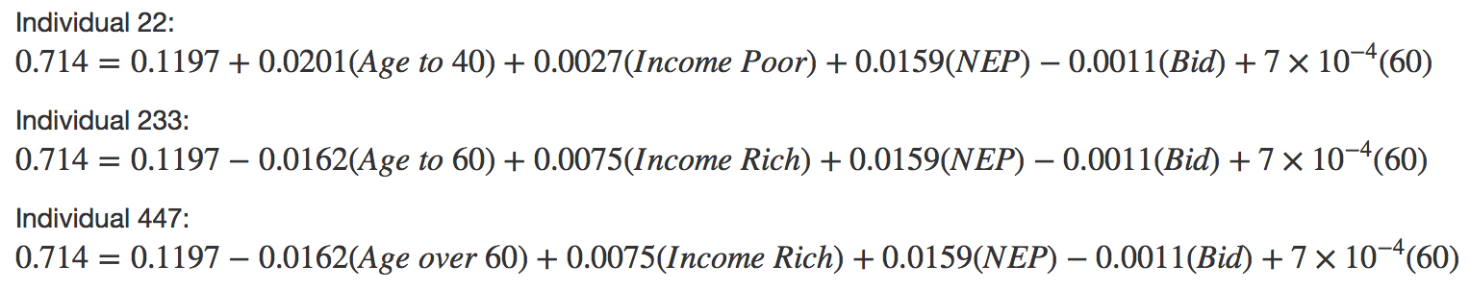

The attributes and expected bid of each of these respondents are included in the following table.

|  |  |  |  |  |
| --- | --- | --- | --- | --- |
| **Respondent** | **Age** | **Income** | **NEP** | **Expected Willingness to Pay** |
| 22 | 40 | Rich | 15 | -$266 |
| 233 | 60 | Poor | 51 | $260 |
| 447 | 60 | Rich | 60 | $309 |

1. To calculate the mean willingness to pay for a VSR program with a 60% risk reduction, we calculated and inserted the average values for each of the variables considered into our model.  We assumed a probability of voting yes of 0.7, middle income level (the reference level), “agetofifty” as the age, and the same mean NEP of 38.366 calculated above. We rearranged the model to find the average expected willingness to pay for all residents in the county to be $64.50.
2. In order to calculate the total benefit of this VSR program to all 150,000 households in Santa Barbara County, we multiplied the average household willingness to pay by the number of households to find the total benefits of the program to be $9,675,000.
3. Subtracting the fixed $7,000,000 cost of the program, we find a net benefit to society in the county of $2,675,000.  Yes, the benefits of the program outweigh the costs.
4. We assume that for any ship transiting the Santa Barbara Channel, a speed reduction (that results in a 60% risk reduction) will cost the shipping company $1,000, but will result in 20 fewer tons of CO2 emitted per transit.  We set 20 x Z* = $1,000, and find Z* to be $50 per ton.  Thus, the shipping industry will adopt the VSR program for purely self-interested reasons when the cost of carbon is at least $50 per ton under these assumptions.
5. Since this carbon trading policy is expected to produce an identical 60% risk reduction in whale collisions, 15 whales would be saved by this program.  This assumes that the risk reduction ratio of 4% to one whale collision avoided stays constant. Since this program has the same social benefit to the county as the mandated VSR, but none of the associated costs, the social value of allowing shipping companies to enter the carbon trading market is the full $9,675,000 of the 60% risk reduction calculated above.

**Appendices**

**Figure 1:**

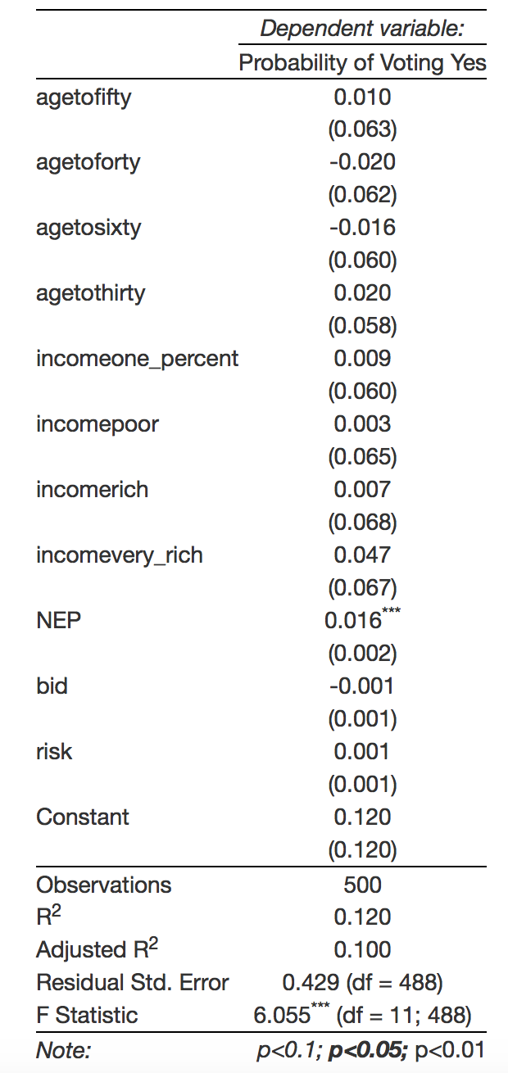

**Figure 2: Summary of Notable Results of Analysis**

|  |  |
| --- | --- |
| Value of a Single Avoided Whale Death per Santa Barbara Household | $2.80 |
| Average Willingness to pay for mandated VSR in Santa Barbara (60% risk reduction) | $64.50 |
| Average Willingness to pay for mandated VSR nationally | $69.00 |
| Total Benefits of mandated VSR Program | $9,675,000.00 |
| Cost of mandated VSR Program | $7,000,000.00 |
| Net Benefits of mandated VSR Program | $2,675,000.00 |
| Projected Whales saved through mandated VSR Program | 15 |
| Net Benefits of VSR Program with carbon trading system | $9,675,000.00 |
| Projected Whales saved through VSR with carbon trading system | 15 |