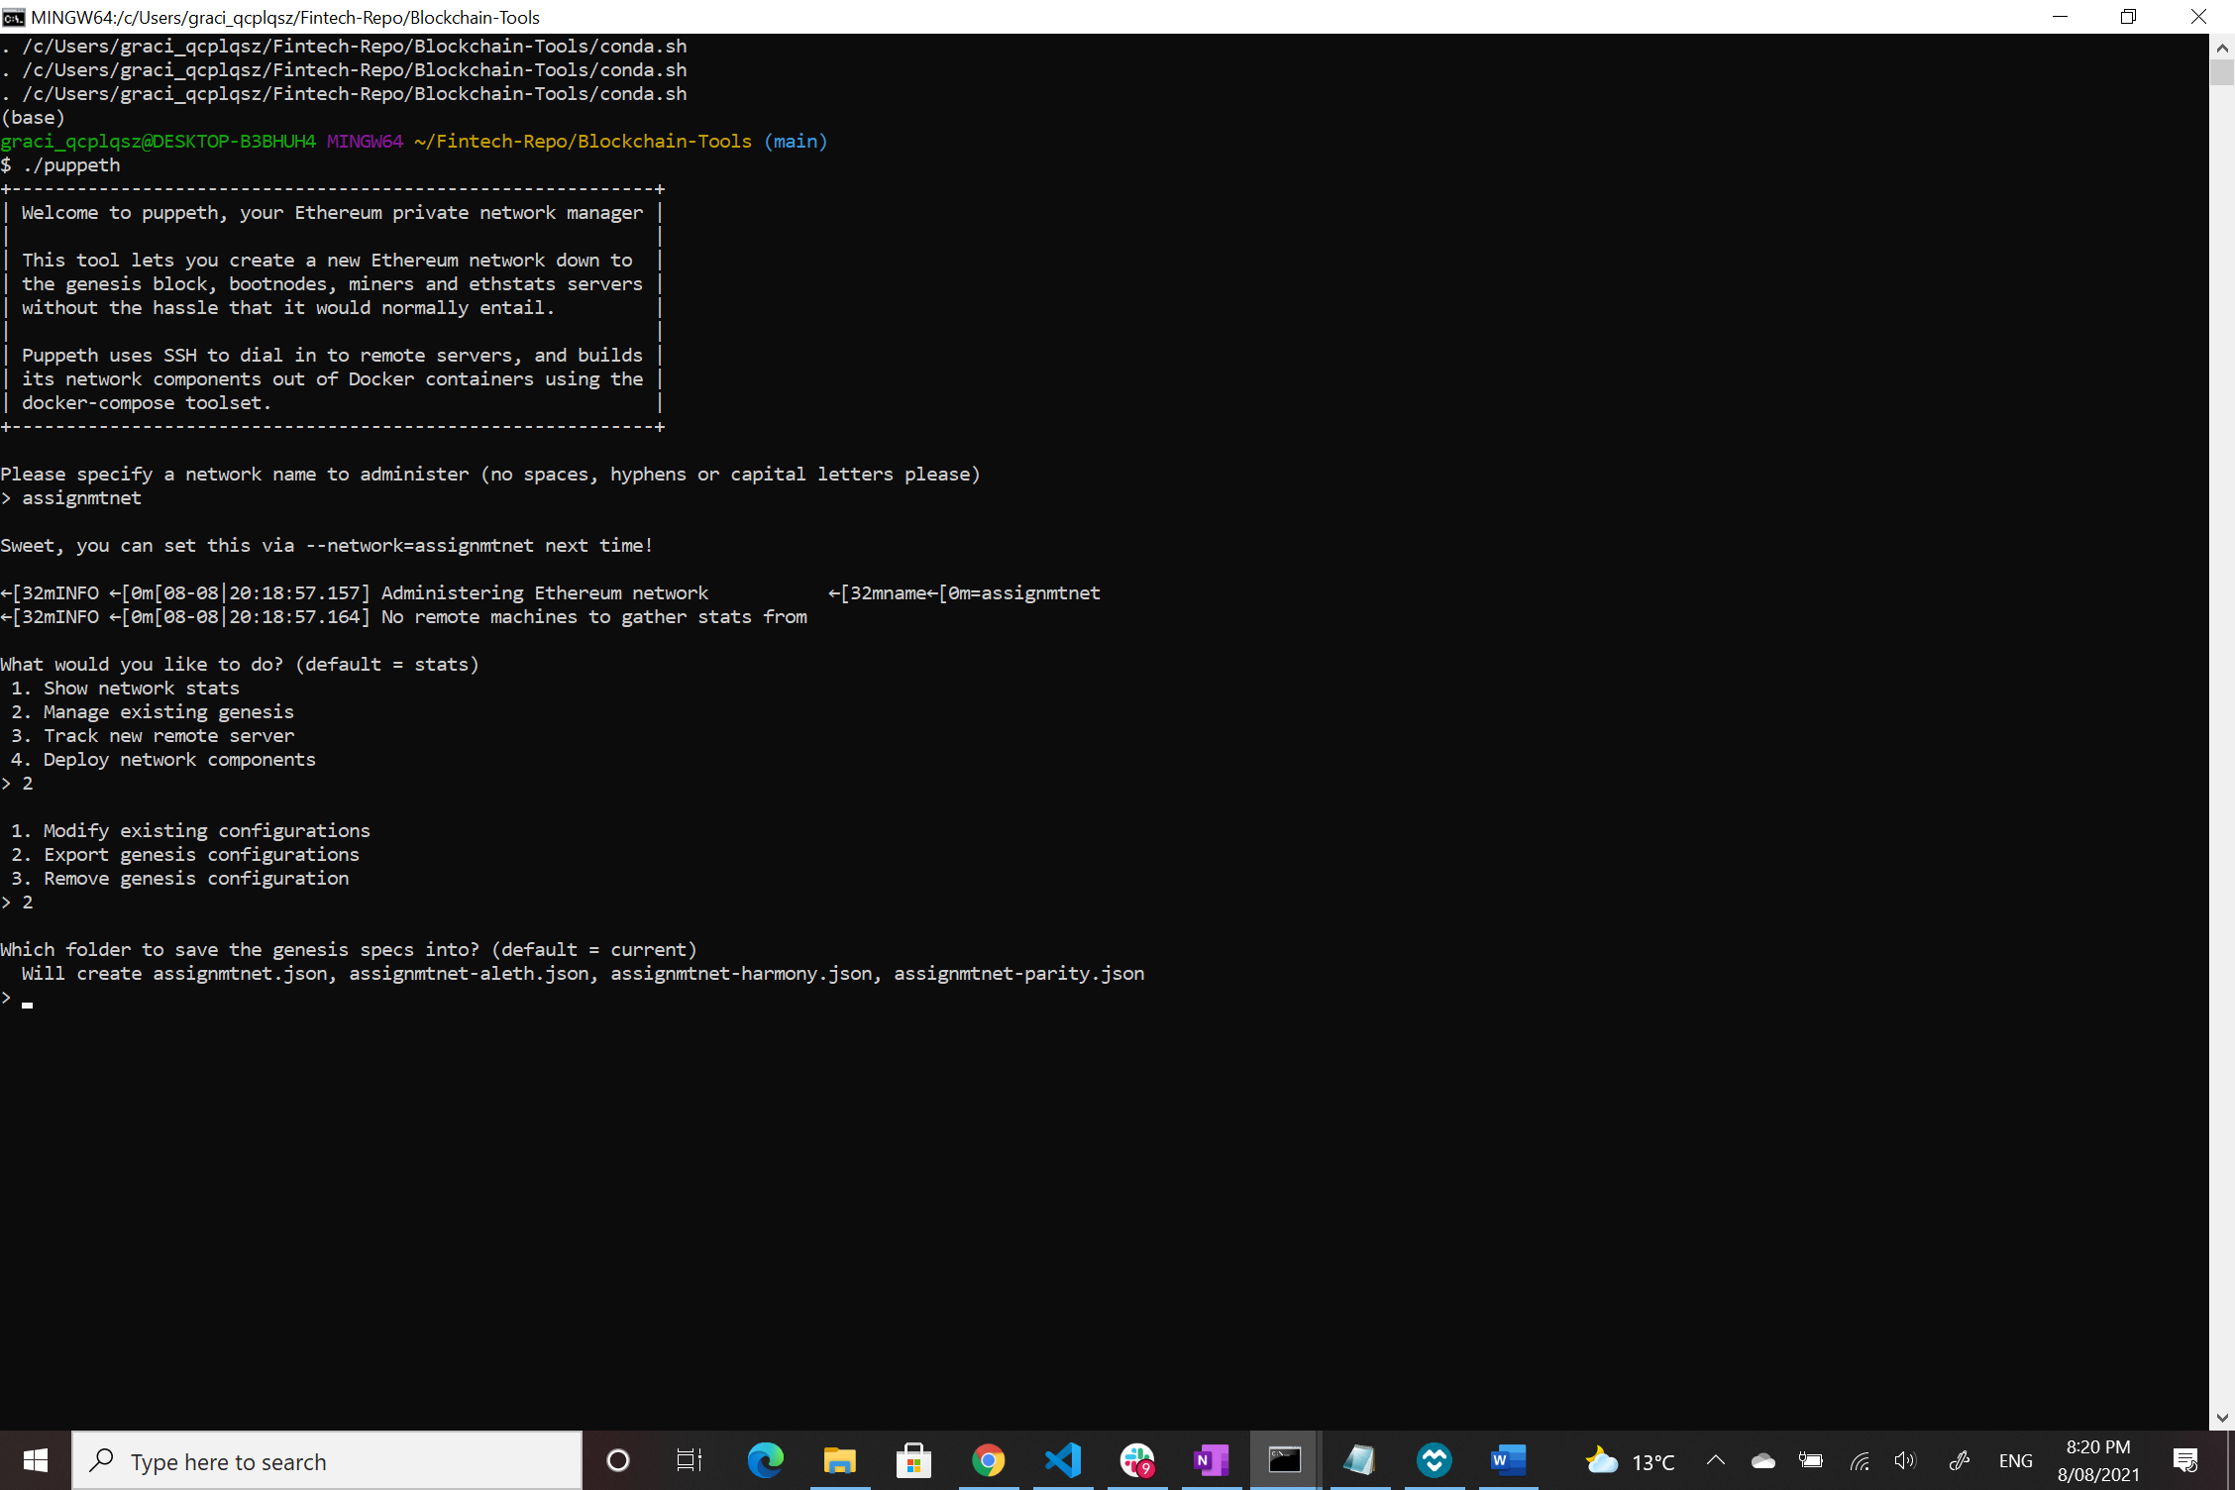

Hit enter to save configurations in current folder (Blockchain-Tools).