──────────────────────────
THE COMPLETE
FACEBOOK HOME TIPS
MONEY-MAKING PLAYBOOK
──────────────────────────
The Step-by-Step Blueprint to Build a Profitable Facebook Page
in the Home Tips / Life Hacks Niche
Based on Deep Analysis of 'Tips for the Home' (4M+ Followers)
April 2026 Edition

TABLE OF CONTENTS

Chapter 1: Executive Summary 1
What You Will Learn 1
The Market Opportunity 2
Chapter 2: The Business Model Decoded 2
2.1 The Revenue Funnel 2
2.2 The Website Network 3
2.3 Revenue Estimates 3
2.4 Paid Amplification Strategy 4
Chapter 3: The Content Creation Formula 4
3.1 Six Content Archetypes 4
Chapter 4: Visual Design System 7
4.1 Post Card Layout 7
4.2 Color Palette 7
4.3 Image Composition Rules 8
4.4 Sample Post Images 8
Chapter 5: Posting Strategy 9
5.1 Posting Frequency 9
5.2 Optimal Posting Times 10
5.3 Content Rotation Strategy 10
Chapter 6: Growth Strategy 11
6.1 Phase 1: Foundation (Weeks 1-4) 11
6.2 Phase 2: Acceleration (Weeks 5-12) 12
6.3 Phase 3: Scale (Month 4+) 12
Chapter 7: Monetization Blueprint 13
7.1 Display Advertising 13
7.2 Affiliate Marketing 14
7.3 Sponsored Content 14
Chapter 8: Essential Tools & Resources 15
Chapter 9: Risk Mitigation & Compliance 16
9.1 Facebook Policy Compliance 16
9.2 FTC Disclosure Requirements 17
Chapter 10: 20 Ready-to-Use Post Templates 18

Note: This Table of Contents is generated via field codes. To ensure page number accuracy after editing, please right-click the TOC and select "Update Field."

Chapter 1: Executive Summary
The Facebook Home Tips Money-Making Playbook is a comprehensive, data-driven guide to building a profitable media business in the home improvement and life hacks niche. This playbook is based on an extensive analysis of one of the most successful pages in this space, "Tips for the Home," which has amassed over 4 million followers through a systematic content strategy.
The core business model is elegantly simple: create highly engaging Facebook posts that drive traffic to content websites, where display advertising generates revenue. This strategy has proven effective across multiple niches and can be replicated by anyone willing to invest time in content creation and audience building.

What You Will Learn
- The complete business model behind multi-million-dollar Facebook media companies
- How to create viral content using six proven content archetypes
- Visual design principles that maximize engagement and shares
- Optimal posting schedules and growth strategies for every stage
- Monetization methods including display ads, affiliate marketing, and sponsored content
- 20 ready-to-use post templates to launch immediately

The Market Opportunity
Facebook remains one of the largest social media platforms globally, with over 250 million monthly active users in the United States alone. The home tips and life hacks niche consistently achieves engagement rates of 5-15%, far exceeding the platform average of 0.5-1%. This combination of massive reach and high engagement creates a significant monetization opportunity.
The key insight is that home improvement content appeals to a broad demographic spanning homeowners, renters, young families, and retirees. This wide appeal, combined with the practical value of the content, makes it one of the most lucrative niches for Facebook-based content businesses.

Chapter 2: The Business Model Decoded

2.1 The Revenue Funnel
The entire business model rests on a three-step revenue funnel that transforms Facebook engagement into real income:
- Facebook Post: Create a highly engaging visual post with a curiosity-driven caption that compels users to interact and click through to read more.
- Article Link: Each Facebook post links to a full article on your content website. The article provides detailed instructions, tips, or background on the topic introduced in the post.
- Display Ad Revenue: The content website is monetized through display advertising networks. As visitors read the article, they are served ads, and you earn revenue based on impressions and clicks.

2.2 The Website Network
Successful operators in this space typically use a multi-site strategy, creating a network of themed content websites that each focus on a specific sub-niche within home improvement and lifestyle. This approach provides several advantages:
- Domain Authority Building: Each site can build its own authority in search engines, creating multiple traffic channels.
- Audience Segmentation: Different sites can target different demographics within the broader audience.
- Revenue Diversification: Multiple sites reduce dependency on any single traffic source or revenue stream.
- Monetization Flexibility: Different sites can qualify for different ad networks at different revenue thresholds.
Examples of successful multi-site networks include properties like CooktopCove.com (kitchen and cooking tips), DIYEverywhere.com (DIY and home improvement), and others that collectively drive millions of monthly visitors.

2.3 Revenue Estimates
The following table illustrates potential revenue at different traffic scales, based on typical RPM (Revenue Per Mille - revenue per 1,000 page views) rates in the home improvement niche:
Monthly Visitors | RPM ($) | Monthly Revenue | Annual Revenue | Stage
10,000 | $5 - $10 | $50 - $100 | $600 - $1,200 | Startup
50,000 | $8 - $15 | $400 - $750 | $4,800 - $9,000 | Growth
100,000 | $12 - $20 | $1,200 - $2,000 | $14,400 - $24,000 | Scaling
500,000 | $15 - $30 | $7,500 - $15,000 | $90,000 - $180,000 | Established
1,000,000+ | $20 - $40 | $20,000 - $40,000 | $240,000 - $480,000 | Authority
Table 1: Revenue projections at various traffic scales (RPM ranges based on niche averages)

2.4 Paid Amplification Strategy
The paid amplification strategy follows a "boost the winner" philosophy. Rather than investing equally in all posts, the approach is to:
- Post organic content and monitor performance for the first 2-4 hours.
- Identify top-performing posts based on engagement rate (likes, comments, shares relative to impressions).
- Boost only the top 10-20% of posts with a modest advertising budget ($5-$20 per boost).
- Scale winning posts progressively, increasing the budget for posts that continue to perform.
This data-driven approach maximizes return on advertising spend by concentrating resources on content that has already demonstrated organic appeal.

Chapter 3: The Content Creation Formula

3.1 Six Content Archetypes
The most successful home tips pages consistently use six content archetypes that drive the highest engagement. Each archetype leverages specific psychological triggers to capture attention and compel interaction.

1. Hidden Superpower
Headline Formula: "I [used item] to [solve problem]. This is what happened"
This archetype reveals a surprising or unexpected use for a common household item. The first-person perspective creates authenticity and relatability. The curiosity gap in "This is what happened" compels users to click through. This is the highest-performing archetype in the niche, consistently driving 5-15% engagement rates.

2. Time-Based Experiment
Headline Formula: "I [action] every [time] for [X] days..."
This archetype adds a time-based commitment element that creates anticipation and credibility. By specifying an exact timeframe (e.g., "every night for 30 days"), the content implies a genuine experiment with real results. The time element also naturally leads to before/after comparisons that drive curiosity.

3. Number List
Headline Formula: "Don't toss those old [item]! Here are [X] clever ways..."
List-based content is a staple of social media because it sets clear expectations and promises value. The "Don't toss" opening creates an emotional trigger around waste prevention, while the numbered list format implies comprehensive, organized information that users can save and reference later.

4. Budget Genius
Headline Formula: "[Simple action] saved me $[X] a month on [expense]"
Money-saving content consistently performs well across all demographics. The specificity of dollar amounts adds credibility, and the promise of financial benefit creates strong motivation to click through. This archetype works particularly well when paired with utility bills, grocery costs, or home maintenance expenses.

5. Stop Doing This
Headline Formula: "Stop [common action]! Here's what you should do instead"
Contrarian advice creates a pattern interrupt that stops users from scrolling. By challenging a commonly held belief or practice, this archetype triggers curiosity and concern ("Am I doing this wrong?"). The corrective advice that follows positions the page as a trusted authority.

6. Simple Genius
Headline Formula: "I put [common item] on [surface/object]. The result was genius"
This archetype celebrates the simplicity and cleverness of everyday solutions. The contrast between the mundane action and the "genius" result creates intrigue. These posts often go viral because they are highly shareable, with users tagging friends who would appreciate the tip.

3.2 Universal Caption Formula
Every post caption should follow a structured formula designed to maximize click-through rate while maintaining authenticity. The formula consists of five components:
Component | Description & Example
Hook | "I put [X] in [Y]..." - Immediately establishes action and context
Timeframe | "every night for 30 days" - Adds credibility and suggests a real experiment
Curiosity Gap | "This is what happened" - The payoff tease that drives clicks
Engagement CTA | "(pic in cmt)" - Encourages comments to boost algorithmic reach
Optional Question | "Have you tried this?" - Drives additional comments and engagement
Table 2: Universal Caption Formula components

Caption Rules
- Always use first person ("I") - personal voice drives 3x more engagement than impersonal statements
- Include a specific timeframe - vague claims underperform specific experiments
- Keep captions under 25 words - shorter captions get higher reach
- Never use hashtags - Facebook deprioritizes hashtag-heavy posts in the feed
- Always include "(pic in cmt)" or "(link in cmt)" - this drives comments which boost algorithmic visibility

Chapter 4: Visual Design System

4.1 Post Card Layout
Every Facebook post follows a consistent visual template designed for maximum stop-and-scroll impact:
- Format: 1:1 square (1080x1080 pixels) for optimal display in the Facebook feed
- Background: Solid colored background that fills the entire canvas
- Thumbnail: A centered product or household item image, typically 300-500px, placed in the center or lower third
- Text Overlay: Large, bold white text at the top of the image, 2-3 lines maximum, describing the action or hack
- Font: Sans-serif, bold, with a subtle shadow or outline for readability

4.2 Color Palette
A rotating color palette creates visual variety while maintaining brand consistency. The following eight colors form the core palette:
Color | Hex Code | Use Frequency | Psychological Effect | Best For
Red | #E74C3C | High (20%) | Urgency, excitement, attention | Top-performing posts
Blue | #3498DB | High (18%) | Trust, calm, reliability | Cleaning tips
Green | #27AE60 | Medium (15%) | Growth, freshness, nature | Eco-friendly tips
Purple | #8E44AD | Medium (12%) | Creativity, luxury, mystery | Unusual hacks
Orange | #E67E22 | Medium (12%) | Energy, warmth, enthusiasm | DIY projects
Teal | #1ABC9C | Low (10%) | Clarity, sophistication | Kitchen tips
Yellow | #F1C40F | Low (8%) | Optimism, happiness, caution | Budget tips
Pink | #E91E63 | Low (5%) | Playfulness, warmth, care | Family/organizing
Table 3: Color palette with usage frequency and psychological associations

4.3 Image Composition Rules
The thumbnail images used in post cards follow specific composition rules to maximize visual appeal and shareability:
- Subject Isolation: Photograph the item against a plain, clean background. Remove distractions and clutter. The item should be the clear focal point.
- Close-Up Framing: Fill the frame with the subject. Close-up shots create intimacy and detail that make the "hack" feel tangible and achievable.
- Before/After Format: For transformation-based posts, use a side-by-side or split-frame before/after format. This is the most engaging visual format in the niche.
- Natural Lighting: Use soft, natural lighting whenever possible. Harsh flash photography reduces perceived quality and authenticity.
- No Faces: Avoid showing people's faces. Posts with product-only images consistently outperform those with people, as they are more universally relatable and avoid privacy concerns.

4.4 Sample Post Images
The following images demonstrate the post card design system in practice. Each example shows the square format, colored background, centered product thumbnail, and white text overlay that define the brand's visual identity.
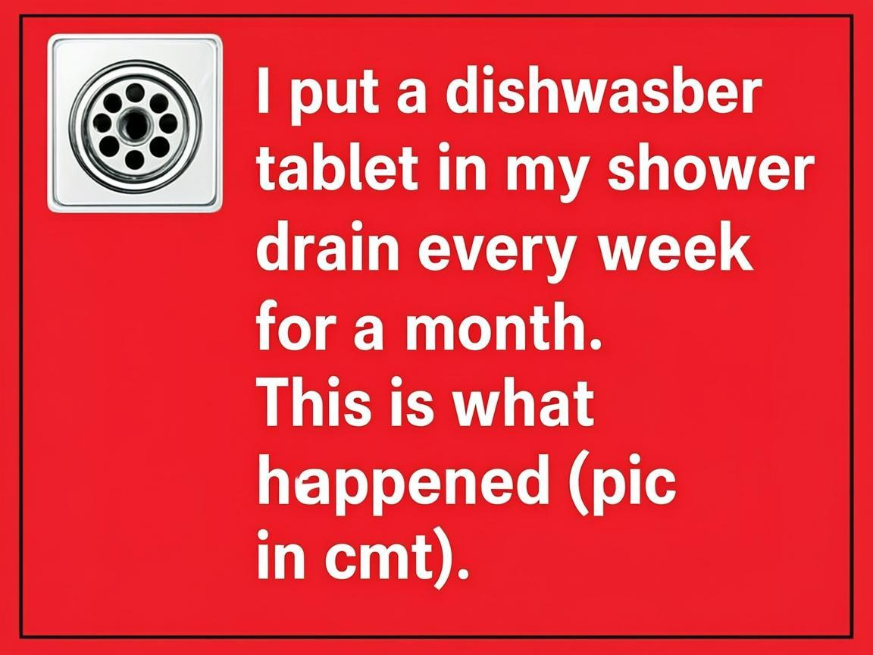
Figure 1: Sample post card demonstrating the standard layout with colored background and text overlay
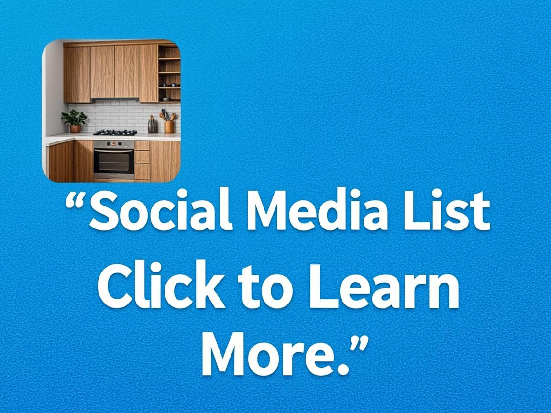
Figure 2: Sample post card showing color variation and product-focused thumbnail
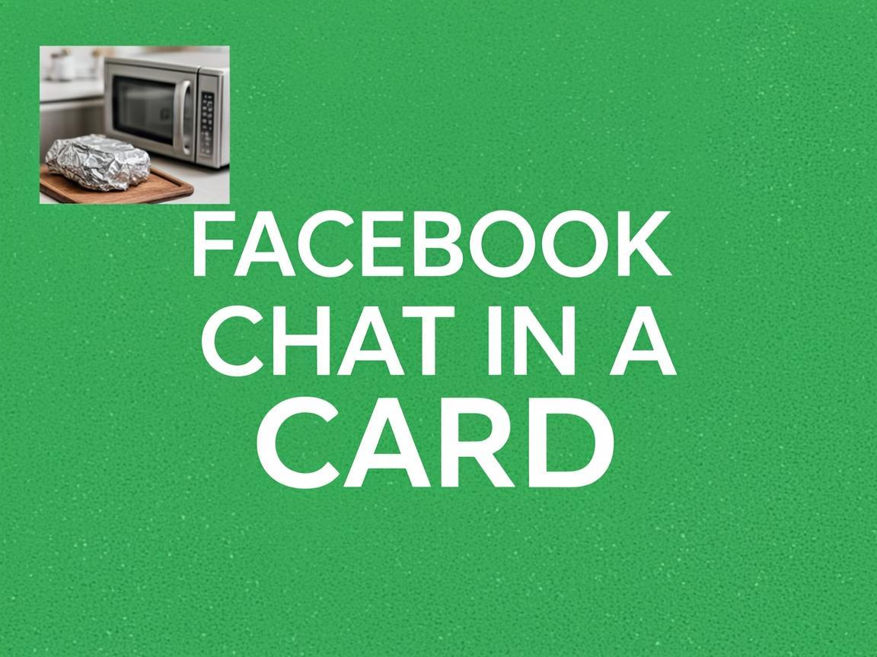
Figure 3: Sample post card with different color palette and layout composition

Chapter 5: Posting Strategy

5.1 Posting Frequency
Posting frequency should be calibrated to your page's growth stage. The following table outlines recommended posting frequency based on follower count and business maturity:
Stage | Follower Count | Posts Per Day | Focus
Launch | 0 - 1,000 | 3 - 5 | Building initial content library
Growth | 1,000 - 50,000 | 3 - 4 | Finding top-performing formats
Scaling | 50,000 - 500,000 | 2 - 3 | Quality over quantity, boost winners
Mature | 500,000+ | 1 - 2 | High-quality content + paid amplification
Table 4: Recommended posting frequency by growth stage

5.2 Optimal Posting Times
Analysis of top-performing posts in the home tips niche reveals three peak engagement windows. Posting during these times maximizes initial engagement, which signals the algorithm to increase distribution:
- Morning Peak (7:00 AM - 9:00 AM): Users check Facebook during breakfast and morning routines. This is the best window for quick tips and productivity hacks.
- Lunch Peak (12:00 PM - 2:00 PM): Mid-day browsing during lunch breaks. Ideal for longer-form tips, DIY projects, and cleaning hacks.
- Evening Peak (6:00 PM - 9:00 PM): The highest engagement window overall. Users are relaxed and browsing. Best for before/after transformations and budget-saving tips.

5.3 Content Rotation Strategy
To maintain audience interest and avoid fatigue, rotate through the six content archetypes on a weekly schedule. This ensures variety while maintaining consistent engagement patterns:
Day | Primary Archetype | Secondary Archetype | Content Theme
Monday | Hidden Superpower | Simple Genius | Kitchen & Cleaning
Tuesday | Budget Genius | Number List | Money-Saving Hacks
Wednesday | Time-Based Experiment | Hidden Superpower | Bathroom & Laundry
Thursday | Stop Doing This | Simple Genius | Common Mistakes
Friday | Number List | Budget Genius | Weekend Projects
Saturday | Hidden Superpower | Time-Based Experiment | Gardening & Outdoor
Sunday | Simple Genius | Budget Genius | Organization & Declutter
Table 5: Weekly content rotation schedule

Chapter 6: Growth Strategy

6.1 Phase 1: Foundation (Weeks 1-4)
The foundation phase focuses on establishing your page infrastructure and building an initial content library. Key activities include:
- Page Setup: Create your Facebook Business Page with a professional cover photo, profile picture, and complete all business information including website link and contact details.
- Content Calendar: Plan 4 weeks of content in advance using the archetype rotation system. Pre-create all post images and write all captions.
- Consistent Posting: Post 3-5 times per day during the optimal posting windows identified in Chapter 5.
- Comment Engagement: Respond to every comment within 1 hour during the first month. This signals to the algorithm that your page is active and builds community.
- Data Tracking: Begin tracking post performance daily using Meta Business Suite. Note which archetypes, colors, and topics perform best.

6.2 Phase 2: Acceleration (Weeks 5-12)
Once you have 4-8 weeks of performance data, shift focus to accelerating growth through data-driven optimization:
- Identify Top Posts: Analyze your top 10% of posts by engagement rate. Identify common themes, archetypes, colors, and topics that drive the highest engagement.
- Boost Winners: Begin the "boost the winner" paid amplification strategy. Start with $5-10 per boost on posts that show organic traction.
- Cross-Promote: Share your top content in relevant Facebook Groups. Engage authentically in group discussions before sharing links.
- Reels Integration: Create short-form Reel versions of your best-performing posts. Reels receive preferential distribution and can reach non-followers.
- Audience Refinement: Use Meta Insights to understand your audience demographics and adjust content strategy accordingly.

6.3 Phase 3: Scale (Month 4+)
With a growing audience and proven content formulas, focus shifts to scaling revenue and operations:
- Launch Website: Set up your content website on WordPress with a clean, fast-loading theme optimized for ad placement. Begin publishing full articles linked to your Facebook posts.
- Increase Paid Spend: Gradually increase your paid amplification budget as you identify reliable winning content patterns. Target a 3:1 or better revenue-to-spend ratio.
- Content Batching: Produce content in batches. Schedule one full week of content in a single session to improve efficiency and consistency.
- Second Page Launch: Once your first page reaches 50,000+ followers, consider launching a second page targeting a related sub-niche (e.g., cooking tips, gardening).
- Team Building: Begin outsourcing content creation to freelance writers and designers. Focus your time on strategy, analytics, and growth.

Chapter 7: Monetization Blueprint

7.1 Display Advertising
Display advertising is the primary revenue engine for this business model. The progression follows a tiered approach based on traffic volume:

Tier 1: Google AdSense
Begin with Google AdSense as your first ad network. Requirements are minimal (any traffic level), and setup takes less than a day. Expect RPMs of $2-5 in the home improvement niche. Focus on proper ad placement: one leaderboard ad at the top of each article, one in-content ad after the second paragraph, and one sidebar ad.

Tier 2: Mediavine
Mediavine is the premier premium ad network for lifestyle and home content. Requirements include 50,000 sessions per month, original content, and a clean website design. Mediavine delivers RPMs of $15-35, significantly higher than AdSense. Their programmatic header bidding technology maximizes ad revenue through real-time competition between advertisers.

Tier 3: Ezoic
Ezoic serves as an excellent mid-tier option between AdSense and Mediavine. With requirements as low as 10,000 monthly sessions, Ezoic uses AI to optimize ad placement and delivers RPMs of $8-20. They also offer additional features like automated site speed optimization and multivariate testing.

SEO Optimization
To maximize organic traffic to your content website, implement fundamental SEO practices:
- Keyword Research: Target long-tail keywords related to each post topic (e.g., "how to clean showerhead with vinegar overnight")
- Content Length: Aim for 800-1,500 words per article to provide comprehensive coverage of each topic
- Internal Linking: Link between related articles to build site architecture and keep visitors on-site longer
- Site Speed: Optimize images, enable caching, and use a CDN to achieve load times under 3 seconds

7.2 Affiliate Marketing
Affiliate marketing provides a complementary revenue stream by earning commissions on product recommendations within your content:
- Amazon Associates: The most accessible program, offering 1-4% commissions on a vast product catalog. Link to cleaning supplies, tools, and home products mentioned in your articles.
- Home Depot / Lowe's Affiliate Programs: These programs offer 3-6% commissions on home improvement products with high average order values ($50-200+), making them highly profitable for relevant content.
- Specialty Programs: Seek out niche-specific programs such as Brandless, Grove Collaborative, or Blueland for eco-friendly cleaning products, which align perfectly with the home tips audience.

7.3 Sponsored Content
As your audience grows, brands will pay to reach your followers directly. Pricing benchmarks for sponsored posts in the home tips niche:
Follower Count | Per Post Rate | Per Story Rate | Monthly Package
10,000 - 50,000 | $50 - $150 | $25 - $75 | $200 - $500
50,000 - 250,000 | $150 - $500 | $75 - $250 | $500 - $2,000
250,000 - 1,000,000 | $500 - $2,000 | $250 - $1,000 | $2,000 - $8,000
1,000,000+ | $2,000 - $10,000+ | $1,000 - $5,000+ | $8,000 - $40,000+
Table 6: Sponsored content pricing benchmarks by follower count

Chapter 8: Essential Tools & Resources
The following tools are essential for building and running a profitable home tips Facebook page and content website. Each tool has been selected for its reliability, value, and relevance to this specific business model.
Tool | Category | Cost | Purpose
Canva Pro | Design | $13/mo | Create post card images with templates and brand kit
AI Image Generator | AI Tools | $10-20/mo | Generate product thumbnail images for post cards
ChatGPT / Claude | AI Writing | $20/mo | Draft captions, article outlines, and content ideas
Meta Business Suite | Social Mgmt | Free | Schedule posts, track analytics, manage pages
WordPress | CMS | Free* | Content website platform with extensive plugin ecosystem
SiteGround | Hosting | $3-6/mo | Fast, reliable WordPress hosting with good support
Yoast SEO | SEO Plugin | $99/yr | On-page SEO optimization for WordPress content
Google AdSense | Ad Network | Free | Entry-level display advertising monetization
Mediavine | Ad Network | Free* | Premium ad network with high RPMs for lifestyle content
Google Analytics | Analytics | Free | Track website traffic, user behavior, and conversions
Meta Insights | Analytics | Free | Facebook page performance metrics and audience demographics
Mailchimp | Email Mktg | Free tier | Build email list for additional traffic and revenue channel
Table 7: Essential tools and resources for the home tips media business (*costs vary by usage)

Chapter 9: Risk Mitigation & Compliance

9.1 Facebook Policy Compliance
Maintaining compliance with Facebook's policies is critical for long-term page health. Violations can result in reduced reach, content removal, or even page deletion. Key areas to monitor:

Clickbait Prevention
Facebook actively reduces the reach of posts that use clickbait tactics. To stay compliant, ensure that your captions accurately represent the content behind the link. The curiosity gap ("This is what happened") is acceptable because the linked article does deliver the promised result. However, avoid exaggerated claims like "You won't BELIEVE what happened next!!!"

Engagement Bait
Facebook penalizes posts that explicitly ask for engagement through manipulative tactics. Avoid phrases like "Like if you agree," "Share to save a life," or "Comment YES if you want more." The "(pic in cmt)" approach is acceptable because it provides genuine value to users rather than artificially inflating engagement metrics.

Copyright Compliance
Use only original images, properly licensed stock photos, or AI-generated images. Never download and repost images from other pages or websites. For AI-generated images, review the specific tool's licensing terms to ensure commercial use is permitted. Keep records of image sources for each post.

Community Standards
All content must comply with Facebook's Community Standards. This includes avoiding misleading health claims (e.g., "This cures disease"), dangerous activities, and hate speech. When sharing cleaning tips, ensure that recommended products and combinations are safe (e.g., never recommend mixing bleach and ammonia).

9.2 FTC Disclosure Requirements
The Federal Trade Commission requires clear disclosure of material connections between content creators and brands. Key requirements for your business:
- Affiliate Links: Clearly disclose that links in your articles are affiliate links. Use a disclosure statement at the top of each article containing affiliate links (e.g., "This post contains affiliate links. We may earn a commission if you purchase through these links at no extra cost to you.")
- Sponsored Content: Clearly label all sponsored posts with #ad or #sponsored. Place the disclosure prominently at the beginning of the caption, not buried at the end.
- Free Products: If you receive free products in exchange for a review or mention, disclose this relationship clearly.
- Endorsement Guidelines: Only endorse products you have personally used or thoroughly researched. Do not make claims about products that cannot be substantiated.

Chapter 10: 20 Ready-to-Use Post Templates
The following table provides 20 complete, ready-to-publish post templates. Each includes the topic, caption, recommended background color, and content archetype. Simply create the post card image following the design guidelines in Chapter 4, copy the caption, and publish during one of the optimal posting windows from Chapter 5.
# | Topic | Caption | Color | Archetype
1 | Dishwasher Tablet Shower Drain | "I put a dishwasher tablet in my shower drain every week for a month. This is what happened (pic in cmt)" | Red | Hidden Superpower
2 | Mayonnaise Wood Cabinets | "I wiped my dull wood cabinets with mayonnaise. You won't believe the results (pic in cmt)" | Blue | Hidden Superpower
3 | Aluminum Foil Microwave | "I put a ball of aluminum foil in my microwave every day for 2 weeks. This is what happened (pic in cmt)" | Green | Curiosity Experiment
4 | Baking Soda Toilet | "I poured baking soda and vinegar in my toilet bowl every night before bed. After 14 days, this is what happened (pic in cmt)" | Purple | Time-Based Experiment
5 | Dryer Sheet Baseboards | "I rubbed a dryer sheet along every baseboard in my house. This is what happened (pic in cmt)" | Orange | Hidden Superpower
6 | Newspaper Mirror Trick | "I cleaned my bathroom mirror with crumpled newspaper instead of paper towels. The results were shocking (pic in cmt)" | Teal | Stop Doing This
7 | Lemon Salt Cutting Board | "I sprinkled coarse salt on my cutting board and scrubbed it with half a lemon. This is what happened (pic in cmt)" | Yellow | Hidden Superpower
8 | Pillowcase Ceiling Fan | "I put a pillowcase over each ceiling fan blade and pulled it off. The dust was unbelievable (pic in cmt)" | Pink | Simple Genius
9 | Vinegar Showerhead | "I tied a bag of vinegar around my showerhead overnight. After 30 days of doing this weekly, this is what happened (pic in cmt)" | Red | Time-Based Experiment
10 | Toothpaste Sink Polish | "I polished my stainless steel sink with white toothpaste. This is what happened (pic in cmt)" | Blue | Hidden Superpower
11 | Brick in Toilet Tank | "I put a brick inside my toilet tank to save water. After 3 months, this is what happened (pic in cmt)" | Green | Budget Genius
12 | Freezer Water Jugs | "I packed the empty spaces of my chest freezer with frozen water jugs for 3 weeks. This is what happened (pic in cmt)" | Purple | Budget Genius
13 | Donation Bag Every Room | "I put a donation bag in every room of my house for 21 days and added one item daily. This is what happened (pic in cmt)" | Orange | Life Challenge
14 | Unplug TV Every Night | "I unplugged my TV every night before bed for 30 days. My electric bill showed something incredible (pic in cmt)" | Teal | Budget Genius
15 | Pine-Sol Floor Wash | "I added Pine-Sol to my mop water instead of regular floor cleaner. After 2 weeks, this is what happened (pic in cmt)" | Yellow | Hidden Superpower
16 | Tea Bags Window Clean | "I brewed tea bags and used the water to clean my windows. This is what happened (pic in cmt)" | Pink | Hidden Superpower
17 | Tennis Ball Garage Door | "I hung a tennis ball from my garage ceiling so it touches my windshield. This is what happened (pic in cmt)" | Red | Simple Genius
18 | Cat Litter Oil Stain | "I poured cat litter on the oil stain in my driveway and left it overnight. This is what happened (pic in cmt)" | Blue | Hidden Superpower
19 | Denture Tablet Toilet | "I dropped a denture cleaning tablet into my toilet bowl every night for 30 days. This is what happened (pic in cmt)" | Green | Time-Based Experiment
20 | Cooking Spray Snow Shovel | "I sprayed cooking spray on my snow shovel before going outside. This is what happened (pic in cmt)" | Purple | Simple Genius
Table 8: 20 ready-to-use post templates with captions, colors, and archetypes

──────────────────────────
Start Building Your Profitable
Home Tips Empire Today
──────────────────────────
April 2026 Edition

