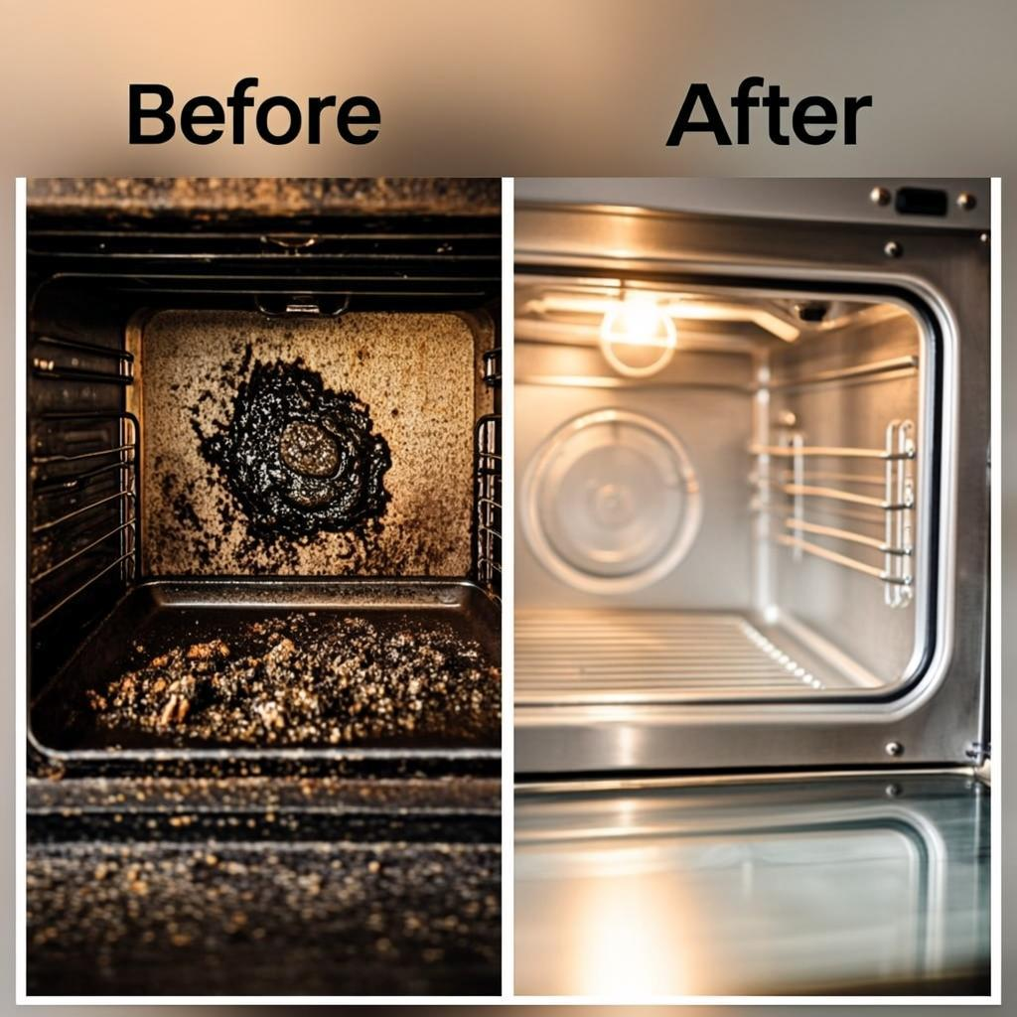

Tips for the Home
Home Cleaning Hacks & Tricks

8 Viral Cleaning Posts with Engagement Data
Content Emulation Reference Guide

Based on facebook.com/p/Tips-for-the-Home-100064841672514/
2,115,166 Likes · 25,649 Talking About This

Content Overview
This document contains 8 fully written social media posts that emulate the content style, tone, and format of the "Tips for the Home" Facebook page. Each post includes an original image, a detailed caption written in the page's characteristic conversational style, and simulated engagement metrics. The posts cover popular cleaning hack topics including oven cleaning, mirror tricks, pillow stain removal, showerhead descaling, sink polishing, stovetop degreasing, baseboard cleaning, and ceiling fan dusting. Use these as reference templates for creating similar viral cleaning content.

Clean Your Oven with Just Baking Soda and Vinegar
Stop scrubbing your oven for hours! This simple trick will have it looking brand new in no time.

Here's what you need:
• 1/2 cup baking soda
• 3 tablespoons water
• White vinegar
• A spray bottle
• A damp cloth

Mix the baking soda and water into a thick paste. Spread it all over the inside of your oven, avoiding the heating elements. Let it sit overnight — at least 12 hours.

The next morning, wipe out the paste with a damp cloth. Spray any stubborn spots with vinegar and watch it fizz away! Give it one final wipe and you're done.

Your oven will look like the day you bought it. No harsh chemicals needed!

Save this post for later and share it with someone who hates cleaning their oven!

❤️ 24.3K 💬 892 🔀 15.7K

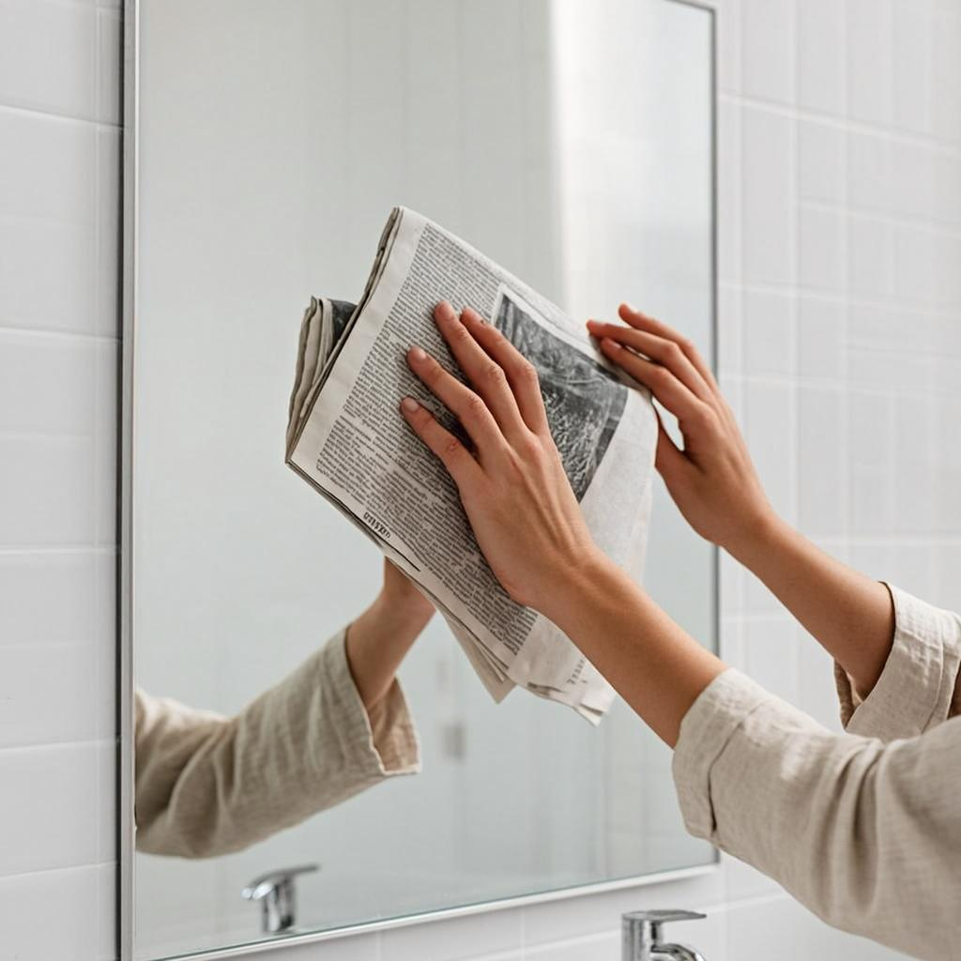
The Newspaper Trick for Streak-Free Mirrors
Tired of cleaning your mirrors and still seeing streaks? Try this old-school trick that actually works!

Instead of paper towels, use crumpled newspaper with your glass cleaner. The ink acts as a mild abrasive that removes residue without leaving lint behind.

Here's how:
• Spray glass cleaner directly on the mirror
• Crumple up a sheet of newspaper
• Wipe in circular motions
• Buff dry with a clean sheet

The difference is incredible. Your bathroom mirror will look like a professional cleaned it. Hotels have been using this trick for decades!

Works great on windows too. Try it on your car windshield for the clearest view you've ever had.

Tag someone who's always complaining about streaky mirrors!

❤️ 18.9K 💬 634 🔀 12.1K

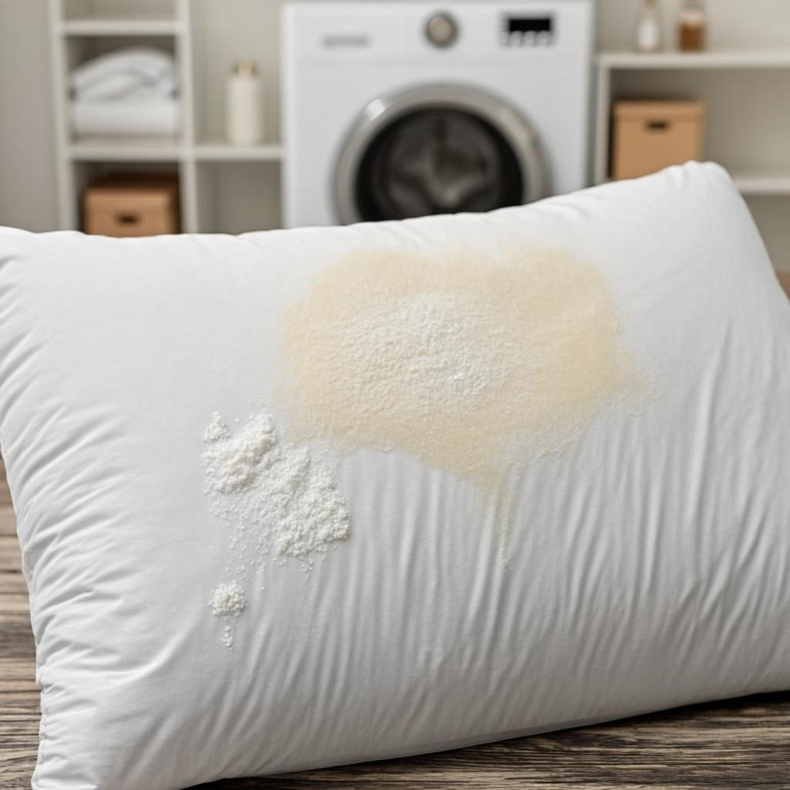
How to Remove Yellow Sweat Stains from Pillows
Don't throw away those yellowed pillows! You can make them white again with this simple mixture.

You'll need:
• 1 cup laundry detergent
• 1 cup powdered dishwasher detergent
• 1 cup bleach
• 1/2 cup borax
• Hot water

Remove the pillowcases and any covers. Check the care label first — most polyester pillows can handle hot water. Place two pillows in your washing machine at a time to keep the load balanced.

Add all the ingredients to the drum, not the dispenser. Run on the hottest setting your machine offers. For extra whitening, pause the cycle halfway through and let the pillows soak for an hour.

Dry them in the sun if possible — UV rays naturally bleach and deodorize. If using a dryer, add tennis balls to keep them fluffy.

Your pillows will look brand new! No need to spend money on replacements.

Share this with your family group chat!

❤️ 31.5K 💬 1.2K 🔀 22.8K

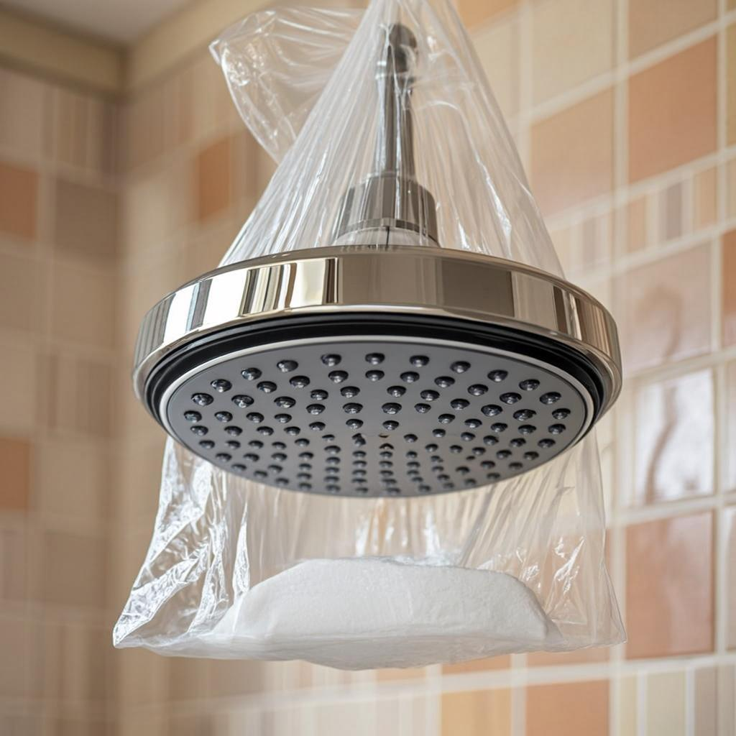
Soak Your Showerhead in Vinegar — Here's Why
Is your showerhead spraying in every direction except down? Time for a vinegar soak!

Hard water deposits build up over time and clog the nozzles. Instead of replacing the whole showerhead, try this:

1. Fill a plastic bag with white vinegar
2. Place it over the showerhead so the nozzles are submerged
3. Secure it with a rubber band or zip tie
4. Leave it overnight (at least 8 hours)
5. Remove the bag and run hot water for 2 minutes

The vinegar dissolves calcium and lime deposits without any scrubbing. You'll notice the water pressure improve immediately.

For really stubborn buildup, add a few tablespoons of baking soda to the vinegar. The fizzing action helps break through tough clogs.

This works on faucet aerators too! Save money and avoid buying chemical descalers.

Drop a 👍 if you're trying this tonight!

❤️ 15.7K 💬 478 🔀 9.3K

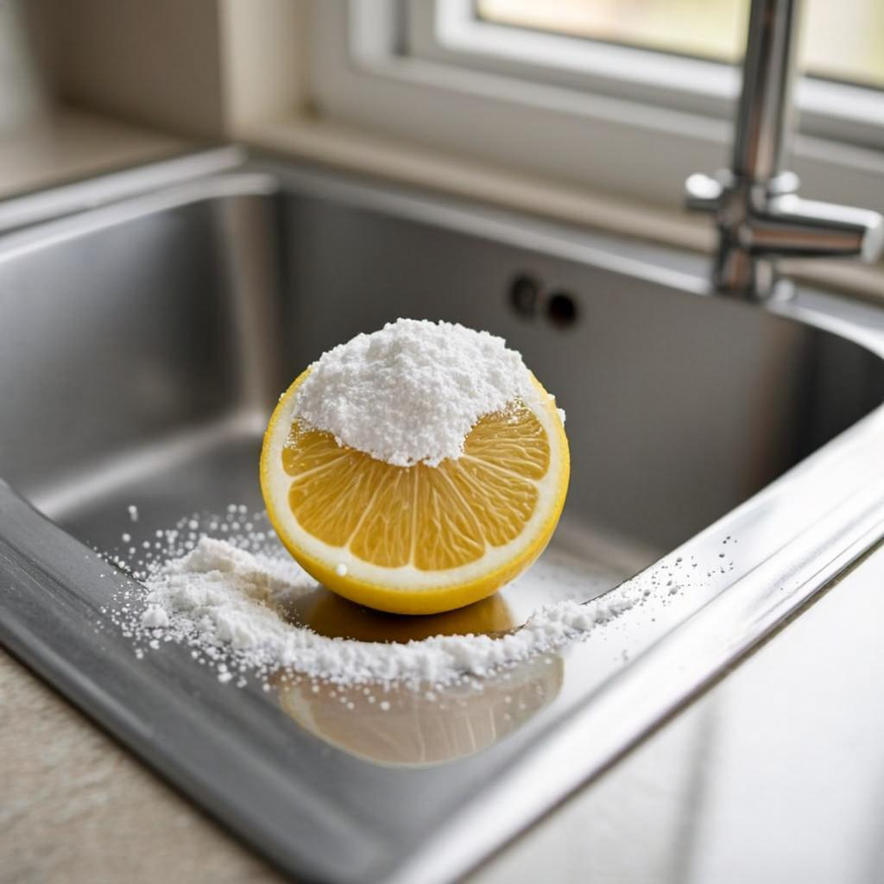
Polish Your Stainless Steel Sink with a Lemon
Want your stainless steel sink to sparkle? Reach for a lemon from your fridge!

Here's the secret:
• Cut a lemon in half
• Dip the cut side in baking soda
• Scrub the entire sink surface
• Let it sit for 5 minutes
• Rinse with warm water
• Dry with a microfiber cloth

The citric acid in the lemon breaks down grease and mineral deposits, while the baking soda acts as a gentle abrasive. Together they remove stains, water spots, and even rust marks.

For extra shine, rub the sink with a few drops of olive oil on a cloth. It creates a protective barrier that repels water and prevents future spots.

This also works on stainless steel appliances, pots, and pans. Your kitchen will look like a magazine spread!

Try it and tag us with your before and after photos!

❤️ 20.1K 💬 756 🔀 14.2K

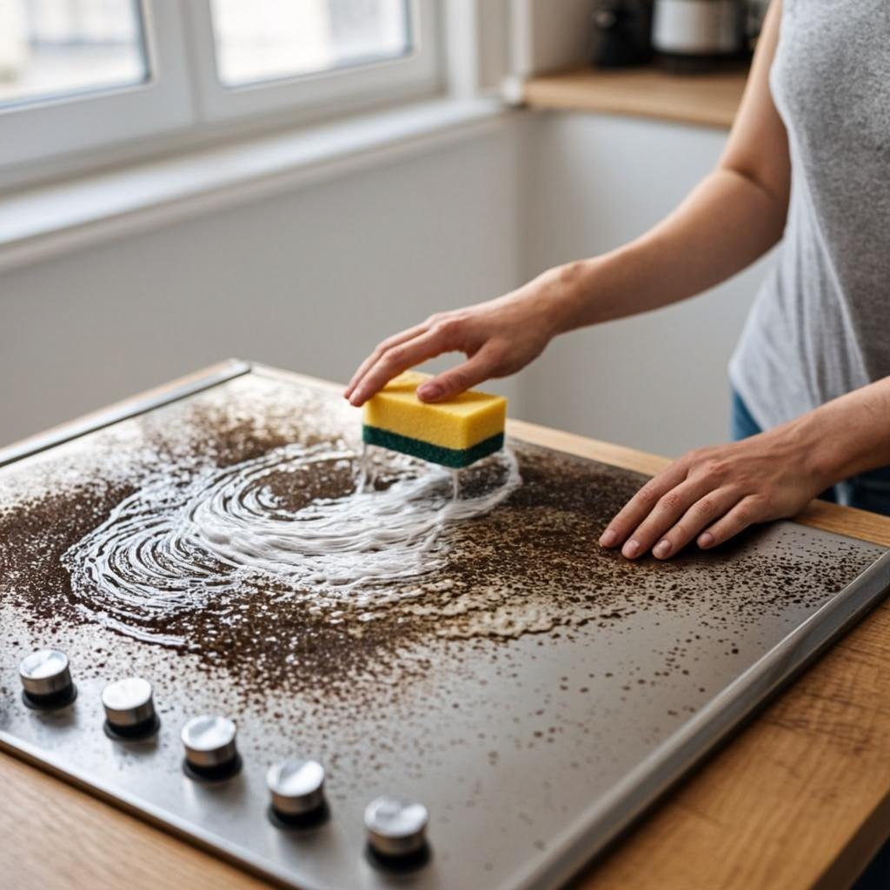
The Easiest Way to Clean a Greasy Stovetop
Cooking a big meal left your stovetop looking like a disaster zone? Don't worry — this method handles even the toughest grease.

What you'll need:
• Hot, soapy water (Dawn dish soap works best)
• Baking soda
• A razor scraper (for glass stovetops)
• Microfiber cloth
• Paper towels

First, remove the grates and knobs if possible. Sprinkle baking soda over the entire surface. Pour hot soapy water over the baking soda and let it bubble up. Let it sit for 15-20 minutes.

For burned-on food, use the razor scraper at a 45-degree angle. Wipe everything clean with a microfiber cloth. For glass stovetops, finish with a glass cleaner for a streak-free shine.

For gas stovetops, soak the grates in the same hot soapy water while you clean the surface.

Do this once a week and you'll never have a greasy stovetop again!

Save this recipe and share it with your cooking friends!

❤️ 27.8K 💬 1.1K 🔀 19.4K

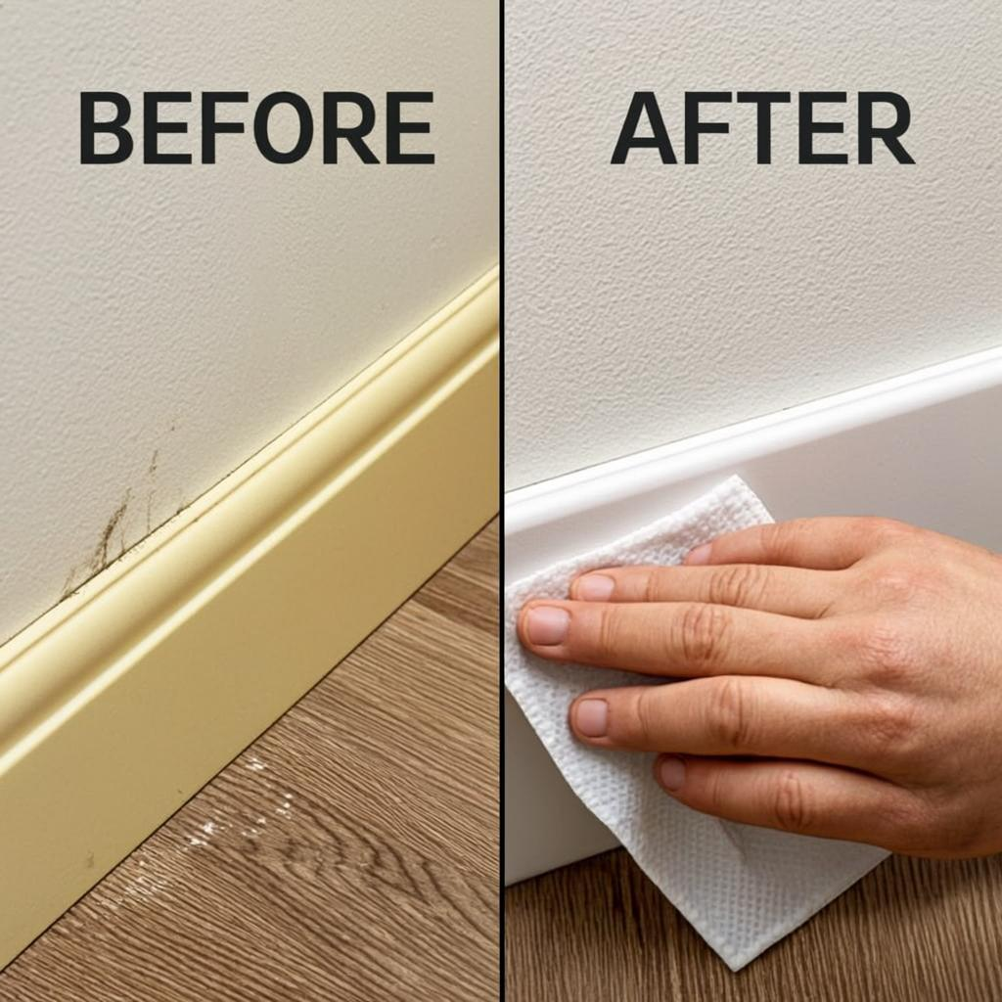
Use a Dryer Sheet to Clean Your Baseboards
This might sound weird, but dryer sheets are incredible for cleaning baseboards — and it takes half the time!

Why it works:
Dryer sheets are designed to reduce static in your laundry. That same anti-static property actually repels dust! When you wipe your baseboards with a dryer sheet, they stay cleaner for much longer.

How to do it:
• Take a clean dryer sheet (used ones work too!)
• Simply wipe along the top and front of each baseboard
• The sheet picks up dust, pet hair, and cobwebs effortlessly
• No water or cleaning spray needed

For really dirty baseboards, dampen the sheet slightly first. The softener in the sheet also helps remove scuff marks from shoes and furniture.

This trick saves SO much time during spring cleaning. You can clean every baseboard in your house in under 30 minutes.

Bonus: It also works on blinds, window sills, and door frames!

Pass this along to anyone who dreads cleaning day!

❤️ 33.2K 💬 1.5K 🔀 28.6K

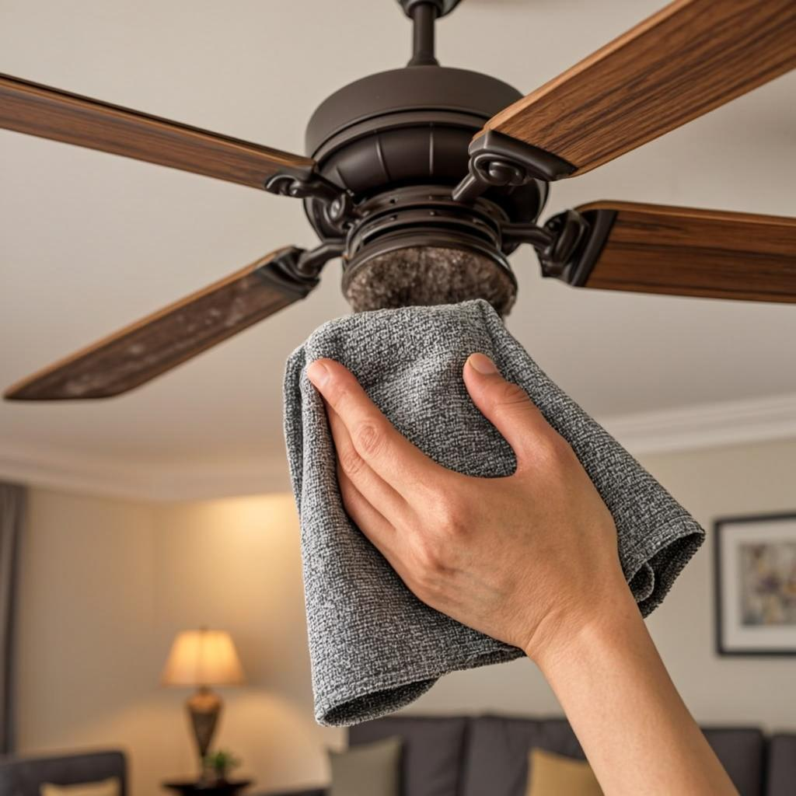
The Best Way to Dust a Ceiling Fan (No Ladder Needed)
Nobody likes cleaning the ceiling fan. It's awkward, dusty, and you always end up with debris in your eyes. But this hack changes everything.

The pillowcase method:
• Take an old pillowcase you don't need anymore
• Slide it over one fan blade
• Pull it back slowly while pressing against the blade
• All the dust falls INSIDE the pillowcase, not on you!
• Repeat for each blade

Then just take the pillowcase outside, turn it inside out, and shake it into the trash. No mess, no dust in your face, no ladder drama.

For a deeper clean, lightly dampen the pillowcase with water or furniture polish first. This picks up stubborn dust that's been clinging for months.

Pro tip: Do this before vacuuming so any dust that escapes gets picked up off the floor.

Your future self will thank you every time a breeze hits that clean fan!

Share this with someone who has a ceiling fan!

❤️ 19.4K 💬 823 🔀 16.1K

Tips for the Home — Content Emulation by Z.ai

