**PICK YOUR SEAT**

**1 INTRODUCTION**

**PickYourSeat** is an application which gives information about movies, events which was throughout the India. From this application the user can book the movie tickets before. And we can book the tickets for the events which were taking place throughout the India. User can book the tickets according to their phase. It gives the correct information about all the movies and activities that are taking place in India. We can cancel the booking before 30 minutes. Through this application the planning becomes easy and it reduces the time of the person because it shows all the information about the movies and events in one platform.

**1.1 PROBLEM STATEMENT**

Now a day’s people are busy with their works. There is no time to know about the information happening around them. In these busy schedules, people are interested to spend their weekends in joyful way. The weekend schedule of the persons differs from one to one. Some people are interested to participate events but they don't know what events and activities are going in their near places. And some people are interested in movies. To solve this problem and to give correct information about the events, activities and movies we are introducing this application called **PickYourSeat.**

**1.2 PURPOSE**

* To give the information about movies and events that are taking place in our location
* To give the correct and accurate information.
* To make the life easy and reduce the time for planning.
* More options for planning the weekend.
* To select the theatre for the movies and location for the events according to our convenience, choice.
  1. **SCOPE**

* PickYourSeat application gives maximum information about the movies and events.
* Users can book their movies and events from any place in anytime...
* There will be more options for the users to select.
* It reduces the time for planning.
* To give correct and accurate information for the user

**1.4 DEFINITIONS. ACRONYMS AND THE ABBREVIATIONS**

* User-One who uses the application
* Admin- One who develops the application
* System-Where all the changes are stored

**2 OVERALL DESCRIPTION**

**2.1 PRODUCT PERSPECTIVE**

The PickYourSeat application makes the users planning easier by showing all the movies and events nearby them By this application the time of he users will be save. It gives various options for the users for their activity. This application gives the accurate and exact results.

**2.2 SOFTWARE INTERFACE**

Operating System: Windows 10 Pro OS

Languages: HTML, JAVA SCRIPT, CSS

**2.3 HARDWARE INTERFACE**

Operating System: 64-bit operating system, x64-based processor

Processor: Intel(R) Core(TM) i3-4030U CPU @ 1.90GHz 1.90 GHz

RAM: 8.00 GB

* 1. **SYSTEM FUNCTIONS**
* In this application the user can login.
* He can book the tickets for movies and events that are taking place in overall India.
* User can add the offers which are available for him.
* User can order the food and beverages at the time of booking ticket
* Comprehensive reports have been developed to track the status of the documents at any given point of time. The user can cancel the booking in before 30 minutes the money will be refunded.
* This application provides so many options for payment
  1. **USER CHARACTERISTICS**
* User- The user can book, cancel the tickets for the movies and events. The payment was in various options.
* Admin - He has the certain activities such as add, delete, update the information about the movies and activities

**2.6 CONSTRAINTS**

* This application need internet to use.
* The refund money will be credited into user accounts after 3 to 4 working days

**3 USECASE DIAGRAM**

**3.1 ACTORS**

1. User: The person who uses the system to book movie tickets.
2. Admin: The person who manages the movie listings and views sales reports.
3. System: The software system that processes requests and manages data.

**3.2 USE CASES FOR USER**

1. Search Movie: The user can search for available movies in the system.
2. Book Ticket: The user can book a ticket for a chosen movie.
3. Cancel Booking: The user can cancel a previously booked ticket.
4. View Booking History:*The user can view the history of their bookings.

**3.3 USE CASES FOR ADMIN**

1. Add Movie: The admin can add new movies to the system.
2. Update Movie: The admin can update details of existing movies.
3. Remove Movie: The admin can remove movies from the system.
4. View Sales Report: The admin can view reports of ticket sales.

**3.4 EXPLAINATION OF RELATIONSHIPS**

1. User to Search Movie: The user initiates a search for movies.
2. User to Book Ticket: The user books a ticket after finding a suitable movie.
3. User to Cancel Booking: The user can cancel their booked tickets.
4. User to View Booking History: The user can see a record of all their bookings.
5. Admin to Add Movie: The admin adds new movies to the system's database.
6. Admin to Update Movie: The admin updates information for movies already in the system.
7. Admin to Remove Movie: The admin removes movies that are no longer available.
8. Admin to View Sales Report: The admin generates and views reports of ticket sales.

**3.5 USE CASE DIAGRAM**

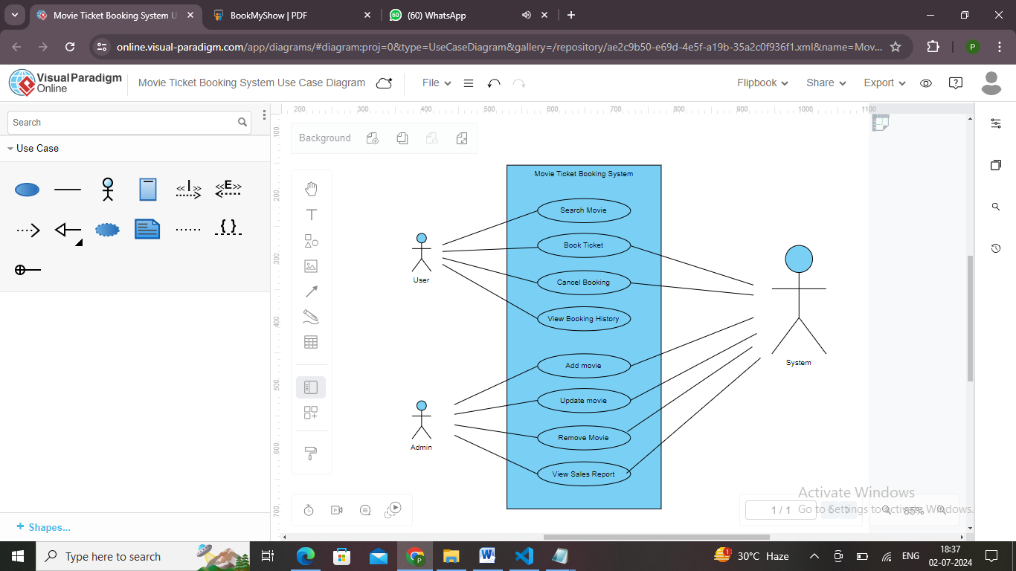

**Diagram Overview**

The diagram shows how the user and admin interact with the system. The user performs actions related to booking and managing their tickets, while the admin handles the maintenance of the movie database and views sales performance. The system acts as the intermediary that processes all these requests.

**4. SAMPLE CODE**

<!DOCTYPE html>

<html lang="en">

<head>

<meta charset="UTF-8">

<meta name="viewport" content="width=device-width, initial-scale=1.0">

<title>BookYourShow</title>

<style>

body {

font-family: Arial, sans-serif;

margin: 0;

padding: 0;

background-color: black;

}

header {

background-color: black;

border-bottom: 1px solid #ddd;

position: relative;

}

.top-bar, .menu-bar {

display: flex;

align-items: center;

padding: 10px 20px;

}

.top-bar {

justify-content: space-between;

}

.black {

color:yellow;

font-weight:bold;

}

.red {

color: yellow;

}

.search-bar {

width: 500px;

margin-left: 20px;

}

.search-bar input {

width: 100%;

padding: 5px 10px;

border: 1px solid #ddd;

border-radius: 3px;

}

.location, .user-actions {

display: flex;

align-items: center;

}

.location {

margin-left: auto;

margin-right: 20px;

position: relative;

}

.location label {

cursor: pointer;

color:yellow;

}

.hero {

background-image: url('https://assets-in.bmscdn.com/promotions/cms/creatives/1718863192962_1240x300hyderabad.png');

background-size: cover;

background-position: center;

height: 300px;

position: relative;

color: white;

text-align: center;

display: flex;

justify-content: center;

align-items: center;

}

.hero h1 {

background-color: black;

padding: 10px 20px;

border-radius: 5px;

}

.recommended-movies {

max-width: 1200px;

margin: 20px auto;

padding: 0 10px;

}

.recommended-movies h2 {

margin-bottom: 20px;

display: inline-block;

color:yellow;

}

.recommended-movies .see-all {

color: yellow;

text-decoration: none;

font-size: 16px;

float: right;

}

.movie-grid {

display: flex;

flex-wrap: wrap;

gap: 10px;

}

.movie {

flex: 1 1 calc(20% - 10px);

box-sizing: border-box;

cursor: pointer; /* Added cursor pointer for visual cue */

}

.movie img {

width: 100%;

border-radius: 5px;

}

.movie-info {

text-align: center;

margin-top: 10px;

}

/* Modal Styles */

.modal {

display: none; /* Hidden by default */

position: fixed; /* Stay in place */

z-index: 1; /* Sit on top */

left: 0;

top: 0;

width: 100%; /* Full width */

height: 100%; /* Full height */

overflow: auto; /* Enable scroll if needed */

background-color: rgba(0,0,0,0.5); /* Black w/ opacity */

}

.modal-content {

background-color: #fff;

margin: 15% auto; /* 15% from the top and centered */

padding: 20px;

border: 1px solid #ccc;

width: 80%; /* Could be more or less, depending on screen size */

max-width: 400px; /* Limit the width */

text-align: center;

border-radius: 10px;

box-shadow: 0 4px 8px rgba(0,0,0,0.2);

}

.close {

color: #aaa;

float: right;

font-size: 28px;

font-weight: bold;

}

.close:hover,

.close:focus {

color: black;

text-decoration: none;

cursor: pointer;

}

.footer {

margin-top: 20px;

background-color: grey;

color: white;

font-family: Arial, sans-serif;

margin: 0;

padding: 0;

}

</style>

</head>

<body>

<header>

<div class="top-bar">

<div>

<span class="red">Pick</span><span class="black">Your</span><span class="red">Seat</span>

</div>

<div class="search-bar">

<input type="text" placeholder="Search for Movies, Events, Plays, Sports and Activities">

</div>

<div class="location">

<label for="city" id="locationLabel" onclick="toggleDropdown()">Location</label>

<div class="dropdown" id="locationDropdown">

<div class="search-city">

<input type="text" placeholder="Search for your city">

</div>

<div class="search-city">

<button id="detectLocationBtn" onclick="detectLocation()">Detect my location</button>

</div>

<div class="cities">

<div>

<img src="https://in.bmscdn.com/m6/images/common-modules/regions/mumbai-selected.png" alt="Mumbai">

<p>Mumbai</p>

</div>

<div>

<img src="https://in.bmscdn.com/m6/images/common-modules/regions/ncr.png" alt="Delhi">

<p>Delhi-NCR</p>

</div>

<div>

<img src="https://in.bmscdn.com/m6/images/common-modules/regions/bang.png" alt="Bengaluru">

<p>Bengaluru</p>

</div>

<div>

<img src="https://in.bmscdn.com/m6/images/common-modules/regions/hyd.png" alt="Hyderabad">

<p>Hyderabad</p>

</div>

<div>

<img src="https://in.bmscdn.com/m6/images/common-modules/regions/ahd.png" alt="Ahmedabad">

<p>Ahmedabad</p>

</div>

<div>

<img src="https://in.bmscdn.com/m6/images/common-modules/regions/chd.png" alt="Chandigarh">

<p>Chandigarh</p>

</div>

<div>

<img src="https://in.bmscdn.com/m6/images/common-modules/regions/chen.png" alt="Chennai">

<p>Chennai</p>

</div>

<div>

<img src="https://in.bmscdn.com/m6/images/common-modules/regions/pune.png" alt="Pune">

<p>Pune</p>

</div>

<div>

<img src="https://in.bmscdn.com/m6/images/common-modules/regions/kolk.png" alt="Kolkata">

<p>Kolkata</p>

</div>

<div>

<img src="https://in.bmscdn.com/m6/images/common-modules/regions/koch.png" alt="Kochi">

<p>Kochi</p>

</div>

</div>

</div>

</div>

<div class="user-actions">

<button>Sign in</button>

</div>

</div>

<!-- Sign-In Modal -->

<div id="signInModal" class="modal">

<div class="modal-content">

<span class="close" id="closeModal">&times;</span>

<h2>Get Started</h2>

<button class="modal-btn google"><img src="google.jpg" alt="Google Logo" width="20"> Continue with Google</button>

<button class="modal-btn email"><img src="email.jpg">Continue with Email</button>

<button class="modal-btn apple"><img src="https://upload.wikimedia.org/wikipedia/commons/f/fa/Apple_logo_black.svg" alt="Apple Logo" width="20"> Continue with Apple</button>

<p>OR</p>

<div class="mobile-number">

<span class="flag"><img src="https://upload.wikimedia.org/wikipedia/en/4/41/Flag_of_India.svg" alt="India Flag" width="20"></span>

<span class="code">+91</span>

<input type="text" placeholder="Continue with mobile number">

</div>

<p>

I agree to the <a href="#">Terms & Conditions</a> & <a href="#">Privacy Policy</a>

</p>

</div>

</div>

<div class="footer">

<div>

<h5 class="he1">MOVIES NOW SHOWING IN HYDERABAD</h5>

<p class="para">Kalki 2898 AD | Maharaja | A Quiet Place - Day One | Chandhu Champion</p>

</div>

<div>

<h5 class="he">UPCOMING MOVIES IN HYDERABAD</h5>

<p class="para">Kill Dooensh | Bispill Basic Ocean | Hardal | Kagadadi | Sita Sangharas</p>

</div>

<div>

<h5 class="he">MOVIES BY GENRE</h5>

<p class="para">Comedy Movies | Drama Movies | Action Movies | Romantic Movies | Thriller Movies</p>

</div>

<div>

<h5 class="he">MOVIES BY LANGUAGE</h5>

<p class="para">Movies in English | Movies in Hindi | Movies in Telugu | Movies in Tamil</p>

</div>

<div>

<h5 class="he">SPORTS EVENTS IN HYDERABAD</h5>

<p class="para">Running | Archery | Athletics | Badminton | Basketball | Baseball</p>

</div>

<div>

<h5 class="he">EVENTS IN TOP CITIES</h5>

<p class="para1">Events in Mumbai | Events in Hyderabad | Events in Chennai | Events in Delhi-NCR | Events in Kolkata</p>

</div>

</div>

<script>

function toggleDropdown() {

const dropdown = document.getElementById('locationDropdown');

dropdown.classList.toggle('active');

if (dropdown.classList.contains('active')) {

document.body.style.overflow = 'hidden';

} else {

document.body.style.overflow = '';

}

}

function detectLocation() {

alert('Detecting location...');

}

// Add event listener to each city item in the dropdown

const cities = document.querySelectorAll('.cities div');

cities.forEach(city => {

city.addEventListener('click', function() {

const cityName = city.querySelector('p').textContent;

document.getElementById('locationLabel').textContent = cityName;

const dropdown = document.getElementById('locationDropdown');

dropdown.classList.remove('active');

document.body.style.overflow = '';

});

});

// Other script for modal and button actions

document.querySelector('.user-actions button').addEventListener('click', function() {

document.getElementById('signInModal').style.display = 'block';

});

document.getElementById('closeModal').addEventListener('click', function() {

document.getElementById('signInModal').style.display = 'none';

}); window.addEventListener('click', function(event) {

if (event.target == document.getElementById('signInModal')) {

document.getElementById('signInModal').style.display = 'none';

}

});

</script>

</body>

</html>

**5 BLOCKS OF CODE**

**5.1 MOVIE PAGE**

<!DOCTYPE html>

<html lang="en">

<head>

<meta charset="UTF-8">

<meta name="viewport" content="width=device-width, initial-scale=1.0">

<title>Kalki 2898 AD</title>

<style>

body {

font-family: Arial, sans-serif;

margin: 0;

padding: 0;

background-color: #fff;

color: #333;

}

.container {

display: flex;

flex-direction: column;

align-items: center;

padding: 20px;

background-color: #1b1b1b;

}

.top-section {

display: flex;

max-width: 1000px;

width: 100%;

background-color: #333;

padding: 20px;

border-radius: 10px;

color: white;

}

.poster {

max-width: 300px;

margin-right: 20px;

}

.poster img {

width: 100%;

border-radius: 10px;

}

.details {

flex: 1;

display: flex;

flex-direction: column;

}

.details h1 {

margin: 0;

font-size: 2em;

}

.rating {

margin-top: 10px;

font-size: 1.2em;

display: flex;

align-items: center;

}

.rating span {

margin-left: 10px;

color: #ffcc00;

}

.rate-now {

background-color: #ccc;

color: black;

padding: 5px 10px;

border-radius: 5px;

margin-left: 10px;

cursor: pointer;

}

.info {

margin-top: 10px;

}

.info p {

margin: 5px 0;

}

.book-tickets {

background-color: black;

color:yellow;

text-decoration: none;

padding: 10px;

border-radius: 5px;

text-align: center;

margin-top: 10px;

display: inline-block;

width: fit-content;

}

.about, .cast {

max-width: 1000px;

width: 100%;

margin-top: 20px;

background-color: #333;

padding: 20px;

border-radius: 10px;

color: white;

}

.about h2, .cast h2 {

margin-top: 0;

}

.cast-list {

display: flex;

justify-content: space-around;

flex-wrap: wrap;

}

.cast-item {

text-align: center;

margin: 10px;

}

.cast-item img {

width: 80px;

height: 80px;

border-radius: 50%;

}

</style>

</head>

<body>

<div class="container">

<div class="top-section">

<div class="poster">

<img src="https://assets-in.bmscdn.com/iedb/movies/images/mobile/thumbnail/xlarge/kalki-2898-ad-et00352941-1718275859.jpg" alt="Kalki 2898 AD"> <!-- Replace with your poster image path -->

<p>In cinemas</p>

</div>

<div class="details">

<h1>Kalki 2898 AD</h1>

<div class="rating">

<span>9/10 (362.6K Votes)</span>

<div class="rate-now">Rate now</div>

</div>

<div class="info">

<p>2D, IMAX 2D, IMAX 3D, 3D</p>

<p>Telugu, Hindi, Tamil, Kannada, Malayalam</p>

<p>3h 1m • Action, Sci-Fi, Thriller • UA • 27 Jun, 2024</p>

</div>

<a href="seat-selection.html" class="book-tickets">Book tickets</a>

</div>

</div>

<div class="about">

<h2>About the movie</h2>

<p>When the world is taken over by darkness. A force will rise.</p>

</div>

<div class="cast">

<h2>Cast</h2>

<div class="cast-list">

<div class="cast-item">

<img src="https://assets-in.bmscdn.com/iedb/artist/images/website/poster/large/prabhas-1708-1686915417.jpg" alt="Prabhas"> <!-- Replace with your cast image paths -->

<p>Prabhas as Bairaava</p>

</div>

<div class="cast-item">

<img src="https://assets-in.bmscdn.com/iedb/artist/images/website/poster/large/deepika-padukone-2822-12-09-2017-06-31-43.jpg" alt="Deepika Padukone">

<p>Deepika Padukone</p>

</div>

<div class="cast-item">

<img src="https://assets-in.bmscdn.com/iedb/artist/images/website/poster/large/amitabh-bachchan-138-12-09-2017-02-34-37.jpg" alt="Amitabh Bachchan">

<p>Amitabh Bachchan</p>

</div>

<div class="cast-item">

<img src="https://assets-in.bmscdn.com/iedb/artist/images/website/poster/large/kamal-haasan-2886-24-03-2017-17-54-38.jpg" alt="Kamal Haasan">

<p>Kamal Haasan</p>

</div>

<div class="cast-item">

<img src="https://assets-in.bmscdn.com/iedb/artist/images/website/poster/large/disha-patani-1061408-1714379037.jpg" alt="Disha Patani">

<p>Disha Patani</p>

</div>

<div class="cast-item">

<img src="https://assets-in.bmscdn.com/iedb/artist/images/website/poster/large/pasupathy-ramasaamy-6875-24-03-2017-17-50-02.jpg" alt="Pasupathy Ramaasamy">

<p>Pasupathy Ramaasamy</p>

</div>

</div>

</div>

</div>

</body>

</html>

**5.2 SEAT-SELECTION**

<!DOCTYPE html>

<html lang="en">

<head>

<meta charset="UTF-8">

<meta name="viewport" content="width=device-width, initial-scale=1.0">

<title>Seat Selection</title>

<style>

body {

font-family: Arial, sans-serif;

margin: 0;

padding: 0;

background-color: grey;

color:black;

}

header {

background-color:grey;

padding: 20px;

text-align: center;

border-bottom: 1px solid #ddd;

}

.tags span {

background-color: #f0f0f0;

border-radius: 4px;

padding: 5px 10px;

margin-right: 5px;

display: inline-block;

}

.container {

margin: 20px auto;

max-width: 1000px;

background-color: grey;

padding: 20px;

border-radius: 8px;

box-shadow: 0 0 10px rgba(0,0,0,0.1);

}

.movie-details {

display: flex;

justify-content: space-between;

align-items: center;

flex-wrap: wrap;

}

.movie-details h2 {

margin: 0;

font-size: 24px;

}

.filters {

margin-top: 10px;

display: flex;

flex-wrap: wrap;

}

.filters label {

margin-right: 10px;

}

.showtimes {

margin-top: 20px;

}

.showtime {

border-bottom: 1px solid #ddd;

padding: 10px 0;

}

.showtime:last-child {

border-bottom: none;

}

.showtime h3 {

margin: 0 0 10px 0;

font-size: 20px;

}

.showtime-info {

display: flex;

justify-content: space-between;

align-items: center;

flex-wrap: wrap;

}

.showtime-info div {

display: flex;

align-items: center;

flex-wrap: wrap;

}

.showtime-info span {

margin-right: 10px;

}

.showtime-info .times {

display: flex;

flex-wrap: wrap;

}

.showtime-info .times span {

background-color: #ffdddd;

border-radius: 4px;

padding: 5px 10px;

margin: 5px;

cursor: pointer;

}

.showtime-info .times span.available {

background-color: #d4edda;

}

.showtime-info .times span.fast-filling {

background-color: #fff3cd;

}

.date-selector {

display: flex;

justify-content: space-around;

margin: 20px 0;

}

.date-selector div {

text-align: center;

padding: 10px;

cursor: pointer;

}

.date-selector .selected {

background-color: #d4edda;

border-radius: 4px;

}

.seats {

display: none;

margin-top: 10px;

}

.seats-grid {

display: grid;

grid-template-columns: repeat(10, 30px);

gap: 5px;

justify-content: center;

}

.seat {

width: 30px;

height: 30px;

background-color: #d4edda;

text-align: center;

line-height: 30px;

border-radius: 4px;

cursor: pointer;

}

.seat.occupied {

background-color: #ffdddd;

cursor: not-allowed;

}

.seat.selected {

background-color: #a1d4a5;

}

.checkout {

text-align: center;

margin-top: 20px;

}

.proceed-button {

padding: 10px 20px;

background-color: yellow;

color: black;

border: none;

border-radius: 4px;

cursor: pointer;

display: none; /* Initially hide the button */

}

.total-cost {

margin-top: 10px;

font-size: 18px;

}

</style>

</head>

<body>

<header>

<h1>Kalki 2898 AD - Telugu</h1>

<div class="tags">

<span>Action</span>

<span>Sci-Fi</span>

<span>Thriller</span>

</div>

</header>

<div class="container">

<div class="date-selector">

<div class="selected">Sun<br>30 Jun</div>

<div>Mon<br>01 Jul</div>

<div>Tue<br>02 Jul</div>

<div>Wed<br>03 Jul</div>

<div>Thu<br>04 Jul</div>

<div>Fri<br>05 Jul</div>

</div>

<div class="movie-details">

<h2>Showtimes</h2>

<div class="filters">

<label for="language">Language:</label>

<select id="language">

<option value="telugu">Telugu - 2D</option>

</select>

<label for="price-range">Filter Price Range</label>

<label for="show-timings">Filter Show Timings</label>

</div>

</div>

<div class="showtimes">

<div class="showtime">

<h3>INOX: Ashoka One Mall, Kukatpally Y Junction</h3>

<div class="showtime-info">

<div>

<span>M-Ticket</span>

<span>Food & Beverage</span>

<span>Cancellation Available</span>

</div>

<div class="times">

<span class="available" onclick="showSeats('seats1')">06:25 PM</span>

<span class="fast-filling" onclick="showSeats('seats2')">07:05 PM</span>

<span class="available" onclick="showSeats('seats3')">07:15 PM</span>

<span class="fast-filling" onclick="showSeats('seats4')">10:10 PM</span>

<span class="available" onclick="showSeats('seats5')">11:00 PM</span>

</div>

</div>

<div id="seats1" class="seats">

<div class="seats-grid">

<!-- Add more seat numbers here -->

<div class="seat" data-seat="A1"></div>

<div class="seat" data-seat="A2"></div>

<div class="seat occupied" data-seat="A3"></div>

<div class="seat" data-seat="A4"></div>

<div class="seat" data-seat="A5"></div>

<div class="seat" data-seat="A6"></div>

<div class="seat" data-seat="A7"></div>

<div class="seat" data-seat="A8"></div>

<div class="seat" data-seat="A9"></div>

<div class="seat" data-seat="A10"></div>

<div class="seat" data-seat="B1"></div>

<div class="seat" data-seat="B2"></div>

<div class="seat occupied" data-seat="B3"></div>

<div class="seat" data-seat="B4"></div>

<div class="seat" data-seat="B5"></div>

<div class="seat occupied" data-seat="B6"></div>

<div class="seat" data-seat="B7"></div>

<div class="seat" data-seat="B8"></div>

<div class="seat occupied" data-seat="B9"></div>

<div class="seat" data-seat="B10"></div>

<div class="seat" data-seat="C1"></div>

<div class="seat occupied" data-seat="C2"></div>

<div class="seat" data-seat="C3"></div>

<div class="seat" data-seat="C4"></div>

<div class="seat" data-seat="C5"></div>

<div class="seat" data-seat="C6"></div>

<div class="seat" data-seat="C7"></div>

<div class="seat" data-seat="C8"></div>

<div class="seat occupied" data-seat="C9"></div>

<div class="seat" data-seat="C10"></div>

</div>

<div class="checkout">

<div class="total-cost">Total Cost: ₹<span id="totalCost1">0</span></div>

<button class="proceed-button" id="button1">Proceed to Payment</button>

</div>

</div>

</div>

<!-- Add more showtimes like the one above -->

<div class="showtime">

<h3>PVR: Forum Sujana Mall, Kukatpally</h3>

<div class="showtime-info">

<div>

<span>M-Ticket</span>

<span>Food & Beverage</span>

<span>Cancellation Available</span>

</div>

<div class="times">

<span class="available" onclick="showSeats('seats6')">05:00 PM</span>

<span class="fast-filling" onclick="showSeats('seats7')">08:00 PM</span>

<span class="available" onclick="showSeats('seats8')">09:15 PM</span>

</div>

</div>

<div id="seats6" class="seats">

<div class="seats-grid">

<div class="seat" data-seat="A1"></div>

<div class="seat" data-seat="A2"></div>

<div class="seat occupied" data-seat="A3"></div>

<div class="seat" data-seat="A4"></div>

<div class="seat" data-seat="A5"></div>

<div class="seat" data-seat="A6"></div>

<div class="seat" data-seat="A7"></div>

<div class="seat" data-seat="A8"></div>

<div class="seat" data-seat="A9"></div>

<div class="seat" data-seat="A10"></div>

<div class="seat" data-seat="B1"></div>

<div class="seat" data-seat="B2"></div>

<div class="seat occupied" data-seat="B3"></div>

<div class="seat" data-seat="B4"></div>

<div class="seat" data-seat="B5"></div>

<div class="seat occupied" data-seat="B6"></div>

<div class="seat" data-seat="B7"></div>

<div class="seat" data-seat="B8"></div>

<div class="seat occupied" data-seat="B9"></div>

<div class="seat" data-seat="B10"></div>

<div class="seat" data-seat="C1"></div>

<div class="seat occupied" data-seat="C2"></div>

<div class="seat" data-seat="C3"></div>

<div class="seat" data-seat="C4"></div>

<div class="seat" data-seat="C5"></div>

<div class="seat" data-seat="C6"></div>

<div class="seat" data-seat="C7"></div>

<div class="seat" data-seat="C8"></div>

<div class="seat occupied" data-seat="C9"></div>

<div class="seat" data-seat="C10"></div>

</div>

<div class="checkout">

<div class="total-cost">Total Cost: ₹<span id="totalCost2">0</span></div>

<button class="proceed-button" id="button2">Proceed to Payment</button>

</div>

</div>

</div>

<!-- Add another showtime with seats -->

<div class="showtime">

<h3>Cinepolis: Manjeera Mall, Kukatpally</h3>

<div class="showtime-info">

<div>

<span>M-Ticket</span>

<span>Food & Beverage</span>

<span>Cancellation Available</span>

</div>

<div class="times">

<span class="available" onclick="showSeats('seats9')">06:00 PM</span>

<span class="fast-filling" onclick="showSeats('seats10')">07:30 PM</span>

<span class="available" onclick="showSeats('seats11')">10:00 PM</span>

</div>

</div>

<div id="seats9" class="seats">

<div class="seats-grid">

<div class="seat" data-seat="A1"></div>

<div class="seat" data-seat="A2"></div>

<div class="seat occupied" data-seat="A3"></div>

<div class="seat" data-seat="A4"></div>

<div class="seat" data-seat="A5"></div>

<div class="seat" data-seat="A6"></div>

<div class="seat" data-seat="A7"></div>

<div class="seat" data-seat="A8"></div>

<div class="seat" data-seat="A9"></div>

<div class="seat" data-seat="A10"></div>

<div class="seat" data-seat="B1"></div>

<div class="seat" data-seat="B2"></div>

<div class="seat occupied" data-seat="B3"></div>

<div class="seat" data-seat="B4"></div>

<div class="seat" data-seat="B5"></div>

<div class="seat occupied" data-seat="B6"></div>

<div class="seat" data-seat="B7"></div>

<div class="seat" data-seat="B8"></div>

<div class="seat occupied" data-seat="B9"></div>

<div class="seat" data-seat="B10"></div>

<div class="seat" data-seat="C1"></div>

<div class="seat occupied" data-seat="C2"></div>

<div class="seat" data-seat="C3"></div>

<div class="seat" data-seat="C4"></div>

<div class="seat" data-seat="C5"></div>

<div class="seat" data-seat="C6"></div>

<div class="seat" data-seat="C7"></div>

<div class="seat" data-seat="C8"></div>

<div class="seat occupied" data-seat="C9"></div>

<div class="seat" data-seat="C10"></div>

</div>

<div class="checkout">

<div class="total-cost">Total Cost: ₹<span id="totalCost3">0</span></div>

<button class="proceed-button" id="button3">Proceed to Payment</button>

</div>

</div>

</div>

</div>

</div>

<script>

const seatPrice = 150; // Assuming each seat costs 150

function showSeats(seatId) {

const seatsContainer = document.getElementById(seatId);

if (seatsContainer.style.display === 'block') {

seatsContainer.style.display = 'none';

} else {

seatsContainer.style.display = 'block';

updateSeatAvailability(seatId);

}

}

function updateSeatAvailability(seatId) {

const seats = document.querySelectorAll(`#${seatId} .seat`);

const occupiedSeats = new Set(['A3', 'B3', 'B6', 'B9', 'C2', 'C9']); // List of occupied seats

seats.forEach(seat => {

const seatNumber = seat.getAttribute('data-seat');

if (occupiedSeats.has(seatNumber)) {

seat.classList.add('occupied');

} else {

seat.classList.remove('occupied');

}

seat.addEventListener('click', () => {

if (!seat.classList.contains('occupied')) {

seat.classList.toggle('selected');

checkSelectedSeats(seatId); // Check if any seats are selected after each click

}

});

});

}

function checkSelectedSeats(seatId) {

const selectedSeats = document.querySelectorAll(`#${seatId} .seat.selected`);

const proceedButton = document.querySelector(`#${seatId} .proceed-button`);

const totalCostElement = document.querySelector(`#${seatId} .total-cost span`);

const totalCost = selectedSeats.length * seatPrice;

totalCostElement.textContent = totalCost;

if (selectedSeats.length > 0) {

proceedButton.style.display = 'block';

} else {

proceedButton.style.display = 'none';

}

}

function saveSelectedSeats() {

const selectedSeats = document.querySelectorAll('.seat.selected');

const seatsArray = Array.from(selectedSeats).map(seat => seat.getAttribute('data-seat'));

localStorage.setItem('selectedSeats', JSON.stringify(seatsArray));

}

// Event listener to save seats and proceed to payment page

document.querySelectorAll('.proceed-button').forEach(button => {

button.addEventListener('click', function(event) {

event.preventDefault();

saveSelectedSeats();

// Redirect to payment page

window.location.href = 'payment.html';

});

});

</script>

</body>

</html>

**5.3 PAYEMENT**

<!DOCTYPE html>

<html lang="en">

<head>

<meta charset="UTF-8">

<meta name="viewport" content="width=device-width, initial-scale=1.0">

<title>Payment Page</title>

<style>

body {

font-family: Arial, sans-serif;

background-color: grey;

margin: 0;

padding: 0;

display: flex;

justify-content: center;

align-items: center;

height: 100vh;

}

.payment-container {

background-color: black;

padding: 20px;

border-radius: 8px;

box-shadow: 0 0 10px rgba(0,0,0,0.1);

text-align: center;

color:white;

}

h1 {

margin-top: 0;

font-size: 24px;

}

p {

margin-bottom: 20px;

color: #666;

}

.payment-button {

padding: 10px 20px;

background-color: yellow;

color: black;

border: none;

border-radius: 4px;

cursor: pointer;

}

</style>

</head>

<body>

<div class="payment-container">

<h1>Confirm Payment</h1>

<p>Please proceed to pay for your selected seats.</p>

<button class="payment-button">Pay Now</button>

</div>

<script>

// Implement payment processing logic here

document.querySelector('.payment-button').addEventListener('click', function() {

alert('Payment Successful!');

// Redirect to home page or confirmation page

window.location.href = 'index.html';

});

</script>

</body>

</html>

**6. SAMPLE OUTPUT**

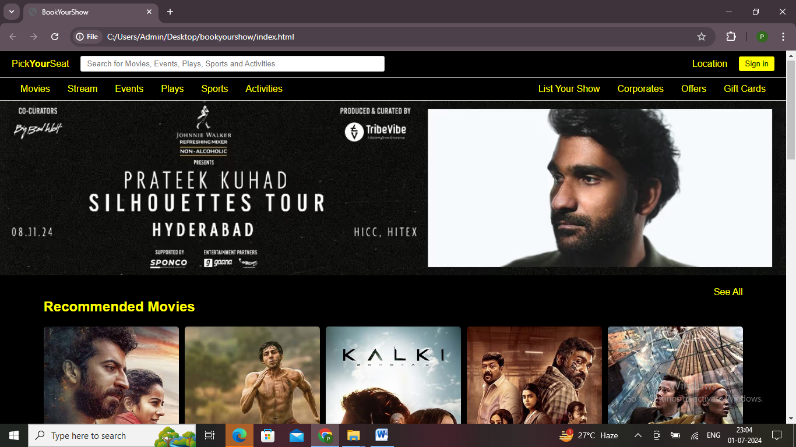

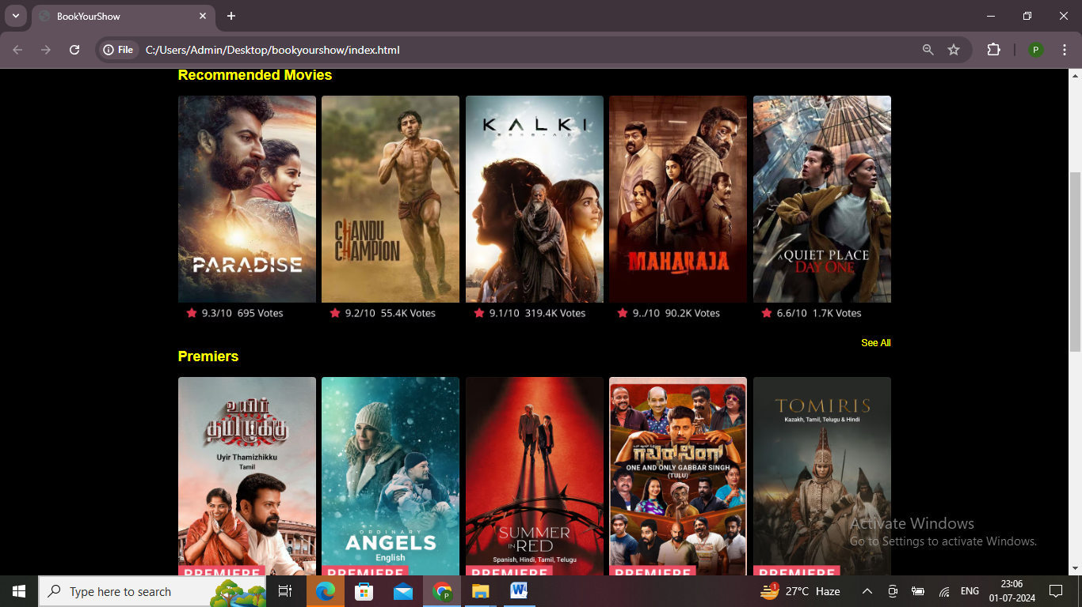

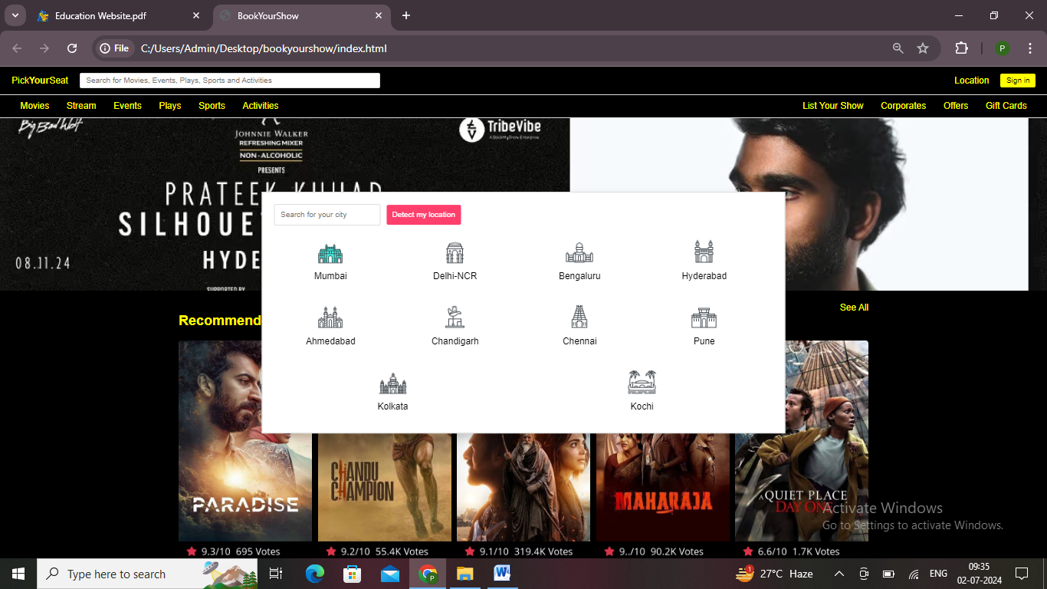

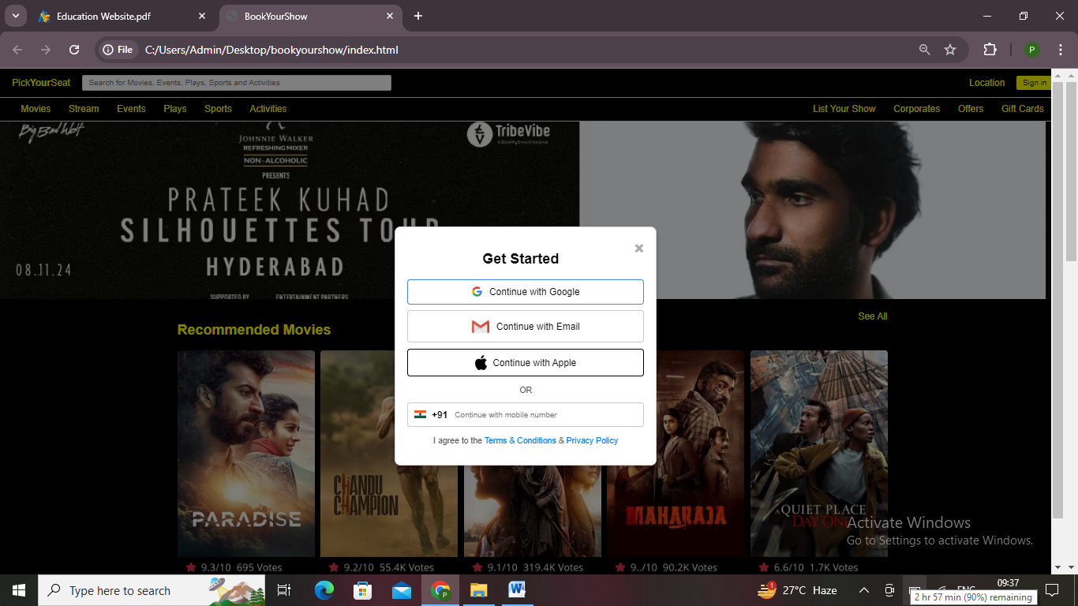

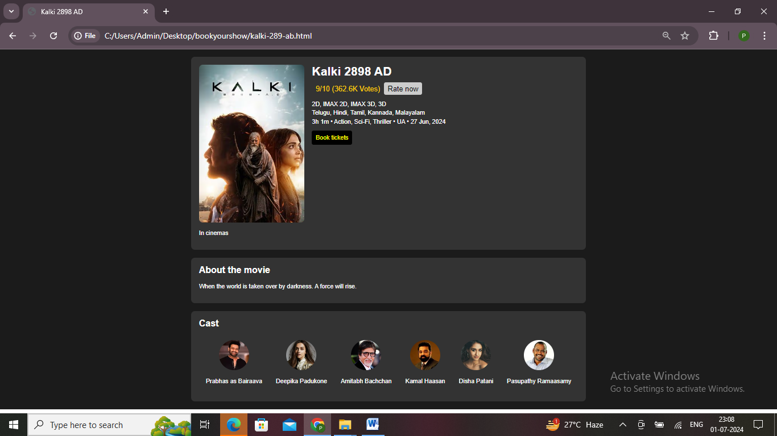

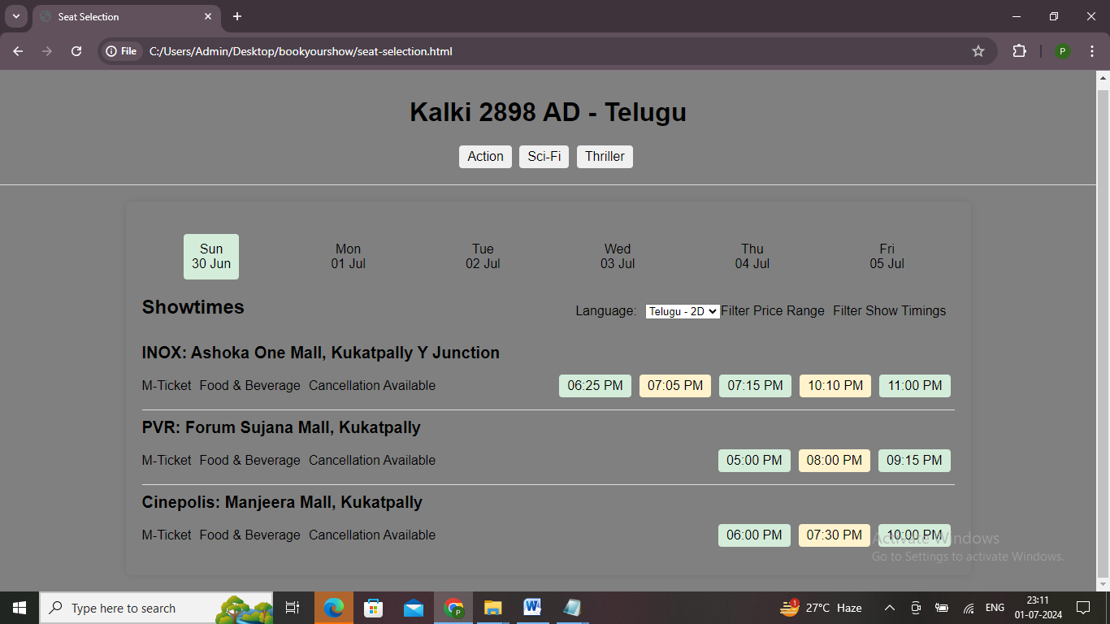

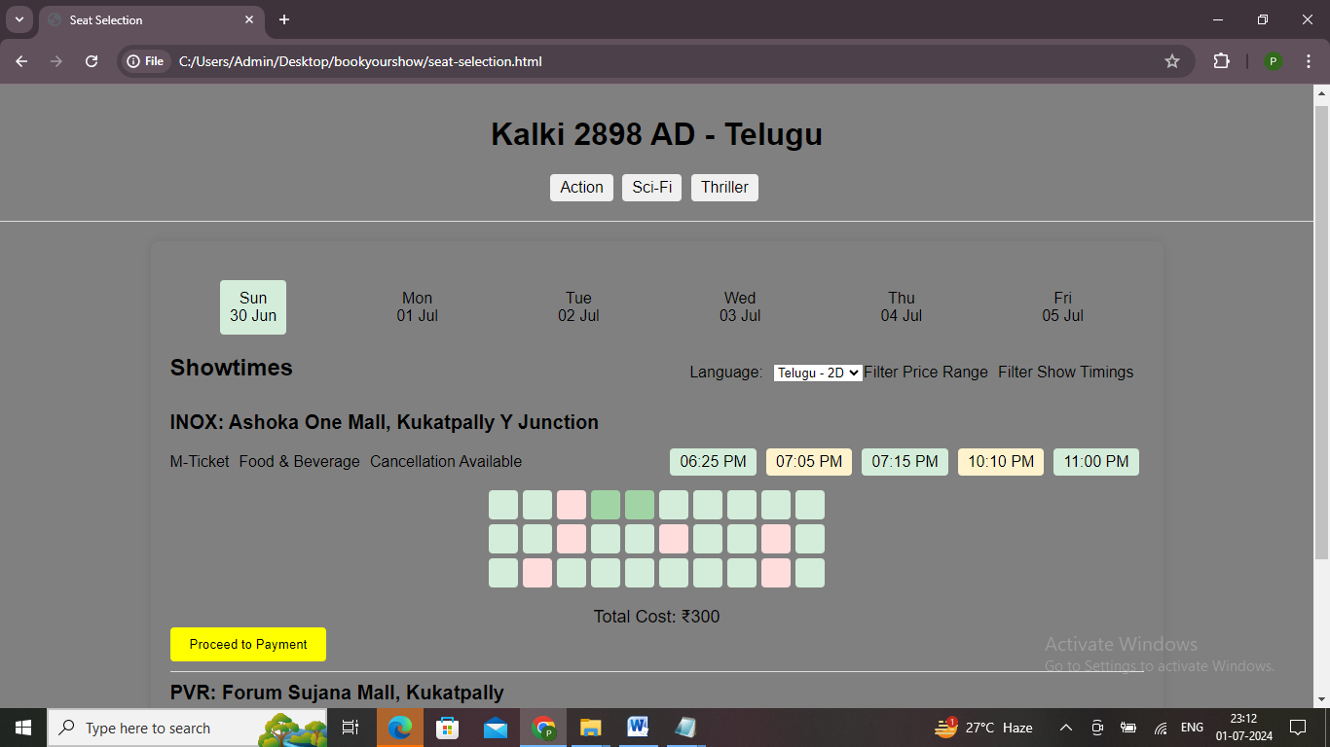

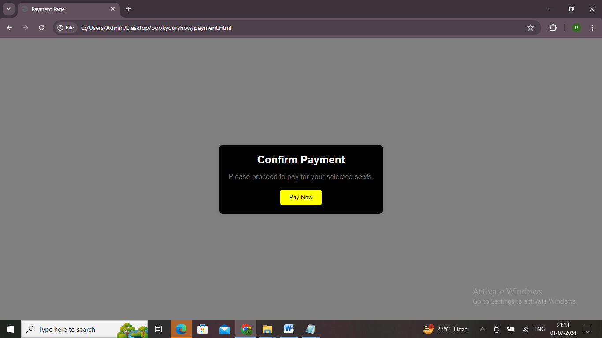

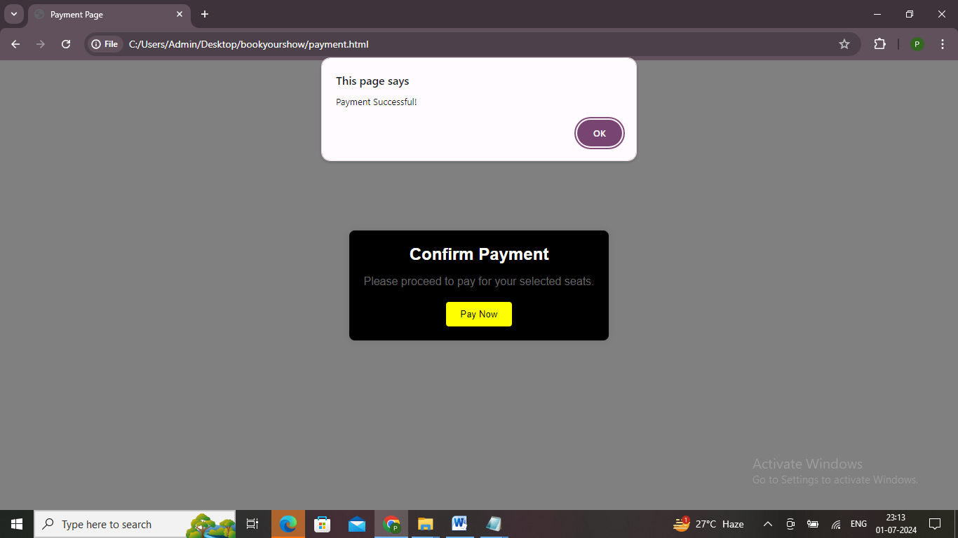

## 7. CONCLUSION

The "PickYourSeat" movie ticket booking application demonstrates how HTML, CSS, and JavaScript can be effectively combined to create a functional and user-friendly web application. This project allows users to browse movies, select show times, and book tickets seamlessly, providing a smooth and intuitive user experience.

The application showcases the power of front-end technologies in building interactive and dynamic web interfaces. By implementing features such as movie listings, seat selection, and payment integration, "PickYourSeat" replicates the essential functionalities of a real-world movie ticket booking system.

Furthermore, this project highlights the importance of responsive design, ensuring that users can access and use the application across various devices and screen sizes. The inclusion of JavaScript enhances the application's interactivity, enabling features such as form validation, dynamic content updates, and real-time feedback.

In conclusion, "PickYourSeat" serves as an excellent example of a web-based application that meets the demands of modern users. It provides a practical solution for movie enthusiasts looking to book tickets online, and it also serves as a valuable learning experience for developers aiming to enhance their skills in web development. With further enhancements and the integration of additional features, this application has the potential to evolve into a comprehensive movie ticket booking platform.