OS Behavior Monitor

Divergence-Gated Behavioral Baseline Learning with Overhead-Budgeted Adaptive Sampling
Project Implementation Report — Review 2 / Review 3
Course | Operating Systems
Team members | Gracy Mehndiratta (24BCE2987), Manan Kulshrestha (24BCE0262)
Roll numbers | 24BCE2987, 24BCE0262
Repository | https://github.com/gracymehndiratta/os-project
Date | October 2026
Document version | 1.0

Table of Contents
- Introduction and Objectives
- Technology Stack
- System Architecture
- Implementation Details
- Configuration Details
- Algorithms
- Testing
- Evaluation Results
- Output Screenshots
- How to Run
- Claim-to-Code Map
- Limitations
- Repository and Access

1. Introduction and Objectives
The OS Behavior Monitor is a Python monitoring agent that learns what "normal" behaviour looks like for each application on a machine and raises an explainable alert when a process deviates from that learned behaviour. The project is a research prototype built to produce measured evidence for two interlocking feedback loops:
- Loop 1 — the divergence gate (poisoning control). An attacker can try to "poison" a
behavioural baseline by changing a process's behaviour *slowly*, so that the baseline learns the malicious behaviour and never raises an alert (a "boiling frog" / slow-ramp attack). The gate compares three baselines — short-term, long-term and a trusted reference snapshot — and freezes the long-term baseline when it detects suspicious drift. New samples are held in a bounded quarantine buffer and are only merged back after independent corroboration (an administrator confirmation or a verified application update). A return to normal behaviour is never treated as corroboration, because malware can stop on purpose.
- Loop 2 — the sampling controller (overhead control). A monitor that measures
everything all the time is itself a resource hog. A self-meter measures the agent's own CPU and memory, and a controller adjusts a per-tick cost budget to stay near a configured CPU target. Sampling is organised into three tiers of increasing cost, and processes are served in priority order within the budget.
- Interlock. A baseline freeze marks the process as flagged and raises its desired
sampling tier, so suspicious processes are observed more closely — subject to the budget.

Objectives
- Learn per-(application, context) behavioural baselines that survive PID reuse.
- Detect anomalies with a joint multi-resource score that accounts for correlations
between resources.
- Protect baselines from slow poisoning using a divergence gate with quarantine and
corroboration.
- Keep the agent's own overhead inside a target budget using adaptive sampling.
- Produce explainable alerts (ranked feature contributions) and **graduated
responses** in dry-run mode.
- Provide a replay simulator and evaluation harness that compares the full system
against ablations on synthetic attack scenarios.

Scope
In scope: per-application, context-keyed baselines; joint multi-resource scoring; a divergence gate with quarantine and reconcile; overhead-budgeted sampling; explainable alerts; graduated responses in dry-run mode; a replay simulator and an evaluation harness.
Out of scope: kernel hooks (eBPF/ETW), real malware, cloud or fleet features, and any claim about performance on real attacks. All attack traces are synthetic.

2. Technology Stack

Programming languages
Language | Version | Used for
Python | 3.12 | Monitoring agent, statistics, gate, sampling controller, evaluation harness, API server
TypeScript | 5.5 | Dashboard application logic and types
TSX / React | 18.3 | Dashboard UI components
CSS (Tailwind) | 3.4 | Dashboard styling

Backend libraries
Library | Version | Role
FastAPI | 0.111 | REST + WebSocket API
Uvicorn | 0.29 | ASGI server
Pydantic | 2.7 | Request/response models
NumPy | 1.26 | Vectors, covariance, linear algebra
SciPy | 1.13 | Chi-squared risk percentiles
psutil | 5.9 | Live per-process telemetry
websockets | 12.0 | WebSocket transport

Frontend libraries
Library | Version | Role
React | 18.3 | Component framework
Vite | 5.3 | Dev server and bundler (proxies /api and /ws)
Recharts | 2.12 | Charts
TailwindCSS | 3.4 | Utility-first styling

Testing and tooling
Tool | Role
Python unittest (standard library) | Unit and integration tests (no pytest dependency)
Node.js 23 / npm 10 | Frontend build and dev server
Git / GitHub | Version control and repository hosting
The project is developed and tested on macOS (Darwin) with Python 3.12.4; the backend is pure Python and portable to Linux.

3. System Architecture
The agent is a per-tick pipeline. Telemetry is collected at a tier chosen by the sampling controller, scored against a context-specific baseline, passed through the gate, and then either learned, quarantined or alerted on.
┌──────────────────────────────────────────────┐
│ MonitorAgent (agent.py) │
└──────────────────────────────────────────────┘
Collector ──► Feature Builder ──► Identity/Context ──► Baseline Store
▲ │
│ sampling tier Joint Scorer ──► Explainer ──► Response Engine
│ │
Sampling Controller ◄── freeze request ◄── Divergence Gate ◄─► Quarantine Buffer
▲ │
Self-Meter (agent CPU / RSS) Corroboration sources

Per-tick data flow
- The controller assigns a sampling tier to every process, in priority order, within the
cost budget.
- The collector returns samples for the processes due at that tier. Tier 0 returns only
the cheap features (CPU and memory).
- Each full sample becomes a log-scale feature vector and is keyed by application identity
and context.
- The store picks the context-specific baseline if it is trusted, otherwise the coarse
application baseline ("*").
- The scorer computes the joint deviation D² and a risk value.
- The gate updates its drift measures and decides whether to learn, freeze, merge or
discard.
- Alerts fire after several consecutive high-risk samples and carry the ranked feature
contributions.
- The self-meter reads the agent's own usage each window and the controller adjusts the
budget.
During the warm-up period every sample is used for learning and nothing is scored, so new baselines are not judged on a handful of samples.

4. Implementation Details
The backend is organised into small modules, each mapping to a module contract in the design document. The table below summarises the module map; the subsections that follow describe each module in detail.
Module | Responsibility
agent/collector.py | ReplayCollector (synthetic traces) and PsutilCollector (live sampling)
agent/features.py | Log-scale feature vector, stable identity, time/parent context
agent/baseline.py | Gaussian, KeyState, QuarantineBuffer, BaselineStore
agent/scoring.py | Regularized joint Mahalanobis score and ranked contributions
agent/isolation.py | Isolation-forest ablation (Review 1 prior work) — not the default detector
agent/gate.py | Drift measures, gate state machine, quarantine, corroboration
agent/sampling.py | SelfMeter, SamplingController, LatencyTracker
agent/response.py | Graduated responses, dry-run, rollback
agent/agent.py | Wires the pipeline and runs the loops
agent/config.py | All tunable parameters
agent/data_model.py | Shared data types
agent/scenarios.py | Synthetic traces for the experiment scenarios
agent/evaluation.py | Variants, scenario runner, metrics table
agent/api.py | FastAPI REST + WebSocket
agent/models.py | Pydantic response models
backend/simulator.py | Standalone demo / replay / live runner
backend/evaluate.py | Evaluation harness CLI

4.1 Feature model
Five canonical features are used per process, matching the design document:
Index | Feature | Unit | Notes
0 | cpu_pct | % CPU
1 | rss_mb | MB | Resident memory
2 | disk_io_kbps | KB/s | Combined read + write
3 | net_kbps | KB/s | Combined network; live mode uses an open-socket-count proxy
4 | child_rate | procs/s | Rate of new child processes
Live psutil collection has no per-process network byte counter, so the live collector uses the open-socket count as a proxy. Real byte counts require eBPF or ETW, which are explicitly out of scope.
Each full sample is transformed to a log-scale vector with log1p(max(x, 0)) so that multiplicative and heavy-tailed resources behave additively and the Gaussian assumptions of the scorer are more reasonable.

4.2 Identity and context
A baseline must survive PID reuse, so two identities are maintained:
- application identity — a 16-hex-character hash of the normalised executable name
(application_id() in features.py); a restarted process reuses the same baseline.
- process instance identity — pid@start_time (process_instance_id()).
The context discriminator is time-bucket|username|parent, where the time bucket is one of night, morning, afternoon, evening. This prevents a midnight cron job from being scored against a daytime interactive baseline. A BaselineKey is (application_id, context); the coarse fallback context is the literal "*".

4.3 Collector
Two collectors implement the same contract and both return Sample objects:
- `ReplayCollector` replays synthetic traces deterministically at the tier requested by
the controller, honouring each tier's sampling interval and feature mask. It drives the evaluation harness and unit tests.
- `PsutilCollector` performs live sampling on a real machine: CPU percent, RSS,
disk read+write rate, open-socket count (network proxy) and child-process rate.

4.4 Baseline statistics and store
- `Gaussian` holds an effective count n, a mean vector and a covariance matrix. It
supports an exact online (Welford) update, an exponentially-weighted (EWMA) update (used for the short and long baselines so they react at different rates), and an exact parallel merge used when quarantined samples are reconciled. The mean and covariance are stored unregularized; every consumer adds its own ridge.
- `KeyState` holds the short, long and reference Gaussians, the gate state, the CUSUM
accumulator, the quarantine buffer, and freeze bookkeeping for one BaselineKey.
- `BaselineStore` maps BaselineKey → KeyState with coarse fallback and **LRU
eviction** (default cap 256 keys). All dict access is serialized with an RLock because the monitoring thread mutates the store while the API/WebSocket threads snapshot it.

4.5 Joint scorer
The scorer computes a regularized joint Mahalanobis distance between a sample's log-scale vector and the long baseline:
D² = (x − μ)ᵀ (Σ + λI)⁻¹ (x − μ)
Because Σ captures correlations between resources, the score detects *combinations* of moderate deviations rather than double-counting correlated ones. The risk value is the chi-squared CDF at df = 5. Each alert carries ranked per-feature contributions δᵢ · (Σ⁻¹δ)ᵢ / D², so a reviewer can see exactly which resource drove the alert.

4.6 Divergence gate
Three drift measures guard against slow poisoning:
- Mean shift — RMS standardized shift between the short and long baselines.
- CUSUM — an accumulated excess of small deviations that a single threshold would miss.
- Reference drift — shift between the long baseline and a trusted reference snapshot,
which catches an attacker who moves both short and long baselines together.
The gate is a state machine per key:
State | Behaviour | Exit
NORMAL | Short baseline always learns; long baseline learns only if the sample score is under the update guard | Freeze when mean shift, CUSUM or reference drift crosses its threshold
FROZEN | Long baseline is not updated; samples go to quarantine; the key is flagged | MERGE on independent corroboration, DISCARD when the TTL expires
MERGE | Buffer summary is merged into the long baseline; reference reset; CUSUM cleared | Back to NORMAL
DISCARD | Buffer dropped; short baseline reset to the long baseline | Back to NORMAL; the gate may freeze again
Drift measures are standardized by the trusted reference covariance (not the live long covariance), so a slow ramp cannot hide by inflating the long baseline's own variance. The reference snapshot is taken once the long baseline has converged (2 × min_samples).

4.7 Sampling controller and self-meter
The controller keeps a cost budget in units per tick. When measured agent CPU exceeds the target the budget shrinks by 20%; when usage stays below 70% of the target for several windows the budget grows by 15%. The asymmetric thresholds and the dwell count provide hysteresis and prevent oscillation.
Tier | Interval | Features | Cost / tick
0 — MINIMAL | every 8 ticks | CPU + memory only | 0.125 units
1 — NORMAL | every 2 ticks | all five | 2 units
2 — DETAILED | every tick | all five | 4 units
When the budget is tight, processes are served in priority order: flagged and high-risk processes first. Every process keeps at least tier 0, and each tick where a process receives less than it wanted is counted as reduced coverage (a signal that load may be pushing the monitor into degraded sampling).
A LatencyTracker records per-sample processing latency and reports p50/p95/p99 (the design's live-run metric).

4.8 Response engine
Risk levels map to graduated responses:
Risk level | Severity | Response
NORMAL | none | log only
NOTIFY | medium | notify administrator
THROTTLE | high | escalate sampling tier + notify
SUSPEND | critical | consider suspension (dry-run unless enabled)
Alerts fire only after alert_consecutive (default 3) consecutive high-risk samples. All disruptive actions are recorded as reversible RollbackActions. The engine stays in dry-run mode by default so automated suspension cannot disrupt legitimate processes.

4.9 Agent orchestrator and interlocks
MonitorAgent wires the pipeline together and runs the two loops each tick. It maintains both the exact-context baseline and the coarse ("*") baseline, and applies two interlocks:
- a baseline freeze marks the process flagged and raises its desired tier to DETAILED;
- a THROTTLE response escalates the tier through the response engine's callback.

4.10 API and dashboard
The backend exposes a REST API under /api and a WebSocket at /ws. The React dashboard connects to the WebSocket for live status and polls the REST endpoints for alerts, baselines and processes. It has four views: Overview (status cards, overhead gauges, overhead chart, recent alerts), Alerts (explainable alert feed), Baselines (short/long bars, gate state, quarantine counts, reconcile button) and Processes (risk, baseline state and sampling tier per process).

5. Configuration Details
All parameters live in agent/config.py. The defaults below are starting points; the design document says to choose final values from experiments, and the evaluation harness is used to re-tune them.
Parameter | Default | Meaning
baseline.alpha_short / alpha_long | 0.1 / 0.01 | EWMA rates of the two baselines
baseline.min_samples | 30 | Samples before a baseline is trusted
baseline.ridge | 0.02 | Covariance regularization (minimum tolerance, log units)
baseline.max_entries | 256 | LRU cap on stored (application, context) keys
gate.shift_thr | 1.5 | Short-vs-long standardized shift that triggers a freeze
gate.cusum_k / cusum_h | 0.5 / 12.0 | CUSUM allowance (slack) and alarm level
gate.ref_thr | 1.0 | Long-vs-reference shift that triggers a freeze
gate.update_guard | 3.0 | Per-sample score above which the long baseline does not learn
gate.ttl_days | 1.0 | Lifetime of an uncorroborated quarantine buffer
gate.max_buffers / max_buffer_samples | 64 / 512 | Buffer caps
score.notify / throttle / suspend | 0.995 / 0.9995 / 0.99995 | Chi-squared risk percentiles for response levels
score.alert_consecutive | 3 | Consecutive high-risk samples before an alert fires
sampling.cpu_budget_pct | 1.0 | Target agent CPU use (percent of one core)
sampling.window_ticks | 20 | Self-meter measurement window
sampling.budget_shrink / budget_grow | 0.20 / 0.15 | Budget change per over/under window
sampling.grow_threshold / dwell_count | 0.70 / 3 | Grow only after several under-target windows
sampling.initial_budget / min / max | 64 / 4 / 512 | Cost-budget bounds (units per tick)
dry_run | True | Disruptive responses are logged, not executed
ticks_per_day | 1440 | Replay ticks representing one simulated day
Tuned in practice. Two knobs were adjusted from the design defaults after experiments: the diurnal amplitude in scenarios._diurnal is 0.08, and the gate's standardization ridge _GATE_RIDGE is 1e-3.
Runtime environment variables (API server):
Variable | Default | Meaning
OSMON_LIVE | 0 | 1 uses live psutil collection instead of replay
OSMON_TICK_INTERVAL | 0.5 | Seconds per tick (smaller = faster simulated demo)

6. Algorithms

6.1 Joint Mahalanobis deviation
Given the long-baseline mean μ and regularized covariance Σ + λI, the deviation and risk are:
δ = x − μ
D² = δᵀ (Σ + λI)⁻¹ δ
risk = chi2.cdf(D², df = 5)
Per-feature contribution cᵢ = δᵢ (Σ⁻¹δ)ᵢ / D², ranked by magnitude, with a z-score δᵢ / σᵢ for direction.

6.2 CUSUM slow-drift detector
Each sample is mapped to a unit-variance excess centered on the long baseline and scaled by the reference covariance:
e_t = (δᵀ Σ_ref⁻¹ δ − df) / sqrt(2·df)
S_t = max(0, S_{t−1} + (e_t − k))
A freeze occurs when S_t ≥ h. Because a benign stream averages zero, k and h are meaningful in standard-deviation units.

6.3 Budget hysteresis
if cpu > target: budget ← budget · (1 − 0.20); violations += 1
elif cpu ≤ 0.70 · target: dwell += 1; if dwell ≥ 3: budget ← budget · (1 + 0.15); dwell ← 0
else: dwell ← 0
budget ← clamp(budget, min_budget, max_budget)

6.4 Exact Gaussian merge
For two Gaussians with counts n₁, n₂:
n = n₁ + n₂
μ = μ₁ + (μ₂ − μ₁)·n₂/n
Σ = [ n₁Σ₁ + n₂Σ₂ + (n₁n₂/n)·(μ₂−μ₁)(μ₂−μ₁)ᵀ ] / n
This is used when quarantined samples are reconciled after corroboration.

7. Testing
The project uses the Python standard-library unittest runner (no pytest dependency). There are 30 tests across two files:
- backend/tests/test_collector_sampling_response.py — the authoritative contract tests for
the collector, self-meter, sampling controller and response engine (9 tests).
- backend/tests/test_pipeline.py — baselines, store fallback, LRU, scorer, gate
freeze/quarantine/corroboration/TTL, interlock, latency, concurrent-snapshot safety, the isolation-forest ablation, evaluator fairness and end-to-end agent behaviour (21 tests).
Run them with:
cd backend
python -m unittest discover -s tests
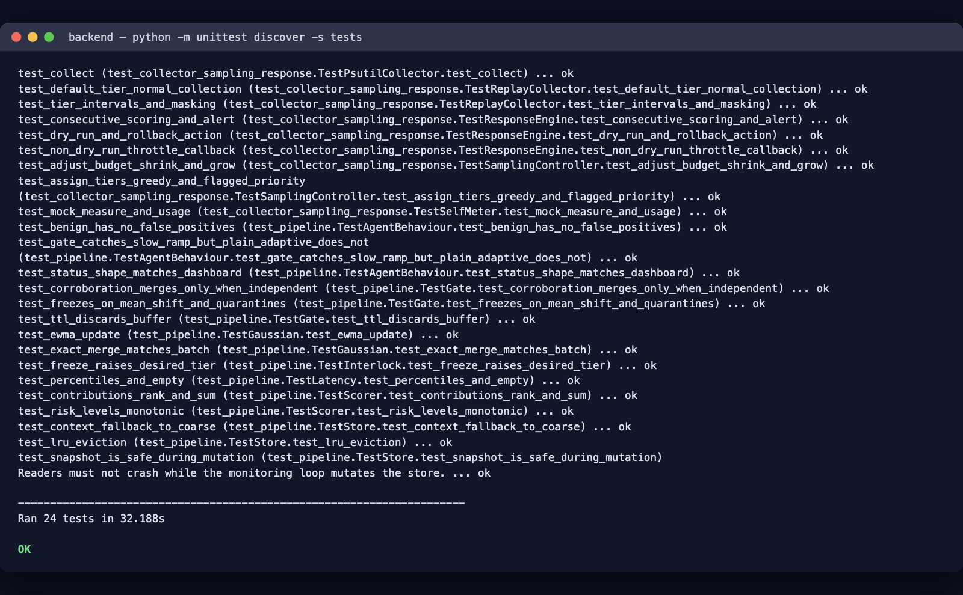
Unit test suite passing

8. Evaluation Results
The evaluation harness (backend/evaluate.py) compares six variants against five scenarios:
- Variants: static, plain_adaptive, gate_only, budget_only, full, and the
iforest ablation (Review 1 §6 prior work). The gate_only and budget_only variants isolate each controller, and iforest is the conventional point-anomaly detector evaluated on the same scenarios.
- Scenarios: benign, slow_ramp, evading_ramp, legit_step, overhead.
- Every variant is evaluated on a freshly rebuilt scenario, so the stateful replay RNG
feeds each variant an identical noise stream.
Reference results from python evaluate.py --quick (all replay; det is attack detection, after is alerts remaining after the legitimate step, recov(d) is days from corroboration until the alerts stop):
scenario | variant | det | delay(d) | atk_alerts | FP/proc/day | freezes | cpu% | viol | reduced | after | recov(d)
benign | static | - | - | 0 | 0.0000 | 0 | 0.02 | 0 | 0 | - | -
benign | plain_adaptive | - | - | 0 | 0.0000 | 0 | 0.02 | 0 | 0 | - | -
benign | gate_only | - | - | 0 | 0.0000 | 0 | 0.02 | 0 | 0 | - | -
benign | budget_only | - | - | 0 | 0.0000 | 0 | 0.02 | 0 | 0 | - | -
benign | full | - | - | 0 | 0.0000 | 0 | 0.02 | 0 | 0 | - | -
benign | iforest | - | - | 0 | 0.0000 | 0 | 0.02 | 0 | 0 | - | -
slow_ramp | static | yes | 0.92 | 240 | 0.0000 | 0 | 0.03 | 0 | 0 | - | -
slow_ramp | plain_adaptive | yes | 1.17 | 1 | 0.0000 | 0 | 0.03 | 0 | 0 | - | -
slow_ramp | gate_only | yes | 0.92 | 433 | 0.0000 | 7 | 0.04 | 0 | 0 | - | -
slow_ramp | budget_only | yes | 1.17 | 1 | 0.0000 | 0 | 0.03 | 0 | 0 | - | -
slow_ramp | full | yes | 0.92 | 433 | 0.0000 | 7 | 0.04 | 0 | 0 | - | -
slow_ramp | iforest | no | - | 0 | 0.0000 | 0 | 0.03 | 0 | 0 | - | -
evading_ramp | static | yes | 1.12 | 253 | 0.0000 | 0 | 0.03 | 0 | 0 | - | -
evading_ramp | plain_adaptive | no | - | 0 | 0.0000 | 0 | 0.03 | 0 | 0 | - | -
evading_ramp | gate_only | yes | 1.92 | 466 | 0.0000 | 8 | 0.04 | 0 | 0 | - | -
evading_ramp | budget_only | no | - | 0 | 0.0000 | 0 | 0.03 | 0 | 0 | - | -
evading_ramp | full | yes | 1.92 | 466 | 0.0000 | 8 | 0.04 | 0 | 0 | - | -
evading_ramp | iforest | no | - | 0 | 0.0000 | 0 | 0.03 | 0 | 0 | - | -
legit_step | static | - | - | 0 | - | 0 | 0.03 | 0 | 0 | 240 | 0.50
legit_step | plain_adaptive | - | - | 0 | - | 0 | 0.03 | 0 | 0 | 4 | 0.25
legit_step | gate_only | - | - | 0 | - | 4 | 0.03 | 0 | 0 | 480 | 0.50
legit_step | budget_only | - | - | 0 | - | 0 | 0.03 | 0 | 0 | 4 | 0.25
legit_step | full | - | - | 0 | - | 4 | 0.03 | 0 | 0 | 480 | 0.50
legit_step | iforest | - | - | 0 | - | 0 | 0.03 | 0 | 0 | 0 | 0.00
overhead | static | - | - | 0 | 0.0000 | 0 | 0.24 | 0 | 0 | - | -
overhead | plain_adaptive | - | - | 0 | 0.0000 | 0 | 0.24 | 0 | 0 | - | -
overhead | gate_only | - | - | 0 | 0.0000 | 0 | 0.24 | 0 | 0 | - | -
overhead | budget_only | - | - | 0 | 0.0000 | 0 | 0.23 | 0 | 15 | - | -
overhead | full | - | - | 0 | 0.0000 | 0 | 0.23 | 0 | 15 | - | -
overhead | iforest | - | - | 0 | 0.6400 | 0 | 0.24 | 0 | 0 | - | -

Interpretation
- No false-positive alerts on the benign scenario for any variant (0 episodes per
process-day), and no benign freezes for the gate variants.
- A non-adapting baseline (static) detects both ramps (0.92 d / 1.12 d) precisely
because it never learns — but it cannot adapt to legitimate change, so on legit_step it keeps alerting (240 alerts after the step) and needs a manual reset. It is not viable in practice.
- An adaptive baseline without the gate (plain_adaptive, budget_only) produces at
most a single late alert on the gradual ramp (1.17 d, atk_alerts = 1) and none on the evading ramp, versus 433–466 sustained alerts for the gate variants. On legit_step it recovers fast (4 alerts after, 0.25 d) — the very adaptation that makes it convenient is what makes it poisonable. The binary det column marks yes for that one marginal alert; the alert count is the meaningful number.
- The divergence gate (gate_only, full) restores sustained ramp detection
(0.92 d / 1.92 d, 433–466 alerts) while still absorbing benign traffic, which is the central result. The evading ramp is caught by reference drift at ~1.92 days. The cost is visible on legit_step: the gate freezes and only clears ~0.50 days after administrator corroboration.
- The budget controller is active only under load (overhead): budget_only and full
reduce coverage for 15 ticks and hold modeled CPU near 0.23% (versus 0.24% for the non-budget variants), with no budget violations.
- Per-sample latency is reported by the harness but is wall-clock and machine dependent,
so it is omitted from the table. In these runs the Gaussian scorer is ≈0.3–0.8 ms p50, while the isolation-forest ablation is ≈4–6 ms p50 (roughly an order of magnitude higher), because every sample is pushed through every tree.

8.1 Isolation-forest ablation (Review 1 prior work)
Review 1 §6 identifies isolation forest as a lightweight but batch-oriented alternative whose "standard implementations require retraining or modification for incremental learning" [6]. It is therefore not part of the proposed solution, but it is implemented as an ablation so the contribution of the divergence gate can be isolated empirically.
Implementation (agent/isolation.py, variant iforest):
- one global forest — a per-key forest sees only 30–60 samples per warm-up window, which
is too few to calibrate a 0.5% alert tail;
- refit every 120 ticks on a 256-sample sliding window, the minimal modification needed for
incremental operation;
- the raw score is converted to a risk with an empirical tail probability against the
reference window, so the same notify / throttle / suspend thresholds apply unchanged;
- no gate and no budget, matching a conventional detector baseline;
- explanations rank features by robust departure (median/IQR), because iForest exposes no
closed-form per-feature attribution.
The ablation misses both ramps (det = no) and raises no alerts on legit_step, which is the expected behaviour of a point-anomaly detector: a slow ramp is a *collective* drift that stays inside the normal cloud, so no individual point is isolated. On the heterogeneous overhead fleet it also produces false positives, because one global forest has no per-application context and flags normal heavy processes as fleet outliers. Unit tests confirm that it *does* score coordinated multi-resource outliers highly, and that a one-feature shift is not detected even when extreme — two limitations of the point-anomaly approach that the proposed per-key, correlation-aware scorer does not share.
Periodic refitting also creates a new poisoning channel: an attacker who influences the refit window shapes the forest. Together with the order-of-magnitude per-sample cost, these results support the design choice: the gate turns an adaptive, context-aware baseline into a poisoning-resistant detector, and the budget controller is what keeps sampling affordable.
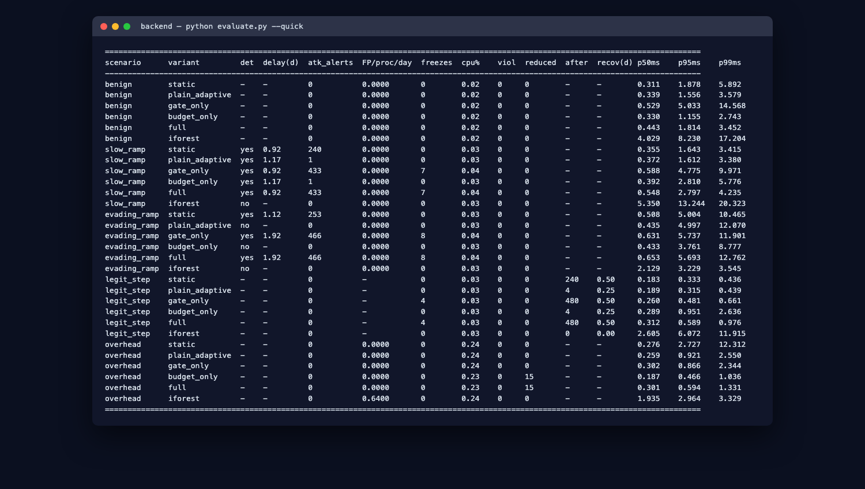
Evaluation harness output

9. Output Screenshots
The screenshots below were captured from the live dashboard and the command-line tools.

9.1 Dashboard — Overview
Status cards (processes, alerts, frozen baselines, budget), the agent-overhead gauges and live chart, and the explainable alert feed with ranked feature contributions.
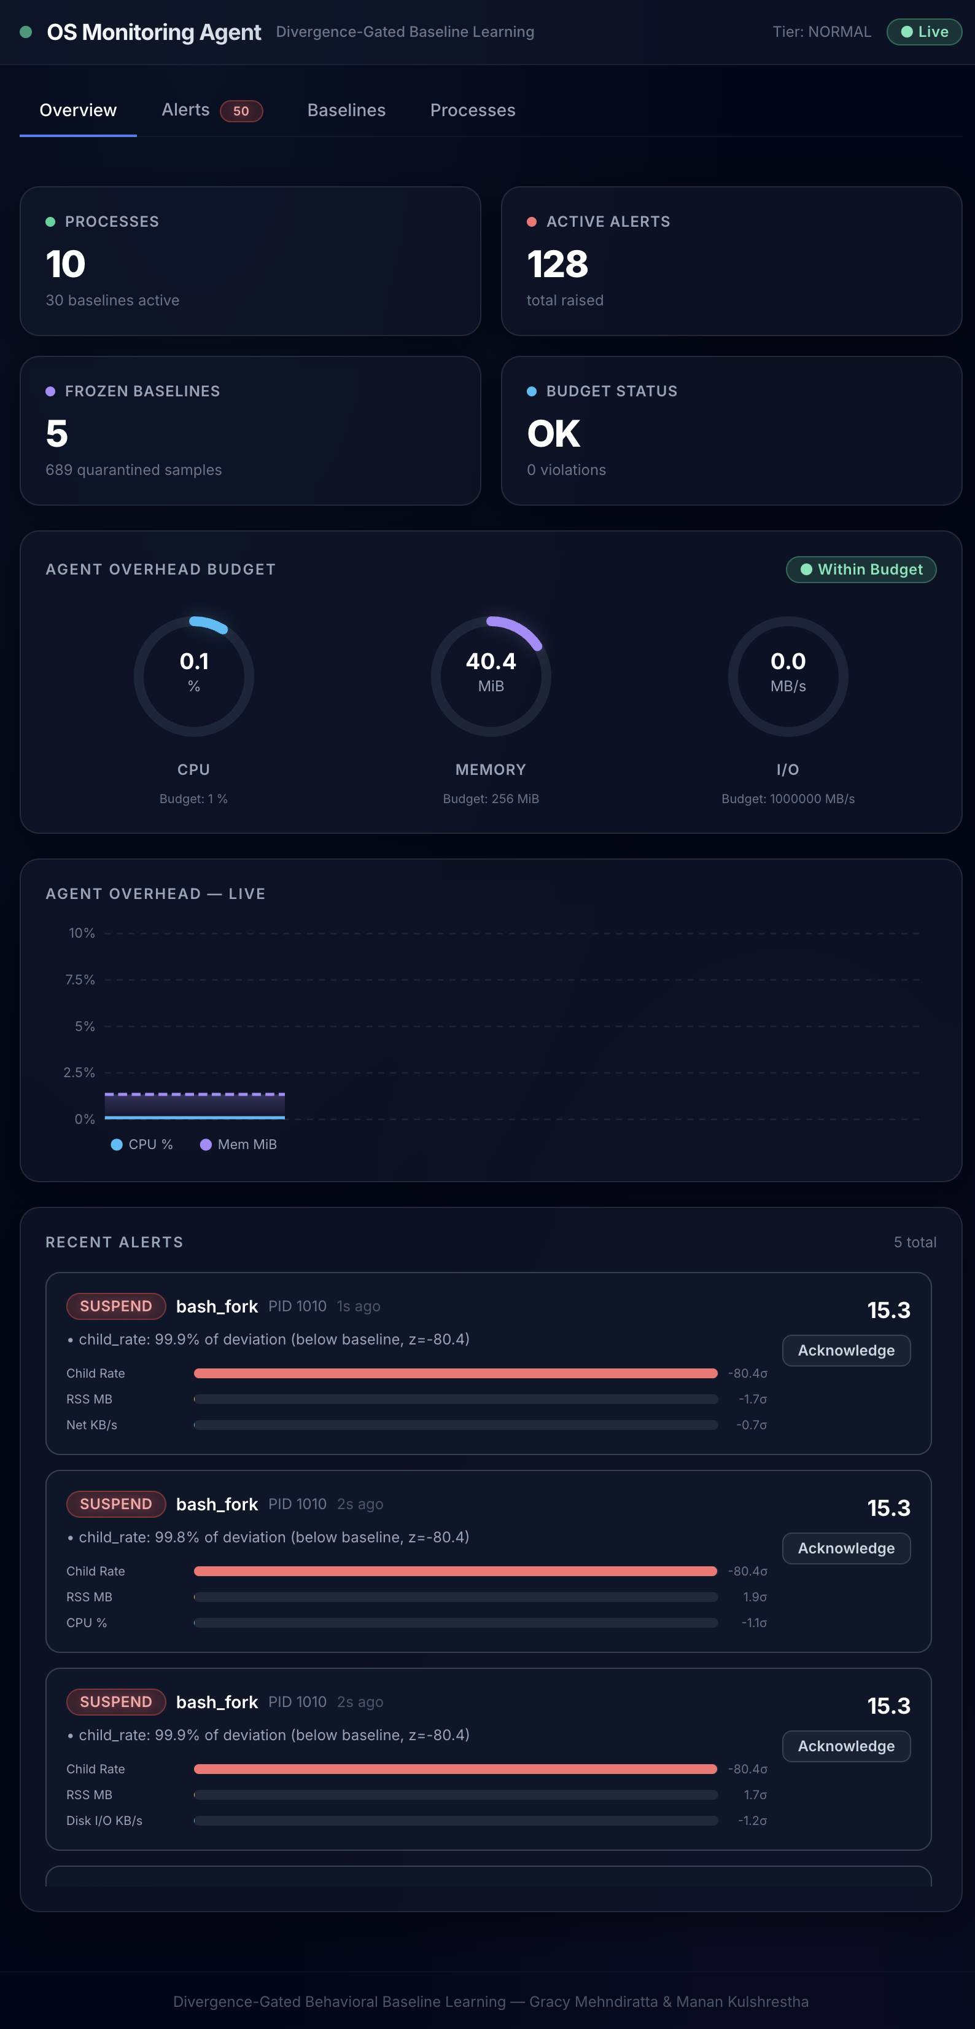
Dashboard overview

9.2 Dashboard — Alerts
The alert feed shows severity badges (NOTIFY / THROTTLE / SUSPEND), the process and PID, the plain-language explanation and the top contributing features with z-scores.
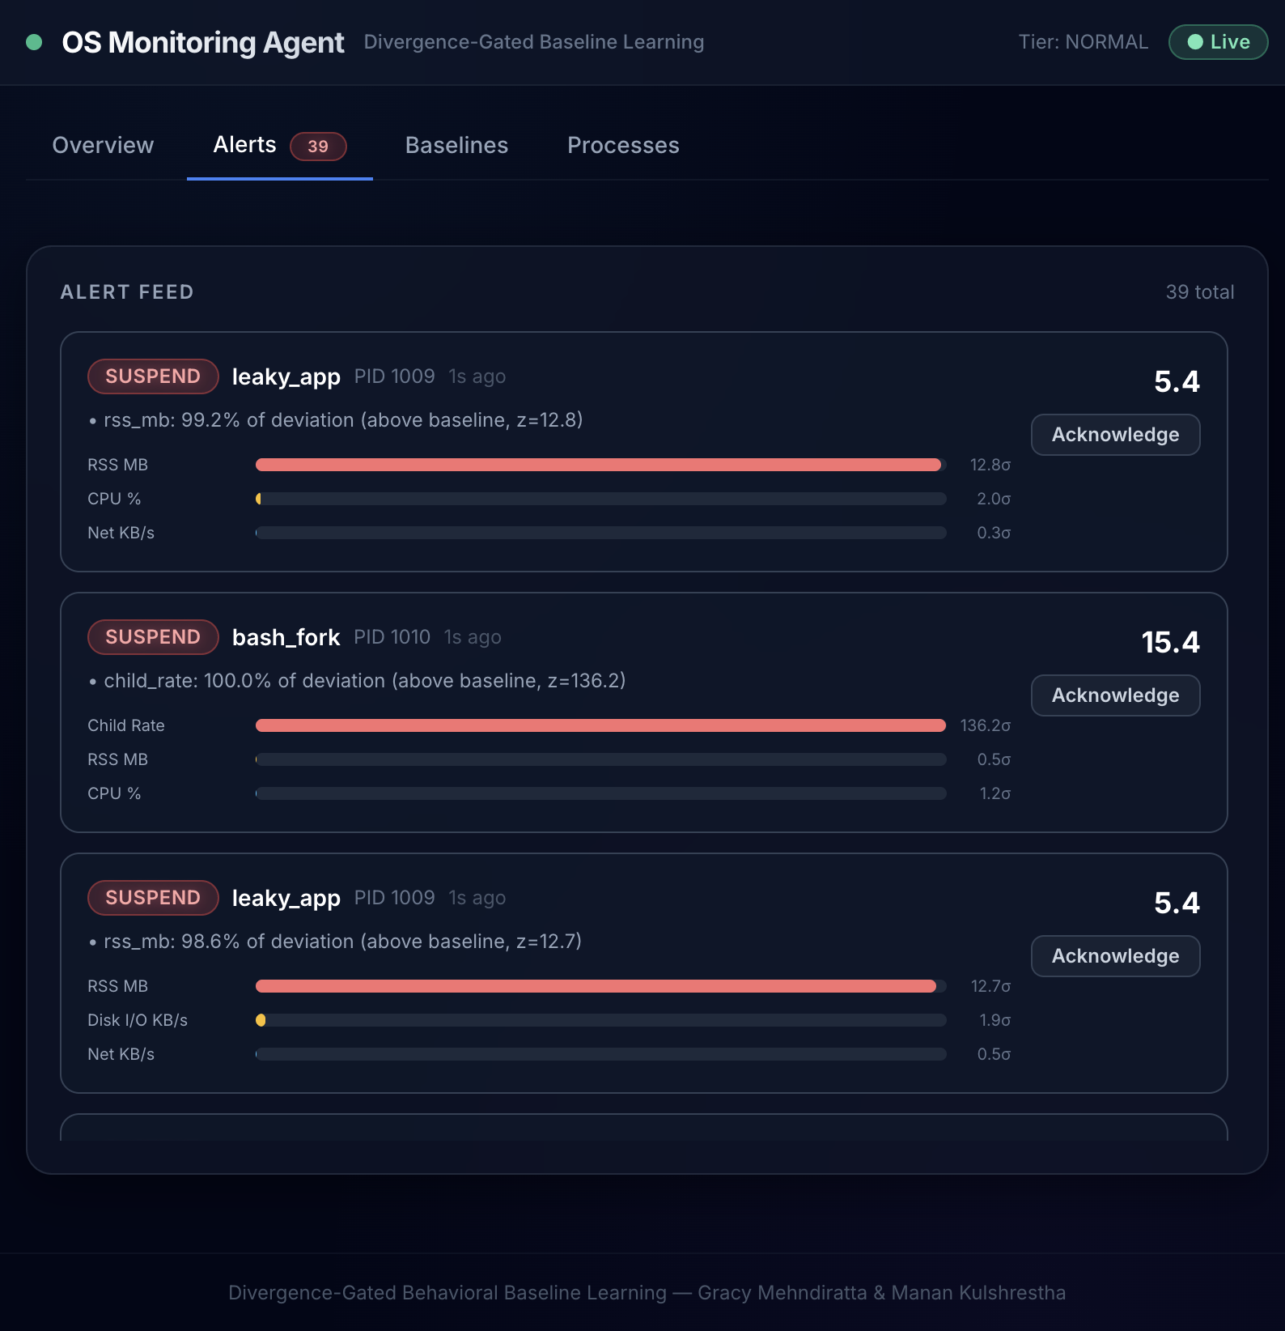
Alert feed

9.3 Dashboard — Baselines
Each baseline shows short-term and long-term statistics per feature, the gate state, the number of quarantined samples and a Reconcile button. The four attack processes are FROZEN with samples held in quarantine.
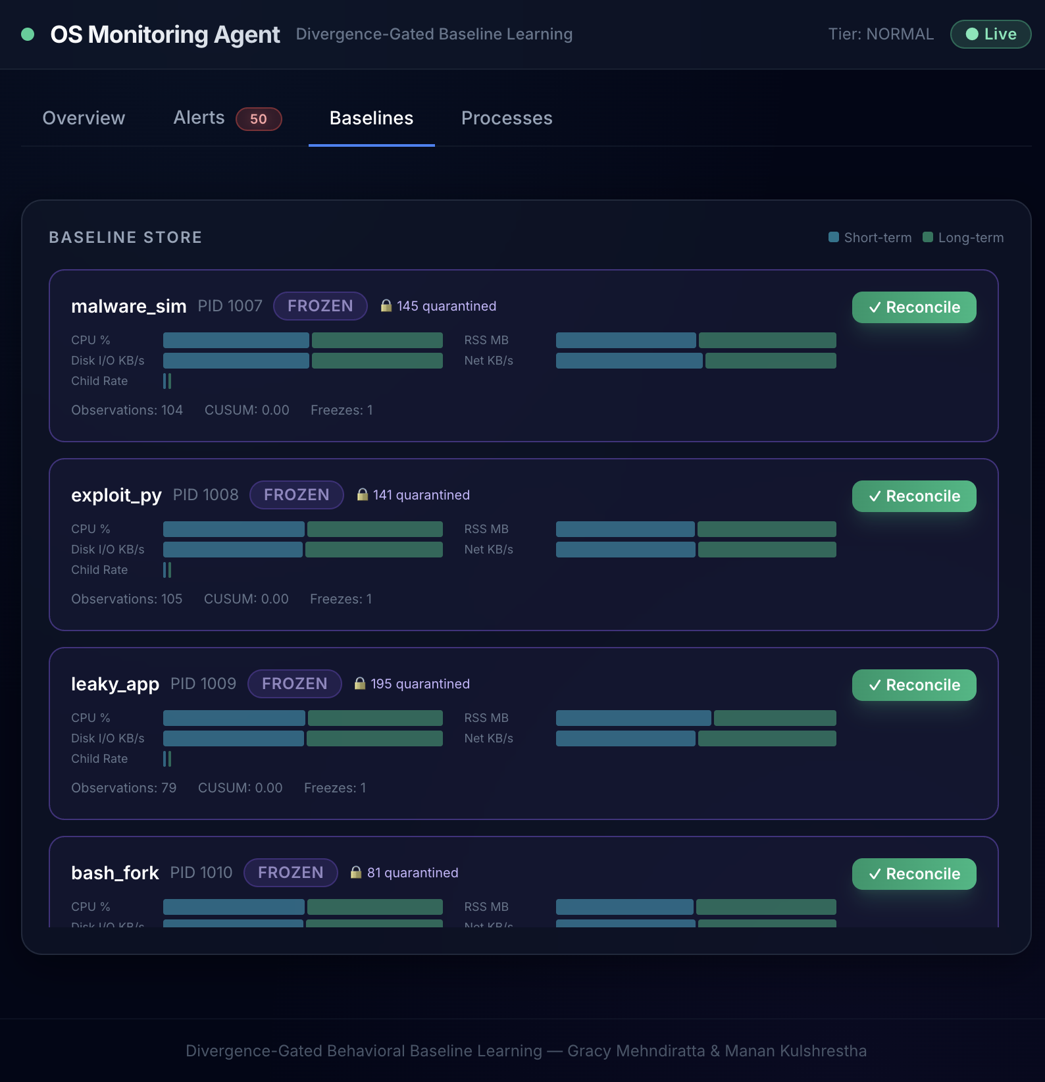
Baseline store

9.4 Dashboard — Processes
Per-process risk, baseline state and assigned sampling tier. Flagged/frozen processes are escalated to the DETAILED tier.
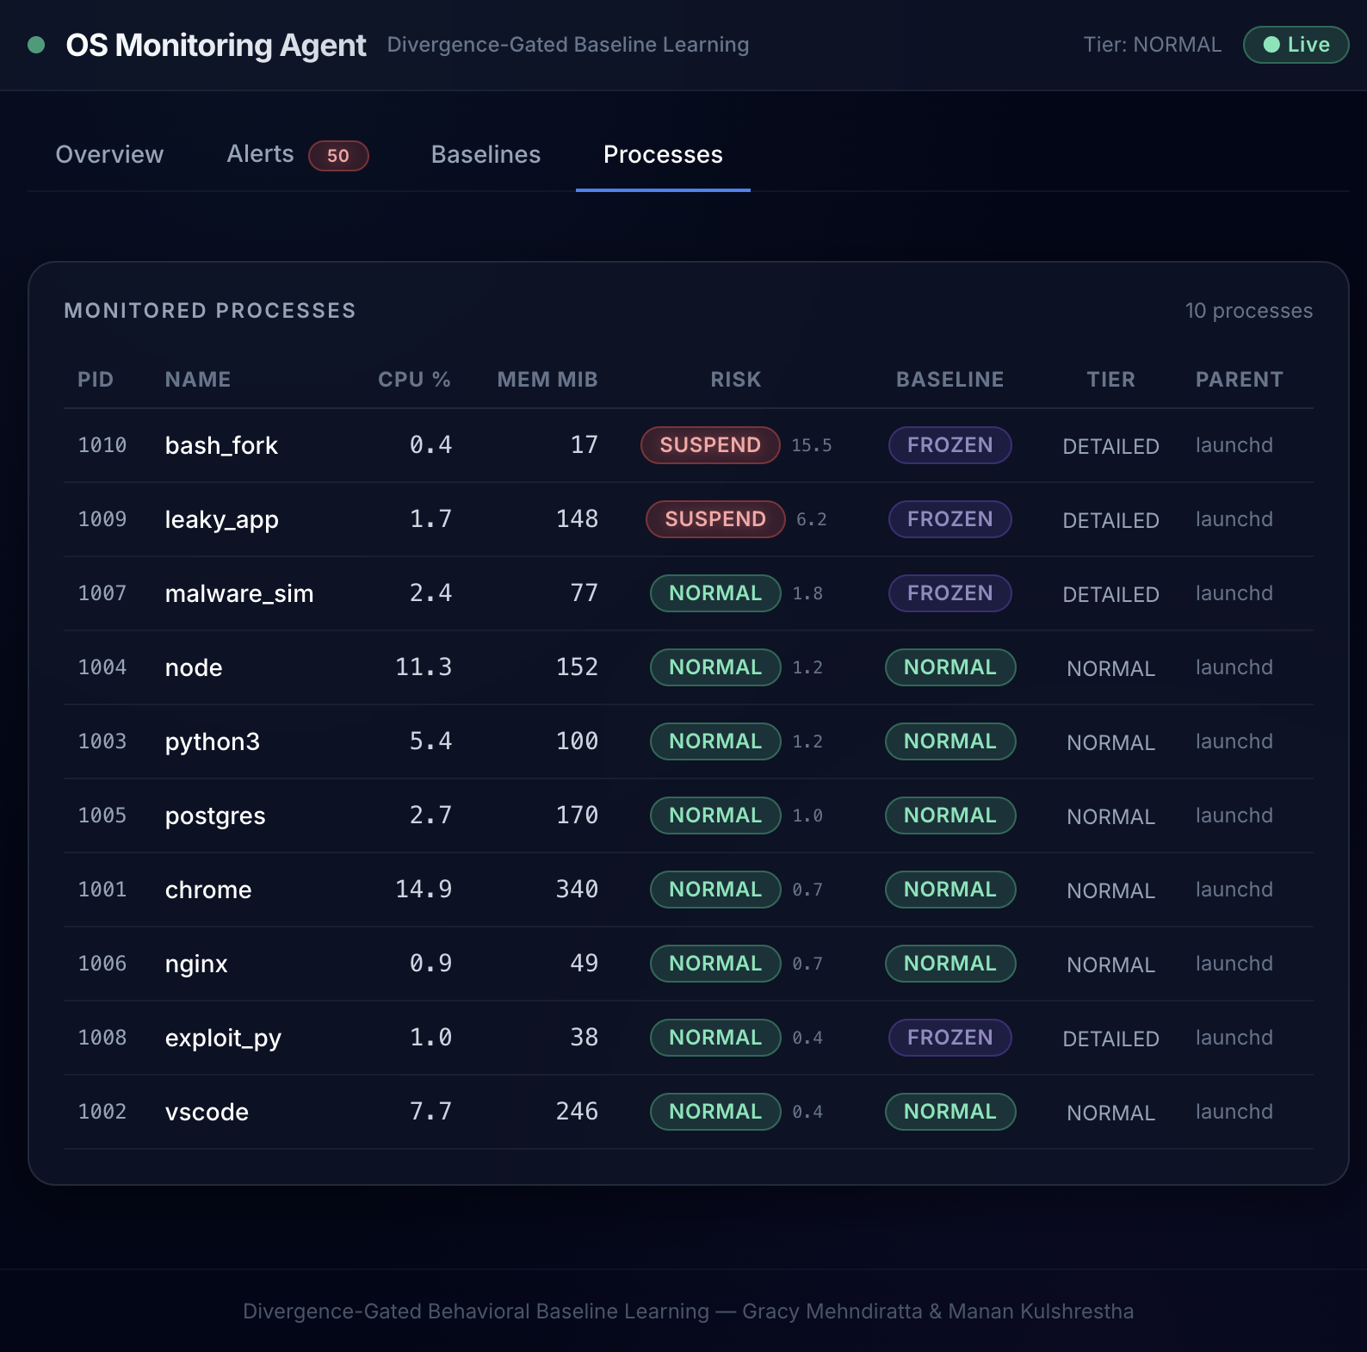
Monitored processes

9.5 API documentation
The FastAPI interactive documentation served at /docs.
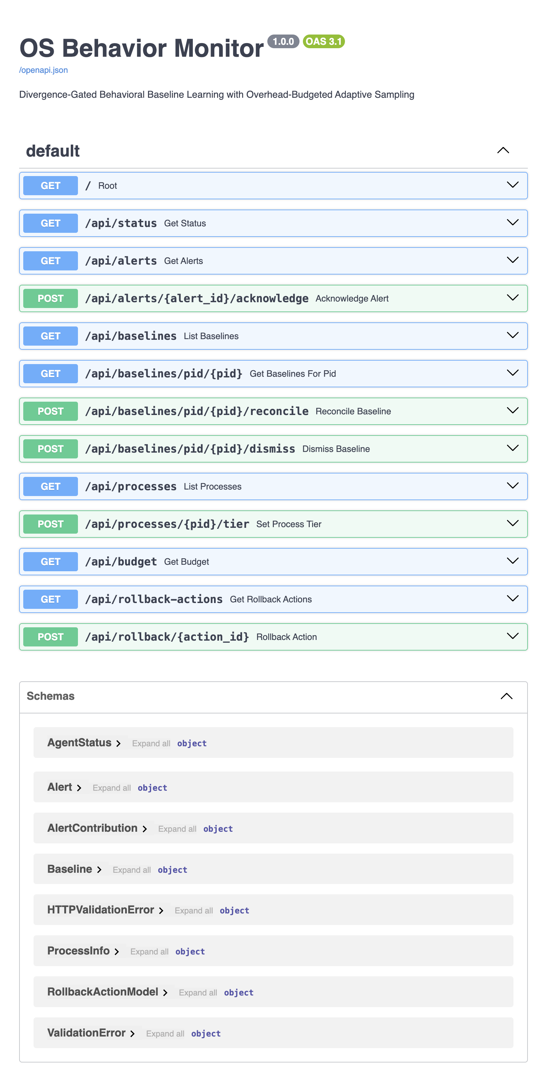
API documentation

10. How to Run

Backend
cd backend
pip install -r requirements.txt

# API server + dashboard backend (simulation mode by default)
python main.py # http://localhost:8000 (docs at /docs)
# or: uvicorn agent.api:app --port 8000

# Live psutil collection instead of replay:
OSMON_LIVE=1 python main.py

# Faster simulated demo (for screenshots):
OSMON_TICK_INTERVAL=0.15 python main.py

# Standalone simulator
python simulator.py --scenario demo --ticks 600

# Evaluation harness
python evaluate.py --quick

Frontend dashboard
cd frontend
npm install
npm run dev # http://localhost:3000, proxies /api and /ws to :8000
npm run build # production build into dist/

Tests
cd backend
python -m unittest discover -s tests

11. Claim-to-Code Map
This table is the evidence trail from each design claim to the code and the test or experiment that proves it.
Claim step | Implemented in | Proved by
Collect multi-resource telemetry | collector, features | TestReplayCollector, TestPsutilCollector; replay runs
Context vector and context-specific baseline | features, baseline | TestStore; benign scenario false positives
Joint deviation score with correlations | scoring.mahalanobis | TestScorer
Divergence between short and long baselines, freeze | gate (mean shift, CUSUM, reference drift, state machine) | TestGate; slow_ramp, evading_ramp
Quarantine buffer and reconcile on independent corroboration | gate + baseline.QuarantineBuffer | TestGate; legit_step
Own-overhead measurement and budgeted sampling | sampling (SelfMeter, SamplingController, LatencyTracker) | TestSelfMeter, TestSamplingController, TestLatency; overhead
Freeze raises sampling priority | agent._priorities, agent._on_throttle | TestInterlock
Ranked alert and graduated response | scoring.explain, response | TestResponseEngine
Isolation-forest ablation (Review 1 prior work) | isolation.IsolationScorer, evaluation.VARIANTS["iforest"] | TestIsolationScorer; iforest rows

12. Limitations
- Attack traces are synthetic; no claim is made about performance on real attacks.
- Divergence gating reduces but does not eliminate slow-poisoning risk. Reference drift
narrows the gap but also freezes on legitimate slow change, which then needs administrator confirmation.
- Requiring independent corroboration means most buffers are discarded, so baselines can go
stale after real workload changes and raise false positives (measured by legit_step).
- Load can push the monitor into degraded sampling; reduced coverage is counted and should
be treated as a risk signal.
- A Python prototype overstates overhead because of interpreter cost.
- Automated suspension can disrupt legitimate processes; responses stay in dry-run mode
unless explicitly enabled.

13. Repository and Access
GitHub repository | https://github.com/gracymehndiratta/os-project
Default branch | main
Access | Repository is shared with the reviewers/course account with read access

Repository layout
os-project/
├── README.md # Project overview, config, results, claim-to-code map
├── .gitignore
├── backend/
│ ├── main.py # API server entry point
│ ├── simulator.py # Standalone demo / replay / live runner
│ ├── evaluate.py # Evaluation harness CLI
│ ├── requirements.txt
│ ├── agent/ # Monitoring agent modules
│ └── tests/ # unittest suite
├── frontend/ # React + Vite dashboard
└── docs/ # This report and screenshots
To grant review access, the repository owner adds the reviewer's GitHub account under Settings → Collaborators and teams (read access).

