From the React documentation – using Webpack and Babel

Download zip file from here - <https://github.com/facebookincubator/create-react-app> and unzip it

(Make sure you have node installed – this next part needs npm)

Open a command line window

Newer versions of node …

npx create-react-app yourappname

cd yourappname

npm start

[npx](https://medium.com/@maybekatz/introducing-npx-an-npm-package-runner-55f7d4bd282b) comes with npm 5.2+ and higher

Older versions of node …

npm install -g create-react-app

create-react-app yourappname

cd yourappname

npm start

NOTE: your directory name cannot contain capitals

When the folder id setup you will see messages similar to this …

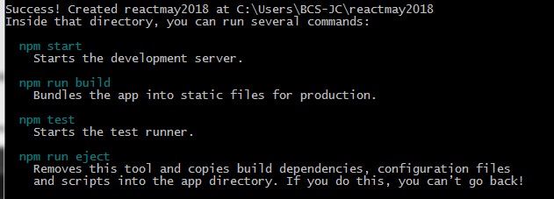

When the react app is started you will see a message similar to this in your cmd line window –

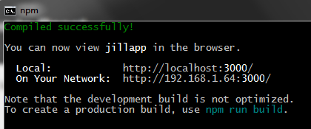

You will also have a tab in your browser started for the localhost, similar to this –

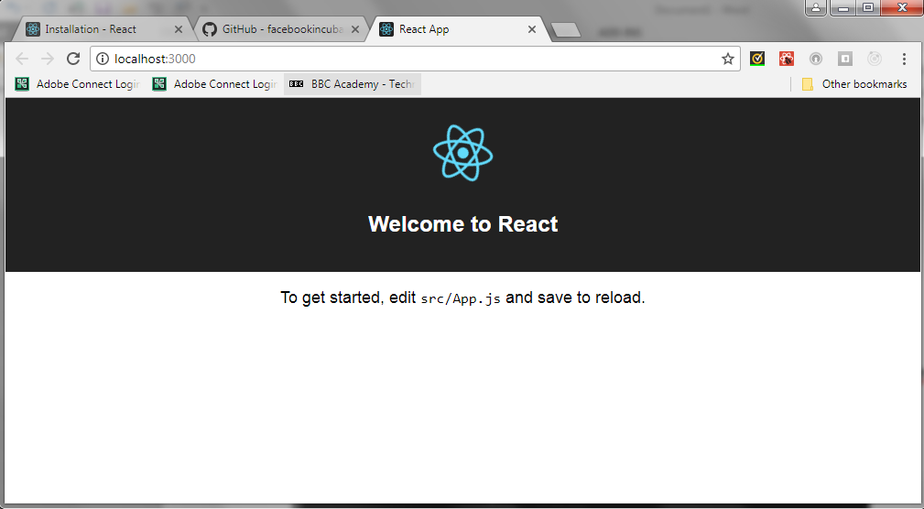

The files in your ‘yourappname’ folder will be similar to this –

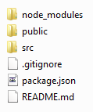

Alternative technique - Using React locally

Create a new folder, create a js folder in the new folder, you might also want to create an images folder in there too.

Get the following files (go to the URL and do a Save As to your newly created js folder) –

<https://unpkg.com/react@16/umd/react.development.js>

<https://unpkg.com/react-dom@16/umd/react-dom.development.js>

<https://unpkg.com/babel-standalone@6.15.0/babel.min.js>

Create a new index.html file in the root of the new folder structure, its content should look like this –

<!DOCTYPE html>

<html>

<head>

<meta charset="UTF-8" />

<title>First React example, running locally</title>

<script src="js/react.development.js"></script>

<script src="js/react-dom.development.js"></script>

<script src="js/babel.min.js"></script></head>

<body>

<div id="root"></div>

<script type="text/babel">

ReactDOM.render(

<h1>First example</h1>,

document.getElementById('root')

);

</script>

</body>

</html>

Open the index.html file in your browser to see the results.

Bear in mind that this may not be the fastest (or best) way to run your webpage.

Using the one page starter from the react.js website

From the links on the website you can download and copy a one page starter file, it looks like this …

<!DOCTYPE html>

<html>

<head>

<meta charset="UTF-8" />

<title>Hello World</title>

<script src="https://unpkg.com/react@16/umd/react.development.js"> </script>

<script src="https://unpkg.com/react-dom@16/umd/react-dom.development.js"> </script>

<script src="https://unpkg.com/babel-standalone@6.15.0/babel.min.js"> </script>

</head>

<body>

<div id="root"></div>

<script type="text/babel">

ReactDOM.render(

<h1>Hello, world!</h1>,

document.getElementById('root')

);

</script>

<!--

Note: this page is a great way to try React but it's not

suitable for production.

It slowly compiles JSX with Babel in the browser and uses a

large development build of React.

To set up a production-ready React build environment, follow

these instructions:

* https://reactjs.org/docs/add-react-to-a-new-app.html

* https://reactjs.org/docs/add-react-to-an-existing-app.html

You can also use React without JSX, in which case you can

remove Babel:

* https://reactjs.org/docs/react-without-jsx.html

* https://reactjs.org/docs/cdn-links.html

-->

</body>

</html>