Set up linting

Open Aton

Atom > Preferences

Install

Install these two files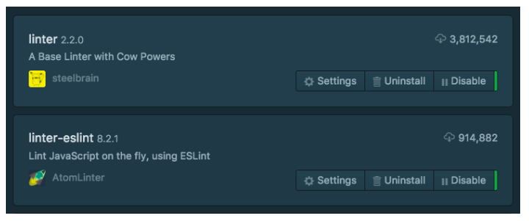

Set up linting - react native

Install a suitable eslint config file (loads are available, this works well for React Native)

npm install --save-dev eslint-config-rallycoding

Create a new file at the root of your project directory, name it .eslintrc

Make the following entry

{

“extends”: “rallycoding”

}