Sentinel Act
Agentic Compliance: From Regulatory Text to Operational Action
Team Gradera Sentinels | SEBI Securities Market TechSprint, GFF 2026
TEAM NAME
Gradera Sentinels
TEAM MEMBERS
Name | Role | Contribution
Kranthi | Vice President, Software Engineer | Solution architecture and Regulatory Knowledge Graph schema design
Saritha | Tech Lead | Web Governance Console front end (React/Next.js): lineage view, redline diff, maker-checker sign-off
Mahesh | Senior Software Engineer | Orchestrator workflow, human-in-the-loop mechanism, audit ledger
Rohit | AI/ML Engineer | Ingestion, extraction, and verification agents
PROBLEM STATEMENT SELECTED
Problem Statement 2: Agentic Compliance, From Regulatory Text to Operational Action.
ONE-LINE SUMMARY
A versioned Regulatory Knowledge Graph and a six-agent pipeline, governed by a tiered human-in-the-loop policy, that turns a SEBI circular into an auditable, operational compliance workflow within minutes, proven on both stockbrokers and investment advisers.
THE PROBLEM WE ARE SOLVING
SEBI issues circulars, master circulars, and notifications continuously, each carrying binding obligations for market intermediaries. Two problems compound each other. First, dynamic regulatory translation: turning a new or amended requirement into updated operational workflows depends today on manual legal interpretation, which is slow and produces inconsistent implementation across similarly placed intermediaries. Second, ongoing compliance management: tracking existing obligations, mapping them to evidence of fulfilment, and catching gaps before they become regulatory findings is manual and error prone, especially at smaller intermediaries with limited compliance resources. Both problems share one root cause: regulation exists as unstructured, human-readable text, while compliance systems need structured, machine-actionable rules. The unsolved problem SEBI has posed is converting regulatory intent into programmable, auditable compliance logic, proven on a real regulatory corpus and at least one concrete scenario.
INTERMEDIARY CATEGORY AND REGULATORY CORPUS
- Both Stockbrokers and Investment Advisers, to prove the same data model and pipeline generalize across categories.
- Master Circular for Stock Brokers, SEBI/HO/MIRSD/MIRSD-PoD/P/CIR/2025/90, dated 17 June 2025.
- Master Circular for Investment Advisers, SEBI/HO/MIRSD/MIRSD-PoD/P/CIR/2025/94, dated 27 June 2025.
CONCRETE REGULATORY SCENARIO
SEBI circular HO/38/11/(9)2026-MIRSD-POD/I/15382/2026, dated 3 July 2026, amending Paragraph 46 of the Master Circular for Stock Brokers on handling of clients' unpaid securities (auto-pledge to a CUSPA account). This circular is days old at submission time, which lets us demonstrate the actual regulatory-issuance-to-operational-action gap the problem statement asks us to close, on a live, current example rather than a synthetic one.
OUR SOLUTION: SENTINEL ACT
Sentinel Act is built around a single, versioned Regulatory Knowledge Graph: a bitemporal property graph where every obligation, task, and piece of evidence is a node or edge carrying a legally accurate effective window (valid_from, valid_to) alongside a record of when our system learned it (recorded_at). This lets the system answer not only what an intermediary must do today, but exactly what it had to do, and by when, as of any historical date, the structural foundation for real auditability.
Six specialized agents read from and write to this graph, coordinated by a deterministic workflow orchestrator, not an LLM, which enforces a propose-then-commit pattern: nothing changes a live obligation without passing through a tiered human-in-the-loop policy. A Regulatory Watch and Ingestion agent detects new or amended circulars. An Obligation Extraction agent, an LLM-backed AI agent, turns each clause into a structured, machine-actionable Obligation. A Grounding and Verification agent independently checks that extraction against the source text and flags contradictions before any human sees them. An Operational Mapping and Risk Prioritization step turns obligations into executable workflow tasks and scores them by risk. A Monitoring and Audit agent tracks fulfilment and logs every human decision as its own auditable fact. A Change and Delta agent turns a new circular into a redlined workflow update via a structural graph diff. An optional Conversational Assistant, an Open WebUI style chat interface, sits alongside as a read-only add-on for plain English questions against the graph.
Human oversight is tiered, not blanket. Low-risk, high-confidence changes auto-commit and are still logged. Medium-risk changes require one qualified reviewer's sign-off within an SLA window. High-risk changes, anything penalty-bearing or that alters a currently live obligation, require two independent reviewers (maker-checker), mirroring the segregation of duties SEBI already expects internally at regulated intermediaries.
TECHNOLOGY STACK
- Mastra as the agent runtime: a deterministic Workflow as the Orchestrator with native suspend and resume powering the tiered review policy; Mastra Agents (LLM-backed, model-agnostic via Mastra's model router) for extraction and verification; an observability console as the execution dashboard; Mastra GraphRAG for semantic clause retrieval; Mastra Schedules and Browser for regulatory watch; Mastra Channels (Slack) for reviewer approvals.
- A bitemporal property graph (Neo4j, or an embedded engine such as Kuzu for a fully offline demo) as the Regulatory Knowledge Graph, our own system of record, independent of any framework.
- SHA-256 hash-chained append-only ledger for tamper-evident audit export.
- Open WebUI (or an equivalent lightweight chat front end) as an optional, read-only add-on for natural language Q&A over the graph, outside the core commit pipeline.
WHAT WE WILL DEMONSTRATE
On stage, we ingest SEBI circular HO/38/11/(9)2026-MIRSD-POD/I/15382/2026, which amends Paragraph 46 of the Master Circular for Stock Brokers. Sentinel Act detects the amendment, extracts the updated obligation, verifies it against the literal clause text, computes a structural graph diff against the obligation it supersedes, and produces a redlined operational workflow change together with a risk score, all with full citation back to the exact paragraph. The change is routed through our tiered human-in-the-loop policy live in our observability console, and once approved, the system exports an audit-ready compliance register. We repeat the same pipeline, unchanged, against a clause from the Master Circular for Investment Advisers to prove that one schema and one Process Taxonomy pattern scale across intermediary categories.
WHY THIS IS THE STRONGEST POSSIBLE ENTRY
Criterion | Our answer
Market Impact | Cuts regulatory-to-operational lag from typical weeks to minutes and reduces compliance gaps, especially for smaller intermediaries.
Technology Stack | A bitemporal knowledge graph as system of record, built on a named, current agent framework (Mastra), used selectively and documented deliberately, including what we chose not to use.
Feasibility | Executable workflow outputs plug into existing GRC tools, governed by a tiered human-in-the-loop policy that matches how compliance teams already operate.
Scalability | One schema and taxonomy pattern proven across two intermediary categories in the same demo; a new category is configuration, not a rebuild.
Alignment with SEBI's Mandate | Structural, queryable audit trail and maker-checker dual sign-off mirror the auditability and segregation of duties SEBI already expects.
ATTACHMENT 1: SYSTEM ARCHITECTURE DIAGRAM
The system architecture diagram below shows the full pipeline from SEBI sources through the Orchestrator, the five agents, the Regulatory Knowledge Graph, tiered human governance, an observability console, the operational outputs, and an optional Conversational Assistant add-on.
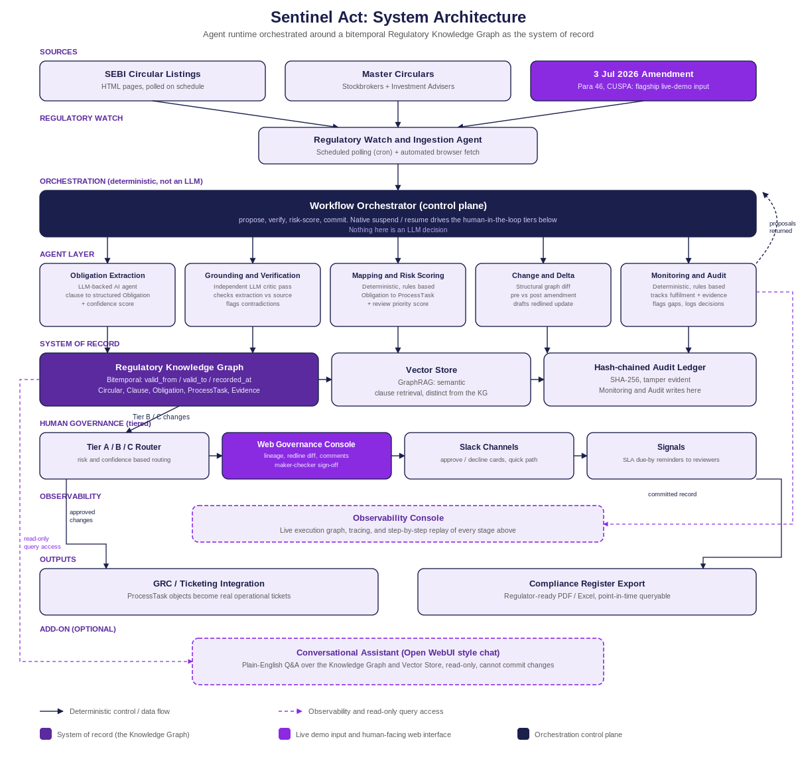
ATTACHMENT 2: REGULATORY KNOWLEDGE GRAPH SCHEMA DIAGRAM
The production entity-relationship schema (v1.1) behind the architecture diagram above: seven node types and seven typed, cardinality-annotated edges, with primary and foreign keys marked and the temporal indexing strategy noted on the diagram itself.
