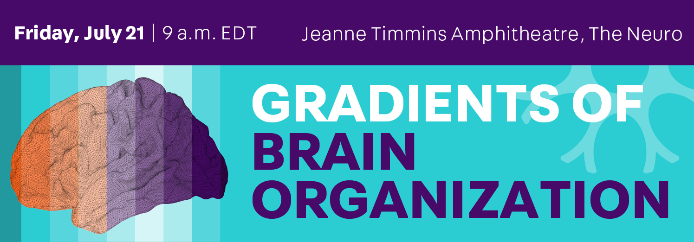

|  |  |
| --- | --- |
| 8:30 - 9:00 | Registration & Coffee |
| 9:00 - 9:15 | Welcome |
| 9:15 - 10:30 | Multiscale Studies  Chairs: Konrad Wagstyl and Jessica Royer |
|  | Tools for multimodal, multiscale annotation of brain networks  *Justine Hansen, McGill University, Canada* |
|  | Three transcriptional axes underpin anatomy, development, and disorders of the human cortex  *Richard Dear, University of Cambridge, UK* |
|  | Organization of laminar thickness covariance in the human cortex  *Amin Saberi, Max Planck Institute for Human Cognitive and Brain Sciences and Forschungszentrum Jülich, Germany* |
|  | Panel discussion |
| 10:30 - 10:45 | Coffee break |
| 10:45 - 12:00 | Evolutionary perspectives  Chairs: Sofie Valk and Ting Xu |
|  | Gradients and the search for human brain specializations  *Nicole Eichert, University of Oxford, UK* |
|  | Intrinsic timescales as a unifying organizational principle of neural processing in nonhuman primates  *Ana M. G. Manea, University of Minnesota, USA* |
|  | Linking temporal lobe organization across modalities to individual differences in language processing  *Marius Braunsdorf, Donders Centre for Cognition, The Netherlands* |
|  | Panel discussion |
| 12:00 - 13:00 | Lunch break |
| 13:00 - 13:15 | Flash Talks |
| 13:15 - 14:30 | Dynamics  Chairs: Seok-Jun Hong and Richard Bethlehem |
|  | Neural state dynamics along the canonical gradients of functional brain organization reflect cognitive and attentional dynamics  *Hayoung Song, University of Chicago, USA* |
|  | Cortex-wide maturational changes in excitation-inhibition ratio  *Shaoshi Zhang, National University of Singapore, Singapore* |
|  | Gradients go to the movies: Macroscale cortical organization during naturalistic viewing  *Tamara Vanderwal, University of British Columbia, Canada* |
|  | Panel discussion |
| 14:30 - 14:45 | Coffee break |
| 14:45 - 16:15 | Cognitive and clinical perspectives  Chairs: Daniel Margulies and Boris Bernhardt |
|  | Why cognitive neuroscience needs a state space  *Bronte Mckeown, Queen’s University, Canada* |
|  | Cortical gradients in semantic cognition  *Tirso Gonzalez-Alam, University of York, UK* |
|  | Atypical functional connectivity subspaces reflect declarative retrieval impairments in temporal lobe epilepsy  *Donna Gift Cabalo, McGill University, Canada* |
|  | Microstructural and functional interactions in visual networks for perceptual learning  *Liz Yuanxi Lee, University of Cambridge, UK* |
|  | Panel discussion |
| 16:15 - 16:45 | Closing comments |
| 16:45 - 17:00 | Transition |
| 17:00 - 18:30 | Poster session and cocktail |