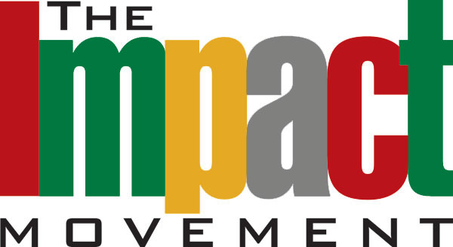

WHO IS JESUS?

WHY DOES IT MATTER?

WHAT IS MY PURPOSE?

**OUR MISSION:** The Impact Movement takes the truth of Jesus Christ to the campus, community and world by producing leaders of African descent who are spiritually focused, financially responsible and morally fit.

JOIN US! For Biblical discussions on all of this and more

7pm Douglas Hall rm 204