Veer D0 High Level Design
Course: Computer Science Senior Design I
Advisor: Dr. Jillian Aurisano
Team: Grady Algire, Brady Cooper, Briar Elliot, Dominic Rowland, Aiden Ward
Design version: 1.0 | October 2, 2026

1. Title, goal statement, and conventions
Project title: Veer. Goal: Convert driver speech into routing constraints for hands-free live navigation.
Veer is a mobile navigation service for a driver using a mounted phone. It interprets requests such as adding a food stop or avoiding rain, highways, or tolls as structured trip constraints, then proposes a revised route and provides turn-by-turn voice guidance.
The basic inputs are driver speech, current phone location, destination, active trip constraints, and a local mute control. The basic outputs are a live route with spoken directions, a short spoken confirmation or recovery prompt, a visible listening/muted indicator, and per-trip API usage counts for the development team.
Scope includes voice capture, transcription, constraint extraction, waypoint insertion by business or category, weather-aware route preferences, highway/toll preferences, and live guidance on the driver's phone. Raw audio is transient; no audio files are retained. Active constraints expire at trip end. Saved-trip accounts and a web trip planner are outside this first-release design.
Conventions: C labels a component built by the team; E labels an external dependency. Solid blue boxes represent team components; dashed gray boxes represent dependencies or external actors. A block-diagram arrow initiates the interface; its response returns along that interface. A data-flow arrow names the information crossing it and its form. Each diagram includes this legend and the project goal.
Story | Capability | Responsible components
US-01 | Add a food stop with a detour no greater than 10 minutes. | C1, C2, C3
US-02 | Use an avoid-rain constraint when selecting a route. | C1, C2, C3
US-03 | Inspect AI and Maps call counts for each trip. | C2, C3, C4
US-04 | Show listening state; stop capture with tap or voice mute. | C1
US-05 | Confirm interpreted speech before changing a route. | C1, C2, C3
The supplied project description, stories, use cases, and clarified acceptance criteria govern this design. Explicit spoken approval is required; silence leaves the route unchanged. The route update must complete within 3 seconds after the driver finishes saying "okay." Section 7 records this decision and remaining D1 choices.

2. Block diagram (the D0 diagram)
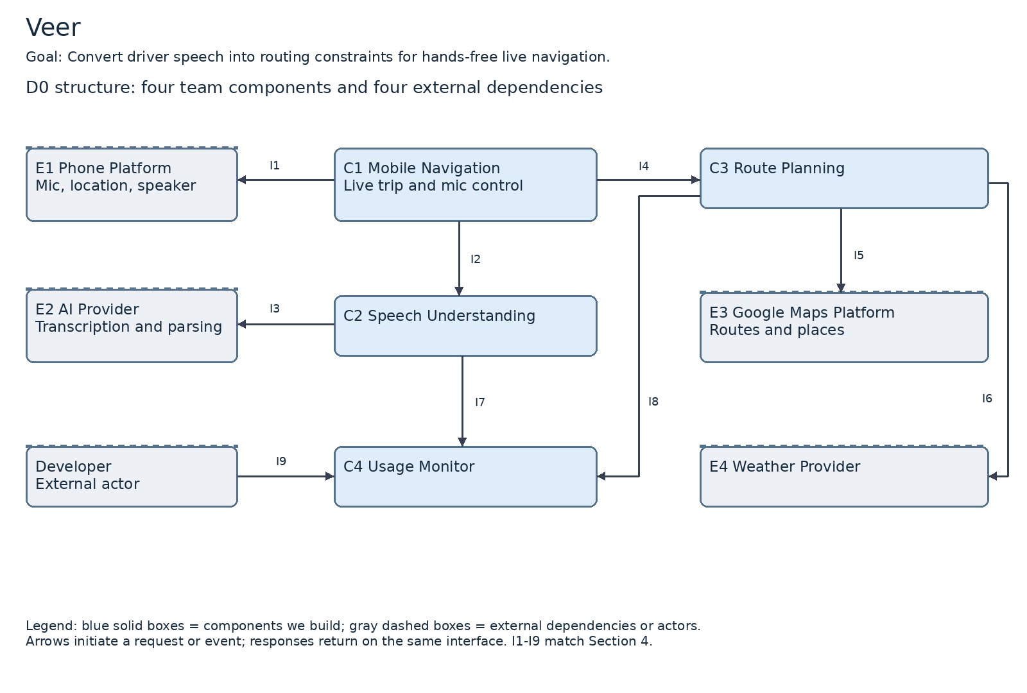
C1 runs on the phone; C2, C3, and C4 are logical modules within a shared backend. E1 is the existing phone platform, not hardware the team builds. E2 supplies transcription and constraint parsing; E3 supplies Google Maps routes and places; E4 supplies weather observations/forecasts. The developer is an external actor using I9. Drivers and passengers interact with C1 through the phone; these local interactions are detailed in I1.
C1 owns active navigation state and the final route update. C2 returns a proposed constraint, not an instruction to mutate the route. C3 returns a route proposal after applying validated constraints. C4 stores consumption metadata only; it is not a repository for conversations, coordinates, or raw audio. Routing, weather integration, and mute implementation algorithms remain for D1/D2.

3. Component responsibility table
The table assigns primary responsibility for each component. Dominic Rowland owns the E4 weather integration task within C3; Brady Cooper owns C3 as a whole.
Component | One-sentence responsibility | Interfaces in / out | Primary owner
C1 Mobile Navigation | Manage the driver's live navigation interaction. | In: I2/I4 replies, I1 device events; out: I1, I2, I4 | Grady Algire
C2 Speech Understanding | Translate transient speech into proposed routing constraints. | In: I2; out: I3, I7 | Briar Elliot
C3 Route Planning | Produce route proposals that satisfy validated trip constraints. | In: I4; out: I5, I6, I8 | Brady Cooper
C4 Usage Monitor | Account for provider consumption by trip. | In: I7, I8, I9; out: I9 reply | Aiden Ward
E1 Phone Platform | Supply device input and output capabilities. | In: I1 control; out: I1 events | External; liaison Grady Algire
E2 AI Provider | Provide speech transcription and structured interpretation. | In: I3; out: I3 reply | External; liaison Briar Elliot
E3 Google Maps Platform | Supply route and place data. | In: I5; out: I5 reply | External; liaison Brady Cooper
E4 Weather Provider | Supply location-indexed precipitation information. | In: I6; out: I6 reply | External; integration owner Dominic Rowland
Story coverage is shown in Section 1. Live guidance and highway/toll constraints additionally trace to the first-release scope in the project description.

4. Interface specification table
I3 uses secure WebSocket streaming (WSS), matching the speech-stream contract on I2. This permits a shared streaming design for utterance audio and interpretation replies; provider selection must support this proposed contract and the no-retention requirement. HTTPS batch uploads were considered but not selected for the continuous voice interaction.
The following logical contracts define the D0 interfaces. Types: string = UTF-8; integer = whole number; number = finite decimal; boolean = true/false; instant = ISO 8601 UTC; [] = array; ? = optional; enum = one listed value. LatLng={lat:number, lon:number} in WGS84. Durations are seconds, distances are meters, precipitation probability is 0-1. JSON records use the named types defined after the table. Each network request includes requestId:string. Error={code:string, message:string, retryable:boolean}; a failure never silently applies a route.
Interface | Named inputs and outputs | Data format | Protocol | Error behavior and handler
I1 C1 <-> E1 | In to E1: micControl:enum(start,stop,forceStop), locationControl:enum(start,stop), spokenText:string. Back to C1: audio:PCMFrame[], location:LocationFix, micState:enum(listening,muted,error), mute:MuteEvent, destination:LatLng?, acknowledgment:enum(accept,reject)?. | PCM bytes plus typed local events | Phone OS calls, callbacks, local UI events | C1 keeps indicator aligned with actual capture state. On mute it closes the send/capture gate, clears buffers, then stops mic; force-stop on failure. No post-request audio is sent or stored.
I2 C1 -> C2 | Input: requestId:string, tripId:string, utteranceId:string, control:enum(audio,cancel), audio:binary?, audioMetadata:AudioMetadata. Output: transcript:string, intent:enum(propose,accept,reject,unknown), constraint:Constraint?, confidence:number, error:Error?. | Binary audio frames; JSON metadata/reply | Authenticated TLS stream (WSS) | C2 rejects invalid/unsupported audio and clears transient audio/transcript state on completion, cancel, or failure. C1 asks for repeat within 2 s after an unparseable utterance; route stays unchanged.
I3 C2 -> E2 | Input: audio:binary, metadata:AudioMetadata, allowedConstraintTypes:string[], allowedIntents:string[]. Output: transcript:string, intent:enum(propose,accept,reject,unknown), constraint:Constraint?, confidence:number, usage:ProviderUsage. | Provider audio stream plus JSON | Authenticated TLS stream (WSS) | C2 handles timeout, quota, invalid output, or unclear speech. Validate structured output before forwarding. Zero-persistence provider behavior must be verified before selection; reject providers/configurations that retain raw audio.
I4 C1 -> C3 | Input: requestId:string, tripId:string, location:LocationFix, destination:LatLng, currentRoute:RoutePlan?, constraints:Constraint[], tripRevision:integer. Output: proposal:RouteProposal?, error:Error?. | JSON | Authenticated HTTPS request/reply | C3 returns no_match, weather_unavailable, quota, or timeout explicitly. C1 keeps the active route and speaks a short recovery prompt. Ignore a stale tripRevision reply; require explicit spoken approval and finish route activation <= 3 s after "okay" ends. Silence cannot authorize an update.
I5 C3 -> E3 | Input: origin:LatLng, destination:LatLng, waypoints:LatLng[], query:string?, avoidHighways:boolean, avoidTolls:boolean, alternatives:boolean. Output: routes:RoutePlan[], places:Place[], attribution:string. | Google provider JSON normalized to typed records | HTTPS request/reply | C3 handles no route/place match, quota, or timeout. Enforce detour <= 600 s for UC-01; otherwise unchanged route and alternate-place prompt <= 3 s. Do not claim Google accepts a weather-avoid flag.
I6 C3 -> E4 | Input: samples:{location:LatLng, expectedAt:instant}[]. Output: weather:WeatherSample[], fetchedAt:instant. | Provider JSON normalized to typed records | HTTPS request/reply | C3 rejects stale/missing coverage for weather avoidance and reports that rain avoidance cannot be verified. Current guidance continues; no unsupported promise of a dry route.
I7 C2 -> C4 | Input: event:UsageEvent for AI calls. Output: accepted:boolean, eventId:string. | Typed record | In-process call/return | C2 records an idempotent event for each outbound attempt, including retries; C4 deduplicates eventId. If unavailable, C2 keeps a metadata-only pending event and applies the configured quota policy.
I8 C3 -> C4 | Input: event:UsageEvent for Maps/weather calls. Output: accepted:boolean, eventId:string. | Typed record | In-process call/return | C3 counts every outbound attempt, including failed calls and retries. C4 deduplicates. Unknown consumption triggers conservative budget handling; optional new replans may be denied while guidance continues.
I9 Developer -> C4 | Input: developerAuth:string, tripId:string?, timeRange:{from:instant,to:instant}?. Output: summaries:UsageSummary[], error:Error?. | JSON | Developer-authenticated HTTPS GET | C4 denies unauthenticated/unauthorized access, rejects invalid filters, and labels incomplete totals. Return provider call counts without utterances, coordinates, or passenger information.

Example interface payload
I2 response after interpreting a food-stop request:
{
"requestId": "req-17",
"intent": "propose",
"transcript": "I am hungry for McDonald's",
"constraint": {
"type": "add_waypoint",
"value": "McDonald's",
"maxDetourSeconds": 600
},
"confidence": 0.94
}

Interface notes
Trip setup: select the initial destination before driving. I1 supplies the current location, so manual origin selection is not required.
Privacy: raw audio is excluded from logs, telemetry, temporary files, and usage summaries.
D1 follow-up: finalize audio encoding and provider-specific wire details. This D0 defines the named fields and error responsibilities.

Shared data types
These records define the fields used by interfaces I1-I9. A question mark marks an optional field; brackets indicate an array. Each field is shown as name: type.
Record | Fields and meaning
PCMFrame | Transient signed 16-bit mono audio samples; kept in memory.
AudioMetadata | encoding: string  sampleRateHz: integer; channels: integer  utteranceEndedAt: instant
LocationFix | position: LatLng  accuracyMeters: number; capturedAt: instant
MuteEvent | source: enum(tap, localVoice)  requestedAt: instant
Constraint | type: enum(add_waypoint, avoid_precipitation, avoid_highways, avoid_tolls)  value: string?; maxDetourSeconds: integer?
Place | placeId: string; name: string  location: LatLng
RoutePlan | routeId: string; geometry: LatLng[]  durationSeconds: number; distanceMeters: number  steps: RouteStep[]
RouteStep | instruction: string; location: LatLng
RouteProposal | tripRevision: integer; route: RoutePlan  selectedPlace: Place?; extraSeconds: number  confirmationText: string; warnings: string[]
WeatherSample | location: LatLng; validAt: instant  precipitationProbability: number?  precipitationRateMmPerHour: number?; sourceTime: instant
ProviderUsage | callCount: integer  inputUnits: number?; outputUnits: number?
UsageEvent | eventId: string; tripId: string  provider: enum(ai, maps, weather); operation: string  attemptedAt: instant; outcome: enum(success, failure)  units: number?
UsageSummary | tripId: string  aiCalls: integer; mapsCalls: integer; weatherCalls: integer  complete: boolean

5. Data-flow diagram
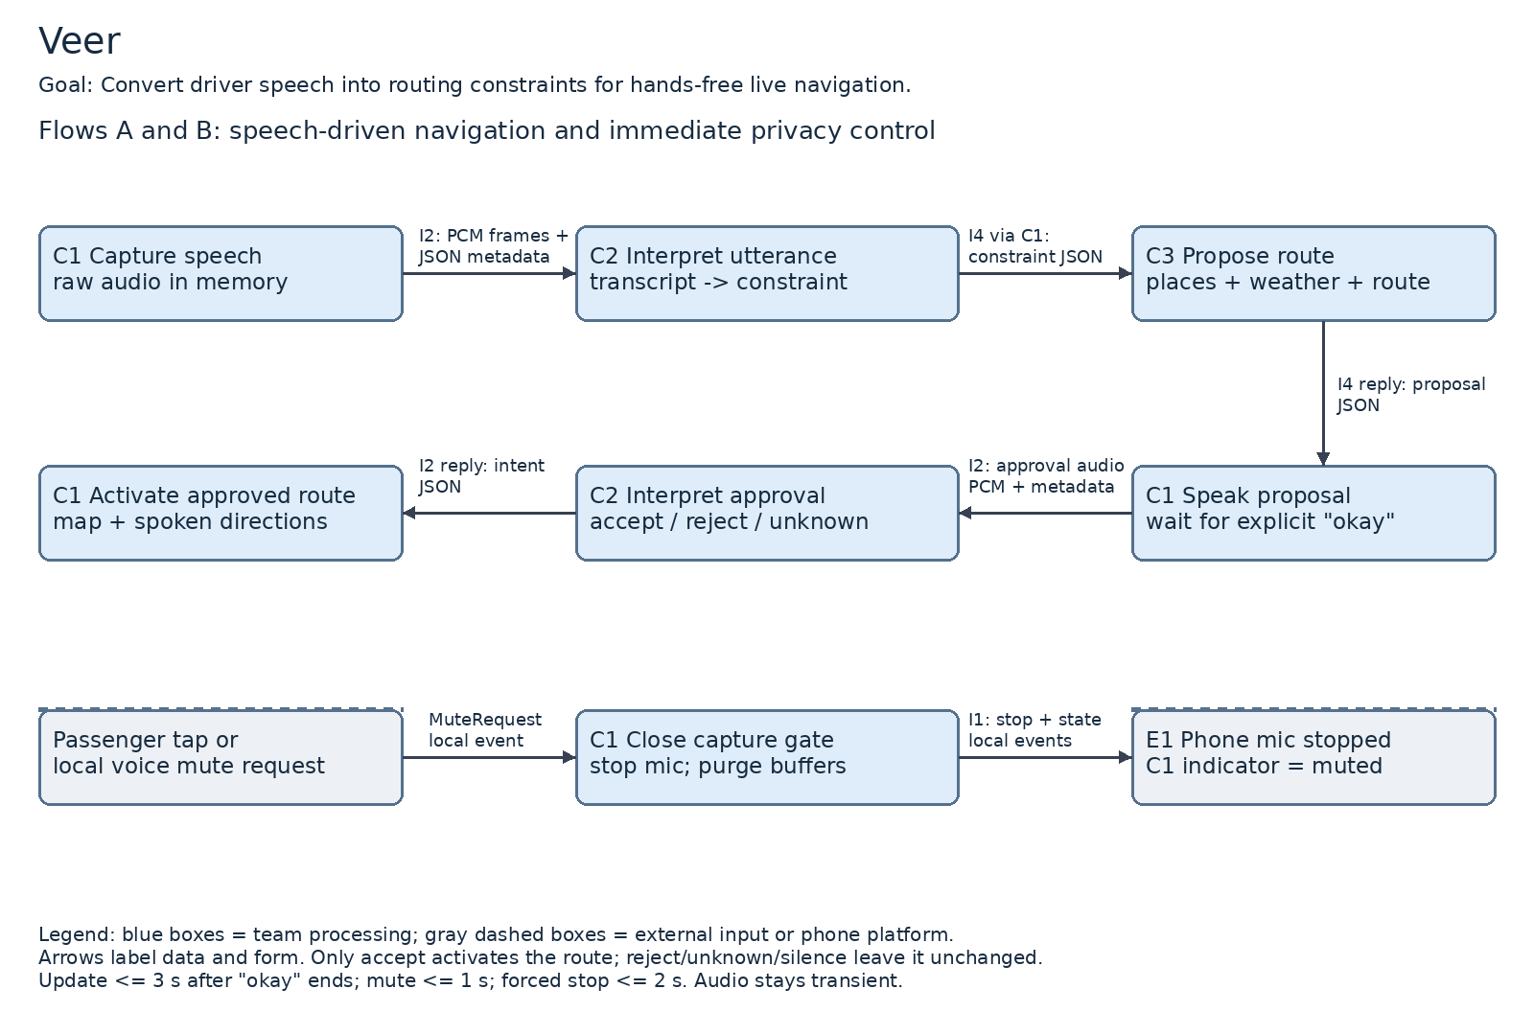
Flow A - Speech-driven navigation. C1 receives microphone frames in memory through I1 and sends the utterance through I2. C2 uses I3 to obtain a transcript and structured constraint, validates it, and returns it to C1. C1 submits the proposed constraint plus current trip context through I4. C3 obtains place/route records through I5 and relevant weather records through I6, then returns a route proposal. C1 speaks its summary, receives accept/reject intent through I2 only after explicit spoken approval, updates the live route, and renders map guidance plus spoken directions through I1. For rejection, C1 requests another candidate through I4; no route update occurs.
Flow B - Mute/privacy control. A passenger tap or locally recognized stop-listening command becomes a MuteEvent. C1 immediately blocks further capture/transmission, discards pending audio, cancels in-flight interpretation, and requests microphone shutdown through I1. It shows muted only when shutdown is confirmed; otherwise it force-stops capture and shows an error. Unmute requires a tap because a stopped mic cannot hear an unmute command. Remote interpretation is not a prerequisite for mute.
Usage side flow. Each AI, Maps, or weather request attempt produces an I7/I8 UsageEvent. C4 aggregates counters into UsageSummary records exposed through I9. No audio, transcript, destination, or route geometry crosses these interfaces. Constraint and active-route state remain trip-scoped and are cleared at trip end; minimal usage counts may persist under a retention policy the team must set.

Provider usage reporting
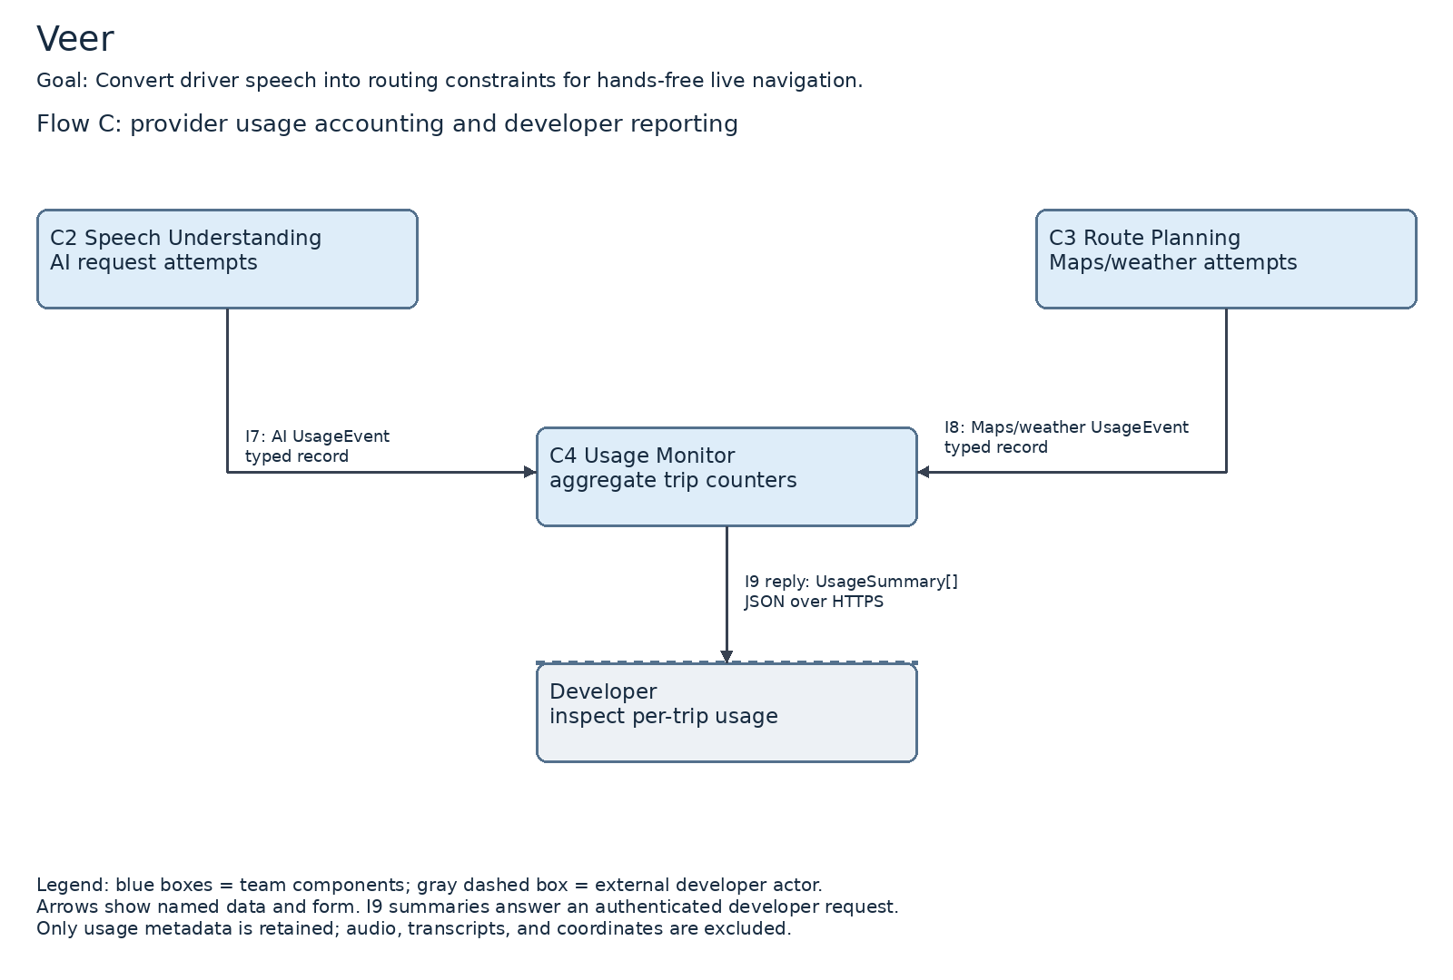
C4 receives AI and Maps/weather usage events through I7 and I8. An authenticated developer queries I9; C4 returns per-trip UsageSummary records. The response flow is drawn explicitly above.

5. Data-flow diagram continued
Acceptance criterion | Budget and required behavior | Responsible boundary
AC-01.1 | Detour <= 600 s; spoken proposal <= 15 words; explicit approval required; route update completes <= 3 s after the driver finishes saying "okay." | C1 -> C2 -> C3 -> C1, including providers
AC-01.2 | 0 raw audio files on phone or any server after the operation. | C1, C2, E2; no disk/log persistence
AC-01.3 | No match <= 600 s: unchanged route and alternate-place question within 3 s. | C3 result -> C1 speech
AC-01.4 | Unparseable speech: unchanged route; repeat prompt within 2 s after speech ends. | C2 result/failure -> C1 speech
AC-02.1 | Mute: mic stops within 1 s; indicator shows muted. | Local C1 <-> E1 control
AC-02.2 | Mic fails to stop: force-stop within 2 s; 0 post-request audio sent/stored. | Local C1 capture/send gate plus E1 stop
AC-01.1 timing is confirmed: start the 3-second timer at the end of the driver's spoken "okay," and stop it when the approved route is active in both the map and turn-by-turn guidance. Approval recognition, validation, any necessary route refresh, and route application are included in this budget. Time spent preparing the proposal or waiting for approval is outside this timer. AC-01.3 retains its 3-second alternate-place prompt deadline after the initial request; AC-01.4 retains its 2-second repeat-prompt deadline after speech ends. Mute timers start at the tap or local recognition of the complete mute command; normal shutdown must finish within 1 second and forced shutdown within 2 seconds of that original mute request. These are acceptance targets to verify during implementation.
Audio lifecycle: capture -> transient phone buffer -> transient backend/provider processing -> disposal. No component writes a raw audio file. Muting discards queued audio and prevents audio captured after the request from leaving the phone; cancellation cannot retract audio already transmitted before mute. Provider logging, retention, crash dumps, and training-use settings must satisfy the no-persistence requirement before E2 is accepted.
Weather semantics: the app evaluates weather information at the route locations and relevant travel times. For US-02, active precipitation is a required context; forecasts support later arrival points when available. Rain avoidance is a preference evaluated by C3 across available candidate routes, not a guarantee that rain is absent. The exact threshold, maximum weather detour, data freshness window, and behavior outside forecast coverage need agreement in D1.
Confirmed approval policy: Veer presents the proposed change and waits for an explicit spoken "okay." Silence is not approval and leaves the active route unchanged. UC-01 step 6 is revised to require explicit approval; step 7 applies the approved route within 3 seconds after that approval utterance ends. A rejection requests another candidate. If approval is unclear, the route stays unchanged and Veer asks for clarification. If the update cannot complete within the deadline, retain the current route and report the failure; such a result does not satisfy the successful-update acceptance criterion. This decision supersedes the original silence-as-approval wording and the earlier confirmation-prompt timing interpretation.

6. Architecture pattern and justification
Client-server governs communication between C1 on the phone and a shared backend containing C2-C4. Layered architecture separates live interaction, speech interpretation, route planning, and operational accounting. A pipeline governs speech-to-route information flow: audio -> transcript -> constraint -> route proposal -> confirmed guidance. A local control path governs mute; it does not depend on a cloud response. These are logical components, not independently deployed microservices.
Class criterion | Fit and justification
Fit to the problem | The pipeline preserves the meaning of a spoken request as it becomes a route constraint. The mobile client owns final route application and listening state; provider modules do not directly control the phone.
Team skills | The architecture divides mobile interaction, speech integration, routing, weather integration, and usage accounting across five student owners. It concentrates deployment work in one backend and avoids requiring every member to manage distributed infrastructure. D1 will select languages and tools against the owners' demonstrated experience.
Performance and timing | Approval recognition and route activation must finish within 3 s after spoken "okay" ends. Prepare the proposed route before requesting approval; revalidate or refresh it if needed within the update budget. Failed interpretation must prompt within 2 s. Local mute avoids network latency for 1 s normal and 2 s forced-stop budgets. Candidate-route/weather calls require measurement and bounded deadlines.
Scalability | Stateless speech/routing requests can scale across backend instances. Trip IDs and revisions prevent stale updates. Usage limits and provider quotas govern admission; paid usage must not exceed the team's configured budget.
Hardware constraints | Use the driver's existing mounted phone with microphone, speaker, location, and a data connection. Battery, permission handling, cabin noise, background execution, and mobile connectivity constrain the design. No vehicle hardware is required.

Project constraints
Economic: Veer is funded by the team. Prioritize free-tier hosted inference and Google Maps credits for routing and place search. Run on the driver's existing phone rather than custom in-dash hardware. The shared backend limits hosting overhead; C4 tracks provider consumption. The team must set actual spending caps and verify credit availability before paid usage.
Security: continuous listening while the vehicle moves makes microphone audio the highest-risk asset. Transcribe each utterance, extract its constraint, then discard audio and transient transcript state. Retain active constraints only for the trip. A visible listening indicator and one-tap passenger/stopped-driver mute are required before any in-car demo. On-device transcription is an alternative to evaluate because it keeps raw audio off third-party servers; hosted transcription remains the current D0 proposal only if its no-retention configuration meets the requirement.
Legal design constraints supplied by the team: driving-time interaction is voice-operated; no feature asks the moving driver to tap the screen. The team cites ORC 4511.204 as the basis for this constraint. Google results must use a compatible Google base map. The team specifies a 30-day upper bound for eligible place-data caching; this does not authorize caching every field. Do not persist provider data by default at D0. Before adding a cache in D1, verify field-specific terms, expire eligible entries within the permitted period, and apply any stricter restriction. Current law and provider terms require verification before implementation; this document does not establish legal compliance.
Ethical: responses use one short sentence; route proposals remain at most 15 words. Longer explanations are shown for a passenger or when stopped. Business selection uses only stated preference and detour cost, with no paid-placement preference. C3 owns selection; C1 owns brief spoken presentation. An unclear request leaves the route unchanged.
Rejected: microservices for the first release, because multiple deployments add latency, monitoring, and coordination overhead under short budgets. A cloud-only mute path was rejected because network failure would block a required local privacy action. Embedded sensor-actuator architecture is not the governing pattern because Veer uses an existing phone rather than dedicated vehicle hardware.

7. Decision log
ID and decision | Alternatives considered | Reason
D01 Use a mobile client plus a layered shared backend. | Web planner; client-only app; microservices. | Matches mounted-phone live navigation and limits deployment overhead. Chosen D0 architecture.
D02 Keep microphone control and mute local. | Ask backend/model to decide when to stop capture. | Required for 1 s mute and immediate post-request transmission blocking. Adopted from US-04/UC-02.
D03 Use transient speech processing with no audio files. | Store audio for debugging; retain trip conversations. | Meets AC-01.2 and the project discard policy. E2 retention behavior is a provider-selection gate.
D04 Represent speech as typed routing constraints. | Send free text directly to routing; let AI invent routes. | Provides validated inputs for waypoint, highway, toll, and weather decisions. Traces to US-01/US-02/US-05.
D05 Use Google Maps for routes/places; separate weather input. | Build all map infrastructure; assume Maps supports rain avoidance directly. | Matches the named dependency; C3 combines weather with route candidates. Specific APIs/navigation support need verification.
D06 Track provider attempts by trip ID. | Collect raw request logs; rely only on a monthly bill. | Supports US-03 with minimal metadata and counts retries. Aiden owns C4; retention duration remains open.
D07 Require explicit spoken confirmation before a route update. | Treat silence as acceptance; automatically apply every parsed request. | Require spoken "okay"; silence leaves the route unchanged. Complete the update within 3 s after "okay" ends. This supersedes UC-01 silence acceptance.
D08 Continue existing guidance when new replanning fails. | Apply an uncertain route; stop all navigation on optional failure. | Preserves the active route on no match, parse failure, missing weather, or quota exhaustion. Offline map/routing behavior is not promised.
D09 Keep spoken replies brief. | Read detailed explanations aloud; require screen interaction in motion. | One short sentence limits attention demands; longer material is for a passenger or a stop. Required by the ethical constraint.
D10 Rank businesses by preference and detour cost. | Sponsored ranking; popularity-only ranking. | Avoid paid steering of driver choices. Required by the ethical constraint.
D1 follow-up: select the initial mobile operating system, hosting environment, provider services, and numerical spending caps. Evaluate on-device transcription against the hosted speech contract; define telemetry retention and precipitation/detour parameters. Verify provider navigation/display terms and audio-retention behavior. These implementation choices preserve the D0 component responsibilities and require interface revisions if deployment boundaries change.

