Income and Life Expectancy: A Global Perspective
  - A short analytical report
Prof. Dr. Claudius Gräbner-Radkowitsch
2026-03-05
Table of contents

1 Introduction
How does income relate to health? This question sits at the heart of development economics — and it turns out the answer is both intuitive and surprising.
At first glance, richer countries do tend to have longer-living populations. But the relationship is not linear: the difference in life expectancy between a country with a GDP per capita of $2,000 and one with $10,000 is much larger than the difference between $50,000 and $100,000. This pattern was first documented systematically by Preston (1975) and has become one of the most replicated findings in the social sciences.
In this report, we explore this relationship using cross-country data from the World Bank. The central question is: how much of the variation in life expectancy across countries can be explained by income alone?
The data and methods follow Békés and Kézdi (2021), who use this dataset as a running example for visualisation and regression.

2 Data and approach
We use a cross-section of 182 countries observed in 2017. The two key variables are:
- Life expectancy (years): average life expectancy at birth
- GDP per capita (USD, PPP-adjusted): a standard measure of average income
The data are publicly available from the World Bank World Development Indicators and can be downloaded from OSF.
For this demonstration, we use a small illustrative dataset to show the code structure. In your own work, replace example_data with the real dataset.

3 Results

3.1 The income–life expectancy relationship
# Illustrative dataset — replace with real World Bank data for your own analysis
example_data <- tibble(
country = c("Nigeria", "India", "Brazil", "China",
"Mexico", "Poland", "Germany", "USA", "Norway"),
gdp_per_capita = c(5300, 6600, 14100, 16800,
19900, 31900, 53700, 63500, 67300),
life_expectancy = c(54, 69, 75, 76,
75, 78, 81, 78, 82)
)
ggplot(example_data, aes(x = gdp_per_capita, y = life_expectancy)) +
geom_point(colour = "#00395B", size = 3, alpha = 0.8) +
geom_text(
aes(label = country),
nudge_y = 0.6, size = 3.2, colour = "#6F6F6F"
) +
scale_x_log10(labels = scales::label_dollar(scale = 1/1000, suffix = "k")) +
labs(
x = "GDP per capita (log scale, USD PPP)",
y = "Life expectancy (years)",
title = "Richer countries tend to live longer",
subtitle = "But the relationship flattens at high income levels"
)
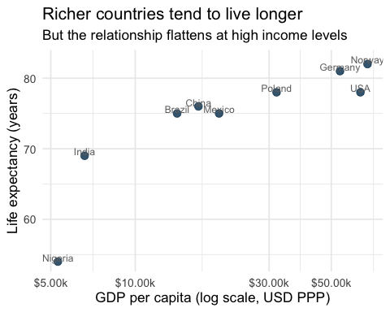
Figure 1: Life expectancy and GDP per capita across selected countries (illustrative data). A log scale on the x-axis straightens the curved relationship.
Figure 1 shows a clear positive association: countries with higher incomes tend to have longer life expectancies. Notice that the x-axis uses a log scale — this straightens the curved relationship and makes the pattern easier to read. We will return to this choice in Session 2.

3.2 A first regression
library(modelsummary) # for clean regression tables
# Add the log-transformed predictor
example_data <- example_data |>
mutate(log_gdp = log(gdp_per_capita))
# Fit the model
model <- lm(life_expectancy ~ log_gdp, data = example_data)
# Display results
modelsummary(
model,
stars = TRUE,
gof_map = c("nobs", "r.squared")
)
Table 1: OLS regression of life expectancy on log GDP per capita.
(Intercept) | -2.662
 | (17.935)
log_gdp | 7.689**
 | (1.787)
Num.Obs. | 9
R2 | 0.726
- p < 0.1, * p < 0.05, ** p < 0.01, *** p < 0.001

The coefficient on log GDP per capita tells us: for each 1% increase in GDP per capita, life expectancy increases by approximately 0.08 years on average.

4 Conclusion
Even a simple regression reveals a strong positive relationship between income and life expectancy. However, income alone cannot explain all of the variation — some countries outperform their income level substantially, while others fall below it. Unpacking these patterns requires controlling for additional variables, a topic we return to in Sessions 2 and 4.

5 References
Békés, G. and Kézdi, G. (2021) Data analysis for business, economics, and policy, Cambridge University Press, available at https://gabors-data-analysis.com.
Preston, S. H. (1975) ‘The changing relation between mortality and level of economic development’, Population Studies 29(2): 231–248.

