Session 1 — Exercise Solution
  - Setting Up a Reproducible Workflow
Your Name
2026-03-05
Table of contents

1 Introduction
This report examines the relationship between economic development and health outcomes across countries. Understanding this relationship is relevant for international businesses assessing market conditions and risk in emerging economies.
As discussed in Békés and Kézdi (2021), regression analysis allows us to estimate the average association between two variables while holding other factors constant. For a formal econometric treatment of these methods, see Wooldridge (2020).

2 Data
The analysis uses data from the World Bank covering 182 countries in 2017. The key variables are GDP per capita (in USD) and life expectancy at birth (in years). The foundational empirical relationship between income and health was documented by Preston (1975).

3 Results
The main finding from the literature is that richer countries tend to have higher life expectancy — but the relationship is non-linear: gains in life expectancy per additional dollar of income shrink as countries become wealthier. A log transformation of GDP per capita helps capture this pattern.
library(tidyverse)
── Attaching core tidyverse packages ──────────────────────── tidyverse 2.0.0 ──
✔ dplyr 1.1.4 ✔ readr 2.1.5
✔ forcats 1.0.0 ✔ stringr 1.5.1
✔ ggplot2 3.5.2 ✔ tibble 3.2.1
✔ lubridate 1.9.4 ✔ tidyr 1.3.1
✔ purrr 1.0.4
── Conflicts ────────────────────────────────────────── tidyverse_conflicts() ──
✖ dplyr::filter() masks stats::filter()
✖ dplyr::lag() masks stats::lag()
ℹ Use the conflicted package (<http://conflicted.r-lib.org/>) to force all conflicts to become errors
ggplot(mpg, aes(x = displ, y = hwy, colour = class)) +
geom_point(alpha = 0.7) +
labs(
x = "Engine displacement (litres)",
y = "Highway fuel economy (mpg)",
colour = "Vehicle class"
) +
theme_minimal()
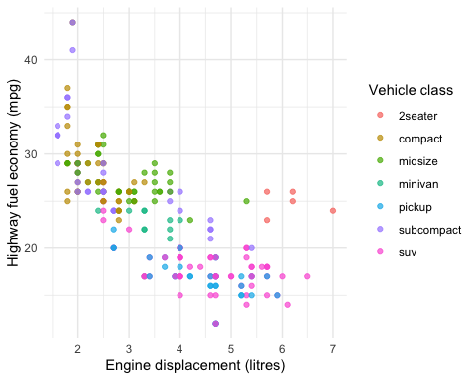
Figure 1: Engine displacement and fuel economy by vehicle class (mpg dataset).

4 References
Békés, G. and Kézdi, G. (2021) Data analysis for business, economics, and policy, Cambridge University Press, available at https://gabors-data-analysis.com.
Preston, S. H. (1975) ‘The changing relation between mortality and level of economic development’, Population Studies 29(2): 231–248.
Wooldridge, J. M. (2020) Introductory econometrics: A modern approach, 7th Ed., Cengage Learning.

