Test Report

Your Name

July 3, 2015

# Header 1

This is a standby template for adjusting the automatic formatting of RMarkdown documents intended to produce scientific manuscripts. It will be iteratively updated as additional object-instances are observed for the manuscript pipeline.

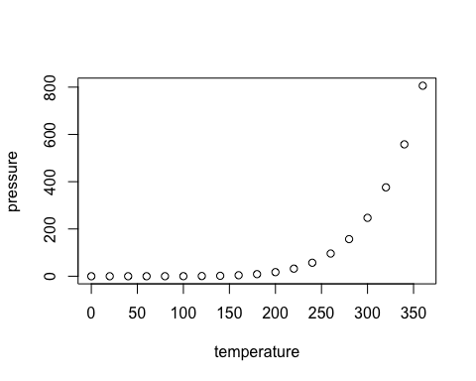

Note that the echo = FALSE parameter was added to the code chunk to prevent printing of the R code that generated the plot.