TtiCompress Framework

Table of contents
TtiCompress Framework 1
Table of contents 1
Use of the TtiCompress 6
Revision history 1
Delphi version 1
What is the TtiCompress? 1
Installing the TtiCompress 1
Dependencies 2
Demonstration source 2
Using the TtiCompress 2
Creating an instance of TtiCompress 3
Compressing a string 3
Compressing a TStream 4
Compressing a file 5
Adding another TtiCompress class 5

What is the TtiCompress?
The TtiCompress is a wrapper around Delphi's ZLib compression library. The Adapter Pattern (GoF 139) and the Factory Pattern (GoF 107) have been used to give a common interface to the compression routine. Using these patterns to wrapper a third party compression components means it is possible to swap compression algorithms at design time or runtime without making any code changes.
For example, an application I have written uses ZLib to compress some documents before storing them in a relational database. At the time of development, ZLib was convenient as it comes with Delphi, but future versions may require PKZip or WinZip compatibility. Using the TtiCompress framework, compression algorithms can be swapped at compile or run time.

Revision history
Revision history:
June 2000, Peter Hinrichsen, Created and made open source

Delphi version
This unit was developed and tested under Delphi 5 enterprise, patch #1. I am not aware of any dependencies which would prevent the unit compiling under any version after 2, however this has not been tested.

Installing the TtiCompress
All the TtiCompress classes and functionality is contained in three PAS file called tiCompress.pas, tiCompressNone.pas and tiCompressZLib.pas. Copy these units to your project's directory, or move them to a directory which contains your shared library code. You may need to set the Library path variable on the Library page of the Tools | Environment Options dialog to point to the directory where you place tiCompress files.

Dependencies
The version of Delphi I developed this family of classes had Zlib.dcu installed in C:\Program Files\Borland\Delphi 5\Lib. I’m not sure that Zlib is installed in earlier version of Delphi and may have to be copied from the CD directly. On the Delphi 5 CD, Zlib can be found in the Info\Extras\Zlib directory.

Demonstration source
The demonstration program comprises an application with a single form that contains the demonstration functionality as shown below:
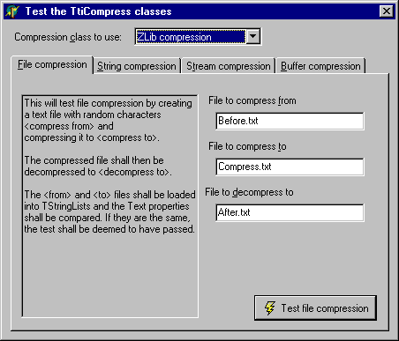
This demo will run four tests using two different compression classes.
Choose a <Compression class to use> from the combo box. The demo comes with a ZLib wrapper and a compression class which has the same functionality, but performs no compression.
- File compression will take the <File to compress from> and compress it to <File to compress to>. It will then decompress the file to <File to decompress to> and confirm that the before and after files are the same.
- String compression will take a string in the memo <Before compression> and compress it to a temporary string. It will then decompress it to <After compression> and compare the two strings to confirm that compression and decompression did not corrupt the data.
- Stream compression will load a file into a TFileStream (loading an EXE into the stream is a good idea to test the compression of binary data). A compressed file and a decompressed file will be produced. The decompressed executable can be launched to confirm there was no corruption.
- Buffer compression test has not been written (any volunteers?)

Using the TtiCompress
The demo has six classes that you need to know about:
Class | Purpose
TtiCompress | Pure abstract class defining interface of TtiCompress classes
TtiCompressClass | A class reference for the TtiCompress descendants
TtiCompressClassMapping | A class to hold the TtiCompress class references. The factory maintains a list of these and uses the CompressClass property to create the objects.
TtiCompressFactory | Factory pattern - Create a descendant of the TtiCompress at runtime.
TtiCompressNone | Implement the NullObject pattern - provide no compression but make the application think compression is being used.
TtiCompressZLib | Implement TtiCompress using the ZLib library that comes with Delphi.

Of these, you may want to use TtiCompress, TtiCompressFactory, TtiCompressNone and TtiCompressZLib
TtiCompress is a pure abstract class that is used to wrapper a third party compression library and give it an interface which is consistent with other compression routines you may want to use in your application.
TtiCompressNone descends from TtiCompress and implements its interface. TtiCompressNone is an example of the NullObject Pattern and will perform no compression, but will look as if it is performing compression to the application.
TtiCompressZLib uses Delphi's ZLib to perform the compression.
TtiCompressFactory is used to create the appropriate concrete TtiCompress class

Creating an instance of TtiCompress
You must use tiCompress.pas in the unit where you are going to create a TtiCompress concrete. You must also use tiCompressNone.pas or tiCompressZLib.pas somewhere in your application if you are going to use either of these concrete classes.
To create an instance of TtiCompressZLib, use the following call to the factory:

const
cgsCompressZLib = 'ZLib compression' ;

var
lCompress : TtiCompress ;

begin

// gCompressFactory is a singleton
lCompress := gCompressFactory.CreateInstance(cgsCompressZLib) ;
// Use the instance of TtiCompress just created…

Compressing a string
The following code shows how to call TtiCompressFactory to compress a string:

procedure TFormMain.bbTestStringCompressionClick(Sender: TObject);
var
lCompress : TtiCompress ;
lsBefore : string ;
lsCompress : string ;
lsDecompress : string ;
begin
// Create the appropriate TtiCompress concrete using a string
// to identify the compression class that is required.
lCompress := gCompressFactory.CreateInstance(cgsCompressZLib ) ;
try
// Get some text to compress
lsBefore := mBefore.Text ;
// Compress the text
lCompress.CompressString( lsBefore, lsCompress ) ;
// Decompress the text
lCompress.DecompressString( lsCompress, lsDecompress ) ;
// Assign the decompressed text to a memo
mAfter.Text := lsDecompress ;
finally
lCompress.Free ;
end ;

end;

Compressing a TStream
The following code shows how to compress a TStream descendant:

procedure TestCompressStream ;
var
lFrom : TFileStream ;
lTo : TFileStream ;
lCompress : TtiCompress ;
lrRatio : real ;
begin
// Read the file to compress into a TFileStream
lFrom := TFileStream.Create( 'CompressionTest.exe',
fmOpenRead or fmShareExclusive ) ;
try
// Create a TFileStream to save the compressed file to
lTo := TFileStream.Create( 'CompressionTest.tmp',
fmCreate or fmShareExclusive ) ;
try
// Create a concrete TtiCompress of the correct type
lCompress := gCompressFactory.CreateInstance(cgsCompressZLib) ;
try
// Perform the compression, returning the compression ratio
lrRatio := lCompress.CompressStream( lFrom, lTo ) ;
finally
lCompress.Free ;
end ;
finally
lTo.Free ;
end ;
finally
lFrom.Free ;
end;

// Show the compression ratio
ShowMessage( Format( 'Compressed size of %n%%',
[lrRatio])) ;
end ;

Compressing a file
The following code shows how to use TtiCompress to compress a file:

Var
LCompress : TtiCompress ;
begin
lCompress := gCompressFactory.CreateInstance(cgsCompressZLib) ;
try
lCompress.CompressFile('FileBefore.txt', 'FileAfter.txt') ;
finally
lCompress.Free ;
end ;

Adding another TtiCompress class
You may want to extend the functionality of the tiCompress system by adding another compression class. For example, you may want add Zip compatible compression using a free or purchased third party zip component. This can be achieved by descending your new class from TtiCompress implementing all the virtual methods, then registering the new class with the TtiCompressFactory.
The Class Diagram for the tiCompress family of classes is shown below:
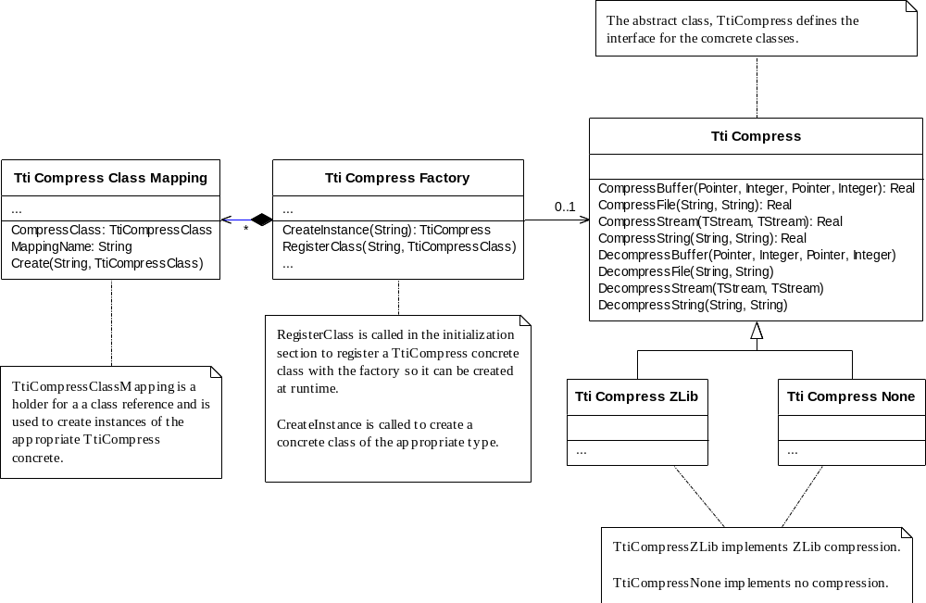
To add a new concrete compression class:
- Create a new unit to hold the concrete class.
- Create a descendant from TtiCompress and implement
CompressBuffer, DecompressBuffer
CompressStream, DecompressStream,
CompressString, DecompressString;
- Create a string constant to identify the tiCompress concrete;
- Register your newly created class with the tiCompressFactory
The tiCompress wrappers and instance of the compression class being used. For example, TtiCompressZLib.CompressBuffer passes the call to Zlib’s CompressBuf method as shown below:

function TtiCompressZLib.CompressBuffer(const pFrom: Pointer;
const piFromSize: Integer; out pTo: Pointer; out piToSize: Integer) : real ;
begin
ZLib.CompressBuf( pFrom, piFromSize, pTo, piToSize ) ;
if piFromSize <> 0 then
result := piToSize / piFromSize * 100
else
result := 0 ;
end;

