TtiLog Framework

Table of contents
TtiLog Framework 1
Table of contents 1
Use of the TtiLog 1
Revision history 1
Delphi version 1
What is the TtiLog? 1
Installing the TtiLog 2
Demonstration source 2
Using the TtiLog 2
Adding another log class 4
Adding a log class which will log immediately 4
Adding a log class which will log to a cache 5

Use of the TtiLog
Originally developed by TechInsite Pty. Ltd.
23 Victoria Pde, Collingwood, Melbourne, Victoria 3066 Australia
PO Box 429, Abbotsford, Melbourne, Victoria 3067 Australia
Phone: +61 3 9419 6456
Fax: +61 3 9419 1682
Web: www.techinsite.com.au
MailTo: mailto:opensource@techinsite.com.au
This code is made available on the TechInsite web site as open source. You may use this code in any way you like, except to sell it to other developers. Please be sure to leave the file header and list of contributors unchanged.
If you make any changes or enhancements, which you think will benefit other developers and will not break any existing code, please forward your changes (well commented) to TechInsite and I will make them available in the next version.

Revision history
Revision history:
June 1998, Peter Hinrichsen, Created
Sept 1999, Peter Hinrichsen, Added functionality
May 2000, Peter Hinrichsen, Made open source

Delphi version
This unit was developed and tested under Delphi 5, patch #1. I am not aware of any dependencies which would prevent the unit compiling under any version after 2, however this has not been tested.

What is the TtiLog?
The TtiLog is a family of classes for logging of debug information to a file or the screen. Some uses of the TtiLog include:
- Logging of debugging information when developing multi threaded code. Debugging multi threaded code can be difficult using Delphi's IDE debugger as several threads can attempt to execute the same code, or use the same resource at the same time. With the TtiLog, it is possible to write out information about the state of the system to a log file, or to the screen and analyse the execution path through the code.
- Server side applications which run unattended should be able to write information about the processes they are running, or error states to the screen, or a file, or perhaps send an EMail to an administrator. The TtiLog provides an interface which makes it simple to log to a file or the screen, and possible to add additional log targets such as an EMail system or a relational database.

Installing the TtiLog
All the TtiLog classes and functionality is contained in the single PAS file called tiLog.pas. Copy this unit to your project's directory, or move it to a directory which contains your shared library code. You may need to set the Library path variable on the Library page of the Tools | Environment Options dialog to point to the directory where you place tiLog.pas

Demonstration source
The demonstration program comprised an application with a single form that contains the demonstration functionality as shown below:
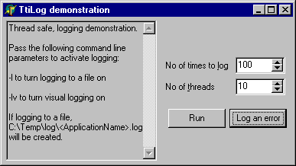
This demo will run two tests:
- Clicking the <Run> button will create some threads (value you enter in 'No of threads') which will each write to the log a number of times (value you enter in 'No of times to log'). These log events are cached and will be written from a thread with a priority of tpLowest. This means that logging will take as little resource from your application as possible.
- Clicking <Log an error> will cause an error to be logged immediately, and an error dialog to show.

Using the TtiLog
When the unit tiLog.pas is included in you application, a single instance of the class TtiLog will be created as part of the applications Initialization process. (This singleton is also automatically freed).
tiLog.pas contains 4 globally visible procedures for logging:

Log a string, with its severity
Useful for writing debugging information out to a log, either while developing an application, or when a server side application is in production.
// Interface
procedure Log( const psMessage : string ;
pSeverity : TLogSeverity = lsNormal ) ; overload ;

// Example
Log( 'My log entry with default severity' ) ;
Log( 'Query took nnn milliseconds', lsQueryTiming ) ;
Log( 'The user has done a bad thing', lsWarning ) ;
Log( 'The user has done a very bad thing', lsError ) ;

Log an integer value for debugging
Useful for writing an integer to the log, which can help trace the flow of an applications logic in a multi threaded system.
// Log an integer value
procedure Log( const piMessage : integer ) ; overload ;

// Example
// This technique is
Log( 1 ) ;
// useful for tracing your position
Log( 2 ) ;
// in multi threaded code
Log( 3 ) ;

Log an array of values of mixed types (variants) for debugging
Log an array of variants which can be useful when you want to examine a series of values like the parameters to a method call.
// Interface
procedure Log( const pA : Array of Const ) ; overload ;

// Example
Log( [ 123.456, 123456, '123456', false ]) ;

procedure MyProc( pStr : string ; pInt : integer ; pReal : real ) ;
begin
Log([ pStr, pInt, pReal ]) ;
DoStuff ;
end ;

Log an error
Logging an error is useful in server side, or multi threaded code where an error must be shown on the screen and a modal dialog can not be used as it would lock the application up until a user clears the dialog.
// Interface
procedure LogError( const psMessage : string ) ;

// Example
Log( 'The user has done a very bad thing. ) ;
try
Query.ExecSQL ;
except
on e:exception do
LogError( 'Error executing SQL: ' + e.Message ) ;
end ;

Adding another log class
You may want to extend the functionality of the tiLog system by adding another logging class. For example, you may want the tiLog to send an EMail to the system administrator when ever an error is logged. This can be achieved by descending your new class from TLogToAbs or TLogToCacheAbs, and registering the new class with the TtiLog.
Sometimes, the log message is critical and must be processed immediately (line an error message). In this case, use the TLogToAbs as the parent of your new log class.
Sometimes, writing to the log can be expensive in system resources (eg when writing to a memo which is currently being displayed) so the TtiLog will cache log messages and write them out when the system is idle. It you want log messages to be cached, use the TLogToCacheAbs as the parent of your new log class.
The Class Diagram for the tiLog family of classes is shown below:
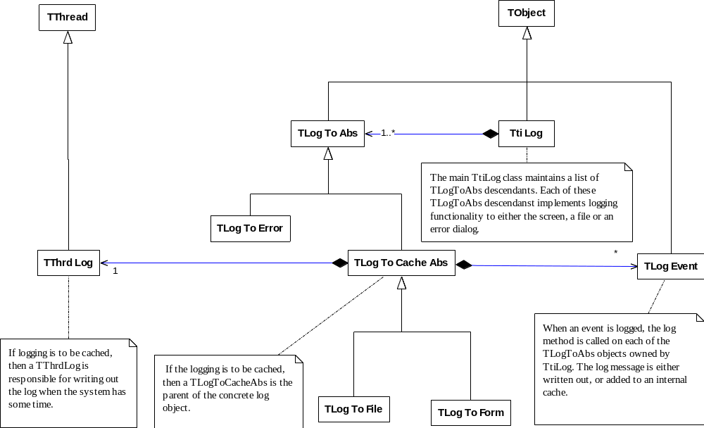

Adding a log class which will log immediately
The interface section of your new class will typically look like this:

interface
uses
tiLog

type
// Adding a class which will log immediately
TLogNow = class( TLogToAbs )
protected
function AcceptEvent( const psDateTime : string ;
const psMessage : string;
pSeverity : TLogSeverity ) : boolean ; override ;
public
procedure Log( const psDateTime : string ;
const psMessage : string;
pSeverity : TLogSeverity ) ; override ;
end;

The implementation section of your new class will typically look like this:
implementation
function TLogNow.AcceptEvent( const psDateTime : string ;
const psMessage : string;
pSeverity : TLogSeverity ) : boolean ;
begin
result := // Perform some test to check the message should be logged,
// for example, should the message be EMailed to someone?
end ;

public
procedure TLogNow.Log( const psDateTime : string ;
const psMessage : string;
pSeverity : TLogSeverity ) ;
begin
if not AcceptEvent( psDateTime,
psMessage,
pSeverity ) then
Exit ; //==>
SendEMail( psMessage ) ;
end ;

You must register the new logging class with the TtiLog in an initialilzation section like this:
initialization
gLog.RegisterLog( TLogNow ) ;
finalization
end.

Adding a log class which will log to a cache
If you want your log to cache messages, and write them out when the system is idle, you descend your new class from TLogToCacheAbs. You will generally only have to override the WriteToLog method as shown below:

interface
uses
tiLog
;

type
TLogLater = class( TLogToCacheAbs )
protected
procedure WriteToOutput ; override ;
end;

implementation
procedure TLogLater.WriteToOutput ;
var
i : integer ;
lLogEvent : TLogEvent ;
begin
// You must cann inherited to copy the LogEvent objects from the cache,
// to a working buffer.
inherited WriteToOutput ;
// Scan the working buffer for log events
for i := 0 to FListWorking.Count - 1 do begin
// Get a pointer to the log event to simplify the code
lLogEvent := TLogEvent( FListWorking.Items[i] ) ;
// Write the log line out here
YourCustomOutputMethod( lLogEvent.AsString ) ;
// Free the log event
lLogEvent.Free ;
end ;
// Empty the working list
FListWorking.Clear ;
end ;

