Lab #3

Daniel Graham

SDEV 300 7981

Building Secure Web Applications – Dr. Jason Cohen

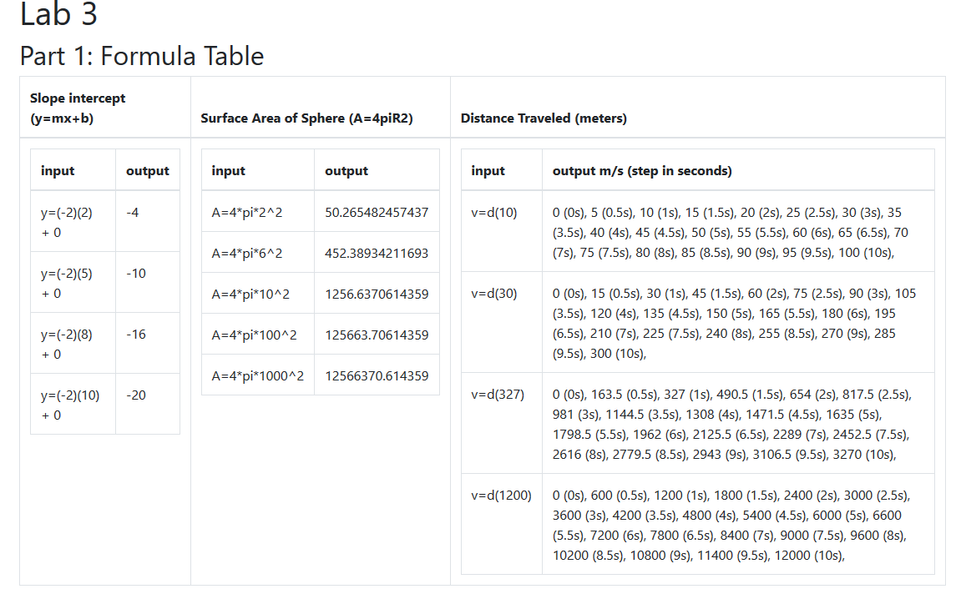As you can see from figure 1, I decided to nest tables since there was a lot of information to display. I included my functions in lab3.php and “required” them in the index.php. This is to keep some of the major functionality that is not display code separate from the html, and display php. Arrays where used to store the original datasets, and arrays were generated and returned to display the data on the page.

Figure - Formula Table

# Part 2: Quote table

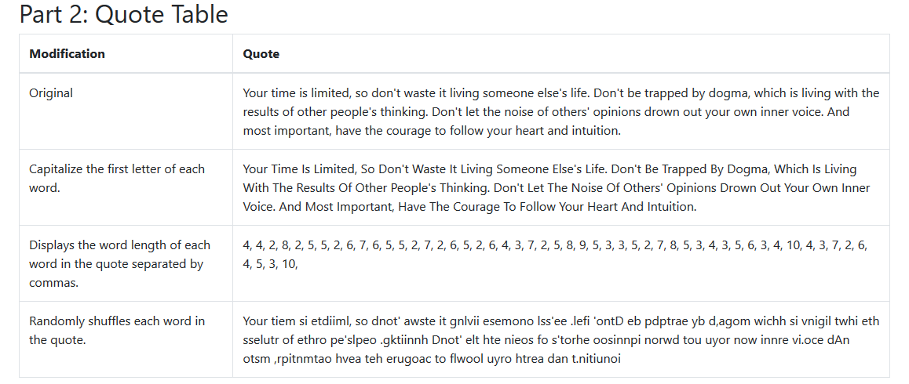From figure 2, you can see the bottom half of my webpage which shows a good quote from Steve Jobs. It is exactly 300 characters including spaces.

Figure - Quote table, showing string modifications

In figure 3 you will see screenshot evidence that the lab was built and ran on the SDEV AWS machine,

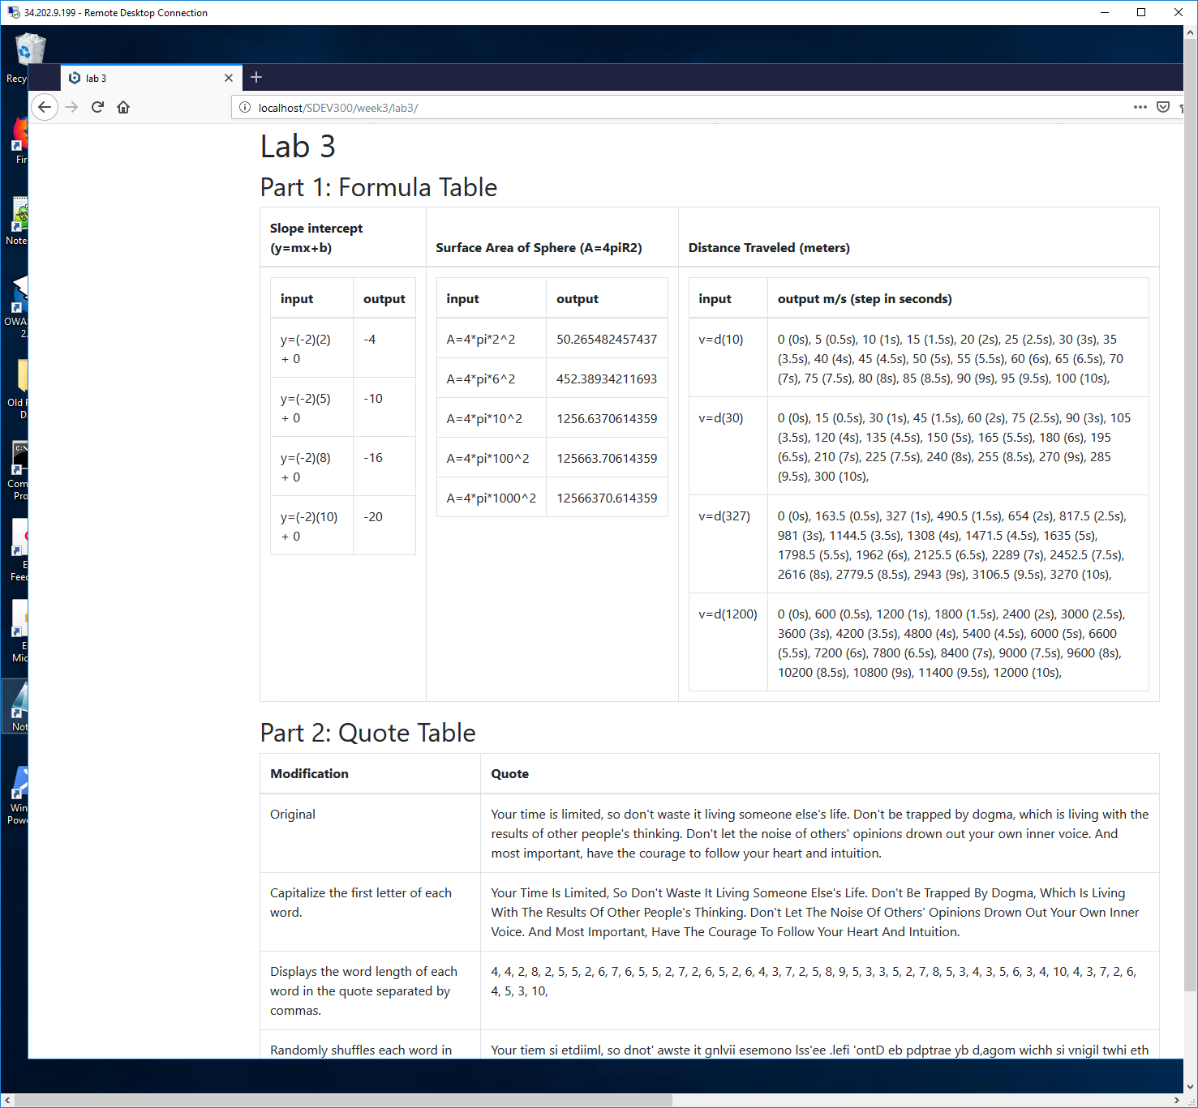

Figure - proof it is running on the SDEV AWS machine