Lab #4

Daniel Graham

SDEV 300 7981

Building Secure Web Applications – Dr. Jason Cohen

There was no indication that the Lab had to be done in multiple files, so I coded it as a single page app. The only php code that is separate is the logout.php which only deletes the session.

C:\Users\Dan\Documents\ShareX\Screenshots\2018-11\mstsc_2018-11-19_20-44-42.png I achieved this by submitting the forms to itself securely (figure 1). I have the login form in a separate file, but I include it where it’s needed.

Figure - submitting to itself

As you can see in figure 2, Index.php includes the login form if there is not a logged in user. Only a logged in user can use the web app regardless.

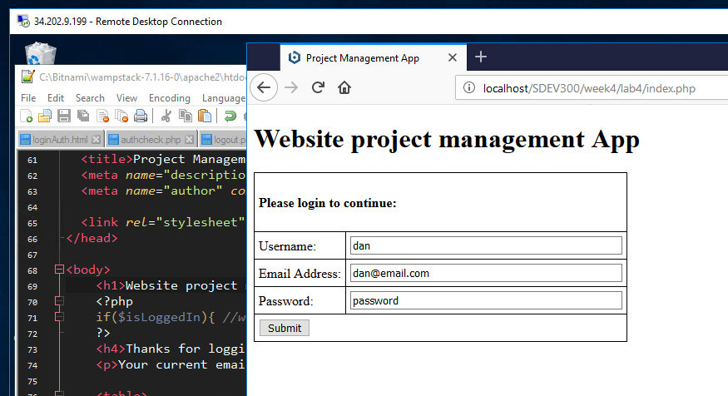

Figure - The Website project management login screen

Once You log in with any information, you will be presented with figure 3, the main web app.

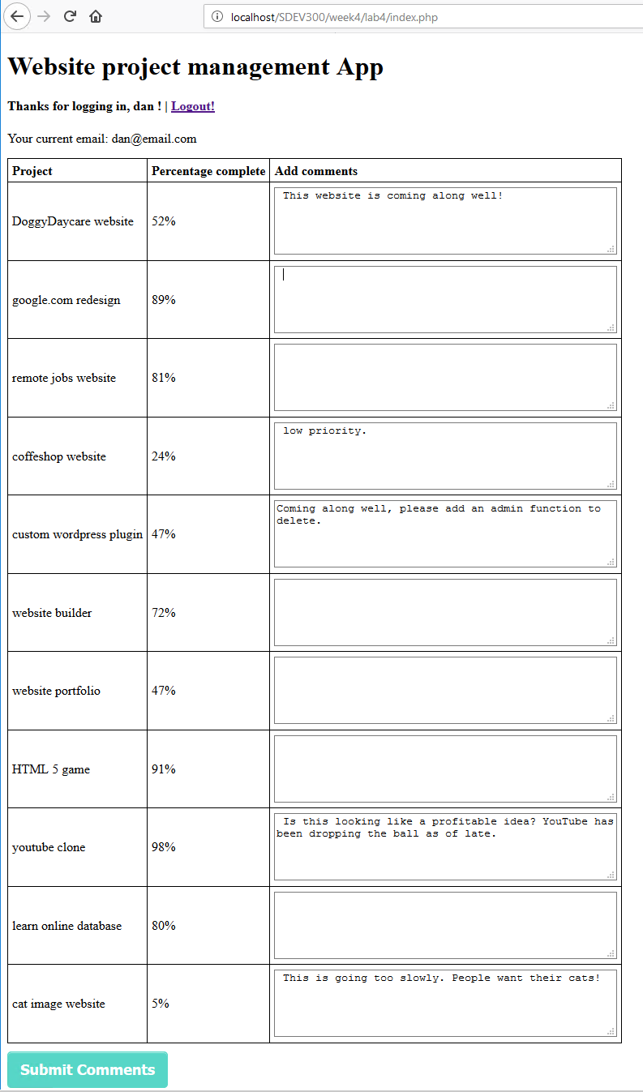

Figure - Website management project main screen

The user has the ability logout, add comments to any of the projects that they currently have going. Their username and email are displayed so that they know what account they are currently using. Once the user clicks submit comments the web app submits to itself, checks for the posted data from the comments form, and changes state so that the user may review the comments that were just submitted. (figure 4). Once the user is finished reviewing the comments, they can click the go back button to be returned the apps main screen/state.

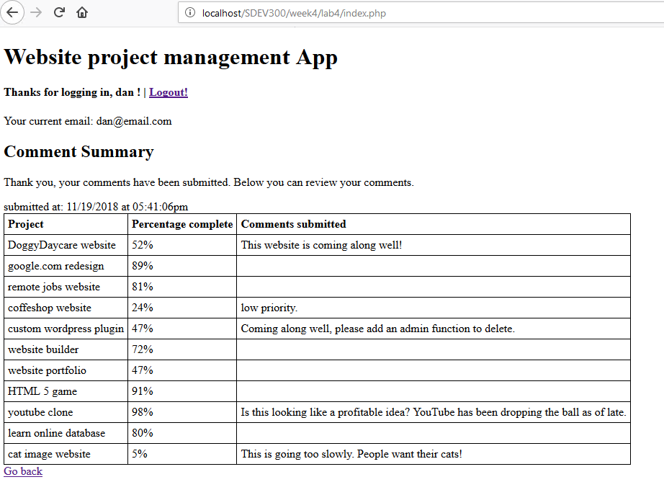

Figure - website project management app comment summary screen