Lab #6

Daniel Graham

SDEV 300 7981

Building Secure Web Applications – Dr. Jason Cohen

1. Creating the Faculty table.

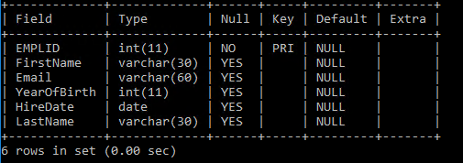

1. Creating the courses table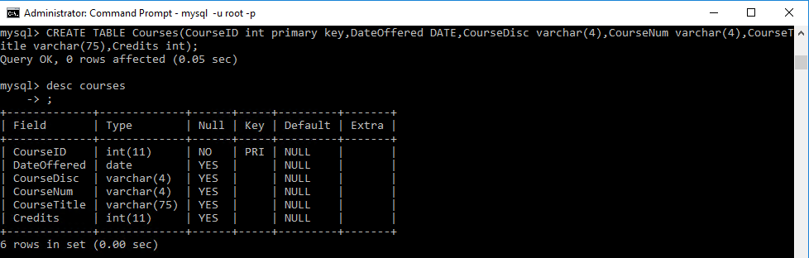
2. Creating the FacultyCourses table with two FK’s pointing towards the courses table and faculty table so that it is a “Link” between the two. 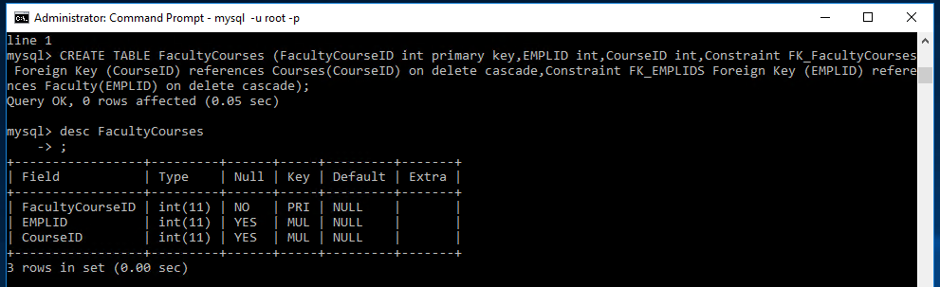
3. Populating the tables with data. Employee table printed out.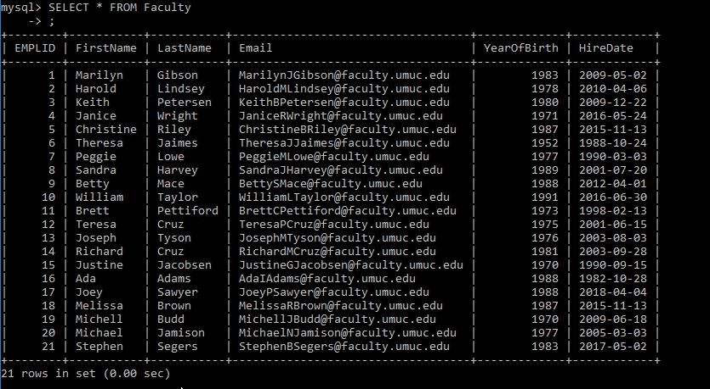

The courses table inserted and printed out.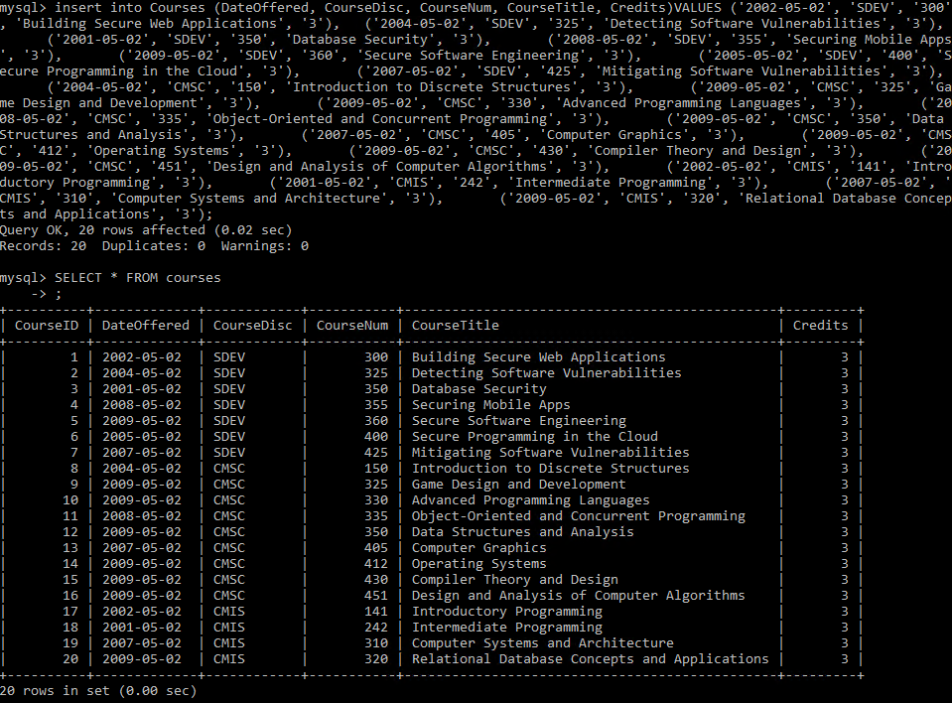

The faculty Courses table printed out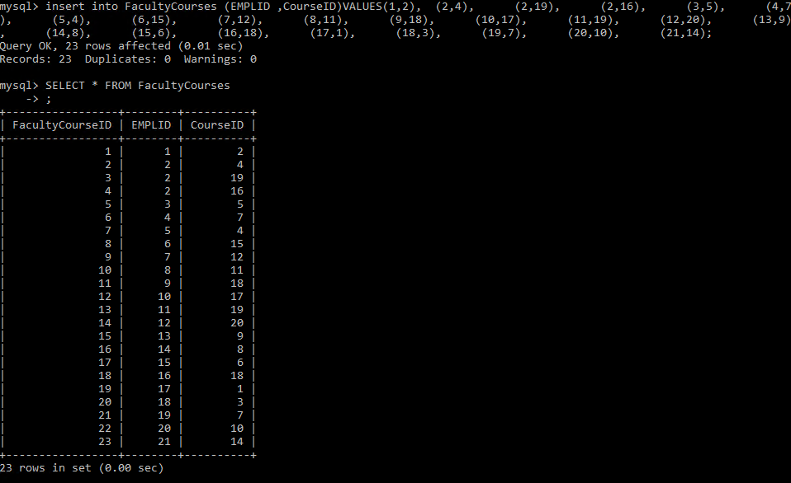

1. All of the credits successfully changed to 6.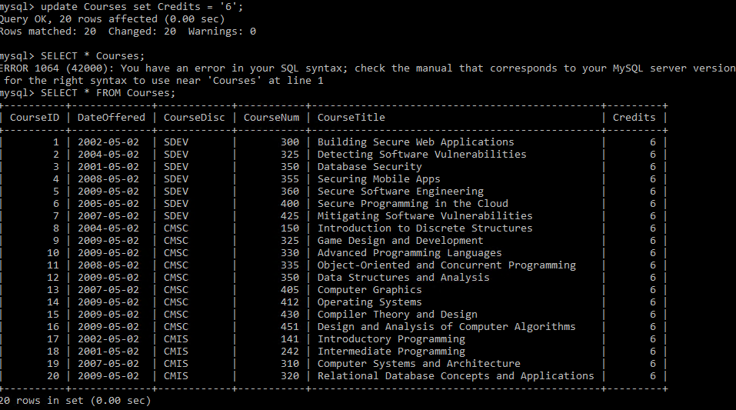
2. Nothing was changed because no employee was born in 1994.C:\Users\Dan\Documents\ShareX\Screenshots\2018-12\mstsc_2018-12-05_00-54-58.png
3. Three employees were removed, more specifically, the ones with employee id 5, 17, and 21.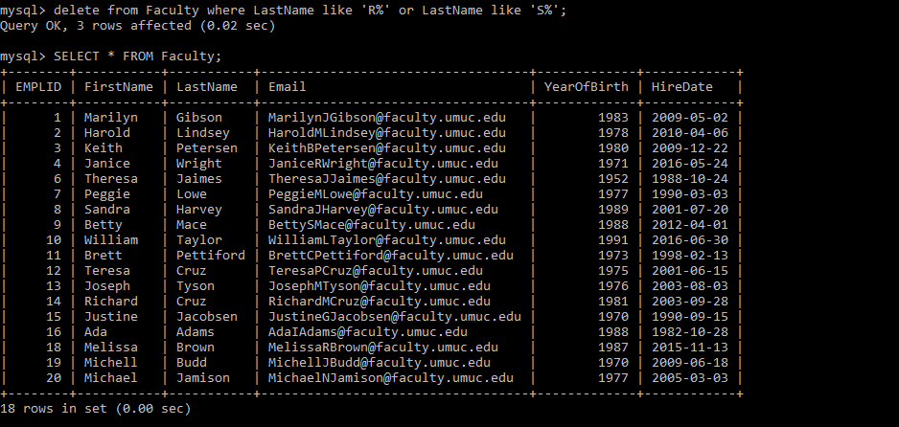
4. As you can see two courses were deleted from the record because they were offered in 2004.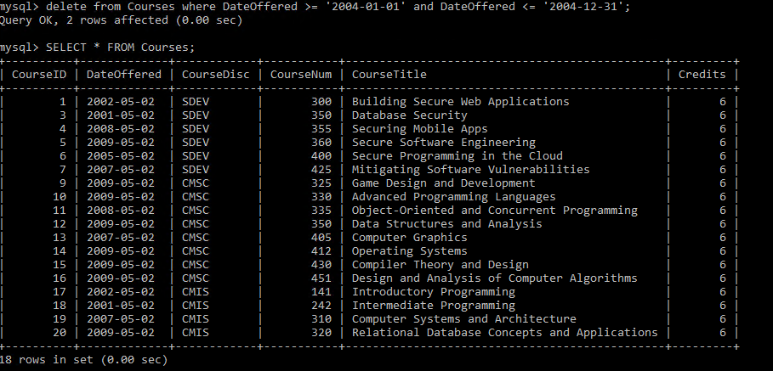
5. This is a printout of all of the tables ordered by lastname desc, the courses ordered by the title asc, and all of the FacultyCourses without any qualifiers as it was not specified or required.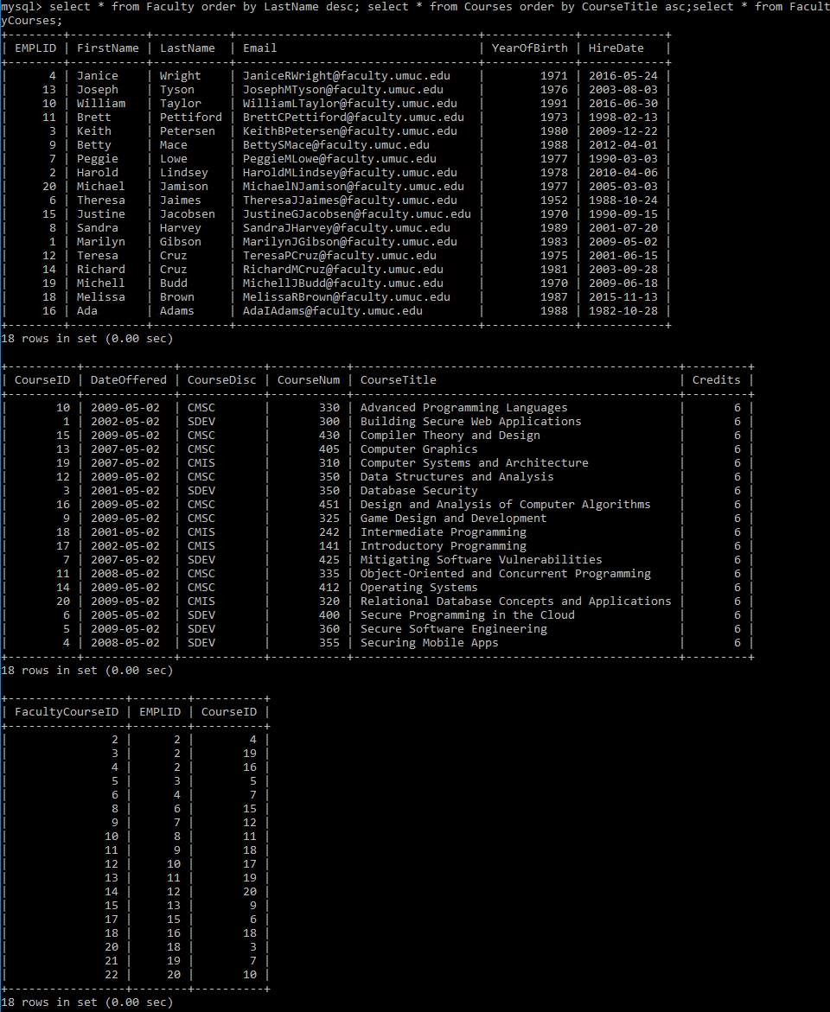
6. This returns the list of Employee ID’s that teach less than three courses.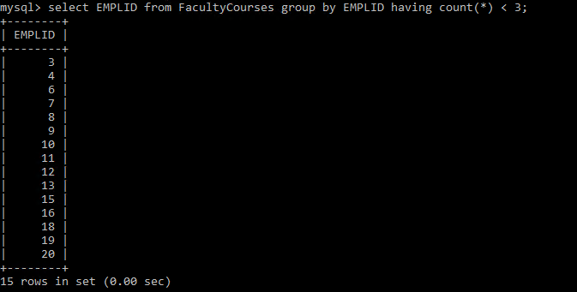
7. The following returns nothing because there are no courses offered before 1999.

C:\Users\Dan\Documents\ShareX\Screenshots\2018-12\mstsc_2018-12-05_02-39-40.png



This is hard to see all in a single screengrab but if you zoom in the document you can see it. The select combines the tables to form a complete overview of the data.

