Daniel Graham

SDEV 300 7981

Building Secure Web Applications – Dr. Jason Cohen

This lab was way more involved than I originally thought. Honestly, two labs of these sizes near the end of the semester is a bit rough.

I added a config directly to which where it reads the database info from a ini file.

If you traverse to <http://localhost/SDEV300/week7/lab7/> you are directed to <http://localhost/SDEV300/week7/lab7/login.php> if not logged in

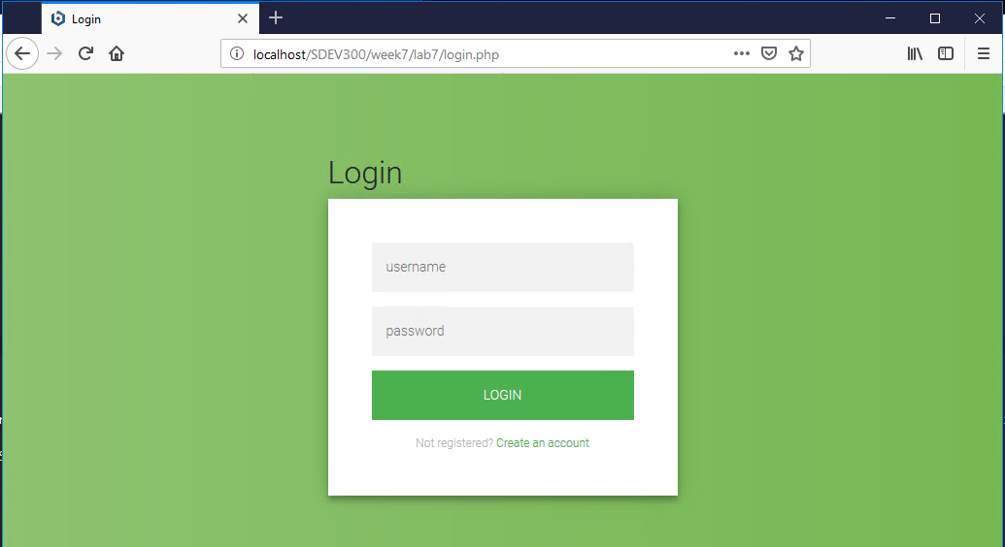

Figure 1 - game app login screen

If you don’t haven account click “create an account” as you see in figure 2 you will be presented with

A register account page.

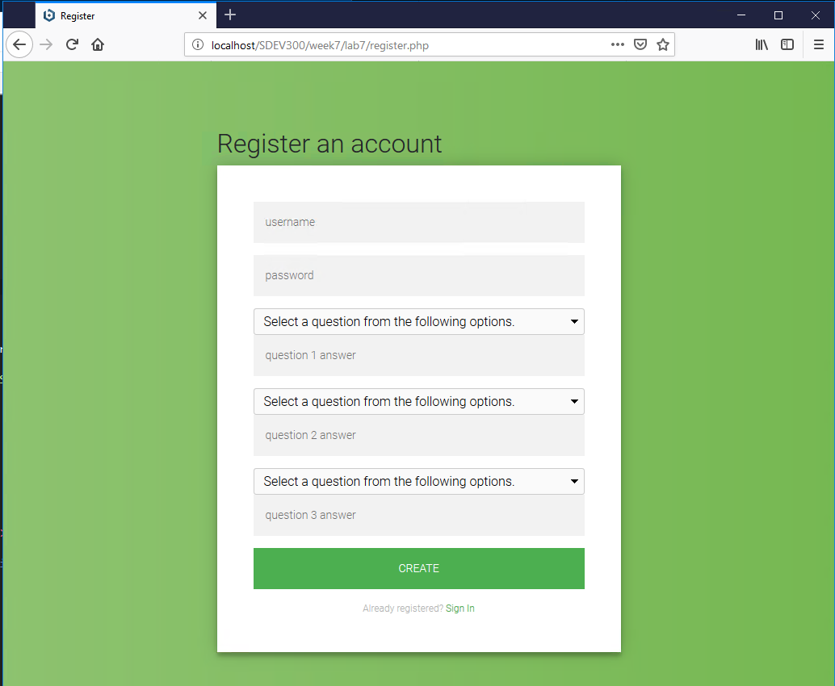

Figure 2 - register an account with game app

If there are any errors the page will not submit for registration and you will be presented with errors like in figure 3.

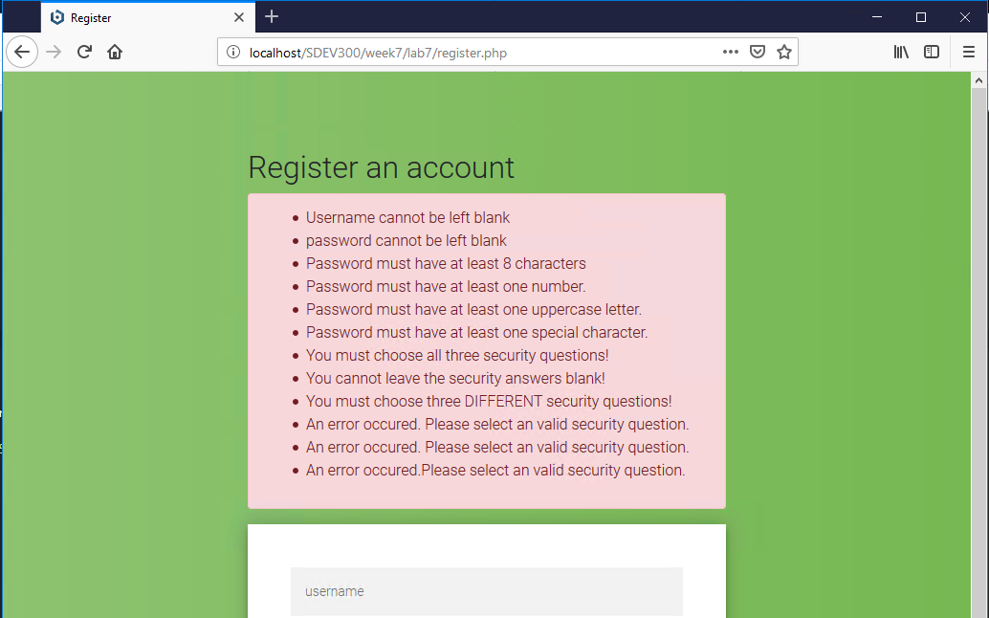

Figure 3 - errors in registration

If you follow those rules, your account will be created and you will be redirected to the login page and asked to login.

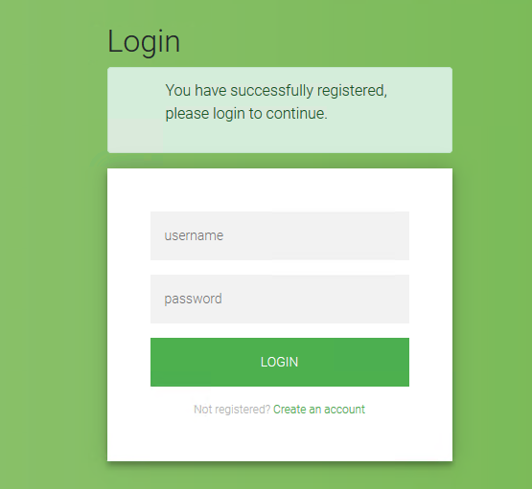

Figure 4 - successful account creation message.

After logging in you will be presented with a security challenge, from one of the questions tied to your account. You get 1 question per login. See figure 5.

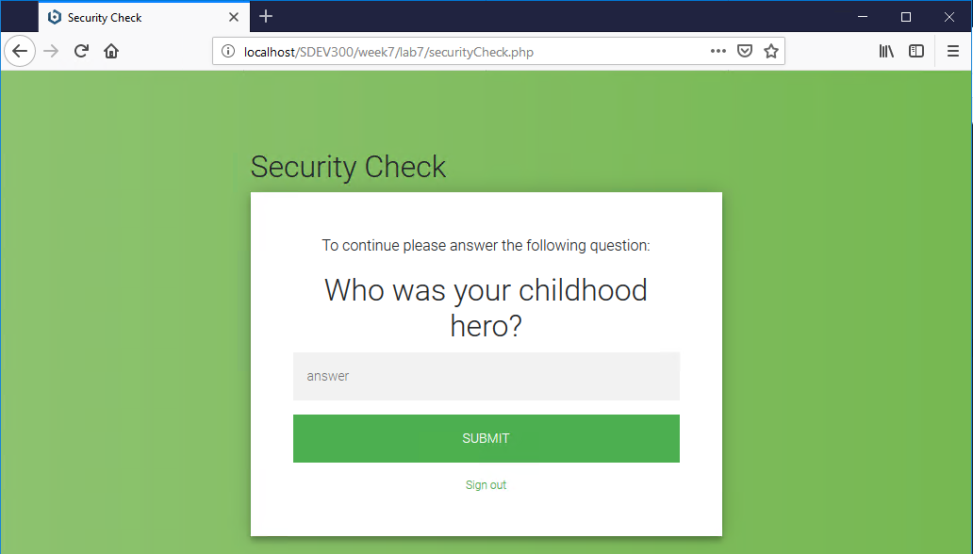

Figure 5 - Security check challenge

If you attempt to go to any page you’ll not allowed to do anything but answer the question or logout.

Once you answer the question you’ll be redirected to the game app (figure 6)

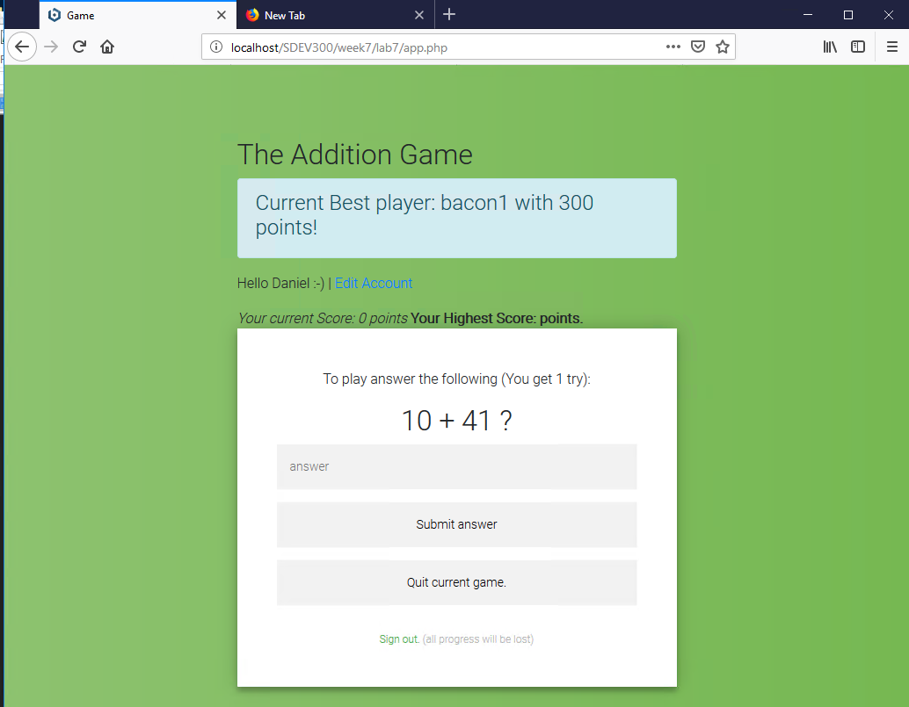

Figure 6 The game app

In the app you are presented with an addition problem you get 10 points per right answer and -10 for a wrong answer. If you submit a blank answer you can skip but are deducted 5 points.

If you click current game, your score is reset and you are in a “new game”. If you currentscore is higher than your highest your highscore will be updated in the database.

You can also click edit account to edit any details, as you see in figure 7. You can also delete your account from this screen.

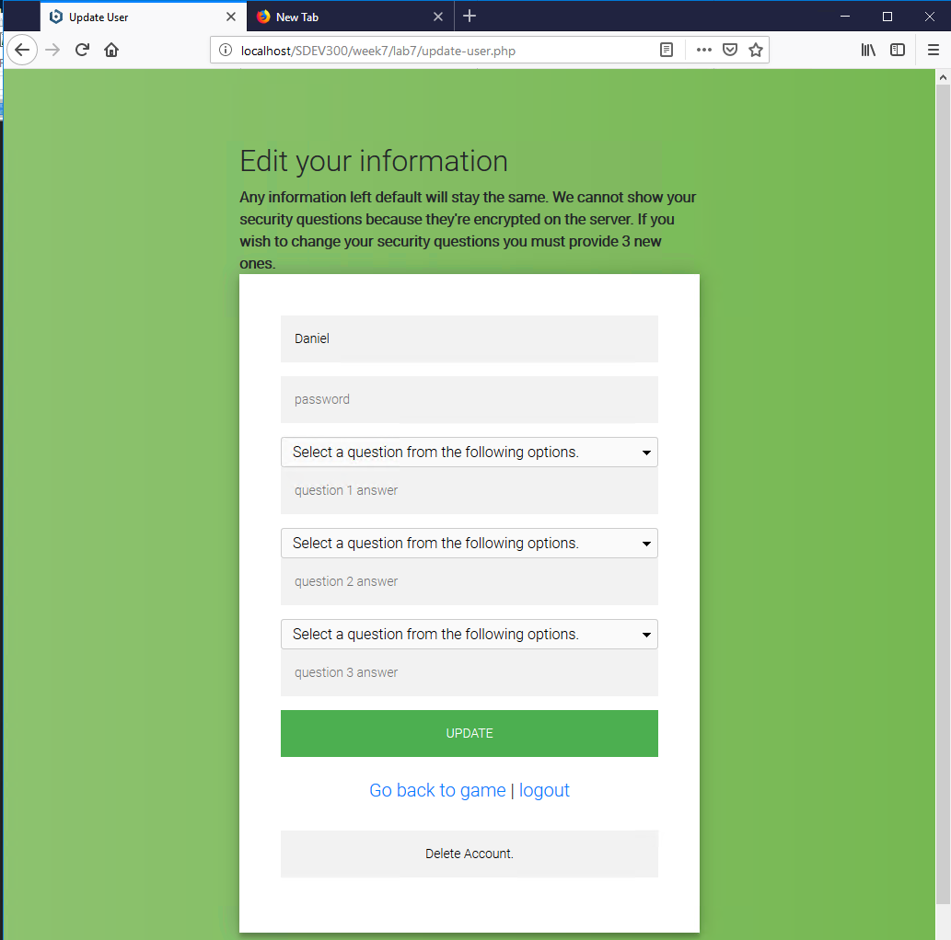

Figure 7 - update account screen